Credit Assistant – AI-Powered Credit & Financial Wellness Platform
Project Report
A web-based AI-powered platform for understanding, monitoring and managing credit information
Project Name | Credit Assistant – AI-Powered Credit & Financial Wellness Platform
Domain | Artificial Intelligence / Financial Technology / Web Development
Primary Technologies | React.js, Vite, Python, FastAPI, SQLAlchemy, PostgreSQL, Supabase, Google Gemini API
Application Type | AI-powered full-stack web application

Prototype / Project URL : https://credit-assistant-e9f07.web.app/
Prototype / Project QR Code :

1. Project Description
Credit Assistant is an AI-powered web application designed to help users understand, monitor, and manage their credit-related information through a centralized platform.
The application allows users to securely create an account, manage their profile, add credit accounts, track credit score history, view credit-related analytics, and interact with an AI Credit Advisor.
The system combines a React and Vite frontend, FastAPI backend, SQLAlchemy, PostgreSQL/Supabase database, REST APIs, secure authentication, and AI integration.
The main purpose of the project is to bring credit-related information and intelligent assistance together in one user-friendly platform.

2. Objectives
- To develop a centralized platform for managing credit-related information.
- To provide secure user authentication and profile management.
- To allow users to add and manage credit card and loan accounts.
- To track credit score information and its historical changes.
- To calculate and display useful credit-related indicators.
- To provide graphical visualization of credit information.
- To provide an AI-powered Credit Advisor for natural-language queries.
- To support English, Marathi, and Hindi interfaces.
- To provide a responsive and user-friendly interface.
- To maintain secure communication between frontend, backend, database, and AI services.

3. Project Scenarios
Scenario 1: Credit Account Management
Users can securely add and manage their credit cards and loan accounts, including bank/lender, account type, credit limit, outstanding balance, EMI, and account age. This information is used for further credit analysis.
Scenario 2: Credit Health Monitoring
Users can view their credit score, credit utilization, debt-to-income ratio, payment information, and score history through the dashboard. Charts and analytics help users understand changes in their credit profile.
Scenario 3: AI-Powered Credit Guidance
Users can ask credit-related questions in natural language through the AI Credit Advisor. The application sends the request to the FastAPI backend, which communicates with the Google Gemini API and returns personalized guidance based on the available user information.

4. Project Workflow
The development of Credit Assistant was carried out through the following six major milestones:
Milestone | Stage | Major Activities
Milestone 1 | Requirement Analysis & System Planning | - Identify the problems faced by users in managing credit information.  - Define project objectives, scope, and major features.  - Identify required frontend, backend, database, and AI technologies.  - Design the overall system architecture and workflow.
Milestone 2 | User Authentication & Profile Management | - Develop user registration and login.  - Implement Google Login and Forgot Password functionality.  - Implement JWT-based authentication.  - Develop user profile creation and editing.  - Implement secure user-specific data access.
Milestone 3 | Credit Management & Analytics | - Develop credit card and loan account management.  - Add bank/lender selection and Indian bank selector.  - Store credit limit, balance, EMI, and account-age information.  - Implement credit utilization and debt-to-income calculations.  - Develop credit score history and analytics.  - Add charts and visualizations.
Milestone 4 | Frontend Application Development | - Develop the React + Vite frontend.  - Create Dashboard, Credit Accounts, Score History, AI Advisor, Profile, and Help & Support pages.  - Implement responsive and user-friendly interface.  - Add English, Marathi, and Hindi language support.  - Connect frontend components with backend REST APIs.
Milestone 5 | AI Integration, Security & Testing | - Integrate the Google Gemini API.  - Develop the AI Credit Advisor and contextual responses.  - Implement secure API-key management using environment variables.  - Perform input validation and error handling.  - Test authentication, APIs, database operations, analytics, AI features, and multilingual functionality.
Milestone 6 | Deployment & Final Demonstration | - Manage source code using Git and GitHub.  - Build the frontend for production.  - Deploy the frontend using Firebase Hosting.  - Deploy the FastAPI backend using Render.  - Connect the application with Supabase PostgreSQL.  - Configure production environment variables.  - Verify the complete deployed application and prepare the final demonstration.

5. Detailed Milestones and Activities
Milestone 1: Requirement Analysis & System Planning
This milestone establishes the foundation of Credit Assistant. The problem statement, target users, functional requirements, major modules, technology stack, and overall system architecture are defined before implementation begins.Activity 1.1: Identify the need for simplified financial-news understanding and define target users.
- Activity 1.1: Identify the need for a centralized platform to understand and manage credit-related information.
- Activity 1.2: Define functional modules such as authentication, credit accounts, dashboard, score history, analytics, AI assistance, profile and support.
- Activity 1.3: Design the interaction between the React frontend, FastAPI backend, database and Google Gemini API.
- Activity 1.4: Plan database structure, API communication, environment variables, security, validation and error-handling requirements.
Milestone 2: User Authentication & Credit Management Backend
This milestone focuses on developing the backend foundation of Credit Assistant. The backend provides secure
user management, profile handling, credit account management and REST API services.Activity 2.1: Set up the
FastAPI application and backend folder structure.
- Activity 2.1: Set up the FastAPI application and organize the backend folder structure.
- Activity 2.2: Implement user registration, login, Google Login, Forgot Password and JWT-based authentication.
- Activity 2.3: Develop APIs for user profiles, credit cards, loans, payments, goals and score history.
- Activity 2.4: Implement request validation, database operations, user-data isolation, exception handling and clear API responses.
Milestone 3: Credit Analytics & AI-Powered Credit Advisor
This milestone introduces the core intelligence and analysis capabilities of the application. Credit-related information is processed to generate useful analytics, while Google Gemini provides AI-powered guidance.
- Activity 3.1: Implement credit utilization, debt-to-income ratio and other credit health calculations.
- Activity 3.2: Develop credit score history, financial indicators and graphical analytics.
- Activity 3.3: Configure the Google Gemini API and connect it securely with the FastAPI backend.
- Activity 3.4: Develop AI-powered responses for credit-related questions using available user information and support English, Marathi and Hindi interactions.
Milestone 4: Frontend & User Interface Development
This milestone converts the backend capabilities into an interactive web application. The interface is designed to provide users with a simple way to manage credit information and access analytical and AI features.
- Activity 4.1: Design the login, registration, dashboard, navigation and common application layout.
- Activity 4.2: Develop Credit Accounts, Score History, Profile and AI Credit Advisor pages.
- Activity 4.3: Add dashboard cards, charts, credit indicators and the comprehensive Indian bank selector.
- Activity 4.4: Implement responsive design, multilingual interface, loading states, validation messages and user-friendly error handling.
Milestone 5: System Integration, Security & Testing
This milestone verifies that all application layers work together correctly and that the system handles user data and common failures securely.
- Activity 5.1: Connect frontend API calls with the FastAPI backend and verify complete data flow.
- Activity 5.2: Test end-to-end workflows including authentication, profile management, credit accounts, analytics and AI Advisor.
- Activity 5.3: Protect passwords, JWT tokens, Gemini API credentials and other sensitive configuration using secure practices and environment variables.
- Activity 5.4: Test invalid inputs, API failures, database operations, authentication errors, multilingual functionality and responsive behavior.

Milestone 6: Deployment, Documentation & Final Demonstration
The final milestone prepares Credit Assistant for production deployment and academic demonstration. The goal is to ensure that the application is documented, reproducible and ready for presentation.
- Activity 6.1: Configure the production environment and install all required frontend and backend dependencies.
- Activity 6.2: Deploy the React frontend using Firebase Hosting and the FastAPI backend using Render with Supabase PostgreSQL.
- Activity 6.3: Prepare project documentation including system architecture, features, technology stack, APIs, setup instructions and environment configuration.
- Activity 6.4: Conduct final acceptance testing and demonstrate the complete Credit Assistant user journey.

6. Exploring the Website's Web Pages
The following five pages represent the main user journey and core functionality of the Credit Assistant application.
- Login / Authentication Page : The login page provides secure access to Credit Assistant. Users can log in, create an account, use Google Login, or reset their password.
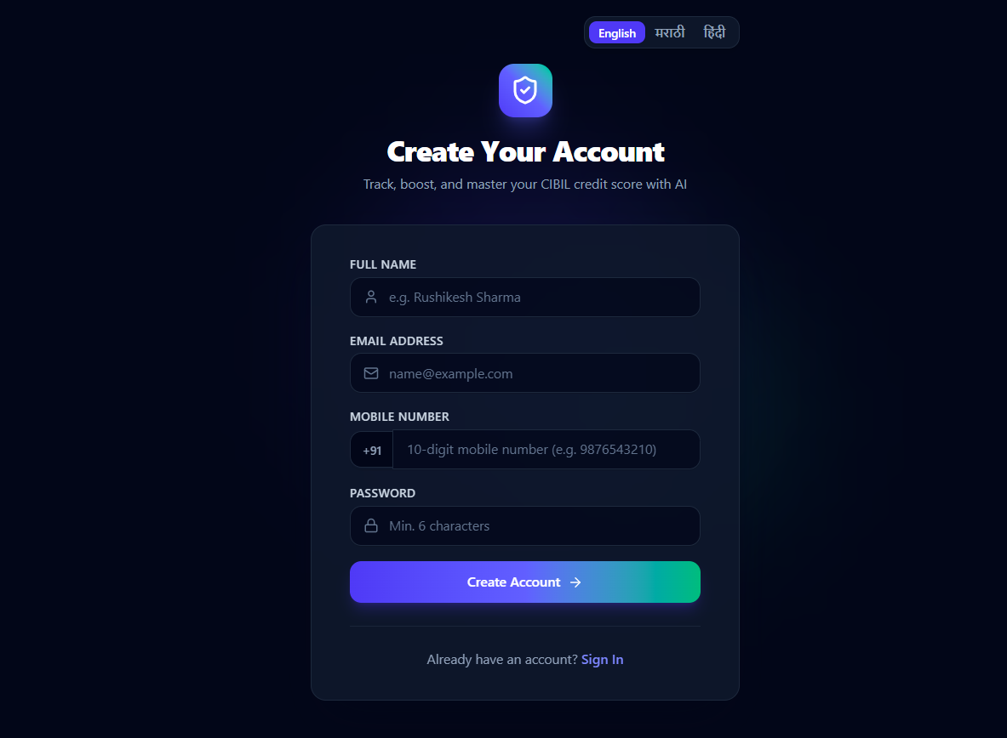
Figure 1: Credit Assistant – Login / Authentication Page

2) Dashboard Page : The dashboard provides an overview of the user's credit information, including credit indicators, account information and visual analytics.
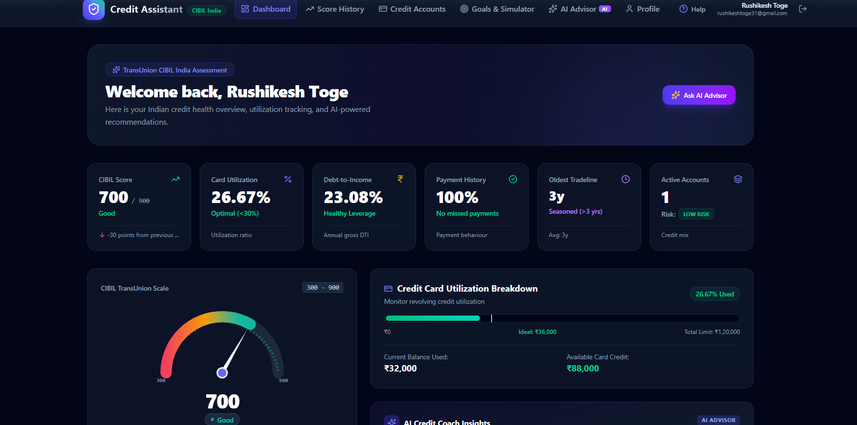

Figure 2: Credit Assistant – Dashboard

3) Credit Accounts Page :
This page allows users to add and manage credit cards and loan accounts with details such as bank, balance, credit limit and EMI.
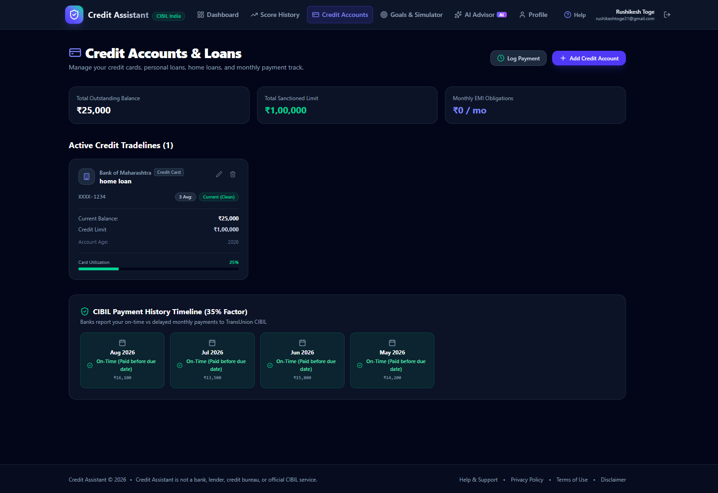
Figure 3: Credit Assistant – Credit Accounts Page

4) Score History Page : The Score History page allows users to track their credit score over time using historical records and graphical visualization.
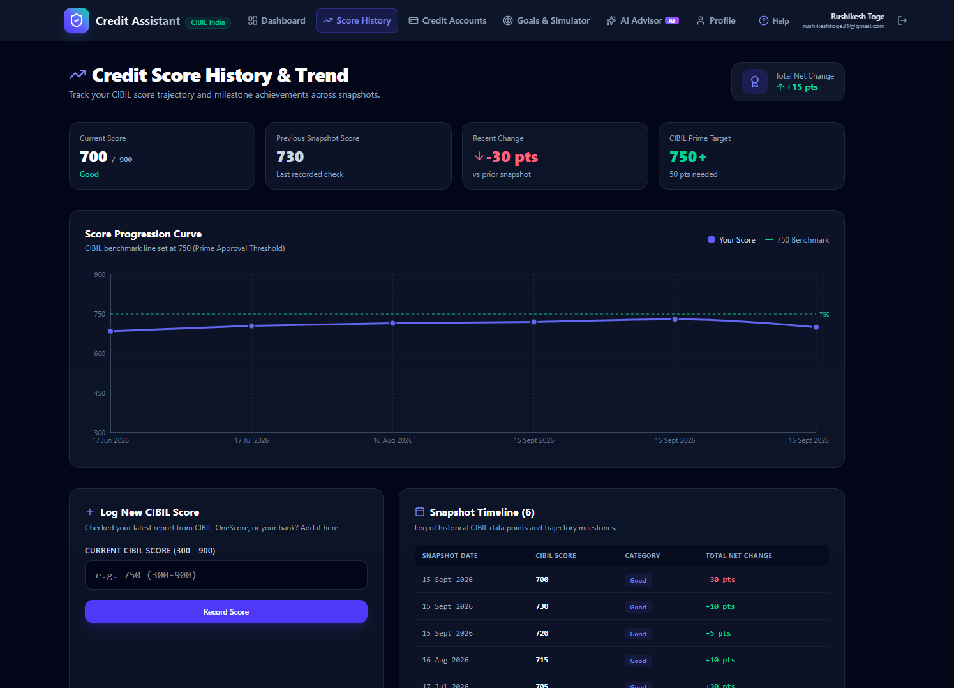
Figure 4: Credit Assistant – Score History Page

5) AI Credit Advisor Page : The AI Credit Advisor allows users to ask credit-related questions and receive AI-powered guidance using the Google Gemini API.
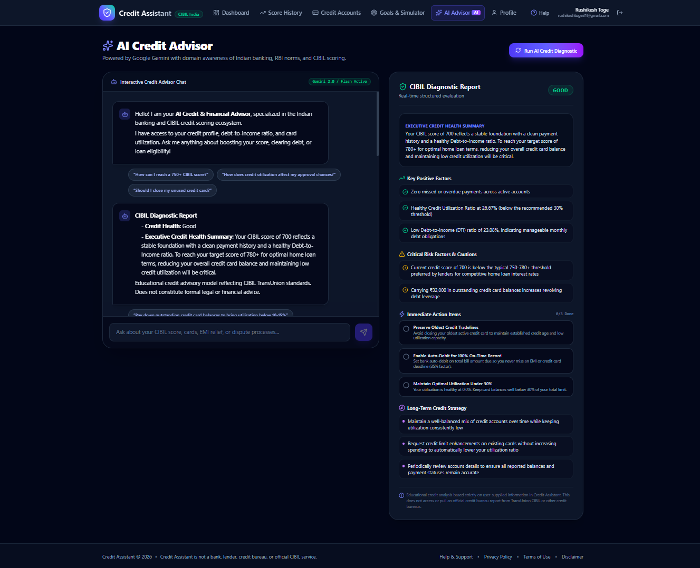
Figure 5: Credit Assistant – AI Credit Advisor Page

7. System Architecture
Credit Assistant follows a layered architecture in which the frontend communicates with the FastAPI backend, while the backend manages authentication, credit-related data, database operations, analytics, and communication with the Google Gemini API.
Layer | Technology / Component | Responsibility
Presentation | React.js + Vite | User interface, navigation, dashboard, credit accounts, score history, AI Advisor, profile and support pages.
Application | FastAPI | API routing, request validation, business logic, authentication and communication between frontend and backend services.
Database | Supabase PostgreSQL + SQLAlchemy | Stores and manages user profiles, credit accounts, score history, payments, goals and other application data.
AI Service | Google Gemini API | Provides AI-powered responses and credit-related guidance through the AI Credit Advisor.
Security / Configuration Layer | JWT + Environment Variables | Handles authentication, protected API access and secure management of sensitive configuration such as API keys.

User → React + Vite Frontend → FastAPI Backend → Supabase PostgreSQL / Google Gemini API → FastAPI Backend → React Frontend → User.

8. Key Features
- Secure user registration and login.
- Google Login and Forgot Password functionality.
- User profile management and editing.
- Credit card and loan account management.
- Comprehensive Indian bank and lender selection.
- Credit score history tracking.
- Credit utilization and debt-to-income analysis.
- Dashboard with credit health indicators and visualizations.
- AI-powered Credit Advisor using Google Gemini API.
- Natural-language credit-related queries and guidance.
- English, Marathi and Hindi language support.
- Responsive and user-friendly interface.
- Secure JWT-based authentication and protected APIs.
- Secure server-side management of API credentials.
- Error handling and input validation.
- Cloud deployment with Firebase, Render and Supabase.

9. Technology Stack
Technology | Role | Purpose
React.js |  | Building the interactive user interface and application pages.
  Frontend
Vite | Frontend Tool | Fast development server and production build for the React application.
JavaScript | Frontend | User interaction, API calls and dynamic application functionality.
Recharts | Data Visualization | Displaying credit analytics, score history and graphical data.
Python | Backend | Core programming language for backend application development.
FastAPI | Backend | API layer, routing, validation, authentication and application logic.
SQLAlchemy | Database ORM | Database models and interaction between the backend and database.
PostgreSQL | Database | Storing user, profile, credit account, score history and related data.
Supabase |  | Hosting and managing the PostgreSQL database.
  Database Platform
Google Gemini API | AI Service | AI-powered credit guidance and natural-language responses.
JWT | Security | Secure authentication and protected API access.
Environment Variables | Security | Secure management of API keys, database configuration and application secrets.
Git & GitHub | Version Control | Source-code management and project version tracking.
Firebase Hosting | Deployment | Hosting and serving the production frontend.
Render | Deployment | Hosting the FastAPI backend and APIs.

10. Security, Reliability & Responsible AI
- User passwords are securely hashed before being stored.
- JWT-based authentication is used to protect authenticated application resources.
- API keys and sensitive configuration are stored using environment variables.
- Gemini API credentials are handled on the backend and are not exposed in the frontend.
- User input and API requests are validated before processing.
- User-specific credit information is protected through authenticated backend access.
- Database operations are handled through the backend rather than directly from the frontend.
- API and database failures are handled with clear error responses.
- The application avoids using hardcoded or fabricated credit information.
- AI-generated responses are provided as guidance based on the available user information.
- The AI Credit Advisor does not represent itself as an official CIBIL or banking service.
- Sensitive credentials should never be included in screenshots, public repositories or demonstration recordings.

11. Future Scope
- Integration with authorized real-time credit-data providers.
- Advanced credit-health analytics and personalized insights.
- More detailed credit improvement recommendations.
- Integration with additional banks and financial institutions.
- Support for additional Indian languages.
- Automated payment and EMI reminders.
- Personalized financial goals and progress tracking.
- Improved AI grounding and response evaluation.
- Advanced dashboards and credit trend visualization.
- Development of a dedicated mobile application.
- Integration with additional financial services and data sources.
- Scalable cloud deployment and performance optimization.

12. Conclusion
Credit Assistant demonstrates how modern web technologies, database systems and generative AI can be combined to create a practical credit and financial wellness platform.
The application provides users with a centralized platform to manage credit accounts, monitor credit-related information, view analytics and track score history.
The AI Credit Advisor, powered by the Google Gemini API, allows users to interact with the system using natural language and receive relevant credit-related guidance.
The project brings together React.js, FastAPI, PostgreSQL, SQLAlchemy, REST APIs, authentication, data visualization and generative AI in a single integrated application.
The project also provides a responsive interface and multilingual support in English, Marathi and Hindi.
Overall, Credit Assistant demonstrates practical experience in full-stack development, database management, API integration, AI integration, security and cloud deployment.
The project provides a foundation that can be further extended with authorized credit-data integrations, advanced analytics, mobile applications and additional financial services.

13. Final Demonstration Checklist
- Open the Credit Assistant application.
- Demonstrate the Login and Registration functionality.
- Demonstrate Google Login and Forgot Password functionality.
- Open the Dashboard and explain the available credit indicators.
- Add and manage a credit card or loan account.
- Demonstrate the Indian bank selector.
- Open Score History and demonstrate the graphical visualization.
- Demonstrate the AI Credit Advisor using a credit-related question.
- Show the English, Marathi and Hindi language support.
- Open the Profile section and demonstrate profile editing and language preference.
- Open Help & Support and show the available support and social links.
- Open VS Code and explain the frontend and backend project structure.
- Explain the FastAPI backend, Supabase database and REST API communication.
- Show the Google Gemini API integration without exposing the API key.
- Explain the complete system architecture and project workflow.
- Conclude with the project objectives, features and future scope.

