**VISION**

* To provide our customers with finest quality products paying utmost attention to customer satisfaction.
* To be recognised a successful brand and market leader in finest and high-quality handicraft sector.
* To offer complete support to every level of handicraft industry. Including people engaged in gathering raw materials and handicraft artisans themselves.
* To help in protection, saving and development of small-scale artisans and their skills in order to preserve that as an integral part of our culture.
* To offer our customers premium functional artwares, table-wares, home-wares, gift-wares, and Indian handicraft and decors and be recognised as a customer and market driven which strives for customer satisfaction, quality products, reliability, performance and excellence.
* -To generate employment for people in the field of handicrafts like artisans and transporters and etc.

**MISSION**

* Boost productivity by updating technology and tailoring products to market needs.
* Empower craftsmen to earn long-term earnings and thereby combat poverty. Our artisan groups come from all over the country and have a wide range of ethnic backgrounds.
* To enable underprivileged communities to use their craft and craftsmen talents as a sustainable source of income.
* Women's Empowerment: We think our women must be financially self-sufficient. We have increased the enthusiasm and participation of craftsmen in their work by giving their craft the respect and genuine value it deserves.
* -Increase awareness of handicrafts and craftsmen' reliance on them by conserving India's rich tradition and culture.
* Develop a platform that allows craftsmen from all across India to sell internationally, allowing buyers to locate and learn about Indian handicrafts that they might like to purchase online.
* To make the produce of Indian handicrafts by small scale industries more accessible to the common public and make Indian handicraft more popular in international markets.

**SHORT TIME GOAL OF THE COMPANY**

Short-term planning examines the company's current features and sets plans to improve them. Employee skills and attitudes are two such examples. Also taking into account the state of the production equipment or the quality of the finished product. We implement short-term remedies to these challenges in order to address them. Short-term remedies include employee training, equipment maintenance, and quality improvements. These answers pave the way for a more comprehensive approach to challenges in the future. As a customer centric and market driven company, we strive to serve our customers the finest quality products and make sure that all our customers are satisfied with our service. We plan on developing both a mobile app for android and iOS as well as a website to make ourselves more reachable. We also plan to use social media to publicize our products well. We can use social media handles like on Facebook, Instagram and Twitter. With the funding we receive, we would use a part of it for promotions and marketing. We would also reach out to artisans asking them if they are willing to sell their handicraft to us so that we can deliver it to a wider public and offer them a steady pay. We would gradually put-up products on our website and apps and ask for the review from initial customers to make any required changes. We would encourage women artisans and even train them so that they can be self sufficient financially. We plan on conserving artisan’s skills and also revive skills that we thought we have lost. We would train artisans and also make them aware about what people actually need in the market. For example, during pandemic times, everyone needs a face mask. We would make artisans aware about the increasing demand of face masks in the market and would try to cater it with our high-quality products. We believe in word of mouth and would let our fine products speak for us.

Setting up a company requires configuring everything from supply to logistics and demand in market as well as customer satisfaction. We would try to reach out to shops in metro cities that can cater the need of people living there. Thereby, we would be making ourselves accessible to people via both online and offline modes. With dedicated shops selling our products, we would be able to reach more people and at the same time people who are afraid of online shopping can also access our premium crafted products without any hesitation.

**COMPANY NAME**

* A company name should convey what the company does.
* It should reflect the product and who it is targeted towards as well.
* It should be something that sticks to people’s minds and something that’s easy to remember as well.
* It should not be difficult to pronounce.
* As we want to host our website as well, we should check with available domains as well.
* It should be a simple name, better if it’s taken from a word that people use commonly so that people don’t find it difficult to use.
* Check grammar of name and tag line.
* It should not be offensive.
* It should not include words that indicate a separate business or legal person like co-operative, trust, or society.
* Do not use abbreviations, adjectives and generic words.
* If the proposed name is the exact translation of an existing reputed company name in English that will not be allowed.

**LOGO**

* Consider how you want to utilise your logo today and, in the future, when choosing a design.
* Consider your company's beliefs as well as your customer/client profile when selecting an image style.
* It should be distinct and unique in its own way.
* Choose colours that you know you'll like today and after 20 years.
* It should be appealing.
* Should depict company values and product.
* Should be iconic and should stick to customer’s mind.

**TAG LINE**

* The tag line should be kept short in length.
* The tag line should be kept very simple.
* The logo and tagline should communicate precisely a story. The story of the brand.
* The tag line should be simple, memorable and functional.
* The message that we want to deliver by the company name and tag line should be communicated very clearly.
* Not every tag line needs alliteration, a clever rhyme, or a pun.
* Tagline should deliver the company’s mission, vision and values to the customers.
* As the market is very dynamic, the tag line should be sustainable to survive the ever-changing market and consistently deliver the company’s morals to the customers and stick with them.
* There should be no hint of mystery in the slogan. Customers should be able to learn everything they need to know about the company from the tagline alone.

Proposed logo –

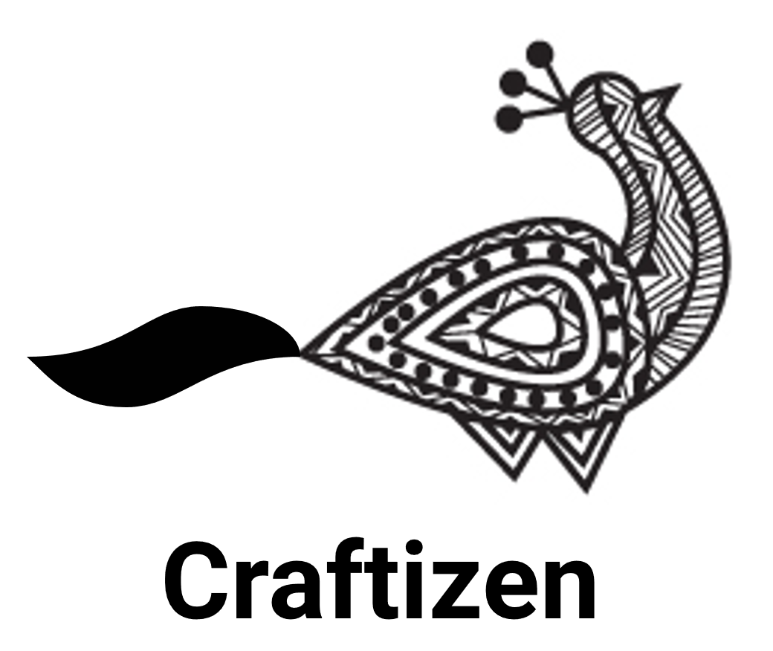

I propose the name of our company to be - **Craftizen.**

Proposed tag line –

**“For The Handmade Joy of Living.”**