**TYPE OF BUSINESS**

As we are just starting our business, we are a micro company but we plan on turning ourselves into a macro company in coming years. We want to implement our idea on a large scale. We want to generate employment for more artisans, from every corner of India. We want to help in preserving tribal art of communities in eastern India to skilled weavers of western India. We are expecting a very reasonable turnover in coming years. We plan on starting with 0.5 crores in the base year and subsequent revenue to increase as much as twice the base year revenue. We also expect our growth to be as of any other big enterprise. We expect a triple digit growth in first few years which would come down after around 4-5 years. Our expectations in case of revenue and growth are very practical and we believe that we can achieve the same. We also aim at providing maximum customer satisfaction. While big enterprises have around 50% customer satisfaction, we aim at around 75% because we understand our customer’s anticipation around buying handicrafts online and thus want to attend to almost every inquiry we get.

We realise the goal we are setting for ourselves are in no way small but we want to establish our company and we aim at becoming the market leaders in premium handicraft segment. We plan on launching both mobile app and website so that we can reach a wider audience. We want to cater our customers regardless of the device they use. We plan on making iOS, android as well as a responsive website so that no customer feels that that cant accesses our services. We realise that managing so many codebases and applications will be difficult but we want to sustain in the market and lead it and hence its very necessary to make ourselves as much accessible as we can.

We want to implement policies and procedures that shape the company's profile

to match top management's ideas. We plan to increase our reach to other people. We plan on doing so by means of television advertisements, social media and hoardings on billboards. We would also look into opportunities of collaborating with other enterprises. We can collaborate with companies like Myntra for products like apparel and clothes. We can supply them products made by artisans which would be incorporated into dresses by Myntra and sold off to customers. This would enable us a wider publicity as well as a platform to reach more people and serve them with premium handicraft products. We might incorporate small businesses into our company if we believe in it or we can also ask small business individuals if they want to work with us. We do not plan on forming a coalition with any other company as of now, but if we think its necessary for the company and is the right opportunity, we would be open to the idea.

Starting off as a start-up who wishes to sustain in the market and is ambitious enough to dream of becoming the market leader is difficult but we wish to stand up against all odds. We are starting out as a micro company but we aspire to transform into a macro business very soon.

**PRODUCT AND SERVICES**

We often hear about how small-scale artisans are forced to leave their businesses as they are not able to earn enough to keep the business going. At the same time, we also see how big ecommerce platforms don’t promote handicrafts and even the products that are available online have very low rating. It’s also important to note that the handicrafts that are available online are mass-produced and is killing the small-scale industry of artisans who are skilled in making these handicrafts. Even people who purchase handicrafts from these ecommerce websites, they are not completely satisfied with the product further decreasing the product ratings. Thus, to serve the customers with handicraft products that come straight from artisans and are not mass produced, delivered to them at their doorstep with ensured customer satisfaction, we decided to develop this platform dedicated to the sale of handicrafts.

Our company has a vision to cater our customers with the finest handicraft products while preserving small scale artisans and their craft and generating employment for them. We want more women to join us so that we can make more women self-sufficient and self-reliant.

* Our products will be sold at very competitive prices and thus will be accessible to more people. We understand that people would be okay spending money on articles they think are worth it, thus we will keep our product prices accordingly so that it is profitable for artisans as well as affordable for customers.
* We understand that many customers have a specific need when it comes to handicrafts which might not be available by the mass-produced handicrafts that are offered on big e-commerce websites. Hence, we plan on adding a feature to our application that will help users to add specific details of the product they want us to make for them. We believe that this will help the users to get products tailored to their needs and will help us deliver the finest customer first experience.
* We understand that a friendly user experience is not just delivered by our products but also our platforms. Thus, we will build very user-friendly applications for payments as well as shipping process where we will be identifying our customers, asking them for shipping address and special requests like gift wrapping or adding a note to their parcel, asking them to select a payment method, show them an overview of the order including the price breakdown, asking them for a confirmation to place order and finally send a confirmation of the order after placing the order via an email. The customer can choose to abort the checkout anytime and also add the product to a wish list for future considerations.
* It is very common to come across reviews on big e-commerce platforms talking about how the shipping was compromised and damaged products were received by the customers. We would try to take action on each complaint we receive. We would try to eliminate issues faced by our customers. One way of ensuring this is collaborating with established and big shipping partners like FedEx, Blue dart and DHL.
* We believe in economical as well as eco-friendly products and thus we will try to avoid and minimize the use of artificial products like plastic etc in our products and replace it with natural supplies so that they are less toxic and harmful for environment while continue being user friendly.
* Most handicrafts are vividly and brightly coloured and mass-produced handicrafts which uses harmful dyes which degrade the environment on disposal. We believe in using natural dyes and colours that would look much attractive on the products and will not harm the environment. We would able to save up the cost by taking this step as well hence reducing the production cost and making the handicrafts available at a much cheaper price.

**MARKET ANALYSIS**

* First, its essential to figure out our target customers. We believe that our customers would be a variety of mixed ethnic backgrounds and of varied ages and gender. Anyone with a thing for Indian décor and a thing for handmade products would be willing to spend their money on our products. We believe that our customers can be traditional people, devotional and religious people, natural product lovers, woven dress enthusiasts, gift shops, fancy stores, emporiums, fashionists, stylists, interior designers and people from different age groups like teenagers, adults and even senior citizens.
* The market we are targeting is huge. India being our target market has surplus opportunities and people who would be interested.
* The profit we make by selling off our products will be more than enough to keep the marketing going as well as enough to sustain the artisans.
* We realise that most big established enterprises are platforms that sell variety of products to their customers. They don’t sell just one segment products while we would be targeting only handicrafts. We believe that because we are focusing on just one category, we would be able to deliver more customer satisfaction compared to these big companies.
* There is a competitive rivalry that exists in the market. The trend of extinction of small retailers through acquisitions, mergers, alliances and high cost to exist this market is common.
* As no company is solely targeting handicraft segment, the competition we will face would be less. We are new to this business so we don’t have any brand in this fields like Amazon or Flipkart. So initially customers will be less. In this time, we may lose some sellers.
* Online stores are more accessible than offline roadside stores. Marketing, record keeping, managing etc becomes easy as well.
* Many people prefer mobile app for making purchases and we have a mobile application is place specifically for this.

**TECHNICAL FEASIBILITY**

Our product is technically feasible and would attract a lot of people. We have made a design of the user interface for both the website as well as mobile application. We will have a team of technicians at all times to help us in case we run into any problem. They would keep updating the online store with new offers and schemes so that we can attract more people. We would also launch a prototype and get feedback over it to perfect our platform. Technical support includes the admin of the software. A team of software engineers need to look after the technical functioning of the business. The success of this online virtual store lies entirely in the hands of the technical team. The other partner includes the inventory clerk who is responsible for managing incoming and outgoing supplies and products within a business. It may involve the task of maintaining the raw supplies and ordering new supplies The admin maintains the record about the customer’s details, the stock details, the supplier details, the delivery person details. The mobile application will be made in flutter which would enable us to make an application for both android as well as iOS mobiles. We plan on using ReactJS for the website which makes the user interface very attractive and is very fast when put into production. We plan on leveraging attractive website to attract more customers and paying emphasis on user experience.

**SCREENSHOTS**

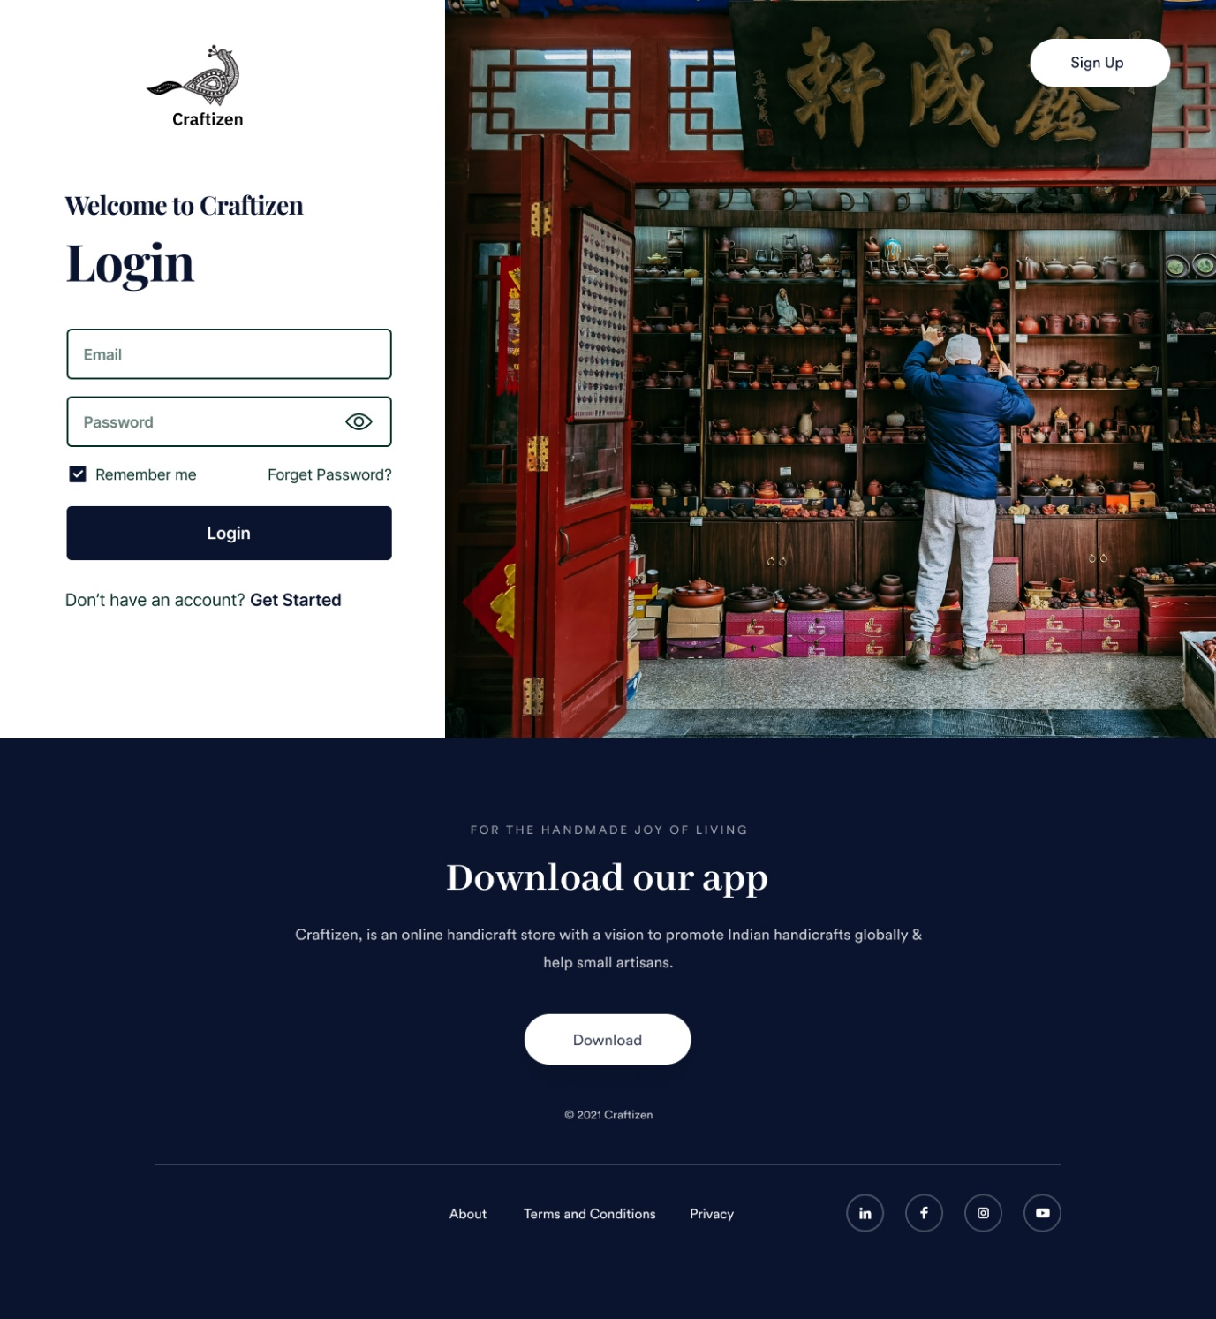

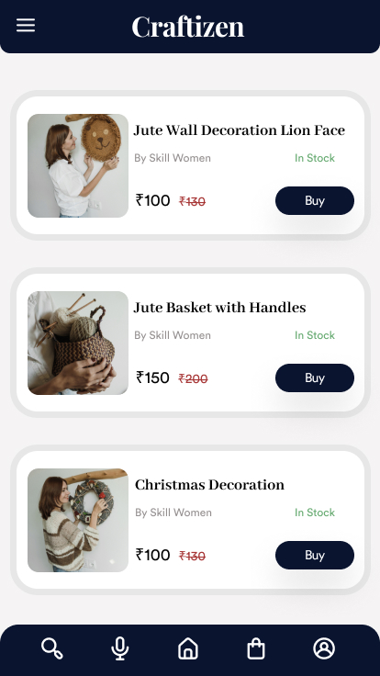

**CSS Code Snippet**

* {

box-sizing: border-box;

}

body {

font-size: 14px;

}

.v159_2 {

width: 100%;

height: 1561px;

background: rgba(255,255,255,1);

opacity: 1;

position: absolute;

top: 0px;

left: 0px;

overflow: hidden;

}

.v164_69 {

width: 153px;

height: 106px;

background: url("../images/v164_69.png");

background-repeat: no-repeat;

background-position: center center;

background-size: cover;

opacity: 1;

position: absolute;

top: 40px;

left: 173px;

overflow: hidden;

}

.v155_5 {

width: 150px;

height: 100px;

background: url("../images/v155_5.svg");

background-repeat: no-repeat;

background-position: center center;

background-size: cover;

opacity: 1;

position: absolute;

top: 0px;

left: 3px;

}

**HTML Code Snippet**

<!DOCTYPE html>

<html>

<head>

<link href="https://fonts.googleapis.com/css?family=IBM+Plex+Sans&display=swap" rel="stylesheet" />

<link href="https://fonts.googleapis.com/css?family=Circular+Std&display=swap" rel="stylesheet" />

<link href="https://fonts.googleapis.com/css?family=Abhaya+Libre&display=swap" rel="stylesheet" />

<link href="https://fonts.googleapis.com/css?family=Inter&display=swap" rel="stylesheet" />

<link href="https://fonts.googleapis.com/css?family=Playfair+Display&display=swap" rel="stylesheet" />

<link href="./css/main.css" rel="stylesheet" />

<title>Craftizen</title>

</head>

<body>

<div class="v159_2">

<div class="v166_46"></div>

<div class="v164_69">

<div class="v155_5"></div>

<div class="v155_7"></div>

<div class="v158_2"></div>

<div class="v158_3"></div>

<div class="v155_8"></div><span class="v155_10">Craftizen</span>

<div class="v158_4"></div>

<div class="v158_22"></div>

<div class="v158_23"></div>

<div class="v158_24"></div>

<div class="v158_12"></div>

<div class="v158_13"></div>

<div class="v158_14"></div>

<div class="v158_15"></div>

<div class="v158_16"></div>

<div class="v158_17"></div>

<div class="v158_18"></div>

<div class="v158_5"></div>

<div class="v158_6"></div>

<div class="v158_7"></div>

<div class="v158_9"></div>

<div class="v158_10"></div>

<div class="v158_11"></div>

<div class="v158_19"></div>

<div class="v158_20"></div>

<div class="v158_21"></div>

</div>

<div class="v159_9"></div><span class="v163_18">Sign Up</span>

<div class="v163_22">

<div class="v163_23"></div>

<div class="v163_24"><span class="v163_25">© 2021 Craftizen</span><span class="v163_26">Download our app</span><span class="v163_27">For the handmade joy of living</span><span class="v163_28">Craftizen, is an online handicraft store with a vision to promote Indian handicrafts globally & help small artisans.</span>

<div class="v163_29">

<div class="v163_30"></div>

</div><span class="v164_97">Download</span>

<div class="v163_32"></div>

<div class="v163_33"><span class="v163_34">About</span><span class="v163_35">Terms and Conditions</span><span class="v163_36">Privacy</span></div>

<div class="v163_37">

<div class="v163_38">

<div class="v163_39">

<div class="v163_40"></div>

<div class="v163_41"></div>

</div>

</div>

<div class="v163_42">

<div class="v163_43">

<div class="v163_44"></div>

</div>

<div class="v163_45">

<div class="name"></div>

</div>

</div>

<div class="v163_49">

<div class="v163_50">

<div class="v163_51"></div>

<div class="v163_52">

<div class="v163_53"></div>

<div class="name"></div>

<div class="name"></div>

</div>

</div>

</div>

<div class="v163_60">

<div class="v163_61"></div>

<div class="v163_62">

<div class="v163_63">

<div class="v163_64"></div>

<div class="v163_65"></div>

<div class="v163_66"></div>

</div>

</div>

</div>

</div>

</div>

</div>

<div class="v164_99">

<div class="name"></div>

</div><span class="v164_107">Password</span>

<div class="v164_108"><span class="v164_109">Don’t have an account?</span><span class="v164_110">Get Started</span></div><span class="v164_111">Email</span><span class="v164_112">Login</span><span class="v164_113">Welcome to Craftizen</span>

<div class="v164_114"></div>

<div class="v164_115"></div>

<div class="v164_116">

<div class="v164_117"></div><span class="v164_118">Login</span></div><span class="v164_119">Forget Password?</span><span class="v164_120">Remember me</span>

<div class="v164_121">

<div class="v164_122"></div>

<div class="v164_123"></div>

</div>

</div>

<div class="v159_2">

<div class="v166_46"></div>

<div class="v164_69">

<div class="v155_5"></div>

<div class="v155_7"></div>

<div class="v158_2"></div>

<div class="v158_3"></div>

<div class="v155_8"></div><span class="v155_10"></span>

<div class="v158_4"></div>

<div class="v158_22"></div>

<div class="v158_23"></div>

<div class="v158_24"></div>

<div class="v158_12"></div>

<div class="v158_13"></div>

<div class="v158_14"></div>

<div class="v158_15"></div>

<div class="v158_16"></div>

<div class="v158_17"></div>

<div class="v158_18"></div>

<div class="v158_5"></div>

<div class="v158_6"></div>

<div class="v158_7"></div>

<div class="v158_9"></div>

<div class="v158_10"></div>

<div class="v158_11"></div>

<div class="v158_19"></div>

<div class="v158_20"></div>

<div class="v158_21"></div>

</div>

<div class="v159_9"></div><span class="v163_18">Sign Up</span>

<div class="v163_22">

<div class="v163_23"></div>

<div class="v163_24"><span class="v163_25">© 2021 Craftizen</span><span class="v163_26">Download our app</span><span class="v163_27">For the handmade joy of living</span><span class="v163_28">Craftizen, is an online handicraft store with a vision to promote Indian handicrafts globally & help small artisans.</span>

<div class="v163_29">

<div class="v163_30"></div>

</div><span class="v164_97">Download</span>

<div class="v163_32"></div>

<div class="v163_33"><span class="v163_34">About</span><span class="v163_35">Terms and Conditions</span><span class="v163_36">Privacy</span></div>

<div class="v163_37">

<div class="v163_38">

<div class="v163_39">

<div class="v163_40"></div>

<div class="v163_41"></div>

</div>

</div>

<div class="v163_42">

<div class="v163_43">

<div class="v163_44"></div>

</div>

<div class="v163_45">

<div class="name"></div>

</div>

</div>

<div class="v163_49">

<div class="v163_50">

<div class="v163_51"></div>

<div class="v163_52">

<div class="v163_53"></div>

<div class="name"></div>

<div class="name"></div>

</div>

</div>

</div>

<div class="v163_60">

<div class="v163_61"></div>

<div class="v163_62">

<div class="v163_63">

<div class="v163_64"></div>

<div class="v163_65"></div>

<div class="v163_66"></div>

</div>

</div>

</div>

</div>

</div>

</div>

<div class="v164_99">

<div class="name"></div>

</div><span class="v164_107">Password</span>

<div class="v164_108"><span class="v164_109">Don’t have an account?</span><span class="v164_110">Get Started</span></div><span class="v164_111">Email</span><span class="v164_112">Login</span><span class="v164_113">Welcome to Craftizen</span>

<div class="v164_114"></div>

<div class="v164_115"></div>

<div class="v164_116">

<div class="v164_117"></div><span class="v164_118">Login</span></div><span class="v164_119">Forget Password?</span><span class="v164_120">Remember me</span>

<div class="v164_121">

<div class="v164_122"></div>

<div class="v164_123"></div>

</div>

</div>

</body>

</html>