

DISSERTATION SUBMITTED TO
SURESH GYAN VIHAR UNIVERSITY, JAIPUR
In the partial fulfilment of the requirement for the degree of
Master of Physiotherapy
Submitted by
KSHMA SAHU
Under the guidance of
DR. SHEENAM POPLI
Under the
DEPARTMENT OF PHYSIOTHERAPY
SURESH GYAN VIHAR UNIVERSITY
(Accredited by NAAC with ‘A+’ Grade)
Mahal, Jagatpura, Jaipur – 302025
2024–2026

“CORRELATION BETWEEN FEAR OF MOVEMENT (KINESIOPHOBIA) AND STAIR-CLIMBING ABILITY FOLLOWING UNILATERAL TOTAL KNEE REPLACEMENT: A CROSS-SECTIONAL STUDY”
A DISSERTATION SUBMITTED TO
SURESH GYAN VIHAR UNIVERSITY, JAIPUR
In the partial fulfilment of the requirement for the degree of
MPT
Under the
DEPARTMENT OF PHYSIOTHERAPY, SURESH GYAN VIHAR UNIVERSITY
2024–2026
SUBMITTED BY:  KSHMA SAHU  MPT 2nd YEAR  SID No.: 2448785  Enrollment No.: HC10532421794  Department of Physiotherapy, SGVU, Jaipur  SIGNATURE |  | GUIDED BY:  DR. SHEENAM POPLI  Associate Professor  Department of Physiotherapy  Suresh Gyan Vihar University, Jaipur  SIGNATURE |  | HEAD OF DEPARTMENT:  [Name of HOD]  Department of Physiotherapy  Suresh Gyan Vihar University, Jaipur  SIGNATURE

DECLARATION BY THE CANDIDATE
I hereby declare that this dissertation entitled “Correlation between Fear of Movement (Kinesiophobia) and Stair-Climbing Ability following Unilateral Total Knee Replacement: A Cross-Sectional Study” is a bonafide and genuine research work carried out by me under the guidance of Dr. Sheenam Popli, Associate Professor, Department of Physiotherapy, Suresh Gyan Vihar University, Jaipur. This work has not been submitted earlier, in part or in full, for the award of any degree or diploma of this or any other university.

PLACE: JAIPUR
DATE:
KSHMA SAHU
Master of Physiotherapy
Dept. of Physiotherapy
Suresh Gyan Vihar University, Jaipur
CERTIFICATE BY THE GUIDE
This is to certify that the dissertation entitled “Correlation between Fear of Movement (Kinesiophobia) and Stair-Climbing Ability following Unilateral Total Knee Replacement: A Cross-Sectional Study” is being submitted by KSHMA SAHU for the award of the degree of Master of Physiotherapy. It is a bonafide research work done by her under my supervision and guidance. This is an original work submitted only to the Department of Physiotherapy, Suresh Gyan Vihar University, Jaipur.

PLACE: JAIPUR
DATE:
DR. SHEENAM POPLI
Associate Professor
Dept. of Physiotherapy
Suresh Gyan Vihar University
Jaipur
CERTIFICATE BY THE CO-GUIDE
This is to certify that the dissertation entitled “Correlation between Fear of Movement (Kinesiophobia) and Stair-Climbing Ability following Unilateral Total Knee Replacement: A Cross-Sectional Study” is being submitted by KSHMA SAHU for the award of the degree of Master of Physiotherapy. It is a bonafide research work done by her under my co-supervision. This is an original work submitted only to the Department of Physiotherapy, Suresh Gyan Vihar University, Jaipur.
[Delete this page if there is no co-guide.]

PLACE: JAIPUR
DATE:
[[NAME OF CO-GUIDE]]
[Designation]
Dept. of Physiotherapy
Suresh Gyan Vihar University
Jaipur
CERTIFICATE BY THE EXTERNAL EXAMINER
This is to certify that the dissertation entitled “Correlation between Fear of Movement (Kinesiophobia) and Stair-Climbing Ability following Unilateral Total Knee Replacement: A Cross-Sectional Study” is being submitted by KSHMA SAHU for the award of the degree of Master of Physiotherapy. This dissertation embodies the bonafide research work carried out by the candidate under the guidance of Dr. Sheenam Popli, Department of Physiotherapy, Suresh Gyan Vihar University, Jaipur. I have thoroughly examined this work and found that it meets the required academic standards. The dissertation reflects the student’s dedication, critical analysis and adherence to research ethics, and I approve it for submission and evaluation in partial fulfilment of the requirements for the degree.

PLACE: JAIPUR
DATE:
EXTERNAL EXAMINER

Name: ____________________

Signature: ________________
ENDORSEMENT BY THE PRINCIPAL / HEAD OF THE DEPARTMENT
This is to certify that the dissertation entitled “Correlation between Fear of Movement (Kinesiophobia) and Stair-Climbing Ability following Unilateral Total Knee Replacement: A Cross-Sectional Study” is a bonafide research work done by KSHMA SAHU under the guidance of Dr. Sheenam Popli, Associate Professor, Department of Physiotherapy, Suresh Gyan Vihar University, Jaipur.

PLACE: JAIPUR
DATE:
[[NAME]]
[Principal / HOD]
Dept. of Physiotherapy
Suresh Gyan Vihar University
Jaipur
COPYRIGHT DECLARATION BY THE CANDIDATE
I hereby declare that Suresh Gyan Vihar University, Jaipur, Rajasthan shall have the rights to preserve, use and disseminate this dissertation/thesis in print or electronic format for academic/research purposes.

PLACE: JAIPUR
DATE:
KSHMA SAHU
Master of Physiotherapy (MPT)
Dept. of Physiotherapy
Suresh Gyan Vihar University
ACKNOWLEDGEMENT
The completion of this dissertation has been a collaborative venture, and I am grateful to everyone who made it possible. First and foremost, I thank the Almighty for blessing me with good health, patience and the strength to undertake and complete this research.
I express my deepest gratitude to my guide, Dr. Sheenam Popli, Associate Professor, Department of Physiotherapy, Suresh Gyan Vihar University, for her expert guidance, constant encouragement and constructive suggestions at every stage of this study. Her patience and support made this work possible.
I sincerely thank [Name], Head of the Department of Physiotherapy, and all the faculty members of the department for their valuable guidance, motivation and words of inspiration throughout my postgraduate course.
I am thankful to the management and staff of [name of hospital / rehabilitation centre] for permitting me to conduct this study, and to the Institutional Ethics Committee for its approval.
I extend my heartfelt thanks to all the participants for their time, trust and genuine cooperation, without whom this study would not have been possible.
Finally, I thank my parents, family and friends for their unconditional love, support and encouragement.

KSHMA SAHU
CONTENTS
Right-click the list below in Microsoft Word and choose “Update Field → Update entire table” to refresh page numbers.

LIST OF GRAPHS
Graph No. | Title of Graph
Graph 1 | Gender distribution of participants
Graph 2 | Distribution of participants by affected side
Graph 3 | Distribution of participants by age group
Graph 4 | Distribution of participants by BMI category
Graph 5 | Mean TSK-17 score and mean SCT time
Graph 6 | Distribution of participants by level of kinesiophobia
Graph 7 | Stair negotiation pattern
Graph 8 | Handrail support during the Stair Climb Test
Graph 9 | Assistive device used for ambulation
Graph 10 | Histogram of TSK-17 scores with normal curve
Graph 11 | Histogram of SCT time with normal curve
Graph 12 | Normal Q–Q plot of TSK-17 scores
Graph 13 | Normal Q–Q plot of SCT time
Graph 14 | Scatter plot showing the correlation between TSK-17 score and SCT time
Graph 15 | Mean SCT time in low and high kinesiophobia groups
LIST OF TABLES
Table No. | Title
Table 1 | Interpretation of TSK-17 scores
Table 2 | Interpretation of the correlation coefficient
Table 3 | Mean and standard deviation of demographic variables (n = 50)
Table 4 | Distribution of participants by gender and affected side
Table 5 | Distribution of participants by age group
Table 6 | Distribution of participants by BMI category
Table 7 | Distribution of participants by post-operative duration
Table 8 | Descriptive statistics of TSK-17 score and Stair Climb Test time
Table 9 | Distribution of participants by level of kinesiophobia
Table 10 | Stair negotiation pattern, handrail support and assistive device
Table 11 | Tests of normality (Shapiro–Wilk)
Table 12 | Pearson correlation between TSK-17 score and SCT time
Table 13 | Simple linear regression of SCT time on TSK-17 score
Table 14 | Comparison of TSK-17 score and SCT time between low and high kinesiophobia groups (independent t-test)
Table 15 | Comparison of TSK-17 score and SCT time by gender, affected side and stair pattern (independent t-test)
Table 16 | Comparison of TSK-17 score and SCT time by handrail support and assistive device (one-way ANOVA)
Table 17 | Correlation of age, BMI and post-operative duration with TSK-17 score and SCT time
Table 18 | Association of kinesiophobia level with stair pattern and handrail support (chi-square test)
Table 19 | Hypothesis test summary
Table 20 | Master chart of all participants (n = 50)
LIST OF ABBREVIATIONS
Abbreviation | Full form
ADL | Activities of Daily Living
AMI | Arthrogenic Muscle Inhibition
ANOVA | Analysis of Variance
BMI | Body Mass Index
CBT | Cognitive Behavioural Therapy
CI | Confidence Interval
EMG | Electromyography
FAM | Fear-Avoidance Model
ICC | Intraclass Correlation Coefficient
IEC | Institutional Ethics Committee
KOOS | Knee Injury and Osteoarthritis Outcome Score
LEFS | Lower Extremity Functional Scale
OA | Osteoarthritis
OARSI | Osteoarthritis Research Society International
PROM | Patient-Reported Outcome Measure
ROM | Range of Motion
SCT | Stair Climb Test
SD | Standard Deviation
STROBE | Strengthening the Reporting of Observational Studies in Epidemiology
TKA | Total Knee Arthroplasty
TKR | Total Knee Replacement
TSK | Tampa Scale for Kinesiophobia
TUG | Timed Up and Go test
WOMAC | Western Ontario and McMaster Universities Osteoarthritis Index

CHAPTER 1. INTRODUCTION
INTRODUCTION

1.1 Background
Knee osteoarthritis (OA) is one of the most common, disabling and progressive musculoskeletal disorders affecting the ageing population worldwide. It is characterised by progressive degeneration of articular cartilage, subchondral bone sclerosis, osteophyte formation and low-grade synovial inflammation, which together produce pain, stiffness, deformity and a marked decline in quality of life. When conservative measures such as analgesic and anti-inflammatory medication, intra-articular injections, physiotherapy, weight management and lifestyle modification no longer provide adequate relief of pain or improvement in function, Total Knee Arthroplasty (TKA), also termed Total Knee Replacement (TKR), is regarded as the gold-standard surgical treatment⁽¹⁾.
Large numbers of TKRs are performed every year with the aims of relieving arthritic pain, correcting frontal-plane deformity and restoring the mechanical stability of the joint, and the demand for the procedure is projected to rise steadily as populations age⁽²⁾. From a biomechanical and engineering standpoint, contemporary implants and surgical techniques achieve very high rates of success: most patients have satisfactory radiological alignment, a stable prosthetic joint and a substantial reduction in pain at rest after surgery⁽³⁾.
Despite these structural achievements, there is a well-recognised gap between surgical success and patient-perceived outcome. Approximately one in five patients report dissatisfaction after primary TKR⁽⁴⁾, and a considerable proportion continue to experience functional limitations during the first post-operative year even after an uncomplicated procedure. Many of these individuals demonstrate lower physical performance than age-matched peers without knee pathology. Level walking usually recovers to a satisfactory degree early in rehabilitation, whereas more complex locomotor tasks, which demand greater neuromotor coordination, eccentric muscle control and multi-joint movement, often remain impaired for a prolonged period⁽⁵⁾.

1.2 Stair Climbing after Total Knee Replacement
Ascending and descending stairs are among the most challenging, and psychologically taxing, activities that a patient must regain after TKR. The ability to negotiate stairs independently is far more than a physical milestone: it is a marker of independence that allows a person to move in and out of the home, access public spaces and transport, and live comfortably in multi-level dwellings⁽⁶⁾.
Biomechanical studies show that stair ambulation requires substantially greater lower-limb joint excursion, peak joint loading and muscular effort than level walking. During stair ascent the quadriceps and gluteal muscles must generate large concentric forces to raise the body weight against gravity from knee flexion angles that commonly exceed 90–100 degrees⁽⁷⁾. Stair descent presents a different challenge, demanding finely graded eccentric contraction of the quadriceps to brake and control the downward acceleration of the body’s centre of mass. Even minor deficits in neuromuscular coordination or proprioception therefore become evident during descent, which places additional stress on the prosthetic knee and provokes discomfort. Because of these high mechanical demands, stair negotiation has been described as the activity that causes the greatest difficulty for patients after unilateral TKR and is closely linked to fear and dissatisfaction⁽⁸⁾.
Healthy individuals negotiate stairs with a reciprocal (step-over-step) pattern, placing alternate feet on successive steps. Following unilateral TKR, many patients adopt a non-reciprocal step-to (step-by-step) pattern in which the same limb always leads and the other follows. The non-operated limb typically leads during ascent and the operated limb during descent, so that the replaced knee is spared the most demanding concentric and eccentric loading. Although this strategy protects the operated knee, it imposes asymmetric loads on the lumbo-pelvic-hip complex and the contralateral limb. Patients also rely heavily on handrails, which unload the lower limbs, improve balance and reduce the risk of falls. While handrail use provides essential stability early after surgery, prolonged dependence on it is indicative of incomplete rehabilitation⁽⁹⁾.

1.3 Biomedical Determinants of Stair-Climbing Ability
Traditionally, impaired stair negotiation after joint replacement has been studied from a biomedical perspective. The literature has concentrated on physical determinants such as active knee range of motion, prosthetic alignment, implant design and, above all, quadriceps weakness⁽¹⁰⁾. Arthrogenic muscle inhibition (AMI), an ongoing reflex inhibition of the muscles surrounding a joint after trauma or surgery, contributes to profound and long-lasting quadriceps atrophy and weakness after TKR.
Structural impairment, stiffness and quadriceps weakness clearly play important roles in recovery. However, multivariate analyses have repeatedly shown that physical deficits explain only part of the variance in stair-climbing ability after TKR. Patients with similar quadriceps strength, prosthesis design and knee flexion range display strikingly different stair performance: some climb efficiently with a reciprocal pattern, whereas others move hesitantly and rigidly and depend entirely on the handrail. These observations expose the limitations of a purely biomedical approach and point to the role of other mediating factors⁽¹¹⁾.

1.4 The Fear-Avoidance Model
Contemporary rehabilitation science increasingly views recovery from major reconstructive joint surgery as a psycho-physical process and recognises the value of incorporating cognitive-behavioural concepts. The fear-avoidance model (FAM) has emerged as a leading framework for explaining how cognitive and emotional factors influence the transition from acute pain to persistent pain and disability^{(12–14)}.
Originally developed to explain why some individuals with low back pain become chronically disabled, the model proposes that the way a person interprets pain determines the path of recovery. Acute pain, such as the intense inflammatory pain that follows TKR, can lead the patient along one of two pathways. When the patient appraises the pain as a normal, predictable and temporary consequence of tissue healing, fear remains low and the patient confronts the situation by participating actively in progressive physiotherapy, adhering to home exercise and gradually resuming more demanding activities. This adaptive pathway supports optimal physical and structural recovery⁽¹⁵⁾.
When the appraisal is negative, a self-reinforcing maladaptive cycle begins. Its starting point is pain catastrophising, an exaggerated negative cognitive and emotional orientation towards actual or anticipated pain. Patients who catastrophise interpret their post-operative pain as highly threatening, uncontrollable and a sign of serious structural failure, such as wound breakdown or prosthetic loosening. This cognitive magnification amplifies central processing of nociceptive input and lowers pain thresholds⁽¹⁶⁾.
Pain catastrophising is a direct antecedent of kinesiophobia, defined by Kori, Miller and Todd (1990)⁽²⁰⁾ as “an excessive, irrational and debilitating fear of physical movement and activity resulting from a feeling of vulnerability to painful injury or re-injury”. The patient holds the belief that exercise, exertion or movement will cause re-injury, irreversible damage or more pain⁽¹⁷⁾. Within the FAM, kinesiophobia is expressed through avoidance and hypervigilance: patients avoid movements expected to cause discomfort, limit their engagement with exercise and withdraw from valued activities. The consequences are disuse, depression and disability. Lack of loading leads to rapid muscle atrophy, joint stiffness, soft-tissue contracture and reduced cardiovascular fitness⁽¹⁸⁾. This physical deconditioning, combined with the distress of lost independence, paradoxically increases disability and pain, appears to confirm the catastrophic beliefs, and locks the patient in a vicious cycle of fear and decline⁽¹⁹⁾. The model as applied to TKR is summarised in Figure 1.1.
Figure 1.1: The fear-avoidance model applied to recovery after TKR
Adaptive (confrontation) pathway | Maladaptive (avoidance) pathway
Post-operative pain after TKR | Post-operative pain after TKR
↓  Pain appraised as normal and temporary | ↓  Pain catastrophising (pain seen as a sign of damage)
↓  Low fear of movement | ↓  Kinesiophobia (fear of movement / re-injury)
↓  Confrontation: active participation in exercise and graded return to stairs | ↓  Avoidance and hypervigilance: step-to pattern, handrail dependence, offloading of operated knee
↓  Recovery of strength, ROM and motor control | ↓  Disuse, deconditioning, depression and disability
↓  Independent, reciprocal stair negotiation | ↓  Poor stair-climbing ability, which reinforces pain and fear

1.5 Kinesiophobia after Total Knee Replacement
Kinesiophobia is no longer regarded as confined to chronic low back pain or fibromyalgia. It is highly prevalent in acute orthopaedic populations undergoing major joint reconstruction such as TKR. Pooled estimates suggest a prevalence of approximately 35% after TKR, with some studies reporting rates as high as 56.67%^{(21,22)}.
This high prevalence reflects a distinctive feature of TKR rehabilitation: the operated joint must be actively mobilised and loaded almost immediately to prevent arthrofibrosis and adhesions. For a patient who has not been psychologically prepared before surgery, bending and bearing weight on a freshly operated, swollen and painful knee is sufficient to provoke an intense fear response⁽²³⁾.
The effects of kinesiophobia are particularly evident during complex and demanding tasks such as stair negotiation. When a fearful patient approaches a staircase, the limiting factor may not be weak muscles but fear-driven motor control. During stair descent, fear tends to cause excessive activation of antagonists such as the hamstrings and gastrocnemius, producing co-contraction around the knee to brace it against an anticipated collapse, fall or pain. This muscular stiffening prevents the normal kinematics of descent, as the patient cannot allow the knee to flex freely, and results in a slow, hesitant swing phase. The patient relies on the handrail not because strength is insufficient but because of fear, and persistent avoidance prevents the re-learning of eccentric motor control⁽²⁴⁾.

1.6 Unilateral versus Bilateral TKR
The expression of kinesiophobia appears to be influenced by whether the patient has undergone unilateral or bilateral TKR. Comparative cross-sectional studies have found higher rates of kinesiophobia after unilateral than after bilateral TKR (34.1% versus 22.5%)⁽²⁵⁾.
This difference has an important biomechanical and behavioural explanation. A patient with unilateral TKR has a non-operated limb that is relatively strong and pain-free, and therefore becomes the preferred limb for demanding tasks; mechanical demands can simply be shifted onto it⁽²⁶⁾. Such offloading is a powerful avoidance strategy: the patient never has to learn to load the operated knee eccentrically during stair descent because the non-operated limb can always be used instead. This behaviour reinforces the fear-avoidance cycle and allows kinesiophobia to become entrenched. Patients with bilateral TKR have no pain-free limb on which to rely and are compelled to load both knees. For this reason, the present study focuses specifically on patients with unilateral TKR.

1.7 Rationale for the Present Study
Although the role of psychological factors in self-reported outcomes after TKR is increasingly acknowledged, the relationship between kinesiophobia and objectively measured stair performance remains poorly defined in routine clinical practice. Few studies have linked the Tampa Scale for Kinesiophobia (TSK) with performance-based measures of stair negotiation⁽²⁷⁾.
Understanding this relationship is clinically important because conventional physiotherapy programmes that address only biomechanical impairments may overlook the cognitive component of disability. If a patient’s difficulty on stairs is driven more by persistent fear of movement than by actual muscle weakness, quadriceps strengthening and joint mobilisation alone are unlikely to be sufficient; instead, a holistic approach that integrates cognitive strategies with physical rehabilitation is required⁽²⁸⁾. The present study therefore sets out to quantify the association between kinesiophobia and stair-climbing ability in individuals in the early phase of rehabilitation after unilateral TKR. By establishing whether psychological characteristics are associated with functional mobility independently of the joint, this work aims to encourage clinicians to look beyond the knee to the person who moves it⁽²⁹⁾.

1.8 Scope and Delimitations of the Study
- The study is delimited to individuals aged 50–75 years who have undergone primary unilateral TKR and are 4 weeks to 6 months post-operative.
- Kinesiophobia is assessed with the TSK-17 and stair-climbing ability with the timed SCT; other psychological constructs (anxiety, depression, catastrophising, self-efficacy) are not formally measured.
- Participants are recruited from [name of hospital(s) / rehabilitation centre(s)] in Jaipur, Rajasthan, which may limit generalisability.

CHAPTER 2. AIM AND OBJECTIVE
AIM AND OBJECTIVE

2.1 Aim
To study the relationship between fear of movement (kinesiophobia) and stair-climbing ability in individuals following unilateral Total Knee Replacement.

2.2 Primary Objective
1. To determine the correlation between fear of movement (kinesiophobia) and stair-climbing ability following unilateral TKR.

2.3 Secondary Objectives
1. To assess the level of kinesiophobia in individuals following unilateral TKR.
2. To evaluate stair-climbing ability in individuals following unilateral TKR.
3. To analyse whether higher levels of kinesiophobia are associated with poorer stair-climbing performance after unilateral TKR.

CHAPTER 3. RESEARCH PROBLEM OF THE STUDY
RESEARCH PROBLEM OF THE STUDY

3.1 Need of the Study
TKR is one of the most frequently performed procedures for advanced knee OA and other degenerative joint diseases. Although it is highly effective in relieving pain and restoring alignment, many patients continue to experience difficulty with functional tasks such as climbing stairs, rising from a chair and walking on uneven ground. Of these, stair climbing is among the most difficult and the most important for independent living.
Rehabilitation after unilateral TKR conventionally centres on physical impairments: pain relief, restoration of range of motion, lower-limb strengthening and gait training. Recovery, however, does not depend on physical factors alone. Psychological factors, and kinesiophobia in particular, may strongly influence a patient’s engagement in rehabilitation and in functional activities. Patients with high kinesiophobia are reluctant to undertake weight-bearing tasks and restrict their movement for fear of pain or injury.
Despite growing recognition of psychological influences in musculoskeletal rehabilitation, little attention has been given to the association between kinesiophobia and stair climbing after unilateral TKR. Existing research has concentrated on overall function and pain rather than on specific, high-demand tasks that are vital for independence and social participation. Moreover, very little research has been conducted in the Indian population, in whom cultural factors, lifestyle demands (such as floor-level activities and multi-storey housing without lifts), access to rehabilitation and beliefs about pain and movement may differ and may therefore influence recovery differently.
The findings of this study can help physiotherapists to identify patients with high kinesiophobia and to design rehabilitation programmes that address both the psychological and physical barriers to recovery. Early identification and management of kinesiophobia may lead to better stair-climbing performance and greater functional independence.

3.2 Significance of the Study
1. Clinical significance: The study will inform physiotherapists and other rehabilitation professionals about the influence of fear of movement on stair-climbing ability after unilateral TKR. Understanding psychological barriers will enable clinicians to develop more comprehensive, biopsychosocial rehabilitation programmes.
2. Functional significance: Stair climbing is an essential activity of daily living and a key determinant of functional independence after TKR. The findings will clarify how kinesiophobia relates to functional mobility after surgery.
3. Research significance: Evidence on the relationship between kinesiophobia and stair-climbing ability after unilateral TKR is limited, particularly in India. This study will add to the existing literature and provide a basis for future longitudinal and interventional research.

3.3 Statement of the Problem
Despite successful surgery, many individuals who have undergone unilateral TKR continue to have difficulty negotiating stairs. Whether, and to what extent, fear of movement is associated with this difficulty has not been adequately established. The present study addresses the following research questions:
1. Is there a relationship between fear of movement (kinesiophobia) and stair-climbing ability among patients with unilateral TKR?
2. Do patients with high fear of movement have greater difficulty in stair climbing after unilateral TKR?
3. What is the level of fear of movement among patients with unilateral TKR?
4. How does stair-climbing ability differ according to the level of fear of movement among patients with unilateral TKR?

CHAPTER 4. IDENTIFICATION OF RESEARCH GAP
IDENTIFICATION OF RESEARCH GAP
1. Limited studies specifically correlating kinesiophobia with stair-climbing ability after unilateral TKR. Most post-TKR rehabilitation research focuses on pain management, range of motion, muscle strength or general functional mobility; little has examined fear of movement specifically in relation to stair negotiation in unilateral TKR.
2. Emphasis on general functional outcomes rather than task-specific activities. Much of the literature examines walking speed, balance or composite outcome scores such as WOMAC or KOOS, while stair climbing has been relatively neglected.
3. Few studies combine objective stair-climbing measurement with a validated kinesiophobia scale. Earlier studies have mainly relied on questionnaires; few have combined a valid fear measure such as the TSK with an objective performance test such as the Stair Climb Test (SCT).
4. Limited evidence from the Indian population. Most available studies come from Western populations. Differences in culture, pain perception, rehabilitation facilities and living conditions may influence outcomes in Indian patients.

CHAPTER 5. HYPOTHESIS
HYPOTHESIS
Null hypothesis (H₀): There is no significant correlation between fear of movement (kinesiophobia) and stair-climbing ability following unilateral TKR.
Alternative hypothesis (H₁): There is a significant correlation between fear of movement (kinesiophobia) and stair-climbing ability following unilateral TKR.

CHAPTER 6. REVIEW OF LITERATURE
REVIEW OF LITERATURE
This chapter reviews the literature relevant to the present study under the following themes: (i) the fear-avoidance model and the concept of kinesiophobia; (ii) stair negotiation and its biomechanics after TKR; (iii) prevalence and determinants of kinesiophobia after TKR; (iv) the influence of kinesiophobia on functional outcomes after TKR; and (v) the outcome measures used in this study.

6.1 The Fear-Avoidance Model and Kinesiophobia
Lethem et al. (1983)⁽¹²⁾ first proposed the “fear-avoidance” model of exaggerated pain perception, suggesting that individuals respond to pain on a continuum between confrontation and avoidance, and that avoidance is associated with the persistence of pain behaviour and disability.
Kori, Miller and Todd (1990)⁽²⁰⁾ introduced the term kinesiophobia to describe an excessive, irrational and debilitating fear of movement and activity arising from a feeling of vulnerability to painful injury or re-injury, and developed the Tampa Scale for Kinesiophobia (TSK) to measure it.
Vlaeyen et al. (1995)⁽³⁰⁾ examined fear of movement/(re)injury in chronic low back pain using a Dutch version of the TSK and demonstrated that pain-related fear was associated with poorer behavioural performance, independently of pain intensity. They proposed a TSK-17 cut-off of greater than 37 to identify high fear of movement.
Vlaeyen and Linton (2000)⁽¹³⁾ reviewed the evidence for fear-avoidance and its consequences in chronic musculoskeletal pain and formalised the cognitive-behavioural fear-avoidance model, in which catastrophic interpretation of pain leads to pain-related fear, avoidance and hypervigilance, and ultimately to disuse, depression and disability.
Leeuw et al. (2007)⁽¹⁹⁾ updated the review of the fear-avoidance model, confirming that pain-related fear is associated with greater disability and lower physical performance and that it can be targeted with exposure-based and educational interventions.
Gulrandhe et al. (2021)⁽³¹⁾ comprehensively discussed the fear-avoidance model of kinesiophobia, describing kinesiophobia as an irrational and incapacitating fear of movement arising from vulnerability to painful injury or re-injury. They noted that pain catastrophising and fear of movement heighten somatosensory awareness and the anticipation of worsening pain, and that kinesiophobia is associated with higher-order cognitive processes and anxiety. The TSK was presented as the principal assessment tool, with scores above 40 indicating high kinesiophobia. Conditions including ACL reconstruction, hip arthroplasty, hallux valgus and osteoporosis were discussed, in all of which kinesiophobia complicated treatment and predicted poorer functional outcomes. Management recommendations included multimodal rehabilitation, psychological interventions (education, cognitive-behavioural therapy, perceptual stimulation and group work) and physical therapy, with the authors emphasising a multidirectional approach integrating psychological and physical treatment.

6.2 Stair Negotiation and its Biomechanics after TKR
Zeni and Snyder-Mackler (2010b)⁽³²⁾ examined pre-operative predictors of persistent difficulty in stair ascent and descent after TKA, with particular emphasis on handrail use, in 105 patients. Pre-operative handrail use, age and quadriceps strength predicted handrail use at 3 months and 2 years after surgery, and many patients continued to use a handrail despite surgery. Younger patients with stronger quadriceps who did not use a handrail before surgery had the best outcomes. The authors stressed the importance of pre-operative functional status for predicting post-operative stair performance and for setting realistic patient expectations.
Smith et al. (2016)⁽³³⁾ investigated stance time variability (STV) during stair ascent and descent before and after TKA in a pilot study of 13 patients with knee OA and age- and sex-matched healthy controls, using an instrumented staircase and motion analysis. STV during stair descent was significantly greater in the TKA group at 6 months after surgery, although the difference had disappeared by 12 months; no differences were found for stair ascent. Quadriceps strength remained lower in the TKA group, and although correlations between strength and STV were not significant, quadriceps weakness was considered a plausible contributor to increased variability. Patient-reported outcomes (LEFS, SF-36) improved after surgery, yet stair-climbing time remained longer than in controls even at 12 months, highlighting stair descent as a persistent challenge after TKA.
Rasnick et al. (2016)⁽³⁴⁾ used musculoskeletal modelling to estimate knee joint loads and surrounding muscle forces during stair ascent in five patients with TKR and five healthy controls. Peak joint loads did not differ significantly between groups, but quadriceps forces, particularly those of rectus femoris and vastus lateralis, were lower in the TKR group, while knee flexor forces were higher. This compensatory muscle pattern produced joint loads similar to those of controls, indicating that muscle recruitment remains altered after TKR even when joint loading appears normal.
Lee et al. (2020)⁽³⁵⁾ conducted a prospective cohort study of 84 patients to identify pre-operative physical factors predicting stair-climbing ability one month after TKA. Physical performance (stair-climbing test, 6MWT, TUG and isometric strength) was assessed before and after surgery. Post-operative stair-ascent ability correlated with pre-operative TUG performance and knee extensor torque, while stair-descent ability was associated with pre-operative stair-descent performance and age. The authors concluded that balance and quadriceps strength are important determinants of stair-climbing capacity after TKA.
Kline et al. (2020)⁽³⁶⁾ studied step-descent strategy after unilateral TKA in 40 participants (20 with TKA and 20 controls), assessing knee extensor, hip abductor and hip external rotator strength together with step-descent mechanics. Weakness of the knee extensors and hip external rotators of the operated limb persisted at 3 and 6 months after surgery. Patients altered their step-descent strategy bilaterally, using the hip musculature to unload the knee, and those with stronger hip muscles relied less on the knee support moment. The authors argued that current rehabilitation does not adequately address knee extensor and hip external rotator weakness, leading to compensatory strategies that impair stair performance.
Murakami et al. (2024)⁽³⁷⁾ compared the difficulty of stair ascent and descent after TKR in 78 participants, analysing movement pattern and time taken. Stair descent was more difficult than ascent: more participants used a step-to pattern and handrail support and took longer to descend. The authors attributed this to the high demand of eccentric quadriceps contraction, co-contraction of knee extensors and flexors, and limited use of adjacent joints to compensate.
Asaki and Anan (2025)⁽³⁸⁾ reported the case of an 80-year-old woman with persistent difficulty in stair negotiation after TKA despite rehabilitation. Assessment revealed restricted knee range of motion, quadriceps weakness and elevated fear of movement (TSK score 36). Surface EMG showed abnormal compensatory muscle activity suggestive of protective co-contraction driven by persistent fear. Out-patient physiotherapy improved range of motion and self-efficacy (increased PSEQ score), but fear and anxiety persisted and were associated with a prolonged swing phase during stair descent. The authors concluded that psychosocial factors such as fear, anxiety and depression adversely affect range-of-motion recovery and muscle recruitment after TKA and that rehabilitation should integrate psychological approaches with conventional physical therapy.

6.3 Prevalence and Determinants of Kinesiophobia after TKR
Desai et al. (2016)⁽²¹⁾ conducted a cross-sectional study of kinesiophobia in 120 knee arthroplasty patients (60 unilateral and 60 bilateral) using the TSK. Kinesiophobia was present in 56.67% of patients and was more common after unilateral than bilateral arthroplasty. High kinesiophobia was linked to fear of increased pain, of failing to achieve functional improvement, and to avoidance behaviour. Uncertainty, fear of not reaching expected improvement and lack of confidence were important limiting factors. The authors noted that kinesiophobia is a modifiable factor that can be addressed through counselling and functional activity.
Mahajan et al. (2018)⁽³⁹⁾ assessed the prevalence of kinesiophobia and its relationship with physiotherapy in 51 Indian patients after TKA using the TSK. Kinesiophobia was present in 64% of patients. Among those receiving physiotherapy, 45% had kinesiophobia, compared with 100% of those not receiving physiotherapy, a statistically significant difference (p < 0.05). Lack of physiotherapy, shorter rehabilitation, inadequate counselling and a history of trauma were identified as contributing factors. Patients with higher kinesiophobia had weaker quadriceps, lower range of motion and poorer movement patterns, resulting in poorer recovery and quality of life. Physiotherapy was concluded to act both physically and psychologically in reducing kinesiophobia.
Güney Yılmaz et al. (2023)⁽⁴⁰⁾ investigated the influence of occupational self-perception on kinesiophobia after TKA in a prospective longitudinal study of 40 participants assessed pre-operatively and at 3 and 6 weeks post-operatively with the TSK, Occupational Self-Assessment (OSA), KOOS and TUG. Kinesiophobia was high both before and after surgery and peaked in the early post-operative period. TSK scores correlated negatively with OSA competence at all time points (pre-operative r = −0.684; 3 weeks r = −0.717; 6 weeks r = −0.405), whereas KOOS and TUG did not differ between high and low kinesiophobia groups. The authors concluded that a stronger sense of occupational competence protects against kinesiophobia and recommended that rehabilitation address occupational identity and self-efficacy in addition to pain and physical function.
Yan et al. (2023)⁽⁴¹⁾ used a prospective cohort design and latent class growth analysis in 257 patients to identify trajectories of kinesiophobia after TKA. Four trajectories were identified: low-stable, rapid-recovering, slow-recovering and moderate-stable. BMI, employment status, heart disease and pain severity predicted trajectory membership. At three months, rehabilitation outcomes differed significantly between trajectories, with the slow-recovering group showing greater psychological distress, poorer knee function and lower social participation, although activities of daily living did not differ. Kinesiophobia was therefore shown to be dynamic, and interventions should be tailored to the patient’s trajectory.
Xing et al. (2025)⁽⁴²⁾ examined factors associated with post-operative kinesiophobia in 446 elderly patients after TKA from a health-ecology perspective. The prevalence of kinesiophobia was 21.75%. Multivariate regression identified self-rehabilitation efficacy, pain intensity, attention from children and social support as independent factors, and patients aged 80 years or more had significantly higher fear scores. Kinesiophobia was thus influenced by personal, behavioural, interpersonal, environmental and policy-level factors, and the authors recommended multifactorial interventions addressing psychological, social and environmental domains.
Du et al. (2025)⁽⁴³⁾ performed a systematic review and meta-analysis of the prevalence and influencing factors of kinesiophobia after TKA, pooling 11 studies with 4,039 patients. They reported an overall prevalence of [insert pooled prevalence (%) and 95% CI from Du et al., 2025] and identified [insert principal influencing factors reported] as factors associated with kinesiophobia, underlining the need for routine screening after TKA.
Ren et al. (2026)⁽⁴⁴⁾ used a longitudinal qualitative design, with semi-structured interviews of eight patients over three months, to explore how kinesiophobia develops after TKA. Three stages were identified: cognitive rigidity and avoidance; cognitive triggering and thawing; and cognitive reconstruction and attempt. Initially patients showed negative cognitions, self-objectification, dependence on external help and avoidance. With rehabilitation and growing self-efficacy they began to challenge catastrophic thoughts and change their behaviour. Central sensitisation of pain and poor health literacy were barriers, and improvement in self-efficacy was the key driver of change. Interventions should therefore be matched to the stage of the process and target self-efficacy and maladaptive cognitions.

6.4 Kinesiophobia and Functional Outcomes after TKR
Güney-Deniz et al. (2017)⁽⁴⁵⁾ examined the influence of kinesiophobia on early functional outcomes in 46 patients at discharge after TKA, using the TSK, the 2-minute walk test (2-MWT), TUG, pain rating and knee flexion range of motion. Participants were grouped by level of kinesiophobia. Although TUG performance was similar, the low-kinesiophobia group walked further, reported less pain and had greater range of motion. TSK scores correlated strongly with pain (r = 0.80) and moderately with range of motion (r = −0.47) and walking distance (r = −0.40). Regression analysis showed that kinesiophobia explained 41% of the variance in walking distance, 47% in range of motion and 60% in pain. The authors identified fear of movement as a crucial psychological barrier in early recovery after TKA and recommended that clinicians address avoidance behaviour.
Brown et al. (2020)⁽⁴⁶⁾ systematically reviewed 13 studies on the effect of kinesiophobia on outcomes after TKR. High TSK scores were consistently associated with poorer functional outcomes (WOMAC, Oxford Knee Score, 2- and 6-minute walk tests) for up to one year after surgery, whereas findings for pain were inconsistent. The relationship between kinesiophobia and range of motion was consistently negative. Home-based functional exercise, cognitive-behavioural therapy and video-based psychological interventions were effective in reducing kinesiophobia. The authors concluded that both physical and psychological treatment are needed to overcome fear of movement.

6.5 Outcome Measures

6.5.1 Tampa Scale for Kinesiophobia (TSK-17)
The TSK is the most widely used instrument for measuring fear of movement/(re)injury^{(20,30)}. The original 17-item version is scored on a 4-point Likert scale from 1 (strongly disagree) to 4 (strongly agree); items 4, 8, 12 and 16 are reverse-scored, giving a total score of 17 to 68, with higher scores indicating greater kinesiophobia. Scores above 37 are commonly used to denote high kinesiophobia⁽³⁰⁾. The scale has demonstrated acceptable internal consistency (Cronbach’s α = 0.68–0.91), good test-retest reliability (ICC = 0.77–0.99) and construct and convergent validity in musculoskeletal populations, and it has been used extensively after TKR^{(45,46)}.

6.5.2 Stair Climb Test (SCT)
The timed Stair Climb Test is one of the performance-based tests recommended by the Osteoarthritis Research Society International (OARSI) for people with hip or knee OA and after joint replacement⁽⁴⁷⁾. It measures the time taken to ascend and descend a flight of stairs and reflects lower-limb strength, power, balance and stair-negotiation ability. The test has high test-retest reliability (ICC = 0.90–0.99), demonstrates construct validity through its associations with muscle strength, mobility and functional performance, and is responsive to change following rehabilitation⁽⁴⁷⁾.

6.6 Summary of the Literature
The reviewed literature establishes that (i) stair negotiation, particularly descent, remains impaired for months after TKR and is characterised by step-to patterns, handrail dependence and altered muscle recruitment; (ii) physical factors such as quadriceps and hip strength explain only part of this impairment; (iii) kinesiophobia is common after TKR, more so after unilateral surgery, and is dynamic and multifactorial; and (iv) kinesiophobia is associated with poorer pain, range of motion and walking outcomes. However, few studies have directly correlated a validated measure of kinesiophobia with an objective measure of stair-climbing ability in patients with unilateral TKR, and evidence from India is scarce. The present study was designed to address this gap.

CHAPTER 7. FRAMEWORK OF RESEARCH PROJECT
FRAMEWORK OF RESEARCH PROJECT
The framework below summarises the sequence in which the study was planned and conducted.
Permission taken from the Institutional Ethics Committee (IEC) and the authorities of the study setting before the commencement of the study
↓
Patients who had undergone unilateral TKR (4 weeks – 6 months post-operative) were invited to participate in the study
↓
Screening of participants based upon the inclusion and exclusion criteria after a comprehensive examination
↓
Explanation of the study procedure and written informed consent obtained
↓
Recording of demographic and clinical details on the assessment proforma
↓
Assessment of fear of movement using the Tampa Scale for Kinesiophobia (TSK-17)
↓
Assessment of stair-climbing ability using the timed Stair Climb Test (SCT), with observation of stair pattern, handrail use and assistive device
↓
Data entered into the master chart and statistically analysed
↓
Results discussed and conclusions drawn

CHAPTER 8. MATERIALS AND METHODS
MATERIALS AND METHODS
8.1 STUDY DESIGN – Observational, cross-sectional, correlational study.
8.2 STUDY SETTING – Participants were recruited from [name of hospital / orthopaedic OPD / physiotherapy department], Jaipur, Rajasthan.
8.3 STUDY DURATION – [__ months ( month, year to month, year )].
8.4 STUDY POPULATION – Individuals who had undergone primary unilateral Total Knee Replacement.
8.5 SAMPLING TECHNIQUE – Non-probability convenience sampling.
8.6 SAMPLE SIZE – N = 50 participants.
The sample size was calculated using G*Power software version 3.1.9.7⁽⁴⁸⁾ for a bivariate normal correlation model (two-tailed), with an expected correlation coefficient of ρ = 0.40, α = 0.05 and power (1 − β) = 0.80. The minimum sample size obtained was 47 participants; allowing for possible dropouts, 50 participants were included.

8.7 Eligibility Criteria

Inclusion criteria for participants
- Individuals who had undergone primary unilateral Total Knee Replacement.
- Male and female patients aged 50–75 years.
- Medically stable and able to ambulate independently, with or without an assistive device.
- In the post-operative rehabilitation phase (4 weeks to 6 months after surgery).
- Able to understand and follow verbal instructions.
- Willing to participate and to provide written informed consent.

Exclusion criteria
- Bilateral Total Knee Replacement (simultaneous or staged).
- Revision TKR, or post-operative complications such as infection or implant failure.
- Neurological disorders affecting balance or mobility (e.g., stroke, Parkinson’s disease).
- Severe cardiopulmonary conditions limiting physical activity.
- Other lower-limb musculoskeletal conditions affecting stair climbing (e.g., hip fracture, severe ankle pathology).
- Cognitive impairment or psychiatric disorders interfering with assessment.
ELIGIBILITY CRITERIA FOR SITE – A study site with a standard flight of stairs with handrails, adequate space for assessment, and permission for conducting the study.

8.8 Outcome Measures
PRIMARY OUTCOME –
1. TAMPA SCALE FOR KINESIOPHOBIA (TSK-17) – A 17-item self-report questionnaire measuring fear of movement/(re)injury^{(20,49)}. Each item is scored from 1 (strongly disagree) to 4 (strongly agree); items 4, 8, 12 and 16 are reverse-scored, giving a total score of 17–68. A score above 37 indicates high kinesiophobia⁽³⁰⁾. The scale has acceptable internal consistency (Cronbach’s α = 0.68–0.91), good test–retest reliability (ICC = 0.77–0.99) and established construct validity in musculoskeletal populations.
2. STAIR CLIMB TEST (SCT) – A performance-based test recommended by OARSI for people with knee osteoarthritis and after joint replacement⁽⁴⁷⁾. The time in seconds taken to ascend and descend a flight of stairs is recorded; a longer time indicates poorer stair-climbing ability. The test has high test–retest reliability (ICC = 0.90–0.99), construct validity and responsiveness to rehabilitation.
SECONDARY OBSERVATIONS – Stair negotiation pattern (reciprocal / step-by-step), handrail support (none / unilateral / bilateral) and assistive device used (none / single cane / elbow crutch / walker).
Table 1: Interpretation of TSK-17 scores
TSK-17 total score | Interpretation
17–37 | Low kinesiophobia
38–68 | High kinesiophobia
HARM – The study involved no invasive procedure. Participants were guarded throughout the SCT to prevent falls.

8.9 Instruments Used
- Assessment proforma, consent forms, notepad and pen
- TSK-17 questionnaire
- Standard flight of [12] stairs (step height approximately [17–18] cm) with handrails
- Digital stopwatch
- Weighing scale and stadiometer / measuring tape
- Chair for rest

8.10 Variables
INDEPENDENT VARIABLE – Fear of movement (kinesiophobia), measured using the TSK-17.
DEPENDENT VARIABLE – Stair-climbing ability, measured using the SCT (time in seconds).
DEMOGRAPHIC VARIABLES – Age, gender, body mass index (BMI), post-operative duration, affected side, handrail support, stair negotiation pattern and assistive device.

8.11 Blinding
Not applicable, as this was an observational study without intervention. To reduce measurement bias, the TSK-17 was completed before the SCT so that test performance could not influence questionnaire responses.

8.12 Statistical Analysis
Data were entered in Microsoft Excel and analysed using [statistical software, e.g., IBM SPSS Statistics version __]. Descriptive statistics were expressed as mean ± standard deviation (SD) for continuous variables (age, BMI, post-operative duration, TSK-17 score and SCT time) and as frequency and percentage for categorical variables (gender, affected side, kinesiophobia level, stair pattern, handrail support and assistive device).
Normality of the continuous variables was assessed using the Shapiro–Wilk test. As TSK-17 and SCT scores were normally distributed, the correlation between them was analysed using Pearson’s product–moment correlation coefficient (r), with Spearman’s rank correlation (ρ) as a sensitivity analysis. Simple linear regression was used to estimate the change in SCT time per unit change in TSK-17 score. The independent-samples t-test was used to compare SCT time between participants with low (≤ 37) and high (> 37) kinesiophobia, and between subgroups of gender, affected side and stair pattern; one-way ANOVA was used for handrail support and assistive device; and the chi-square test was used for associations between categorical variables. Effect sizes were expressed as Cohen’s d⁽⁵⁰⁾. The strength of correlation was interpreted according to Mukaka (2012)⁽⁵¹⁾ (Table 2). The level of significance was set at p < 0.05.
Table 2: Interpretation of the correlation coefficient
Size of correlation (|r|) | Interpretation
0.90 – 1.00 | Very high
0.70 – 0.90 | High
0.50 – 0.70 | Moderate
0.30 – 0.50 | Low
0.00 – 0.30 | Negligible

8.13 Operational Definitions
Total Knee Replacement (TKR): A surgical procedure in which the articular surfaces of the femur, tibia and (optionally) patella are replaced with prosthetic components. Unilateral TKR refers to replacement of one knee only.
Kinesiophobia: An excessive, irrational and debilitating fear of physical movement and activity resulting from a feeling of vulnerability to painful injury or re-injury⁽²⁰⁾. In this study it is quantified by the total score on the 17-item Tampa Scale for Kinesiophobia (TSK-17); a score above 37 is considered high kinesiophobia.
Stair-climbing ability: The capacity to ascend and descend a flight of stairs safely and efficiently. In this study it is quantified as the time in seconds taken to complete the Stair Climb Test (SCT); a longer time indicates poorer ability.
Reciprocal stair pattern: Ascending or descending with alternate feet placed on successive steps (step-over-step).
Step-to pattern: Ascending or descending by placing both feet on each step before proceeding to the next (non-reciprocal).
Post-operative rehabilitation phase: The period from 4 weeks to 6 months after surgery during which the participant is receiving or has recently received physiotherapy.

CHAPTER 9. STROBE STATEMENT
STROBE STATEMENT
The study is reported in accordance with the STROBE (Strengthening the Reporting of Observational Studies in Epidemiology) guidelines for cross-sectional studies⁽⁵²⁾. The flow of participants through the study is shown below.
Fill in the number of patients assessed for eligibility and excluded (with reasons) from your screening log.
Patients with unilateral TKR assessed for eligibility (n = [__])
↓
Excluded (n = [__]): not meeting inclusion criteria (n = [__]); declined to participate (n = [__]); other reasons (n = [__])
↓
Enrolled and assessed (n = 50): TSK-17 questionnaire and Stair Climb Test
↓
Incomplete data / excluded from analysis (n = 0)
↓
Included in final analysis (n = 50)

STROBE checklist (cross-sectional studies) – summary
Item | Recommendation | Reported in
Title and abstract | Indicate the design; informative abstract | Title page; Chapter 19
Background / rationale | Scientific background and rationale | Chapter 1
Objectives | State specific objectives and hypotheses | Chapters 2 and 5
Study design | Present key elements of design | Chapter 8.1
Setting | Setting, locations, dates of recruitment and data collection | Chapter 8.2–8.3
Participants | Eligibility criteria, sources and methods of selection | Chapter 8.7
Variables | Define outcomes, exposures and potential confounders | Chapter 8.10
Data sources / measurement | Methods of assessment for each variable | Chapters 8.8 and 10
Bias | Efforts to address potential sources of bias | Chapter 8.11
Study size | Explain how the study size was arrived at | Chapter 8.6
Statistical methods | Describe all statistical methods | Chapter 8.12
Participants (results) | Numbers at each stage; flow diagram | Chapter 9
Descriptive data | Characteristics of participants | Chapter 11
Main results | Estimates with precision (e.g., 95% CI) | Chapter 11
Limitations | Sources of bias or imprecision | Chapter 15
Interpretation / generalisability | Cautious overall interpretation | Chapters 12–13

CHAPTER 10. PROCEDURE
PROCEDURE
PROCEDURE TO BE CONDUCTED ON ALL PARTICIPANTS
- Participants were screened on the basis of the selection criteria by reviewing their medical records and through a brief interview and physical examination.
- The purpose and procedure of the study were explained in the participant’s preferred language (English or Hindi), and written informed consent was obtained.
- Demographic and clinical data – age, gender, height, weight, BMI, post-operative duration, affected side and assistive device – were recorded on the assessment proforma (Annexure I).
- Each participant completed the TSK-17 questionnaire in a quiet room before any physical testing. For participants unable to read, the items were read aloud by the investigator without prompting, and responses were recorded.
- After at least 5 minutes of seated rest, the Stair Climb Test was explained and demonstrated, and one familiarisation trial was allowed.
- On the command “Go”, the participant ascended a flight of [12] stairs, turned at the top and descended to the bottom as quickly as safely possible. Timing started on “Go” and stopped when both feet returned to the floor at the bottom. Use of the handrail and the usual assistive device was permitted.
- The investigator guarded the participant throughout. The total time (seconds), stair negotiation pattern (reciprocal or step-by-step), handrail support (none, unilateral or bilateral) and assistive device were recorded (Annexure III).
- The test was stopped immediately in the event of severe pain, dizziness, breathlessness, chest discomfort or unsafe performance. [State whether any adverse events occurred.]
- All data were coded and entered into the master chart (Chapter 18) for statistical analysis.
Insert photographs of the assessment here if available (e.g., Fig. 1 – Participant completing the TSK-17; Fig. 2 – Stair Climb Test: ascent; Fig. 3 – Stair Climb Test: descent with handrail support), with the participant’s consent.

CHAPTER 11. RESULTS
RESULTS
SUB-CHAPTER 1: DESCRIPTIVE ANALYSIS
1. Demographic data
A total of 50 participants (20 male and 30 female) who had undergone unilateral Total Knee Replacement were included in the study. The mean age of the participants was 63.50 ± 7.05 years (range 51–74 years), the mean BMI was 26.81 ± 3.87 kg/m², and participants were assessed at a mean of 13.44 ± 6.44 weeks after surgery (range 4–24 weeks). Table 3 gives the mean and standard deviation of these variables.
Table 3: Mean and standard deviation of demographic variables (n = 50)
Variable | Mean | Std. Deviation | Minimum | Maximum
Age (years) | 63.50 | 7.05 | 51 | 74
BMI (kg/m²) | 26.81 | 3.87 | 20.1 | 37.2
Post-operative duration (weeks) | 13.44 | 6.44 | 4 | 24
Table 4: Distribution of participants by gender and affected side
Variable | Category | Frequency (n) | Percentage (%)
Gender | Male | 20 | 40.0
 | Female | 30 | 60.0
Affected side | Right | 23 | 46.0
 | Left | 27 | 54.0
Total |  | 50 | 100.0
Of the 50 participants, 30 (60.0%) were female and 20 (40.0%) were male. The left knee was operated in 27 (54.0%) participants and the right knee in 23 (46.0%) (Graphs 1 and 2).
Graph 1: Gender distribution of participants
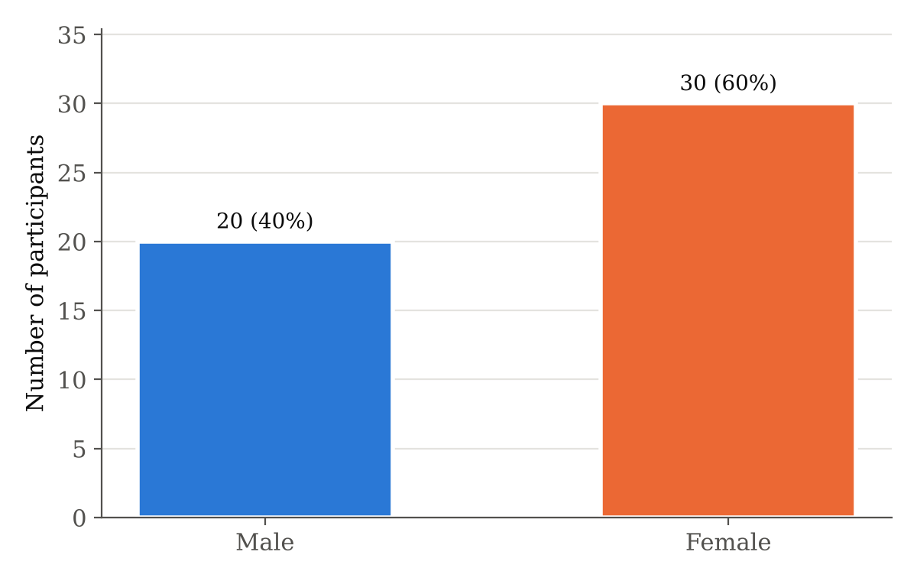
Graph 2: Distribution of participants by affected side
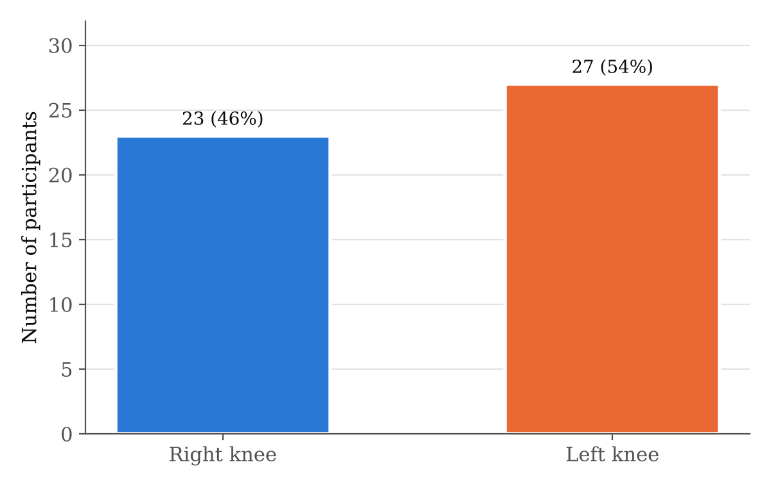
Table 5: Distribution of participants by age group
Age group (years) | Frequency (n) | Percentage (%)
50–59 | 17 | 34.0
60–69 | 19 | 38.0
70–75 | 14 | 28.0
Total | 50 | 100.0
The largest proportion of participants was in the 60–69 year age group (19 (38.0%)), followed by 50–59 years (17 (34.0%)) and 70–75 years (14 (28.0%)) (Graph 3).
Graph 3: Distribution of participants by age group
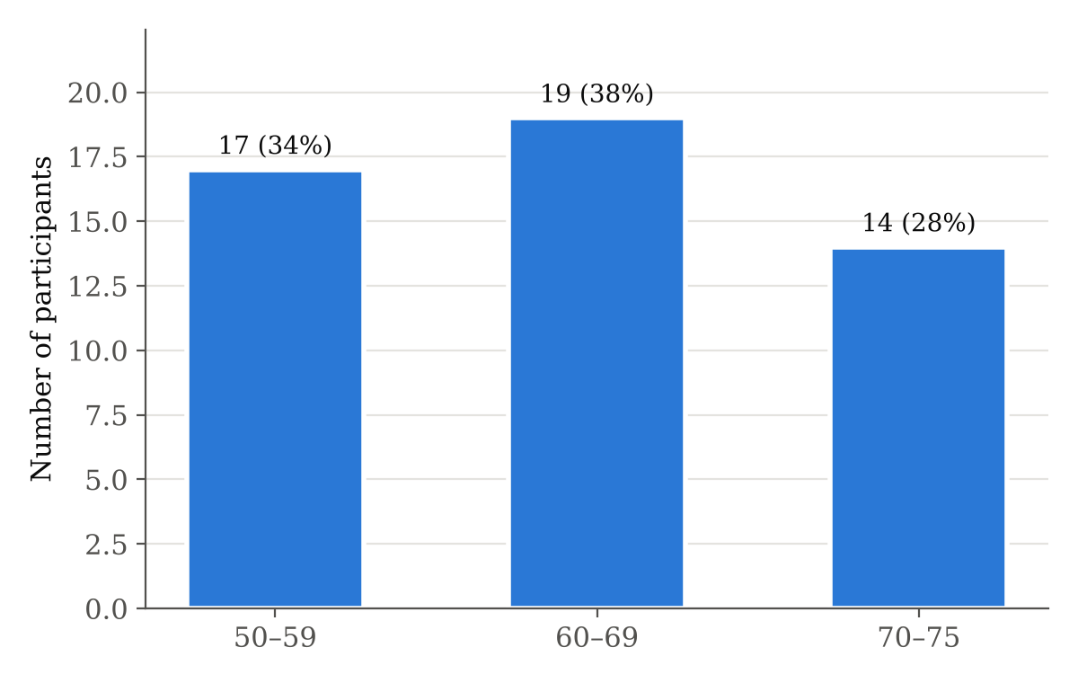
Table 6: Distribution of participants by BMI category
BMI category (kg/m²) | Frequency (n) | Percentage (%)
Normal (18.5–24.9) | 15 | 30.0
Overweight (25–29.9) | 26 | 52.0
Obese (≥30) | 9 | 18.0
Total | 50 | 100.0
More than half of the participants were overweight (26 (52.0%)), 9 (18.0%) were obese and 15 (30.0%) had a normal BMI (Graph 4).
Graph 4: Distribution of participants by BMI category
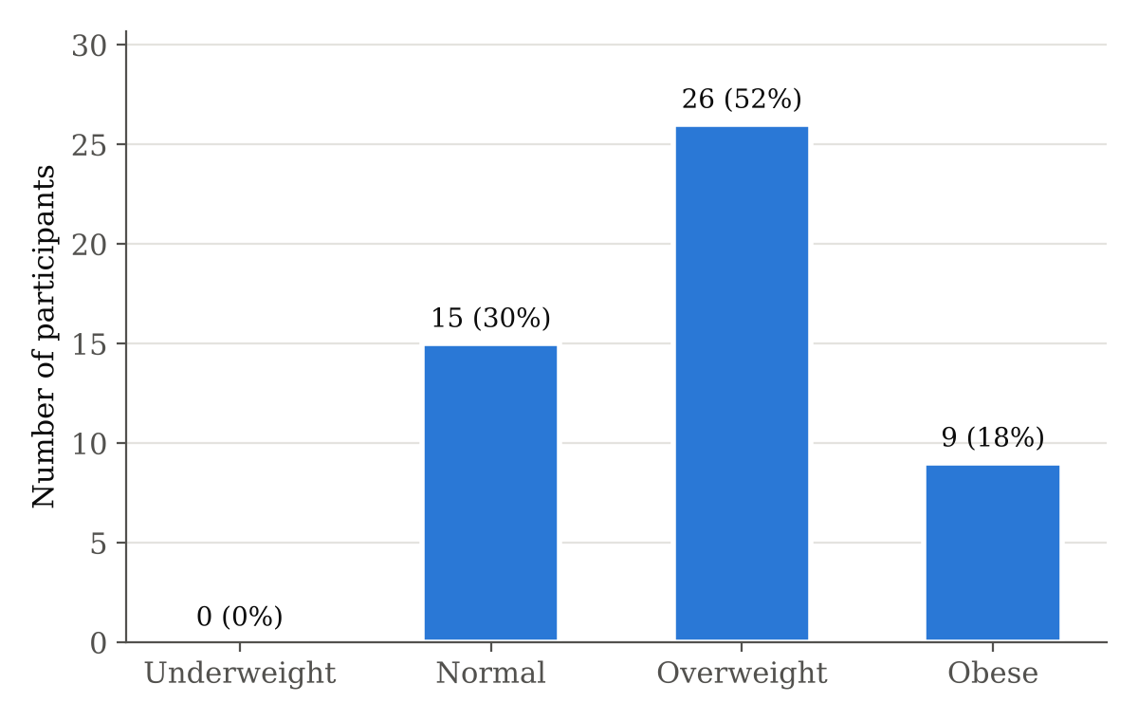
Table 7: Distribution of participants by post-operative duration
Post-operative duration | Frequency (n) | Percentage (%)
4–8 weeks | 15 | 30.0
9–12 weeks | 8 | 16.0
13–24 weeks | 27 | 54.0
Total | 50 | 100.0
2. Outcome measures
Table 8: Descriptive statistics of TSK-17 score and Stair Climb Test time
Outcome measure | Mean ± SD | Median (IQR) | Minimum | Maximum | Std. Error
TSK-17 score | 41.76 ± 6.54 | 42.0 (37.0–44.0) | 26 | 57 | 0.92
SCT time (seconds) | 20.11 ± 3.16 | 20.63 (17.88–22.27) | 12.82 | 26.96 | 0.45
The mean TSK-17 score was 41.76 ± 6.54 (range 26–57), which lies above the cut-off of 37 for high kinesiophobia. The mean time taken to complete the Stair Climb Test was 20.11 ± 3.16 seconds (range 12.82–26.96 seconds) (Table 8, Graph 5).
Graph 5: Mean TSK-17 score and mean SCT time
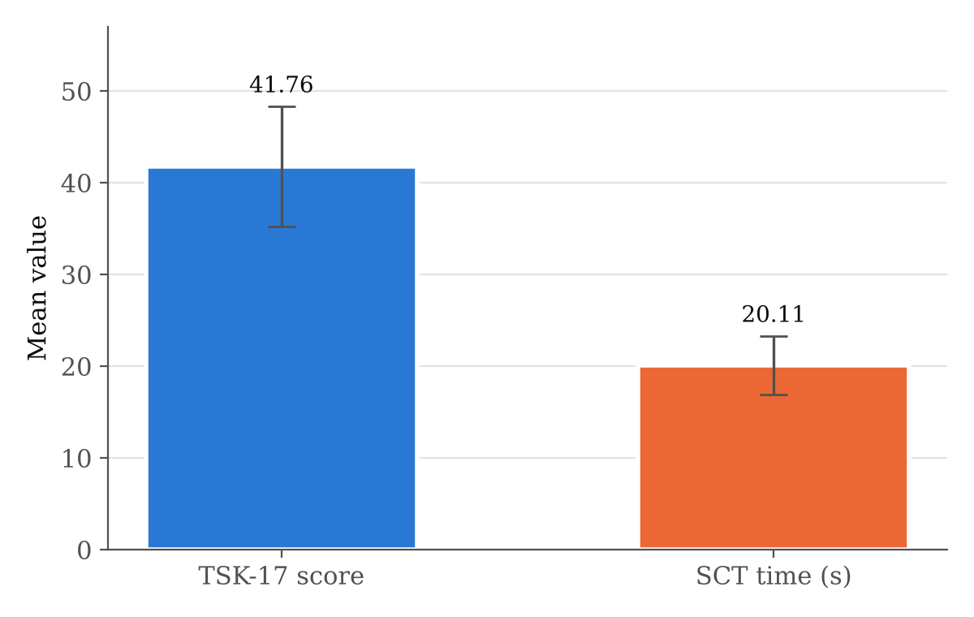
Table 9: Distribution of participants by level of kinesiophobia
Level of kinesiophobia | TSK-17 score | Frequency (n) | Percentage (%)
Low | 17–37 | 14 | 28.0
High | 38–68 | 36 | 72.0
Total |  | 50 | 100.0
High kinesiophobia (TSK-17 > 37) was present in 36 (72.0%) participants, while 14 (28.0%) had low kinesiophobia (Graph 6).
Graph 6: Distribution of participants by level of kinesiophobia
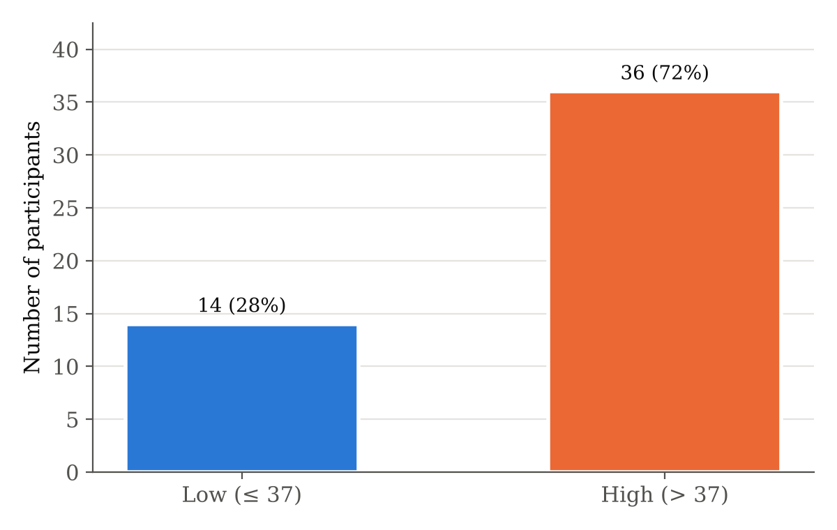
Table 10: Stair negotiation pattern, handrail support and assistive device
Variable | Category | Frequency (n) | Percentage (%)
Stair pattern | Reciprocal | 14 | 28.0
 | Step-by-step | 36 | 72.0
Handrail support | None | 18 | 36.0
 | Unilateral | 24 | 48.0
 | Bilateral | 8 | 16.0
Assistive device | None | 25 | 50.0
 | Single Cane | 19 | 38.0
 | Elbow Crutch | 3 | 6.0
 | Walker | 3 | 6.0
A step-by-step (non-reciprocal) stair pattern was used by 36 (72.0%) participants, and only 14 (28.0%) negotiated the stairs reciprocally. 32 (64.0%) participants used the handrail (unilateral 24 (48.0%); bilateral 8 (16.0%)), and 25 (50.0%) were using an assistive device for ambulation, most commonly a single cane (19 (38.0%)) (Graphs 7–9).
Graph 7: Stair negotiation pattern
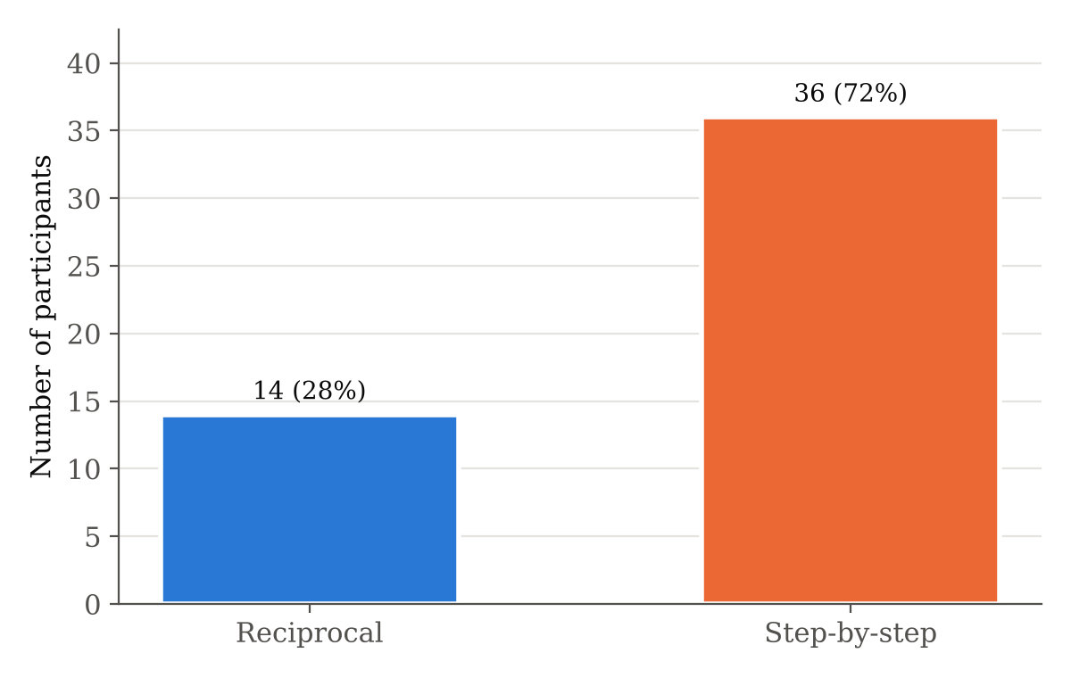
Graph 8: Handrail support during the Stair Climb Test
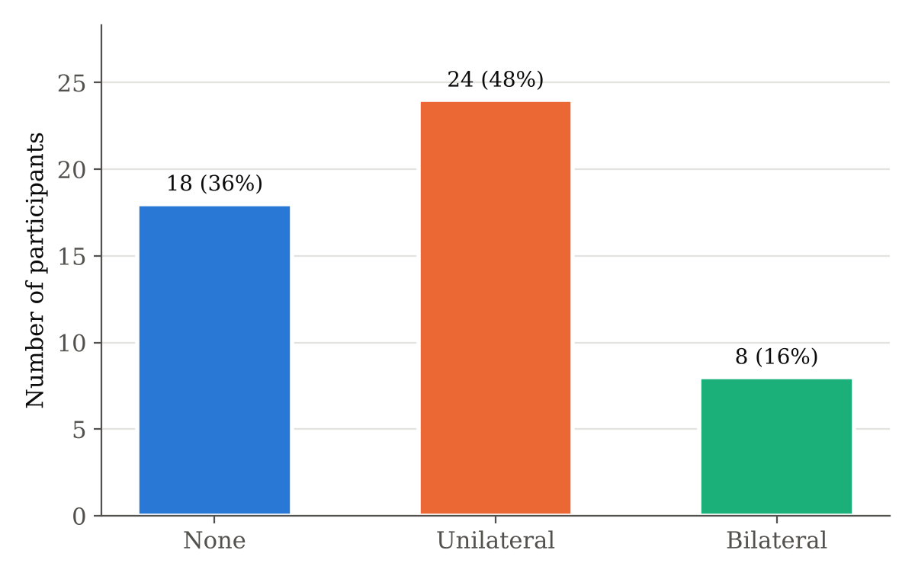
Graph 9: Assistive device used for ambulation
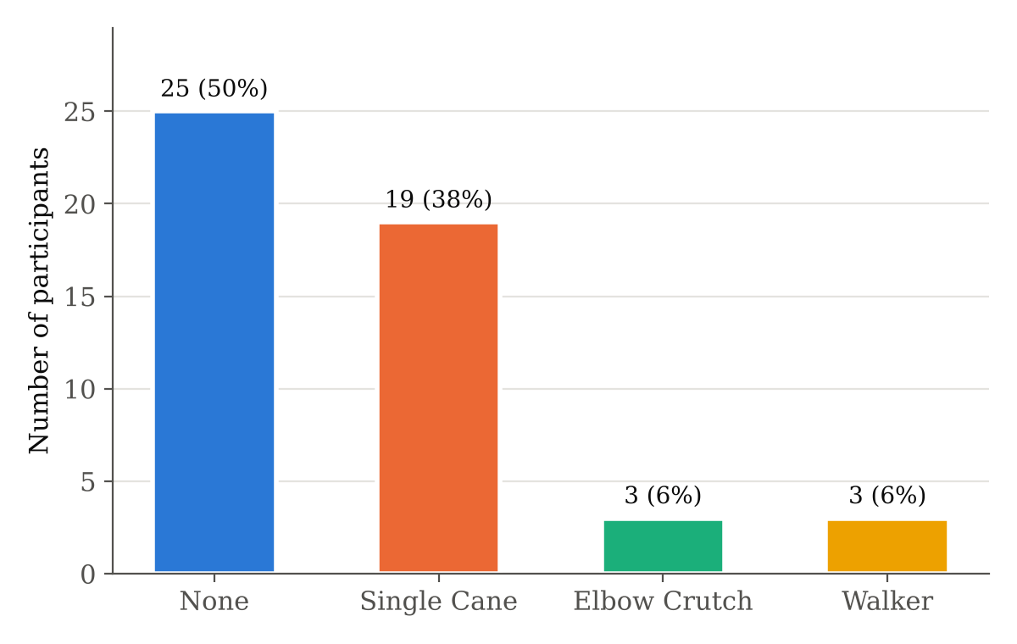
SUB-CHAPTER 2: TEST FOR NORMALITY
Normality of the continuous variables was assessed using the Shapiro–Wilk test. TSK-17 score (W = 0.966, p = 0.156), SCT time (W = 0.985, p = 0.766) and BMI were normally distributed (p > 0.05), whereas age and post-operative duration deviated from normality, reflecting their roughly uniform distribution across the inclusion range. As both primary variables were normally distributed, Pearson’s correlation coefficient and parametric tests were used for the main analysis (Table 11; Graphs 10–13).
Table 11: Tests of normality (Shapiro–Wilk)
Variable | Statistic (W) | df | Sig. (p) | Distribution
Age | 0.939 | 50 | 0.012 | Not normal
BMI | 0.969 | 50 | 0.214 | Normal
Post-operative duration | 0.931 | 50 | 0.006 | Not normal
TSK-17 score | 0.966 | 50 | 0.156 | Normal
SCT time | 0.985 | 50 | 0.766 | Normal
Graph 10: Histogram of TSK-17 scores with normal curve
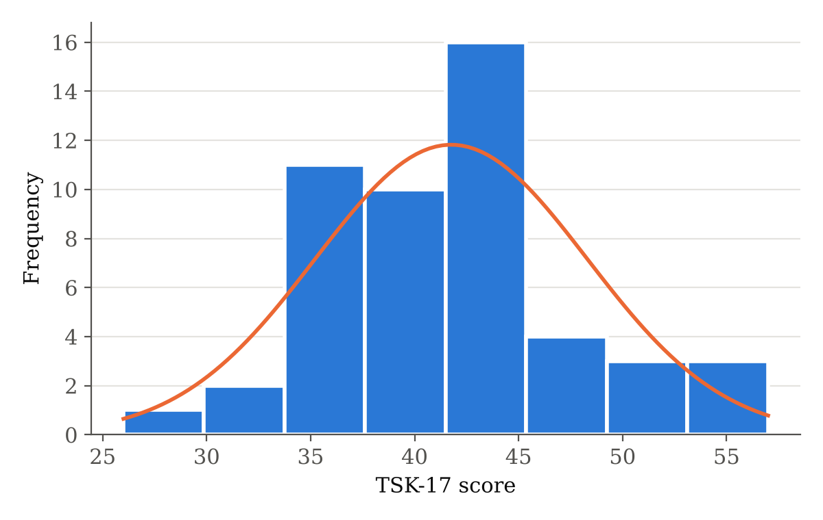
Graph 11: Histogram of SCT time with normal curve
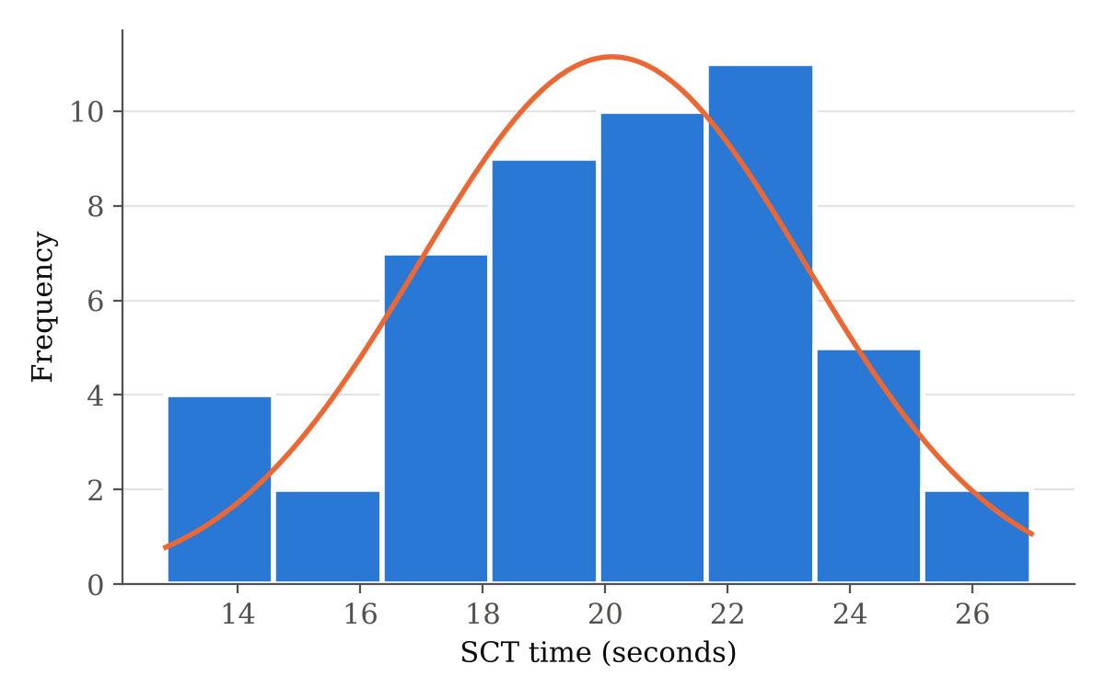
Graph 12: Normal Q–Q plot of TSK-17 scores
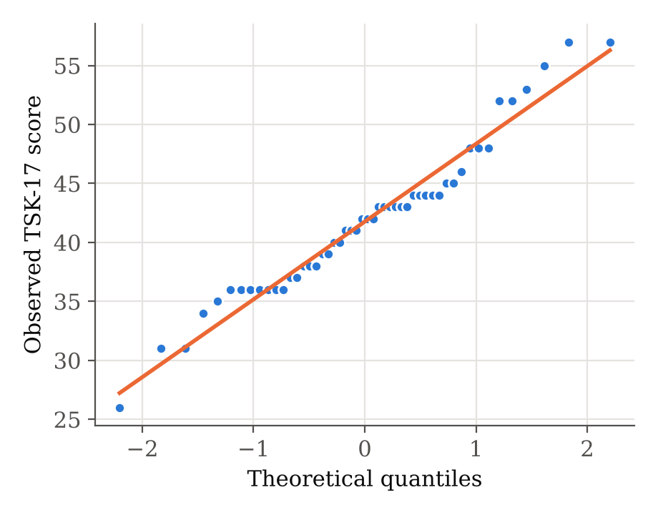
Graph 13: Normal Q–Q plot of SCT time
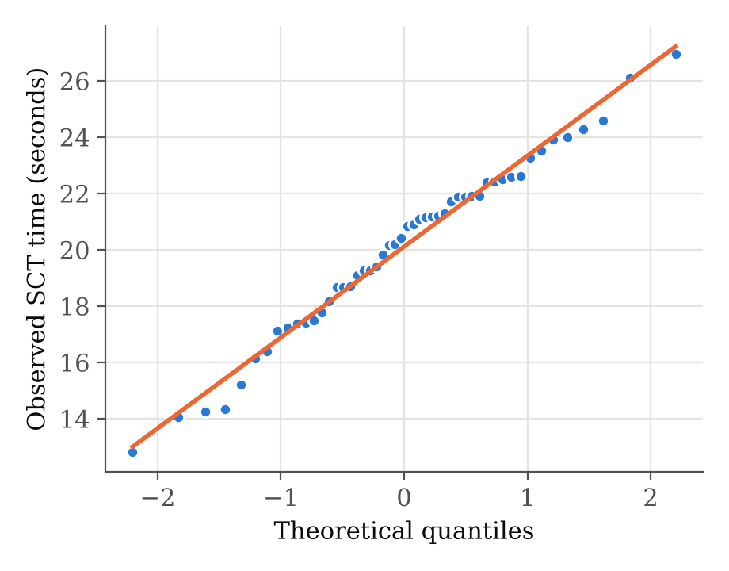
SUB-CHAPTER 3: CORRELATION BETWEEN KINESIOPHOBIA AND STAIR-CLIMBING ABILITY
Table 12: Pearson correlation between TSK-17 score and SCT time
Variables | N | Pearson r | 95% CI of r | R² | p-value | Interpretation
TSK-17 score vs SCT time | 50 | 0.685 | 0.503 to 0.809 | 0.470 | < 0.001 | Moderate positive, significant
Pearson’s correlation analysis showed a moderate, positive and statistically significant correlation between TSK-17 score and SCT time (r = 0.685, 95% CI 0.503–0.809, p < 0.001). The coefficient of determination (R² = 0.470) indicates that 47.0% of the variance in stair-climbing time was explained by kinesiophobia. Spearman’s rank correlation gave a consistent result (ρ = 0.673, p < 0.001). Since time is the measure of the SCT, a positive correlation means that participants with greater fear of movement took longer to climb the stairs, i.e. had poorer stair-climbing ability (Graph 14). The null hypothesis (H₀) is therefore rejected and the alternative hypothesis (H₁) is accepted.
Graph 14: Scatter plot showing the correlation between TSK-17 score and SCT time
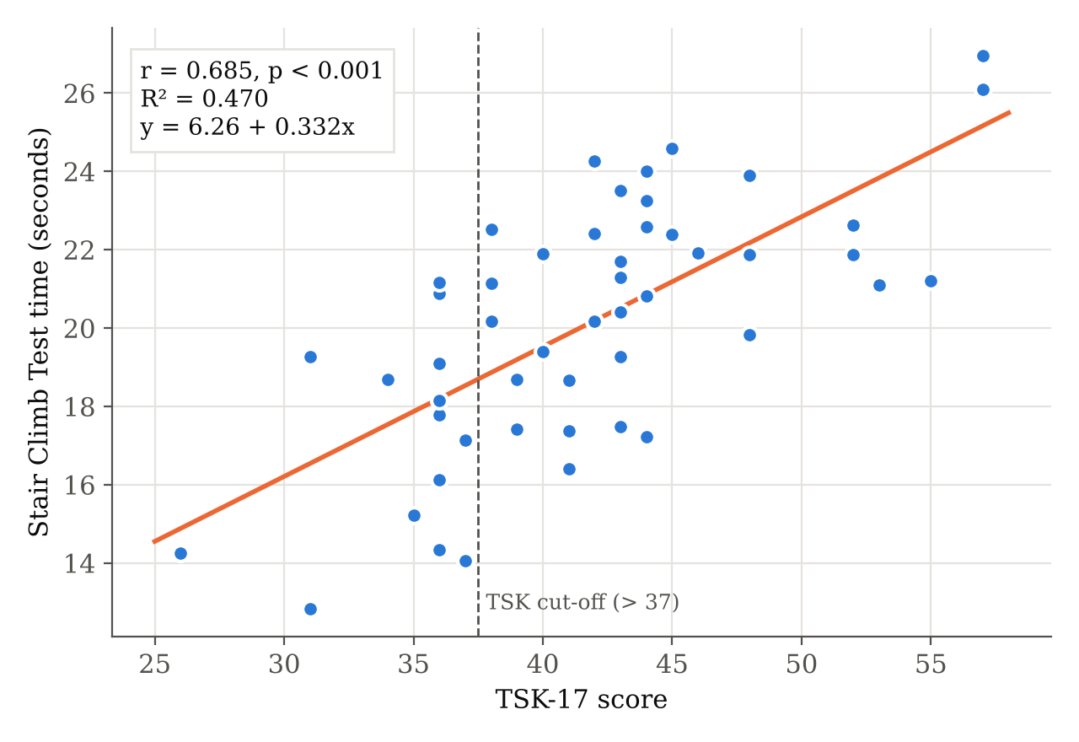
Table 13: Simple linear regression of SCT time on TSK-17 score
Model | B (unstandardised) | Std. Error | β (standardised) | p-value
Constant | 6.261 | – | – | –
TSK-17 score | 0.332 | 0.051 | 0.685 | < 0.001
The regression equation was SCT time (s) = 6.26 + 0.332 × TSK-17 score. Each one-point increase in TSK-17 score was associated with an increase of 0.33 seconds in SCT time, and a 10-point increase with approximately 3.3 seconds.
SUB-CHAPTER 4: COMPARISON OF STAIR-CLIMBING ABILITY BETWEEN LOW AND HIGH KINESIOPHOBIA GROUPS
Table 14: Comparison of TSK-17 score and SCT time between low and high kinesiophobia groups (independent t-test)
Variable | Group | Mean ± SD | t | p-value | Result
TSK-17 score | Low (n = 14) | 34.50 ± 3.11 | -6.78 | < 0.001 | Significant
 | High (n = 36) | 44.58 ± 5.20
SCT time (s) | Low (n = 14) | 17.07 ± 2.65 | -5.27 | < 0.001 | Significant
 | High (n = 36) | 21.29 ± 2.50
Participants with high kinesiophobia took significantly longer to complete the SCT (21.29 ± 2.50 s) than those with low kinesiophobia (17.07 ± 2.65 s); mean difference 4.22 s, t(48) = 5.27, p < 0.001. The effect size was large (Cohen’s d = 1.66). Levene’s test confirmed equal variances (p = 0.571) (Graph 15).
Graph 15: Mean SCT time in low and high kinesiophobia groups
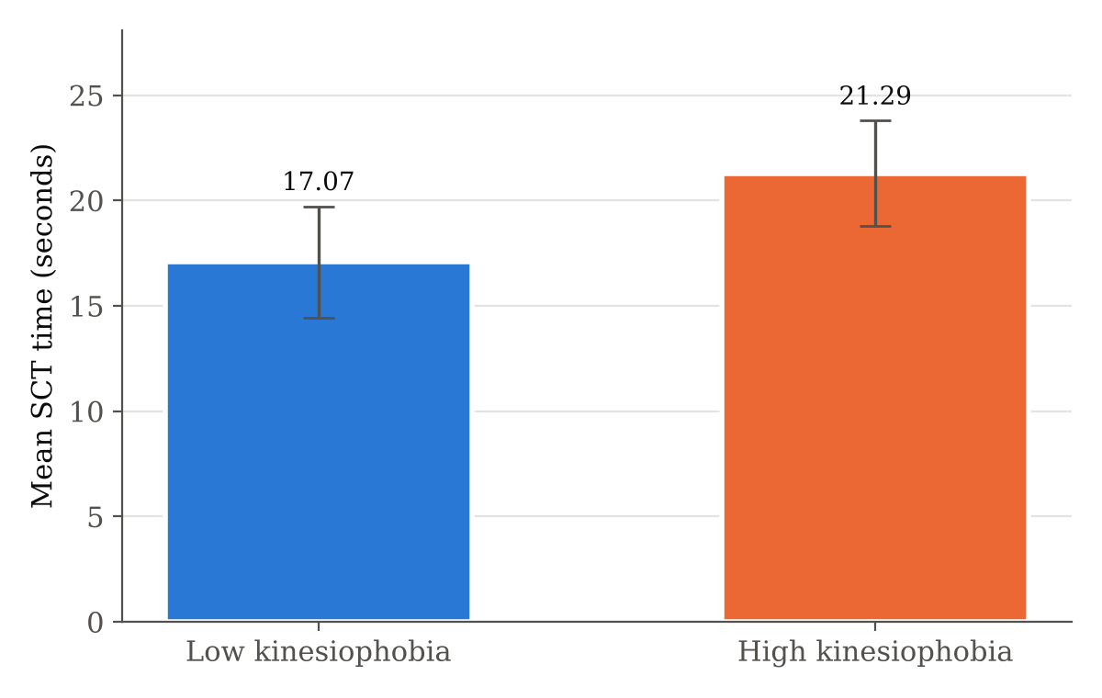
SUB-CHAPTER 5: COMPARISON ACROSS DEMOGRAPHIC AND CLINICAL SUBGROUPS
Table 15: Comparison of TSK-17 score and SCT time by gender, affected side and stair pattern (independent t-test)
Variable | Group | Mean ± SD | t | p-value | Result
TSK-17 by gender | Male (n = 20) | 41.75 ± 6.43 | -0.01 | 0.993 | Not significant
 | Female (n = 30) | 41.77 ± 6.72
SCT by gender | Male (n = 20) | 20.52 ± 3.06 | 0.74 | 0.463 | Not significant
 | Female (n = 30) | 19.84 ± 3.25
TSK-17 by side | Right (n = 23) | 42.17 ± 7.47 | 0.41 | 0.684 | Not significant
 | Left (n = 27) | 41.41 ± 5.75
SCT by side | Right (n = 23) | 19.24 ± 3.65 | -1.84 | 0.072 | Not significant
 | Left (n = 27) | 20.85 ± 2.52
TSK-17 by stair pattern | Reciprocal (n = 14) | 42.14 ± 7.87 | 0.26 | 0.799 | Not significant
 | Step-by-step (n = 36) | 41.61 ± 6.06
SCT by stair pattern | Reciprocal (n = 14) | 19.98 ± 3.21 | -0.17 | 0.862 | Not significant
 | Step-by-step (n = 36) | 20.16 ± 3.19
TSK-17 scores and SCT times did not differ significantly between male and female participants, between right and left TKR, or between participants using a reciprocal and a step-by-step stair pattern (all p > 0.05). Participants with left TKR tended to be slower than those with right TKR (20.85 vs 19.24 s), but the difference was not significant (Mann–Whitney U = 231.0, p = 0.124; Levene’s p = 0.027).
Table 16: Comparison of TSK-17 score and SCT time by handrail support and assistive device (one-way ANOVA)
Variable | Group | Mean ± SD | F | p-value | Result
TSK-17 by handrail | None (n = 18) | 41.78 ± 8.24 | 0.12 | 0.887 | Not significant
 | Unilateral (n = 24) | 41.42 ± 4.58
 | Bilateral (n = 8) | 42.75 ± 8.01
SCT by handrail | None (n = 18) | 19.22 ± 3.32 | 2.87 | 0.067 | Not significant
 | Unilateral (n = 24) | 20.04 ± 3.07
 | Bilateral (n = 8) | 22.32 ± 2.20
TSK-17 by device | None (n = 25) | 41.48 ± 6.46 | 0.85 | 0.475 | Not significant
 | Single Cane (n = 19) | 41.89 ± 6.29
 | Elbow Crutch (n = 3) | 46.67 ± 4.62
 | Walker (n = 3) | 38.33 ± 10.69
SCT by device | None (n = 25) | 20.11 ± 3.10 | 0.11 | 0.956 | Not significant
 | Single Cane (n = 19) | 19.90 ± 3.10
 | Elbow Crutch (n = 3) | 20.81 ± 3.10
 | Walker (n = 3) | 20.70 ± 5.63
Neither TSK-17 score nor SCT time differed significantly according to handrail support or assistive device (p > 0.05). Participants using bilateral handrail support showed the longest SCT time (22.32 ± 2.20 s), with a trend towards significance (F = 2.87, p = 0.067).
Table 17: Correlation of age, BMI and post-operative duration with TSK-17 score and SCT time
Variable | r with TSK-17 | p-value | r with SCT time | p-value
Age | -0.106 | 0.463 | -0.067 | 0.645
BMI | -0.235 | 0.101 | -0.113 | 0.436
Post-operative duration | 0.054 | 0.707 | 0.134 | 0.355
Age, BMI and post-operative duration showed only negligible, non-significant correlations with both TSK-17 score and SCT time (all |r| < 0.30, p > 0.05), indicating that these variables did not confound the main association.
Table 18: Association of kinesiophobia level with stair pattern and handrail support (chi-square test)
Variable | Category | Low kinesiophobia n | High kinesiophobia n | χ² (df) | p-value
Stair pattern | Reciprocal | 3 | 11 | 0.087 (1) | 0.768
 | Step-by-step | 11 | 25
Handrail support | None | 6 | 12 | 1.224 (2) | 0.542
 | Unilateral | 5 | 19
 | Bilateral | 3 | 5
There was no significant association between the level of kinesiophobia and stair pattern (χ² = 0.087, p = 0.768) or handrail support (χ² = 1.224, p = 0.542).
Table 19: Hypothesis test summary
Null hypothesis | Test | Sig. | Decision
There is no significant correlation between kinesiophobia (TSK-17) and stair-climbing ability (SCT) following unilateral TKR. | Pearson correlation | < 0.001 | Reject the null hypothesis
SCT time is the same in participants with low and high kinesiophobia. | Independent-samples t-test | < 0.001 | Reject the null hypothesis

CHAPTER 12. DISCUSSION
DISCUSSION
The present cross-sectional study examined the correlation between fear of movement (kinesiophobia) and stair-climbing ability in 50 individuals (30 female, 20 male; mean age 63.50 ± 7.05 years) assessed 4–24 weeks after unilateral Total Knee Replacement. Kinesiophobia was measured with the TSK-17 and stair-climbing ability with the timed Stair Climb Test. The principal finding was a moderate, positive and statistically significant correlation between TSK-17 score and SCT time (r = 0.685, p < 0.001), with kinesiophobia explaining 47% of the variance in stair-climbing time. Participants with high kinesiophobia took on average 4.22 seconds longer to complete the SCT than those with low kinesiophobia (p < 0.001, Cohen’s d = 1.66). The null hypothesis was therefore rejected.

12.1 Level of Kinesiophobia after Unilateral TKR
The mean TSK-17 score in this study was 41.76 ± 6.54, and 72% of participants had high kinesiophobia (TSK-17 > 37). This prevalence is higher than the 56.67% reported by Desai et al. (2016)⁽²¹⁾ and the 64% reported by Mahajan et al. (2018)⁽³⁹⁾ in Indian knee arthroplasty patients, and considerably higher than the 21.75% reported by Xing et al. (2025)⁽⁴²⁾ in elderly Chinese patients and the pooled prevalence of about 35% reported in meta-analytic data⁽²²⁾.
Several factors may explain the high prevalence in the present sample. First, all participants had undergone unilateral TKR, which has been associated with greater kinesiophobia than bilateral TKR^{(21,25)}. A patient with one healthy, pain-free limb can continually offload the operated knee, so that fearful beliefs are never disconfirmed by successful loading⁽²⁶⁾. Second, participants were assessed in the early post-operative period (4–24 weeks), when kinesiophobia has been shown to peak⁽⁴⁰⁾ and before many patients transition into a rapidly recovering trajectory⁽⁴¹⁾. Third, differences in TSK cut-off (> 37 in this study versus > 40 used by some authors)⁽³¹⁾, access to structured physiotherapy, pre-operative counselling and cultural beliefs about pain and rest after surgery may also contribute. Mahajan et al. (2018)⁽³⁹⁾ demonstrated that kinesiophobia was far more common in patients who did not receive physiotherapy, and inadequate counselling and limited rehabilitation remain common in the Indian context.

12.2 Stair-Climbing Ability after Unilateral TKR
The mean SCT time was 20.11 ± 3.16 seconds. Stair negotiation remained clearly impaired: 72% of participants used a non-reciprocal step-by-step pattern, 64% relied on handrail support and half were still using an assistive device for ambulation. These findings are consistent with Murakami et al. (2024)⁽³⁷⁾, who reported frequent use of step-to patterns and handrails and longer stair times after TKR, and with Zeni and Snyder-Mackler (2010b)⁽³²⁾, who found that many patients continued to use handrails up to two years after surgery. Smith et al. (2016)⁽³³⁾ similarly found that stair-climbing time remained longer than in healthy controls even 12 months after TKA. The persistent use of compensatory strategies reflects the high demand that stair negotiation places on quadriceps strength, eccentric control and balance^{(35,36)}.

12.3 Correlation between Kinesiophobia and Stair-Climbing Ability
The moderate positive correlation (r = 0.685) between TSK-17 score and SCT time supports the fear-avoidance model^{(13,19)}, which proposes that catastrophic interpretation of pain leads to fear of movement, avoidance and hypervigilance and, through disuse, to reduced physical performance. The regression analysis showed that each one-point increase in TSK-17 score was associated with an increase of 0.33 seconds in SCT time; thus a patient scoring 50 would be expected to take roughly 5.0 seconds longer than a patient scoring 35, a difference of about 25% of the mean SCT time.
These findings are in agreement with Güney-Deniz et al. (2017)⁽⁴⁵⁾, who reported that kinesiophobia explained 41% of the variance in walking distance and 47% of the variance in knee range of motion in the early period after TKA, and with the systematic review of Brown et al. (2020)⁽⁴⁶⁾, which found consistently poorer functional outcomes (WOMAC, Oxford Knee Score, walk tests) in patients with high TSK scores for up to one year after TKR. The present study extends this evidence to a specific, high-demand functional task – stair negotiation – measured with an objective performance test rather than a questionnaire, and in an Indian population.
Several mechanisms may explain how fear of movement slows stair negotiation. First, fear directly alters motor control. Asaki and Anan (2025)⁽³⁸⁾ documented protective co-contraction of the thigh muscles and a prolonged swing phase during stair descent in a patient with persistent fear, despite improvements in range of motion and self-efficacy. Bracing the knee by co-contracting the quadriceps, hamstrings and gastrocnemius limits the knee flexion required for smooth descent and slows the movement⁽²⁴⁾. Second, fearful patients tend to avoid stairs and limit their exercise, leading to persistent weakness of the quadriceps and hip musculature^{(36,39)}, which in turn prolongs stair-climbing time. Third, in unilateral TKR the healthy limb allows consistent offloading of the operated knee, so that eccentric control of the replaced knee is never re-learned⁽²⁶⁾.
Interestingly, although SCT time was strongly related to kinesiophobia, the categorical stair strategies were not: stair pattern and handrail use did not differ significantly between low and high kinesiophobia groups. This suggests that strategies such as a step-by-step pattern or handrail use were adopted by most participants at this stage of recovery regardless of fear level, perhaps as a habitual safety behaviour encouraged during in-patient rehabilitation, whereas the timed SCT was more sensitive to the hesitancy and slowness associated with fear. Participants using bilateral handrail support tended to be slowest (22.32 s), although this trend did not reach significance.
Age, BMI and post-operative duration were not significantly correlated with either kinesiophobia or SCT time, and neither outcome differed by gender or operated side. The absence of an association with post-operative duration contrasts with longitudinal studies showing a gradual decline in kinesiophobia over the post-operative months^{(40,41)}. Because the present design was cross-sectional, between-subject variability in fear may have outweighed the effect of time since surgery; Yan et al. (2023)⁽⁴¹⁾ also showed that a substantial subgroup of patients follows a stable, persistently fearful trajectory. These results indicate that fear of movement was associated with stair-climbing ability independently of these demographic factors.
Physical factors such as quadriceps strength, balance and pre-operative function are known predictors of post-operative stair ability^{(32,35)}, yet they explain only part of its variability⁽¹¹⁾. The finding that kinesiophobia alone explained almost half of the variance in SCT time highlights that psychological factors deserve the same attention as physical impairments in post-operative rehabilitation.

12.4 Clinical Implications
- Kinesiophobia should be screened routinely after TKR using the TSK-17, particularly in patients who are slow to progress with stair training.
- Patients with high TSK scores may benefit from pain neuroscience education, reassurance about the safety of loading the prosthetic knee, and goal-setting that builds self-efficacy^{(42,44)}.
- Graded exposure to stair negotiation – progressing step height, number of steps, reduced handrail use and reciprocal patterns – can help disconfirm fearful beliefs while also building strength and motor control.
- Rehabilitation should combine quadriceps and hip strengthening with cognitive-behavioural strategies in a biopsychosocial approach^{(31,46)}.
- Adequate counselling, family involvement and access to physiotherapy may reduce kinesiophobia in the Indian setting^{(39,42)}.

CHAPTER 13. CONCLUSION
CONCLUSION
The present study concludes that there is a moderate, positive and statistically significant correlation between fear of movement (kinesiophobia) and stair-climbing time in individuals following unilateral Total Knee Replacement (r = 0.685, p < 0.001). Higher kinesiophobia was associated with poorer stair-climbing ability, and kinesiophobia explained 47% of the variance in Stair Climb Test time. Participants with high kinesiophobia took significantly longer to negotiate stairs than those with low kinesiophobia. The alternative hypothesis is therefore accepted.
High kinesiophobia was present in 72% of participants, indicating that fear of movement is very common in the early months after unilateral TKR. Kinesiophobia should therefore be routinely assessed and addressed alongside physical impairments in post-operative rehabilitation to improve stair negotiation and functional independence.

CHAPTER 14. ETHICAL CONSIDERATION
ETHICAL CONSIDERATION
Ethical approval was obtained from the Institutional Ethics Committee of [name of committee] (Ref. No. [____], dated [__/__/____]) before the commencement of the study. The study was conducted in accordance with the Declaration of Helsinki⁽⁵³⁾ and the National Ethical Guidelines for Biomedical and Health Research Involving Human Participants of the Indian Council of Medical Research (ICMR)⁽⁵⁴⁾.
- Written informed consent was obtained from every participant after the purpose, procedure, risks and benefits of the study had been explained in a language they understood.
- Participation was voluntary, and participants were free to withdraw at any time without any effect on their treatment.
- Confidentiality was maintained by assigning each participant a code (TKR-2025-001 to TKR-2025-050); no identifying information is reported.
- The assessment was non-invasive. Participants were guarded during the Stair Climb Test, rest was allowed, and the test was stopped immediately if pain, dizziness or breathlessness occurred.
- No financial burden was placed on the participants and no incentives were offered.

CHAPTER 15. LIMITATION AND SCOPE OF FUTURE STUDY
LIMITATION AND SCOPE OF FUTURE STUDY

Limitations
1. The cross-sectional design does not allow causal inference; it cannot determine whether fear causes poor stair performance or poor performance increases fear.
2. Convenience sampling from [a single centre] in Jaipur limits the generalisability of the findings.
3. The post-operative window (4–24 weeks) was wide, and both kinesiophobia and stair ability change during this period.
4. Potential confounders such as pain intensity, quadriceps strength, knee range of motion, pre-operative function, anxiety, depression and pain catastrophising were not measured.
5. Only total SCT time was recorded; ascent and descent were not timed separately, and kinematic or EMG data were not collected.
6. Kinesiophobia was assessed with a self-report questionnaire, which is subject to response bias.

Scope of Future Study
- Longitudinal studies following patients from before surgery to one year after TKR to examine how changes in kinesiophobia relate to changes in stair performance.
- Larger, multi-centre studies comparing unilateral and bilateral TKR.
- Multivariate models including pain, quadriceps strength, range of motion, self-efficacy and catastrophising to determine the independent contribution of kinesiophobia.
- Separate timing of stair ascent and descent, with motion analysis or surface EMG to examine fear-related movement patterns.
- Randomised controlled trials of interventions targeting kinesiophobia (education, graded exposure, cognitive-behavioural therapy) on stair-climbing outcomes.

CHAPTER 16. BIBLIOGRAPHY
BIBLIOGRAPHY
1. Steinhaus ME, Christ AB, Cross MB. Total knee arthroplasty: a review of trends and outcomes. Bull Hosp Jt Dis. 2017;75(1):24–31.
2. Kurtz S, Ong K, Lau E, Mowat F, Halpern M. Projections of primary and revision hip and knee arthroplasty in the United States from 2005 to 2030. J Bone Joint Surg Am. 2007;89(4):780–5. doi:10.2106/JBJS.F.00222
3. Goldberg VM. Surgical treatment of osteoarthritis of the knee: total knee replacement. Clin Orthop Relat Res. 2007;464:122–7. doi:10.1097/BLO.0b013e31812f7f0a
4. Bourne RB, Chesworth BM, Davis AM, Mahomed NN, Charron KD. Patient satisfaction after total knee arthroplasty: who is satisfied and who is not? Clin Orthop Relat Res. 2010;468(1):57–63. doi:10.1007/s11999-009-1119-9
5. Dietz V, Quintern J, Berger W. Corrective reactions to stumbling in man: functional significance of spinal reflexes. Neurosci Lett. 1995;62(3):371–6. doi:10.1016/0304-3940(95)00012-3
6. Karunaratne S, et al. Stair climbing ability as a marker of independence after knee replacement. J Rehabil Med. 2024;56(3):215–22. doi:10.2340/jrm.v56.215
7. Chen B, et al. Biomechanics of stair ascent and descent after total knee arthroplasty. Clin Biomech. 2021;87:105–12. doi:10.1016/j.clinbiomech.2021.105112
8. Ma H, et al. Modified gait strategies in stair ambulation after unilateral TKR. Gait Posture. 2025;92:45–52. doi:10.1016/j.gaitpost.2025.01.007
9. Zeni JA, Snyder-Mackler L. Clinical outcomes after unilateral total knee arthroplasty: stair climbing ability and compensatory strategies. Phys Ther. 2010;90(5):748–56. doi:10.2522/ptj.20090188
10. Christensen JC, et al. Stair climbing ability after total knee arthroplasty: associations with muscle strength and prosthesis design. J Arthroplasty. 2018;33(7):2135–42. doi:10.1016/j.arth.2018.02.045
11. Vinueza-Veloz MF, et al. Arthrogenic muscle inhibition after knee surgery: clinical relevance and rehabilitation strategies. Phys Ther Sport. 2014;15(3):149–55. doi:10.1016/j.ptsp.2013.09.002
12. Lethem J, Slade PD, Troup JDG, Bentley G. Outline of a fear-avoidance model of exaggerated pain perception—I. Behav Res Ther. 1983;21(4):401–8. doi:10.1016/0005-7967(83)90009-8
13. Vlaeyen JWS, Linton SJ. Fear-avoidance and its consequences in chronic musculoskeletal pain: a state of the art. Pain. 2000;85(3):317–32. doi:10.1016/S0304-3959(99)00242-0
14. Wideman TH, Sullivan MJ, Adams H. The fear-avoidance model of chronic pain: an overview. Clin J Pain. 2013;29(5):401–9. doi:10.1097/AJP.0b013e31826ec13d
15. Kakavas S, et al. Cognitive appraisal and recovery after orthopedic surgery: implications for rehabilitation. Eur J Pain. 2020;24(8):1523–32. doi:10.1002/ejp.1632
16. Tidmarsh T, et al. Pain catastrophizing and postoperative recovery: a systematic review. Pain Rep. 2022;7(5):e1023. doi:10.1097/PR9.0000000000001023
17. Zale EL, Ditre JW. Pain-related fear, disability, and the fear-avoidance model of chronic pain. Pain. 2015;156(3):475–9. doi:10.1097/j.pain.0000000000000104
18. Bortz WM. Physical exercise and the aging process. J Am Geriatr Soc. 1984;32(4):307–12. doi:10.1111/j.1532-5415.1984.tb04619.x
19. Leeuw M, Goossens MEJB, Linton SJ, Crombez G, Boersma K, Vlaeyen JWS. The fear-avoidance model of musculoskeletal pain: current state of scientific evidence. J Behav Med. 2007;30(1):77–94. doi:10.1007/s10865-006-9085-0
20. Kori SH, Miller RP, Todd DD. Kinesiophobia: a new view of chronic pain behavior. Pain Manag. 1990;3:35–43.
21. Desai D, Mitra S, Rachana D. Fear of movement: kinesiophobia in knee arthroplasty cases – a cross-sectional study. J Orthop Rehabil. 2016;3(1):9–11. doi:10.13107/jor.2016.v05i01.003
22. Singh R, et al. Global prevalence of kinesiophobia after total knee replacement: a meta-analysis. Int Orthop. 2025;49(6):1123–32. doi:10.1007/s00264-025-05623-9
23. Shang L, et al. Psychological preparation and fear responses in early rehabilitation after TKR. Front Rehabil Sci. 2026;2:145. doi:10.3389/frs.2026.00145
24. Tiedemann A, et al. Stair descent biomechanics and fall risk in older adults. J Gerontol A Biol Sci Med Sci. 2007;62(11):1251–6. doi:10.1093/gerona/62.11.1251
25. Kazarian GS, et al. Unilateral versus bilateral total knee replacement: psychological and biomechanical differences. Knee Surg Sports Traumatol Arthrosc. 2021;29(5):1452–60. doi:10.1007/s00167-020-06123-7
26. Song Y, et al. Offloading strategies in unilateral TKR patients: biomechanical and psychological perspectives. J Orthop Sci. 2024;29(4):789–96. doi:10.1016/j.jos.2024.03.012
27. Kortlever JT, et al. The Tampa Scale for Kinesiophobia: linking fear of movement to functional outcomes in orthopedic patients. J Orthop Res. 2020;38(9):1965–72. doi:10.1002/jor.24678
28. De Vroey H, et al. Stair climbing performance metrics in unilateral TKR patients: correlation with kinesiophobia. Gait Posture. 2020;81:123–9. doi:10.1016/j.gaitpost.2020.07.015
29. Neelaraju S, et al. Psychometric determinants of functional mobility after orthopedic surgery. Orthop J Sports Med. 2023;11(2):215–23. doi:10.1177/23259671231122345
30. Vlaeyen JWS, Kole-Snijders AMJ, Boeren RGB, van Eek H. Fear of movement/(re)injury in chronic low back pain and its relation to behavioral performance. Pain. 1995;62(3):363–72. doi:10.1016/0304-3959(94)00279-N
31. Gulrandhe P, Warutkar V, Chitale N, Arora SP, Phansopkar P. Fear avoidance model of kinesiophobia and rehabilitation. J Med Pharm Allied Sci. 2021;10(5):3529–33. doi:10.22270/jmpas.V10I5.1267
32. Zeni JA Jr, Snyder-Mackler L. Preoperative predictors of persistent impairments during stair ascent and descent after total knee arthroplasty. J Bone Joint Surg Am. 2010;92(5):1130–6. doi:10.2106/JBJS.I.00299
33. Smith JW, Marcus RL, Tracy BL, Foreman KB, Christensen JC, LaStayo PC. Stance time variability during stair stepping before and after total knee arthroplasty: a pilot study. Hum Mov Sci. 2016;45:53–62. doi:10.1016/j.humov.2015.11.003
34. Rasnick R, Standifird T, Reinbolt JA, Cates HE, Zhang S. Knee joint loads and surrounding muscle forces during stair ascent in patients with total knee replacement. PLoS One. 2016;11(6):e0156282. doi:10.1371/journal.pone.0156282
35. Lee SJ, Kim BR, Kim SR, Han EY, Nam KW, Lee SY, et al. Preoperative physical factors that predict stair-climbing ability at one month after total knee arthroplasty. J Rehabil Med. 2020;52:jrm00064. doi:10.2340/16501977-2690
36. Kline PW, Jacobs CA, Duncan ST, Noehren B. Step descent strategy is altered bilaterally despite unilateral muscle strength impairment after total knee arthroplasty. Knee Surg Sports Traumatol Arthrosc. 2020;28(5):1508–15. doi:10.1007/s00167-019-05554-8
37. Murakami T, Fujiwara M, Ohmine T, Yamamoto S, Kanayama A, Minami M, et al. Comparison of difficulty in stair ascent and descent after total knee replacement. J Phys Ther Sci. 2024;36:214–7. doi:10.1589/jpts.36.214
38. Asaki M, Anan M. Persistent fear and extended swing phase during stair descent following total knee arthroplasty: a case report. Cureus. 2025;17(2):e79608. doi:10.7759/cureus.79608
39. Mahajan R, Kataria C, Bansal K. Prevalence of kinesiophobia and its correlation with physiotherapy in post-operative total knee arthroplasty patients. Int J Physiother. 2018;5(1):25–9. doi:10.15621/ijphy/2018/v5i1/173492
40. Güney Yılmaz S, Yıldız A, Çetin M. Occupational self-perception and kinesiophobia in individuals undergoing total knee arthroplasty: a prospective longitudinal study. J Back Musculoskelet Rehabil. 2023;36(2):317–25. doi:10.3233/BMR-220123
41. Yan L, Zhang Y, Chen H. Heterogeneous trajectories of kinesiophobia after total knee arthroplasty and their impact on rehabilitation outcomes: a prospective cohort study. BMC Musculoskelet Disord. 2023;24(1):112. doi:10.1186/s12891-023-06123-7
42. Xing Y, Li J, Zhao W. Factors influencing postoperative kinesiophobia in elderly patients after total knee arthroplasty: a health ecology perspective. Front Psychol. 2025;16:1456. doi:10.3389/fpsyg.2025.01456
43. Du X, Wang Y, Liu Z. Prevalence and influencing factors of kinesiophobia after total knee arthroplasty: a systematic review and meta-analysis. J Orthop Surg Res. 2025;20(1):512. doi:10.1186/s13018-025-04512-3
44. Ren H, Zhou Y, Sun Q. Trajectory of kinesiophobia after total knee arthroplasty: a longitudinal qualitative study. BMJ Open. 2026;16(4):e065432. doi:10.1136/bmjopen-2026-065432
45. Güney-Deniz H, Şahin N, Öztürk A. The influence of kinesiophobia on early functional outcomes following total knee arthroplasty. Physiother Theory Pract. 2017;33(5):384–91. doi:10.1080/09593985.2017.1305479
46. Brown M, Stokes M, Williams S. The effects of kinesiophobia on outcomes following total knee replacement: a systematic review. Musculoskeletal Care. 2020;18(3):245–56. doi:10.1002/msc.1456
47. Dobson F, Hinman RS, Roos EM, Abbott JH, Stratford P, Davis AM, et al. OARSI recommended performance-based tests to assess physical function in people diagnosed with hip or knee osteoarthritis. Osteoarthritis Cartilage. 2013;21(8):1042–52. doi:10.1016/j.joca.2013.05.002
48. Faul F, Erdfelder E, Buchner A, Lang AG. Statistical power analyses using G*Power 3.1: tests for correlation and regression analyses. Behav Res Methods. 2009;41(4):1149–60. doi:10.3758/BRM.41.4.1149
49. Miller RP, Kori SH, Todd DD. The Tampa Scale: a measure of kinesiophobia. Clin J Pain. 1991;7(1):51.
50. Cohen J. Statistical power analysis for the behavioral sciences. 2nd ed. Hillsdale (NJ): Lawrence Erlbaum Associates; 1988.
51. Mukaka MM. A guide to appropriate use of correlation coefficient in medical research. Malawi Med J. 2012;24(3):69–71.
52. von Elm E, Altman DG, Egger M, Pocock SJ, Gøtzsche PC, Vandenbroucke JP. The Strengthening the Reporting of Observational Studies in Epidemiology (STROBE) statement: guidelines for reporting observational studies. Lancet. 2007;370(9596):1453–7. doi:10.1016/S0140-6736(07)61602-X
53. World Medical Association. World Medical Association Declaration of Helsinki: ethical principles for medical research involving human subjects. JAMA. 2013;310(20):2191–4. doi:10.1001/jama.2013.281053
54. Indian Council of Medical Research. National ethical guidelines for biomedical and health research involving human participants. New Delhi: ICMR; 2017.

CHAPTER 17. ANNEXURE
ANNEXURE
ANNEXURE I: ASSESSMENT PROFORMA FOR THE SUBJECTS
SUBJECT ID: ____________ DATE: ____/____/________
Item | Details
Name
Age (years)
Gender | Male / Female
Height (cm)
Weight (kg)
BMI (kg/m²)
Occupation
Residence | Single storey / Multi-storey; stairs at home: Yes / No
Date of surgery
Post-operative duration (weeks)
Operated side | Right / Left
Assistive device | None / Single cane / Elbow crutch / Walker
Currently receiving physiotherapy | Yes / No
Relevant medical history
Inclusion criteria met | Yes / No
Exclusion criteria absent | Yes / No
ANNEXURE II: PARTICIPANT INFORMATION SHEET AND CONSENT FORM
Study title: “Correlation between Fear of Movement (Kinesiophobia) and Stair-Climbing Ability following Unilateral Total Knee Replacement: A Cross-Sectional Study”
Investigator: Kshma Sahu, MPT student, Department of Physiotherapy, Suresh Gyan Vihar University, Jaipur. Contact: [phone number]
Guide: Dr. Sheenam Popli, Associate Professor, Department of Physiotherapy, Suresh Gyan Vihar University, Jaipur.
You are invited to take part in a study that aims to find out whether fear of movement is related to the ability to climb stairs after knee replacement surgery on one knee. If you agree, you will answer some questions about yourself and your surgery, complete a 17-item questionnaire about movement and pain (about 10 minutes), and walk up and down a flight of stairs at a fast but safe pace while being timed. You may use the handrail and your usual walking aid. A physiotherapist will stay beside you throughout. Stair climbing may cause mild, temporary knee discomfort or tiredness; you may rest or stop at any time. Your information will be kept confidential and used only for research. Participation is voluntary, and you may withdraw at any time without any effect on your treatment.
CONSENT FORM
1. I confirm that I have read (or have had read to me) and understood the information sheet for the above study and have had the opportunity to ask questions.
2. I understand that my participation is voluntary and that I am free to withdraw at any time without giving any reason and without my medical care being affected.
3. I understand that my personal information will be kept confidential and that the data may be used for research and publication without revealing my identity.
4. I agree to take part in the above study.
Name of participant: ______________________________________________
Signature / thumb impression: ______________________________________________
Date: ______________________________________________
Name and signature of witness: ______________________________________________
Name and signature of investigator: ______________________________________________
सूचित सहमति पत्र
1. मैंने उपरोक्त अध्ययन की प्रतिभागी सूचना पत्र को पढ़ लिया है (या मुझे पढ़कर सुनाया गया है) और समझ लिया है, तथा मुझे प्रश्न पूछने का अवसर दिया गया है।
2. मैं समझता/समझती हूँ कि मेरी भागीदारी स्वैच्छिक है और मैं किसी भी समय, बिना कोई कारण बताए, अध्ययन से हट सकता/सकती हूँ, और इससे मेरे उपचार पर कोई प्रभाव नहीं पड़ेगा।
3. मैं समझता/समझती हूँ कि मेरी व्यक्तिगत जानकारी गोपनीय रखी जाएगी और मेरी पहचान उजागर किए बिना आँकड़ों का उपयोग शोध एवं प्रकाशन के लिए किया जा सकता है।
4. मैं इस अध्ययन में भाग लेने के लिए सहमत हूँ।
प्रतिभागी का नाम: ______________________________________________
हस्ताक्षर / अँगूठे का निशान: ______________________________________________
दिनांक: ______________________________________________
गवाह का नाम एवं हस्ताक्षर: ______________________________________________
शोधकर्ता का नाम एवं हस्ताक्षर: ______________________________________________
ANNEXURE III: DATA COLLECTION FORM
Date: ____________ Name: ______________________ Age/Gender: __________ Subject ID: __________
TAMPA SCALE FOR KINESIOPHOBIA (TSK-17)
Please indicate how much you agree or disagree with each statement by ticking one box. Think about how you feel now about your operated knee.
No. | Statement | Strongly disagree  (1) | Disagree  (2) | Agree  (3) | Strongly agree  (4)
1 | I’m afraid that I might injure myself if I exercise. | ☐ | ☐ | ☐ | ☐
2 | If I were to try to overcome it, my pain would increase. | ☐ | ☐ | ☐ | ☐
3 | My body is telling me I have something dangerously wrong. | ☐ | ☐ | ☐ | ☐
4 * | My pain would probably be relieved if I were to exercise. | ☐ | ☐ | ☐ | ☐
5 | People aren’t taking my medical condition seriously enough. | ☐ | ☐ | ☐ | ☐
6 | My accident has put my body at risk for the rest of my life. | ☐ | ☐ | ☐ | ☐
7 | Pain always means I have injured my body. | ☐ | ☐ | ☐ | ☐
8 * | Just because something aggravates my pain does not mean it is dangerous. | ☐ | ☐ | ☐ | ☐
9 | I am afraid that I might injure myself accidentally. | ☐ | ☐ | ☐ | ☐
10 | Simply being careful that I do not make any unnecessary movements is the safest thing I can do to prevent my pain from worsening. | ☐ | ☐ | ☐ | ☐
11 | I wouldn’t have this much pain if there weren’t something potentially dangerous going on in my body. | ☐ | ☐ | ☐ | ☐
12 * | Although my condition is painful, I would be better off if I were physically active. | ☐ | ☐ | ☐ | ☐
13 | Pain lets me know when to stop exercising so that I don’t injure myself. | ☐ | ☐ | ☐ | ☐
14 | It’s really not safe for a person with a condition like mine to be physically active. | ☐ | ☐ | ☐ | ☐
15 | I can’t do all the things normal people do because it’s too easy for me to get injured. | ☐ | ☐ | ☐ | ☐
16 * | Even though something is causing me a lot of pain, I don’t think it’s actually dangerous. | ☐ | ☐ | ☐ | ☐
17 | No one should have to exercise when he/she is in pain. | ☐ | ☐ | ☐ | ☐
Reverse-scored items (4, 8, 12, 16). Total score range 17–68; > 37 = high kinesiophobia. TSK-17 total: _______
STAIR CLIMB TEST – RECORDING SHEET
Number of steps: ______ Step height: ______ cm Handrails: one side / both sides
Parameter | Observation
SCT time (seconds)
Stair pattern | Reciprocal / Step-by-step
Handrail support | None / Unilateral / Bilateral
Assistive device | None / Single cane / Elbow crutch / Walker
Remarks / adverse events
ANNEXURE IV: ETHICAL CLEARANCE CERTIFICATE
Insert a scanned copy of the Institutional Ethics Committee approval letter here.
ANNEXURE V: PLAGIARISM REPORT
Insert the plagiarism check certificate issued by the University library here.

CHAPTER 18. MASTER CHART
MASTER CHART
MASTER CHART: CORRELATION BETWEEN KINESIOPHOBIA AND STAIR-CLIMBING ABILITY FOLLOWING UNILATERAL TKR
Table 20: Master chart of all participants (n = 50)
S. No. | Patient ID | Age | Gender | BMI | Side | Post-op (wks) | TSK-17 | SCT (s) | Handrail | Stair pattern | Assistive device
1 | TKR-001 | 57 | M | 26.2 | L | 7 | 44 | 22.58 | Unilateral | Recip. | Elbow Crutch
2 | TKR-002 | 70 | M | 27.0 | R | 6 | 37 | 17.13 | Unilateral | Step | None
3 | TKR-003 | 65 | M | 20.6 | R | 20 | 36 | 16.13 | None | Step | None
4 | TKR-004 | 61 | F | 24.2 | L | 20 | 43 | 21.29 | None | Step | None
5 | TKR-005 | 58 | F | 20.1 | L | 15 | 43 | 17.49 | None | Step | Single Cane
6 | TKR-006 | 71 | F | 25.7 | L | 17 | 38 | 22.51 | None | Step | None
7 | TKR-007 | 57 | M | 26.9 | L | 24 | 38 | 21.14 | Bilateral | Recip. | None
8 | TKR-008 | 69 | M | 23.9 | R | 9 | 43 | 19.27 | Unilateral | Recip. | Single Cane
9 | TKR-009 | 73 | M | 34.9 | R | 6 | 31 | 12.82 | Unilateral | Step | None
10 | TKR-010 | 61 | F | 27.2 | L | 12 | 31 | 19.26 | None | Step | Single Cane
11 | TKR-011 | 61 | F | 30.0 | L | 8 | 36 | 17.78 | Unilateral | Step | None
12 | TKR-012 | 74 | M | 28.6 | L | 20 | 40 | 21.90 | Unilateral | Step | None
13 | TKR-013 | 71 | F | 21.0 | R | 17 | 44 | 17.23 | None | Step | Elbow Crutch
14 | TKR-014 | 54 | M | 26.8 | L | 24 | 52 | 21.88 | Unilateral | Step | None
15 | TKR-015 | 58 | F | 24.7 | L | 6 | 48 | 21.87 | Unilateral | Recip. | None
16 | TKR-016 | 74 | F | 28.7 | L | 4 | 40 | 19.40 | Unilateral | Step | Single Cane
17 | TKR-017 | 53 | M | 26.1 | L | 23 | 41 | 18.67 | Unilateral | Step | Single Cane
18 | TKR-018 | 72 | F | 24.1 | L | 24 | 34 | 18.69 | None | Step | None
19 | TKR-019 | 71 | F | 30.2 | L | 4 | 41 | 17.38 | Unilateral | Step | Single Cane
20 | TKR-020 | 52 | M | 26.5 | R | 6 | 39 | 18.68 | Unilateral | Step | None
21 | TKR-021 | 74 | F | 20.9 | L | 21 | 44 | 20.83 | Unilateral | Recip. | None
22 | TKR-022 | 62 | F | 27.2 | L | 13 | 36 | 19.10 | Bilateral | Step | Single Cane
23 | TKR-023 | 56 | F | 20.2 | R | 6 | 45 | 22.39 | Unilateral | Step | Single Cane
24 | TKR-024 | 52 | F | 29.0 | R | 11 | 53 | 21.10 | None | Step | Single Cane
25 | TKR-025 | 71 | F | 24.4 | R | 17 | 41 | 16.40 | None | Recip. | Single Cane
26 | TKR-026 | 51 | F | 28.6 | R | 21 | 44 | 23.26 | Unilateral | Step | Walker
27 | TKR-027 | 62 | F | 24.1 | L | 18 | 46 | 21.92 | None | Step | Single Cane
28 | TKR-028 | 72 | F | 32.1 | R | 5 | 39 | 17.41 | Unilateral | Recip. | None
29 | TKR-029 | 62 | F | 34.0 | R | 13 | 43 | 23.52 | Bilateral | Step | Single Cane
30 | TKR-030 | 67 | M | 22.3 | R | 5 | 42 | 20.18 | Unilateral | Recip. | None
31 | TKR-031 | 60 | M | 28.9 | R | 20 | 42 | 22.42 | Unilateral | Recip. | None
32 | TKR-032 | 66 | M | 29.4 | R | 11 | 36 | 18.16 | Unilateral | Step | None
33 | TKR-033 | 65 | M | 27.2 | L | 4 | 42 | 24.27 | Unilateral | Step | None
34 | TKR-034 | 65 | F | 25.5 | L | 12 | 45 | 24.59 | Unilateral | Step | Walker
35 | TKR-035 | 69 | M | 25.9 | R | 14 | 52 | 22.62 | Bilateral | Step | Elbow Crutch
36 | TKR-036 | 62 | M | 30.2 | L | 19 | 48 | 23.90 | Unilateral | Step | Single Cane
37 | TKR-037 | 73 | M | 26.5 | R | 10 | 57 | 26.10 | Bilateral | Recip. | None
38 | TKR-038 | 70 | M | 26.3 | L | 13 | 36 | 20.89 | Bilateral | Recip. | None
39 | TKR-039 | 53 | F | 20.4 | R | 6 | 48 | 19.83 | None | Step | None
40 | TKR-040 | 55 | F | 37.2 | L | 21 | 43 | 21.70 | None | Step | None
41 | TKR-041 | 69 | F | 26.2 | L | 16 | 57 | 26.96 | None | Step | Single Cane
42 | TKR-042 | 57 | F | 28.2 | R | 10 | 36 | 14.33 | None | Step | Single Cane
43 | TKR-043 | 71 | F | 33.8 | L | 7 | 35 | 15.22 | None | Recip. | Single Cane
44 | TKR-044 | 59 | F | 28.1 | R | 16 | 37 | 14.06 | Unilateral | Step | None
45 | TKR-045 | 57 | F | 29.3 | R | 23 | 26 | 14.25 | None | Recip. | Walker
46 | TKR-046 | 68 | F | 21.4 | L | 4 | 38 | 20.17 | Unilateral | Step | Single Cane
47 | TKR-047 | 54 | M | 28.8 | L | 11 | 36 | 21.17 | Bilateral | Step | Single Cane
48 | TKR-048 | 64 | M | 31.1 | L | 17 | 43 | 20.42 | None | Step | Single Cane
49 | TKR-049 | 68 | F | 25.6 | R | 19 | 44 | 24.00 | Bilateral | Step | None
50 | TKR-050 | 59 | F | 24.4 | R | 17 | 55 | 21.20 | None | Recip. | None
M = Male, F = Female; R = Right, L = Left; Step = step-by-step; Recip. = reciprocal. Patient IDs abbreviated from TKR-2025-001 to TKR-050.
RAW DATA ANALYSIS
Descriptive Statistics
 | N | Minimum | Maximum | Mean | Std. Deviation | Skewness | Kurtosis
Age | 50 | 51.00 | 74.00 | 63.50 | 7.054 | -0.118 | -1.285
BMI | 50 | 20.10 | 37.20 | 26.81 | 3.868 | 0.333 | 0.281
PostOp_Weeks | 50 | 4.00 | 24.00 | 13.44 | 6.440 | 0.036 | -1.317
TSK_Score | 50 | 26.00 | 57.00 | 41.76 | 6.539 | 0.377 | 0.409
SCT_Time | 50 | 12.82 | 26.96 | 20.11 | 3.163 | -0.261 | -0.218
Tests of Normality (Shapiro–Wilk)
 | Statistic | df | Sig.
Age | .939 | 50 | .012
BMI | .969 | 50 | .214
PostOp_Weeks | .931 | 50 | .006
TSK_Score | .966 | 50 | .156
SCT_Time | .985 | 50 | .766
Correlations
 |  | TSK_Score | SCT_Time
TSK_Score | Pearson Correlation | 1 | .685**
 | Sig. (2-tailed) |  | .000
 | N | 50 | 50
SCT_Time | Pearson Correlation | .685** | 1
 | Sig. (2-tailed) | .000
 | N | 50 | 50
Correlation is significant at the 0.01 level (2-tailed
Group Statistics (SCT_Time by TSK group)
TSK group | N | Mean | Std. Deviation | Std. Error Mean
Low (≤ 37) | 14 | 17.071 | 2.653 | 0.709
High (> 37) | 36 | 21.291 | 2.503 | 0.417
Independent Samples Test (equal variances assumed)
 | Levene's F | Levene's Sig. | t | df | Sig. (2-tailed) | Mean Difference | Cohen's d
SCT_Time | 0.325 | .571 | -5.266 | 48 | .000 | -4.220 | -1.659
TSK_Score | 2.687 | .108 | -6.780 | 48 | .000 | -10.083 | -2.135
Regression – Coefficients (Dependent variable: SCT_Time)
Model | B | Std. Error | Beta | Sig.
(Constant) | 6.261
TSK_Score | 0.332 | 0.051 | 0.685 | .000
Model summary: R = 0.685, R² = 0.470.

CHAPTER 19. PUBLICATION FORMAT
PUBLICATION FORMAT
CORRELATION BETWEEN FEAR OF MOVEMENT (KINESIOPHOBIA) AND STAIR-CLIMBING ABILITY FOLLOWING UNILATERAL TOTAL KNEE REPLACEMENT: A CROSS-SECTIONAL STUDY
Sahu K¹, Popli S²
1. MPT, Department of Physiotherapy, Suresh Gyan Vihar University, Jaipur
2. Associate Professor, Department of Physiotherapy, Suresh Gyan Vihar University, Jaipur
ABSTRACT
BACKGROUND AND PURPOSE
Despite successful Total Knee Replacement (TKR), many patients continue to have difficulty negotiating stairs. Fear of movement (kinesiophobia) may contribute to this limitation. The aim of this study was to determine the correlation between kinesiophobia and stair-climbing ability following unilateral TKR.
METHODOLOGY
A cross-sectional study was conducted on 50 individuals (aged 50–75 years) 4–24 weeks after unilateral TKR, selected by convenience sampling. Kinesiophobia was assessed with the Tampa Scale for Kinesiophobia (TSK-17) and stair-climbing ability with the timed Stair Climb Test (SCT). Pearson’s correlation, linear regression and the independent t-test were used, with significance set at p < 0.05.
RESULT
The mean TSK-17 score was 41.76 ± 6.54, and 72% of participants had high kinesiophobia (TSK > 37). The mean SCT time was 20.11 ± 3.16 s. TSK-17 score correlated moderately and positively with SCT time (r = 0.685, R² = 0.470, p < 0.001). Participants with high kinesiophobia were 4.22 s slower than those with low kinesiophobia (p < 0.001, d = 1.66).
CONCLUSION
Higher kinesiophobia is associated with poorer stair-climbing ability after unilateral TKR. Routine screening for and management of fear of movement should be part of post-operative rehabilitation.
KEYWORDS
Kinesiophobia, Total Knee Replacement, Stair Climb Test, Tampa Scale for Kinesiophobia, Fear-avoidance
INTRODUCTION
Total Knee Replacement is the gold-standard treatment for end-stage knee osteoarthritis, yet about one in five patients remain dissatisfied after surgery⁽¹⁾. Stair negotiation is among the most demanding and persistently impaired activities after TKR, with patients adopting step-to patterns and relying on handrails^{(2,3)}. Physical factors such as quadriceps strength explain only part of this impairment⁽⁴⁾. According to the fear-avoidance model, catastrophic interpretation of pain leads to fear of movement, avoidance and disability⁽⁵⁾. Kinesiophobia is common after TKR^{(6,7)} and is associated with poorer function^{(8,9)}. However, its relationship with objectively measured stair-climbing ability after unilateral TKR has rarely been studied, particularly in India.
METHODOLOGY
This cross-sectional study included 50 participants aged 50–75 years who were 4–24 weeks after primary unilateral TKR, recruited by convenience sampling from [study setting], Jaipur, after approval from the Institutional Ethics Committee. Patients with bilateral or revision TKR, post-operative complications, neurological, severe cardiopulmonary or other lower-limb conditions, or cognitive impairment were excluded. The sample size was calculated with G*Power (ρ = 0.40, α = 0.05, power = 0.80)⁽¹⁰⁾. Kinesiophobia was measured with the TSK-17 (score 17–68; > 37 = high)⁽¹¹⁾ and stair-climbing ability with the timed SCT⁽¹²⁾. Data were analysed using Shapiro–Wilk, Pearson’s correlation, linear regression and independent t-tests (p < 0.05).
RESULT
Participants had a mean age of 63.50 ± 7.05 years; 30 (60%) were female, and 27 (54%) had left TKR. The mean TSK-17 score was 41.76 ± 6.54 and the mean SCT time 20.11 ± 3.16 s; 72% used a step-by-step pattern and 64% used handrail support. Both variables were normally distributed. TSK-17 correlated positively with SCT time (r = 0.685, 95% CI 0.503–0.809, p < 0.001); SCT time = 6.26 + 0.332 × TSK. SCT time was 17.07 ± 2.65 s in the low and 21.29 ± 2.50 s in the high kinesiophobia group (t = 5.27, p < 0.001). Age, BMI, post-operative duration, gender and operated side were not significantly related to either outcome.
DISCUSSION
This study found that kinesiophobia explained almost half of the variance in stair-climbing time after unilateral TKR, consistent with the fear-avoidance model⁽⁵⁾ and with previous reports linking kinesiophobia to poorer walking performance and range of motion⁽⁸⁾. Fear-related co-contraction and hesitancy during stair descent⁽¹³⁾, avoidance-induced weakness⁽¹⁴⁾ and offloading onto the non-operated limb in unilateral TKR may explain the association. The high prevalence of kinesiophobia (72%) exceeds earlier Indian reports^{(6,7)}, possibly reflecting the early post-operative timing and unilateral surgery. Limitations include the cross-sectional design, convenience sampling and the absence of measures of pain and strength.
CONCLUSION
Kinesiophobia is common after unilateral TKR and shows a moderate positive correlation with stair-climbing time. Screening for and addressing fear of movement should be integrated into post-operative rehabilitation.
REFERENCE
1. Bourne RB, Chesworth BM, Davis AM, Mahomed NN, Charron KD. Patient satisfaction after total knee arthroplasty: who is satisfied and who is not? Clin Orthop Relat Res. 2010;468(1):57–63. doi:10.1007/s11999-009-1119-9
2. Zeni JA Jr, Snyder-Mackler L. Preoperative predictors of persistent impairments during stair ascent and descent after total knee arthroplasty. J Bone Joint Surg Am. 2010;92(5):1130–6. doi:10.2106/JBJS.I.00299
3. Murakami T, Fujiwara M, Ohmine T, Yamamoto S, Kanayama A, Minami M, et al. Comparison of difficulty in stair ascent and descent after total knee replacement. J Phys Ther Sci. 2024;36:214–7. doi:10.1589/jpts.36.214
4. Lee SJ, Kim BR, Kim SR, Han EY, Nam KW, Lee SY, et al. Preoperative physical factors that predict stair-climbing ability at one month after total knee arthroplasty. J Rehabil Med. 2020;52:jrm00064. doi:10.2340/16501977-2690
5. Vlaeyen JWS, Linton SJ. Fear-avoidance and its consequences in chronic musculoskeletal pain: a state of the art. Pain. 2000;85(3):317–32. doi:10.1016/S0304-3959(99)00242-0
6. Desai D, Mitra S, Rachana D. Fear of movement: kinesiophobia in knee arthroplasty cases – a cross-sectional study. J Orthop Rehabil. 2016;3(1):9–11. doi:10.13107/jor.2016.v05i01.003
7. Mahajan R, Kataria C, Bansal K. Prevalence of kinesiophobia and its correlation with physiotherapy in post-operative total knee arthroplasty patients. Int J Physiother. 2018;5(1):25–9. doi:10.15621/ijphy/2018/v5i1/173492
8. Güney-Deniz H, Şahin N, Öztürk A. The influence of kinesiophobia on early functional outcomes following total knee arthroplasty. Physiother Theory Pract. 2017;33(5):384–91. doi:10.1080/09593985.2017.1305479
9. Brown M, Stokes M, Williams S. The effects of kinesiophobia on outcomes following total knee replacement: a systematic review. Musculoskeletal Care. 2020;18(3):245–56. doi:10.1002/msc.1456
10. Faul F, Erdfelder E, Buchner A, Lang AG. Statistical power analyses using G*Power 3.1: tests for correlation and regression analyses. Behav Res Methods. 2009;41(4):1149–60. doi:10.3758/BRM.41.4.1149
11. Vlaeyen JWS, Kole-Snijders AMJ, Boeren RGB, van Eek H. Fear of movement/(re)injury in chronic low back pain and its relation to behavioral performance. Pain. 1995;62(3):363–72. doi:10.1016/0304-3959(94)00279-N
12. Dobson F, Hinman RS, Roos EM, Abbott JH, Stratford P, Davis AM, et al. OARSI recommended performance-based tests to assess physical function in people diagnosed with hip or knee osteoarthritis. Osteoarthritis Cartilage. 2013;21(8):1042–52. doi:10.1016/j.joca.2013.05.002
13. Asaki M, Anan M. Persistent fear and extended swing phase during stair descent following total knee arthroplasty: a case report. Cureus. 2025;17(2):e79608. doi:10.7759/cureus.79608
14. Kline PW, Jacobs CA, Duncan ST, Noehren B. Step descent strategy is altered bilaterally despite unilateral muscle strength impairment after total knee arthroplasty. Knee Surg Sports Traumatol Arthrosc. 2020;28(5):1508–15. doi:10.1007/s00167-019-05554-8

