NAME: RUSHIL PILLAMARI

ROLL NO: SE20UCSE151

SECTION : CSE - 3 (A2)

SUBJECT: COMPUTER NETWORKS

ASSIGNMENT - 1

1)What is the IP address of your host? What is the IP address of the destination host?

- Why is it that an ICMP packet does not have source and destination port numbers?

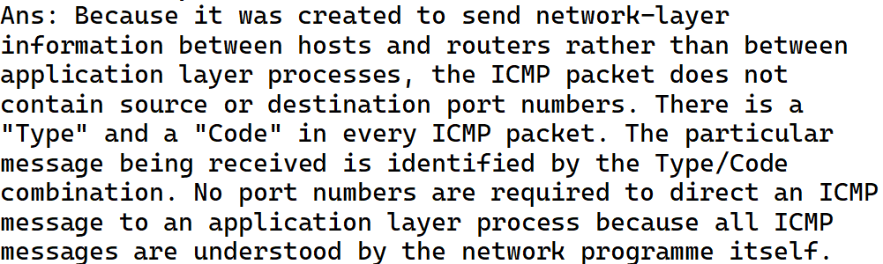

- Examine one of the ping request packets sent by your host. What are the ICMP type and code numbers? What other fields does this ICMP packet have? How many bytes are the checksum, sequence number and identifier fields?

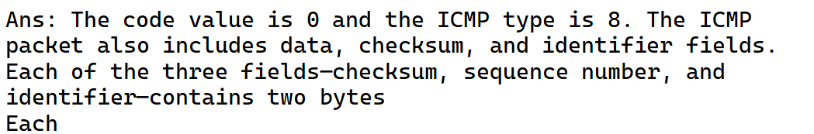

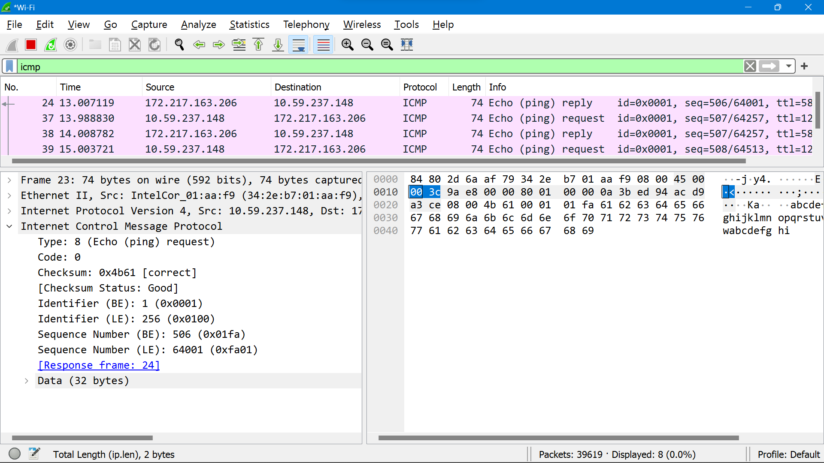

- Examine the corresponding ping reply packet. What are the ICMP type and code numbers? What other fields does this ICMP packet have? How many bytes are the checksum, sequence number and identifier fields?

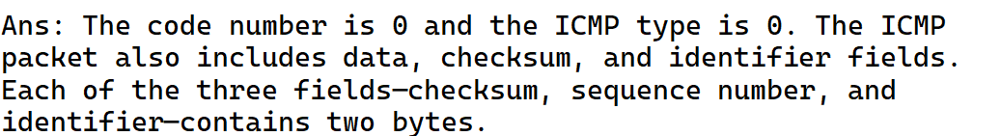

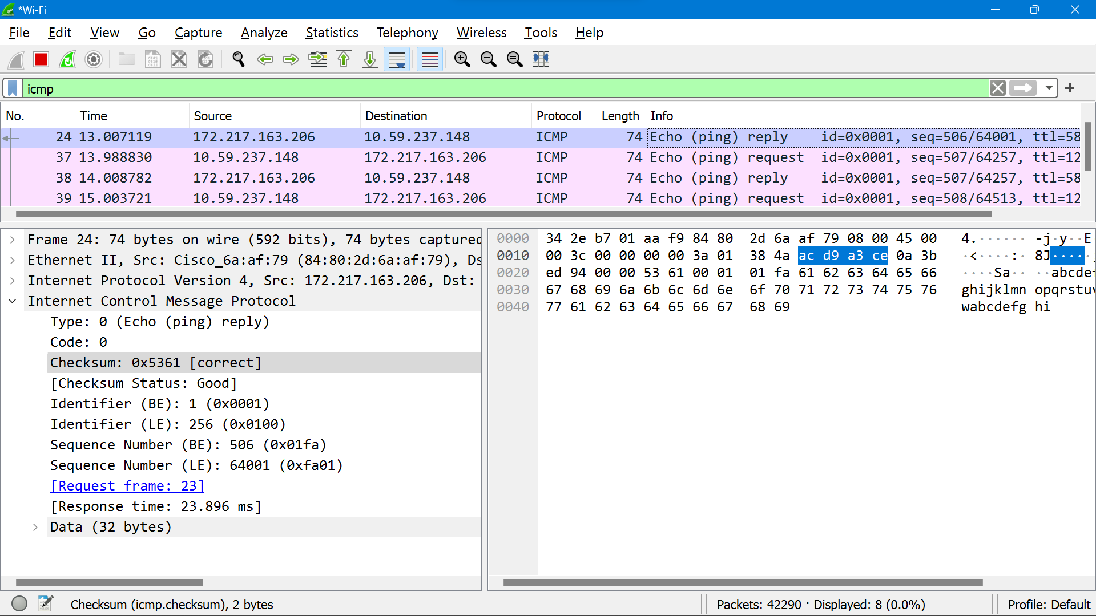

- What is the IP address of your host? What is the IP address of the target destination host?

- If ICMP sent UDP packets instead (as in Unix/Linux), would the IP protocol number still be 01 for the probe packets? If not, what would it be?

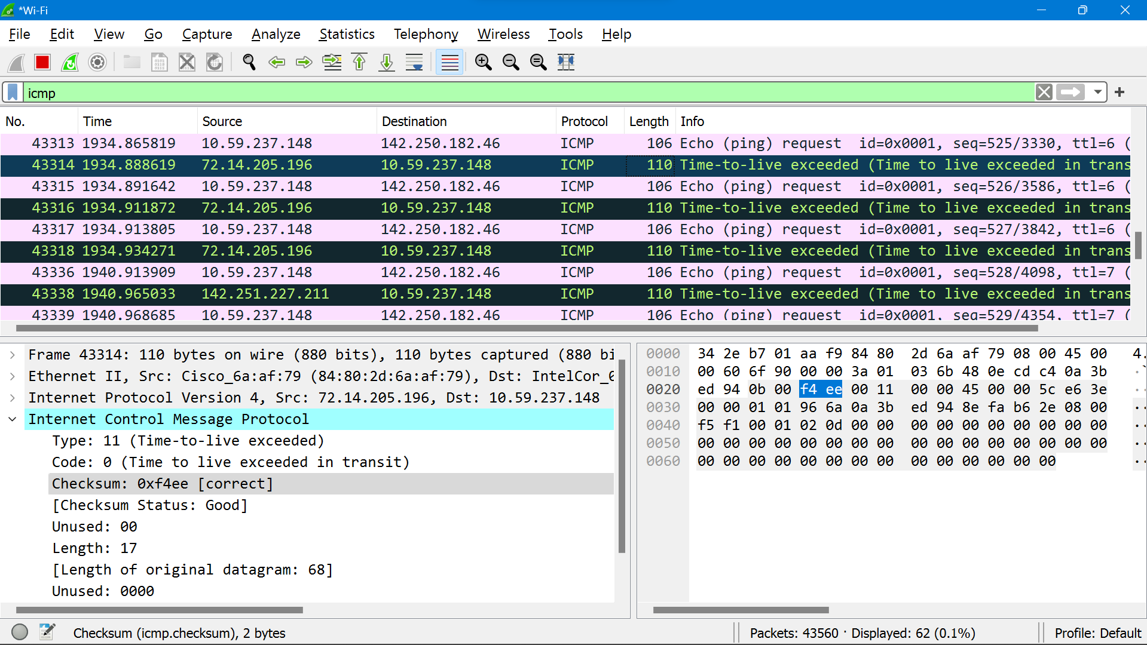

- Examine the ICMP echo packet in your screenshot. Is this different from the ICMP ping query packets in the first half of this lab? If yes, how so?

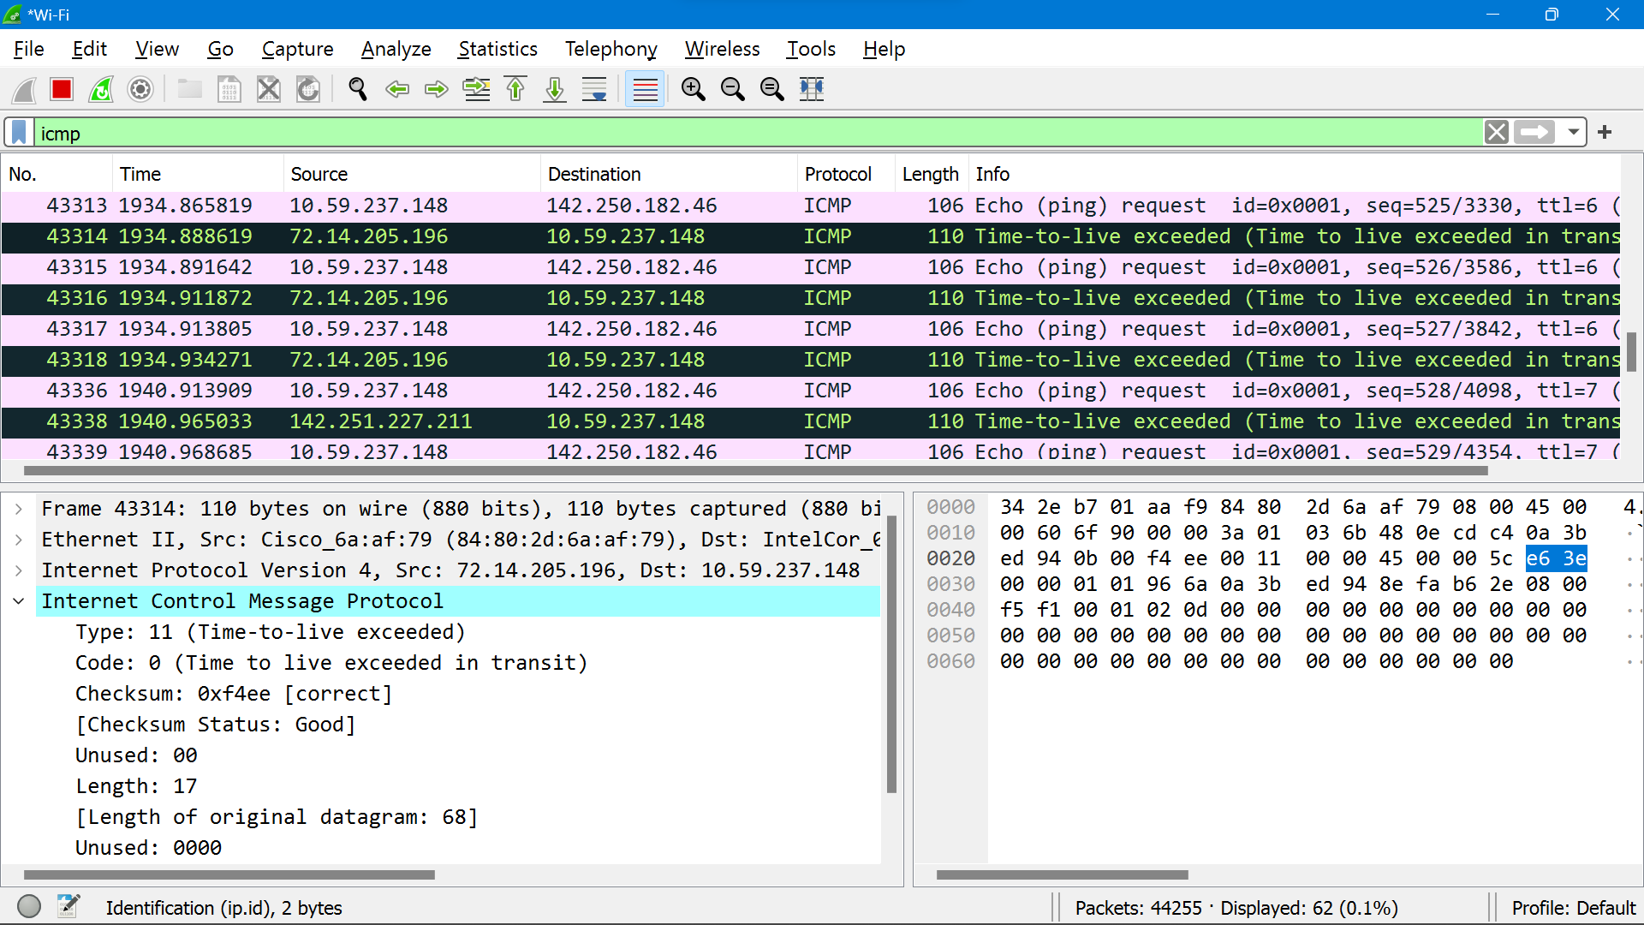

- Examine the ICMP error packet in your screenshot. It has more fields than the ICMP echo packet. What is included in those fields?

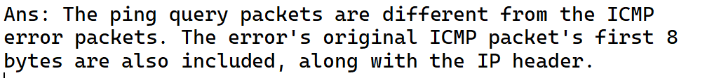

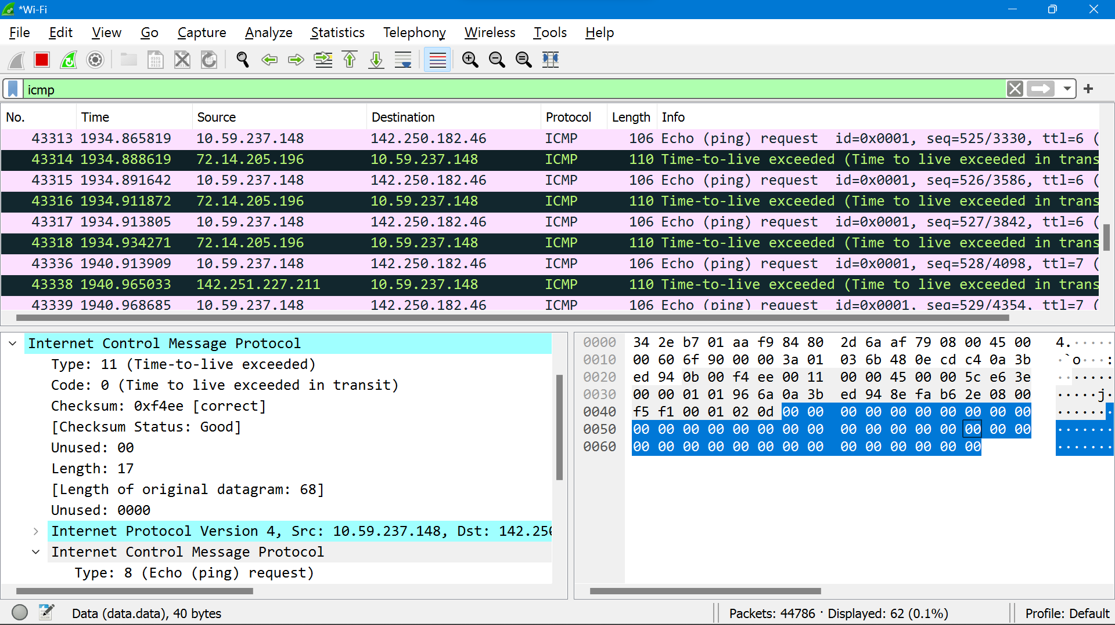

- Examine the last three ICMP packets received by the source host. How are these packets different from the ICMP error packets? Why are they different?

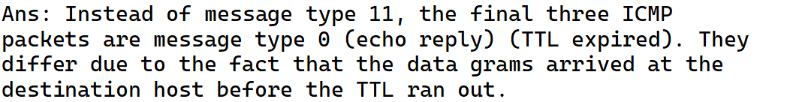

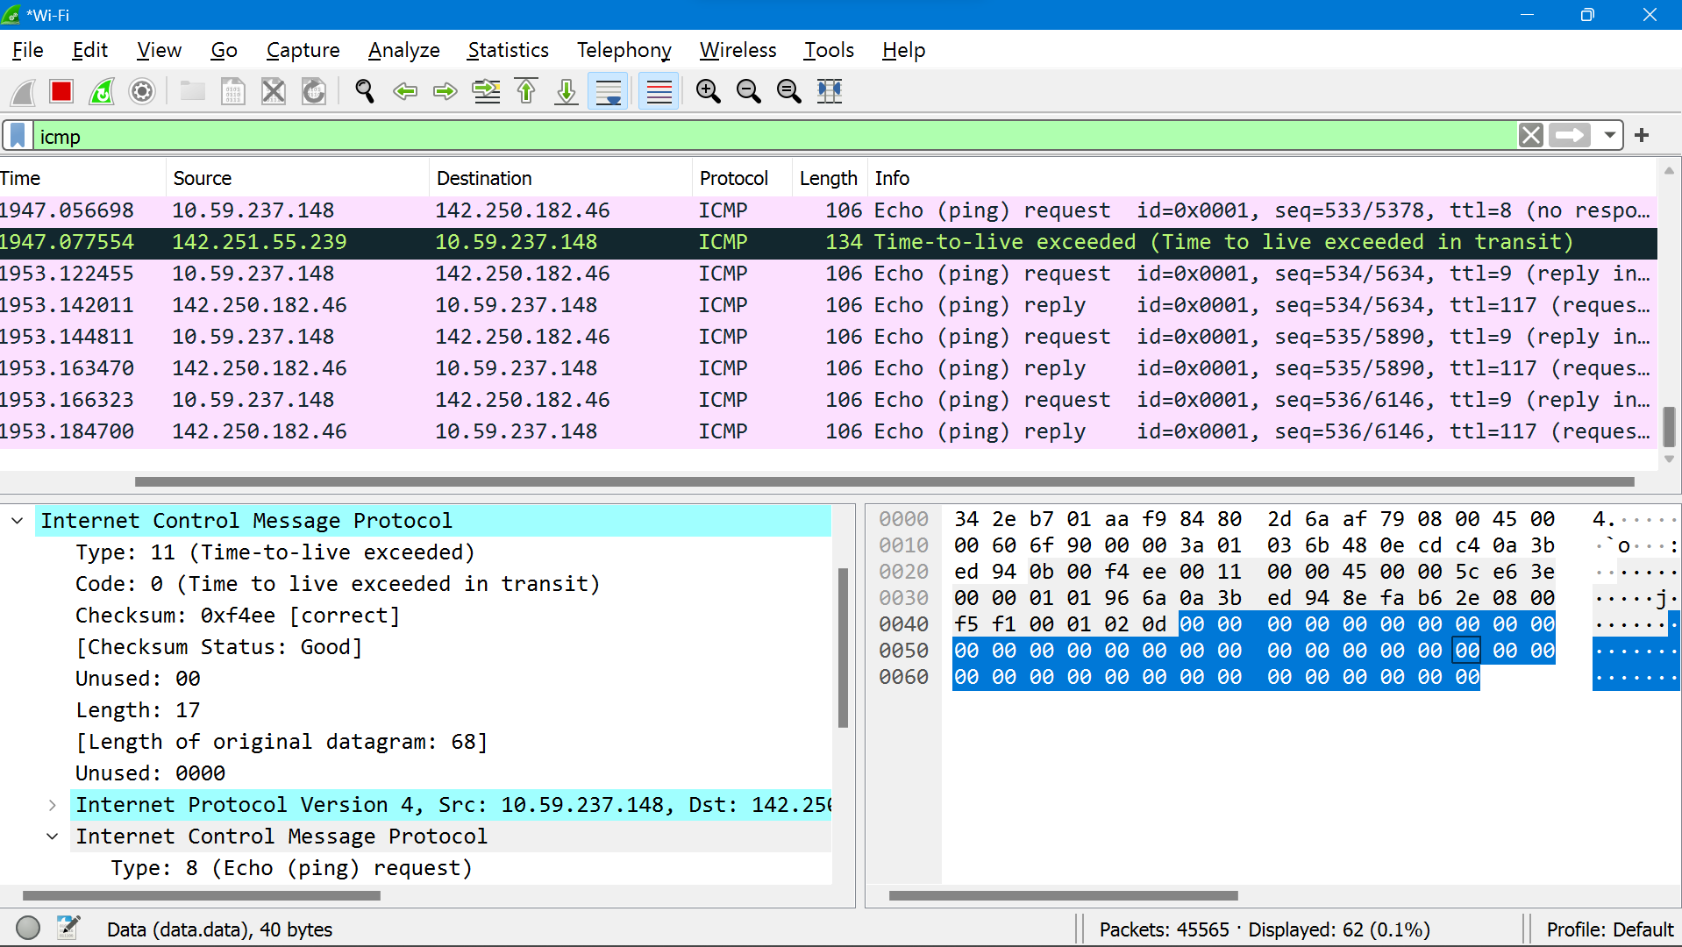

- Within the tracert measurements, is there a link whose delay is significantly longer than others? Refer to the screenshot in Figure 4, is there a link whose delay is significantly longer than others? On the basis of the router names, can you guess the location of the two routers on the end of this link?

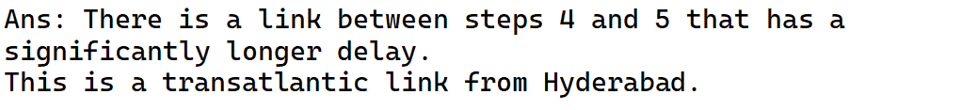
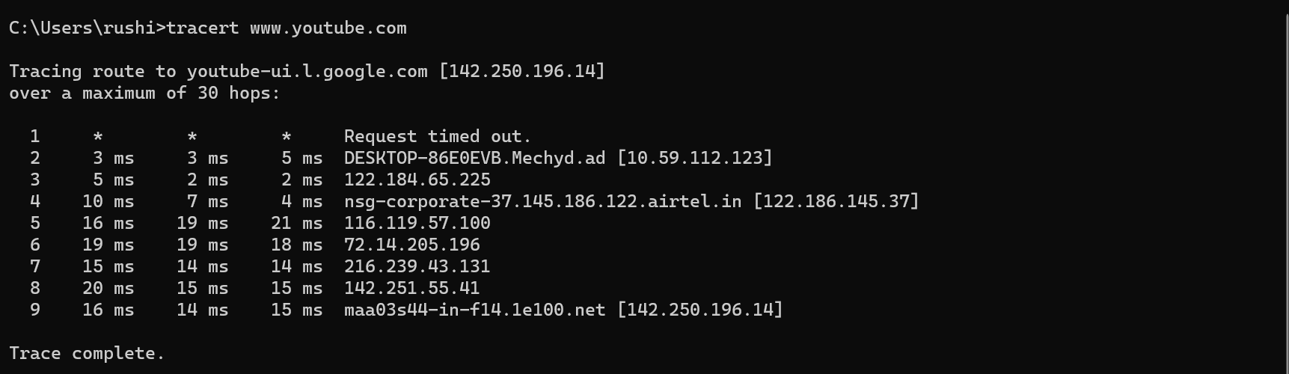

HTTPS QUESTIONS

- List 3 different protocols that appear in the protocol column in the unfiltered packet-listing window in step 7 above.

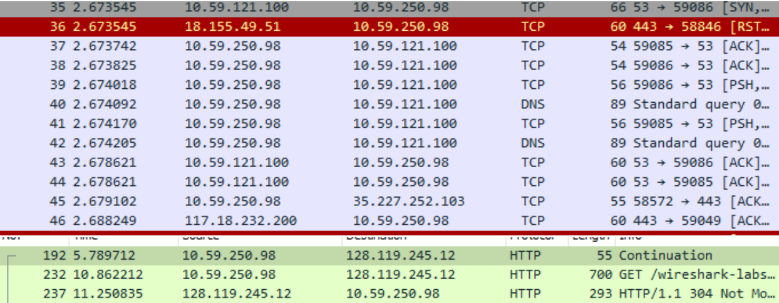

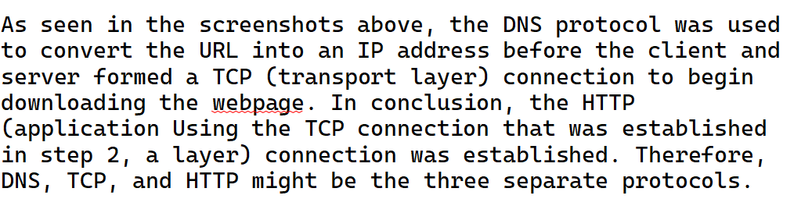

- How long did it take from when the HTTP GET message was sent until the HTTP OK reply was received? (By default, the value of the Time column in the packet-listing window is the amount of time, in seconds, since Wireshark tracing began. To display the Time field in time-of-day format, select the Wireshark View pull down menu, then select Time Display Format, then select Time-of-day

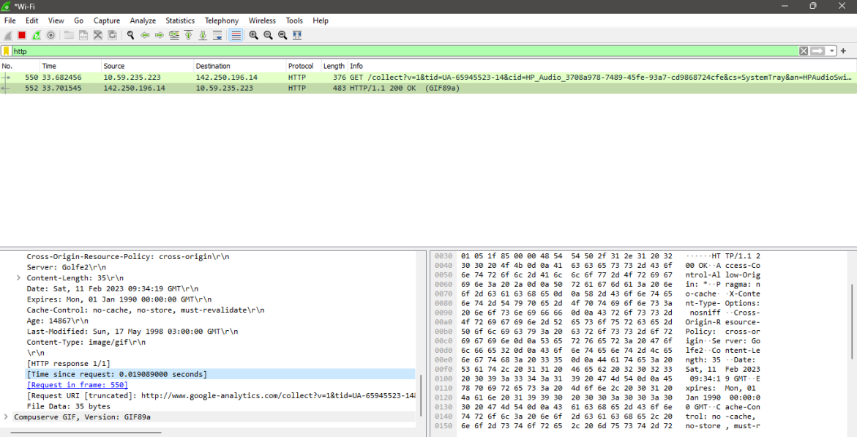

- What is the Internet address of the gaia.cs.umass.edu? What is the Internet address of your computer?

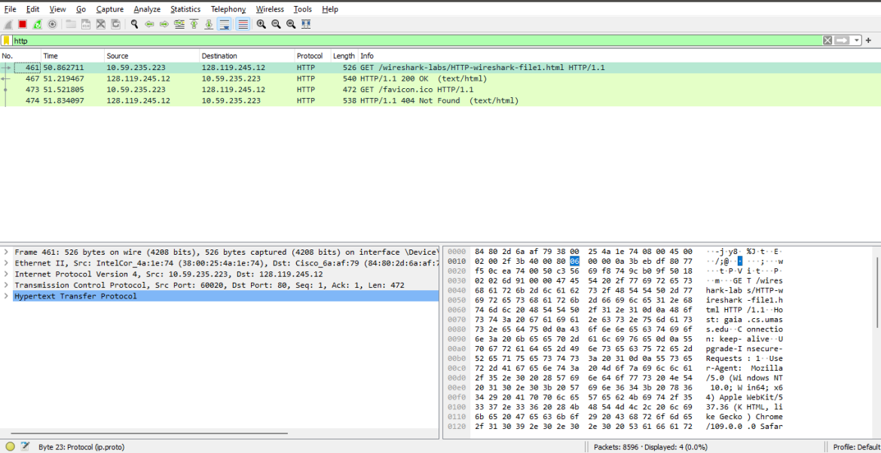

gaia.cs.umass.edu: 128.119.245.12
my computer: 10.59.235.223

4) Print the two HTTP messages (GET and OK) referred to in question 2 above. To do so, select Print from the Wireshark File command menu, and select the “Selected Packet Only” and “Print as displayed” radial buttons, and then click OK.
