Sarcasm Detection Using RoBERTa

A Deep Learning Model Dissection and Audit Report

Technical Report

Course: Natural Language Processing

Model Studied: RoBERTa-base (Fine-Tuned for Binary Sarcasm Classification) Dataset: News Headlines Dataset for Sarcasm Detection

Table of Contents
Table of Contents 2
- Abstract 3
- Introduction 3
- Problem Statement 3
- Objectives 3
- Dataset Description 4
- Data Preprocessing 4
- Experimental Setup 4
- Baseline Model — TF-IDF + Logistic Regression 5
- Main Model — RoBERTa 5
- RoBERTa Architecture 6
- Working of RoBERTa in This Project 7
- Training Procedure 7
- Performance Evaluation 7
- Results and Model Comparison 8
- Confusion Matrix Analysis 8
- Error Analysis 10
- Strengths of RoBERTa 10
- Limitations 11
- Suggestions for Improvement 11
- Additional Qualitative Analysis 11
- Conclusion 12
- References 12

Abstract
This report presents a technical audit of a sarcasm detection system built around RoBERTa-base, a pretrained transformer language model, fine-tuned for binary sarcasm classification on the News Headlines Dataset for Sarcasm Detection. A TF-IDF with Logistic Regression pipeline was implemented as a traditional machine learning baseline for comparison. On the held-out test set, RoBERTa achieved an accuracy of 81.06% and a Macro-F1 score of 80.94%, outperforming the baseline, which achieved 77.13% accuracy and 77.13% Macro-F1. The report explains RoBERTa's architecture in simple terms, describes the experimental setup, presents the quantitative results with a confusion matrix and ROC curve, analyses the model's errors, and discusses its strengths, limitations, and possible directions for improvement.

Introduction
Sarcasm is a form of language in which the literal meaning of a sentence differs from its intended meaning, often to express irony or criticism through seemingly positive or neutral wording. Detecting sarcasm automatically is a well-known challenge in Natural Language Processing (NLP) because it requires understanding context and tone rather than just the surface meaning of words. This project investigates the use of RoBERTa, a pretrained transformer-based language model, for detecting sarcasm in news headlines, and compares its performance against a simple traditional baseline built using TF-IDF features and Logistic Regression.

Problem Statement
Given a piece of text, specifically a news headline, the task is to classify whether the headline is sarcastic or not sarcastic. This is framed as a binary classification problem with two output classes: 0 (Not Sarcastic) and 1 (Sarcastic). The challenge lies in the fact that sarcastic headlines can use normal or even positive-sounding language while conveying a negative or ironic meaning, which makes the task difficult for models that rely only on surface-level word patterns.

Objectives
- Understand and explain the architecture of the RoBERTa transformer model.
- Fine-tune RoBERTa-base for binary sarcasm classification on news headlines.
- Implement a TF-IDF with Logistic Regression model as a baseline for comparison.
- Evaluate both models using accuracy, precision, recall, Macro-F1, and ROC-AUC.
- Analyse the RoBERTa model's confusion matrix and prediction errors.
- Discuss the strengths and limitations of the RoBERTa-based approach.
- Suggest realistic directions for future improvement.

Dataset Description
The primary dataset used in this project is the News Headlines Dataset for Sarcasm Detection, which contains news headlines labelled as sarcastic or non-sarcastic. The dataset consists of approximately 28,619 headlines in total, each labelled with a binary sarcasm indicator.
For the RoBERTa fine-tuning experiment, a smaller subset of 6,000 training samples was used in order to keep training time practical within the scope of this assignment. The dataset was cleaned and divided into training, validation, and test sets prior to model training.
As a secondary, exploratory analysis, Amazon Unlocked Mobile Reviews were examined to observe how the trained model behaves on text from a different domain. It is important to note that the Amazon review dataset does not contain sarcasm labels, and therefore no sarcasm accuracy, precision, recall, or F1-score could be or was computed for it. It is used purely as a qualitative, secondary point of discussion and is not the focus of this report.

Data Preprocessing
Before training, the headline text was cleaned to remove noise while preserving the wording that is important for sarcasm detection. The cleaned dataset was then split into training, validation, and test sets using a stratified split, ensuring that the proportion of sarcastic and non-sarcastic examples remained consistent across all splits. A fixed random seed (42) was used throughout to keep the data split and experiments reproducible.

Experimental Setup
The table below summarises the configuration used to fine-tune the RoBERTa-base model for the sarcasm classification task.

Setting | Value
Model | RoBERTa-base
Training samples | 6,000
Maximum sequence length | 96 tokens
Batch size | 32
Epochs | 1
Learning rate | 2 × 10
Weight decay | 0.01
Random seed | 42

Baseline Model — TF-IDF + Logistic Regression
As a point of comparison for RoBERTa, a traditional machine learning baseline was built using Term Frequency–Inverse Document Frequency (TF-IDF) features combined with a Logistic Regression classifier. TF-IDF converts text into a numeric vector by weighting words based on how frequently they appear in a document relative to how common they are across the entire dataset. Logistic Regression then uses these vectors to learn a linear decision boundary between the sarcastic and non-sarcastic classes.

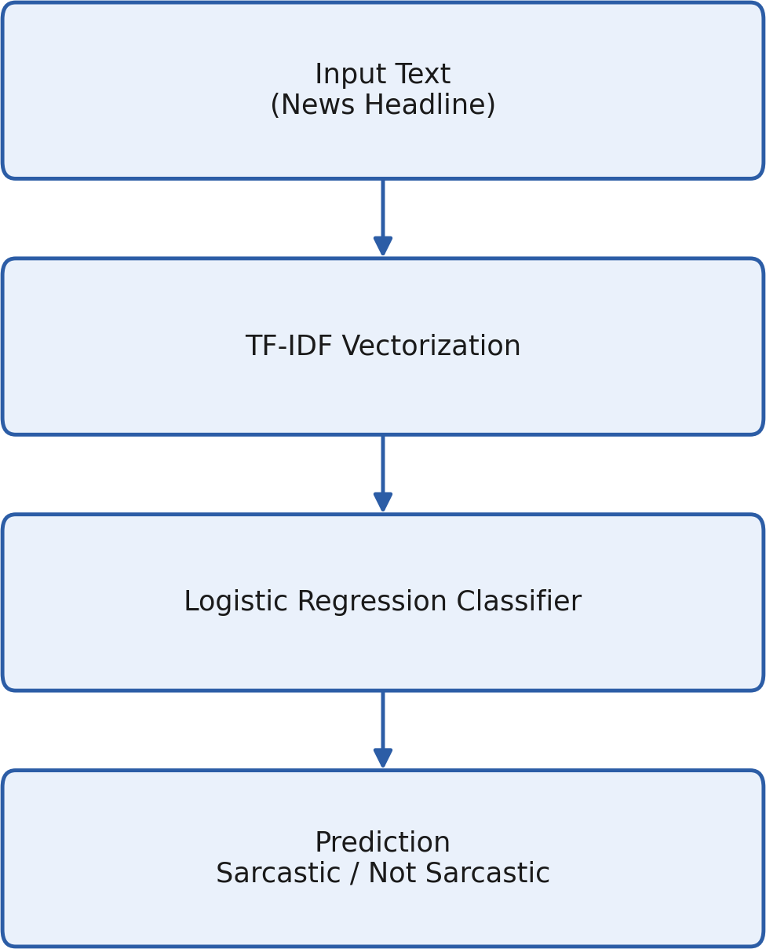

Figure 1: TF-IDF + Logistic Regression baseline pipeline.

This baseline is simple and computationally inexpensive, but it treats words largely as independent features and does not capture word order, context, or long-range relationships between words in a sentence.

Main Model — RoBERTa
RoBERTa (Robustly Optimized BERT Pretraining Approach) is a pretrained transformer-based language model built on the same underlying architecture as BERT, but trained with an improved and more extensive pretraining procedure. RoBERTa is pretrained on large amounts of text to learn general-purpose language representations, which can then be fine-tuned for a specific downstream task — in this case, binary sarcasm classification. In this project, the RoBERTa-base variant was used, and a classification layer was added on top of it to output a sarcastic / not-sarcastic prediction.

RoBERTa Architecture
The overall flow of the RoBERTa-based classifier, from raw input text to the final sarcasm prediction, is illustrated below.

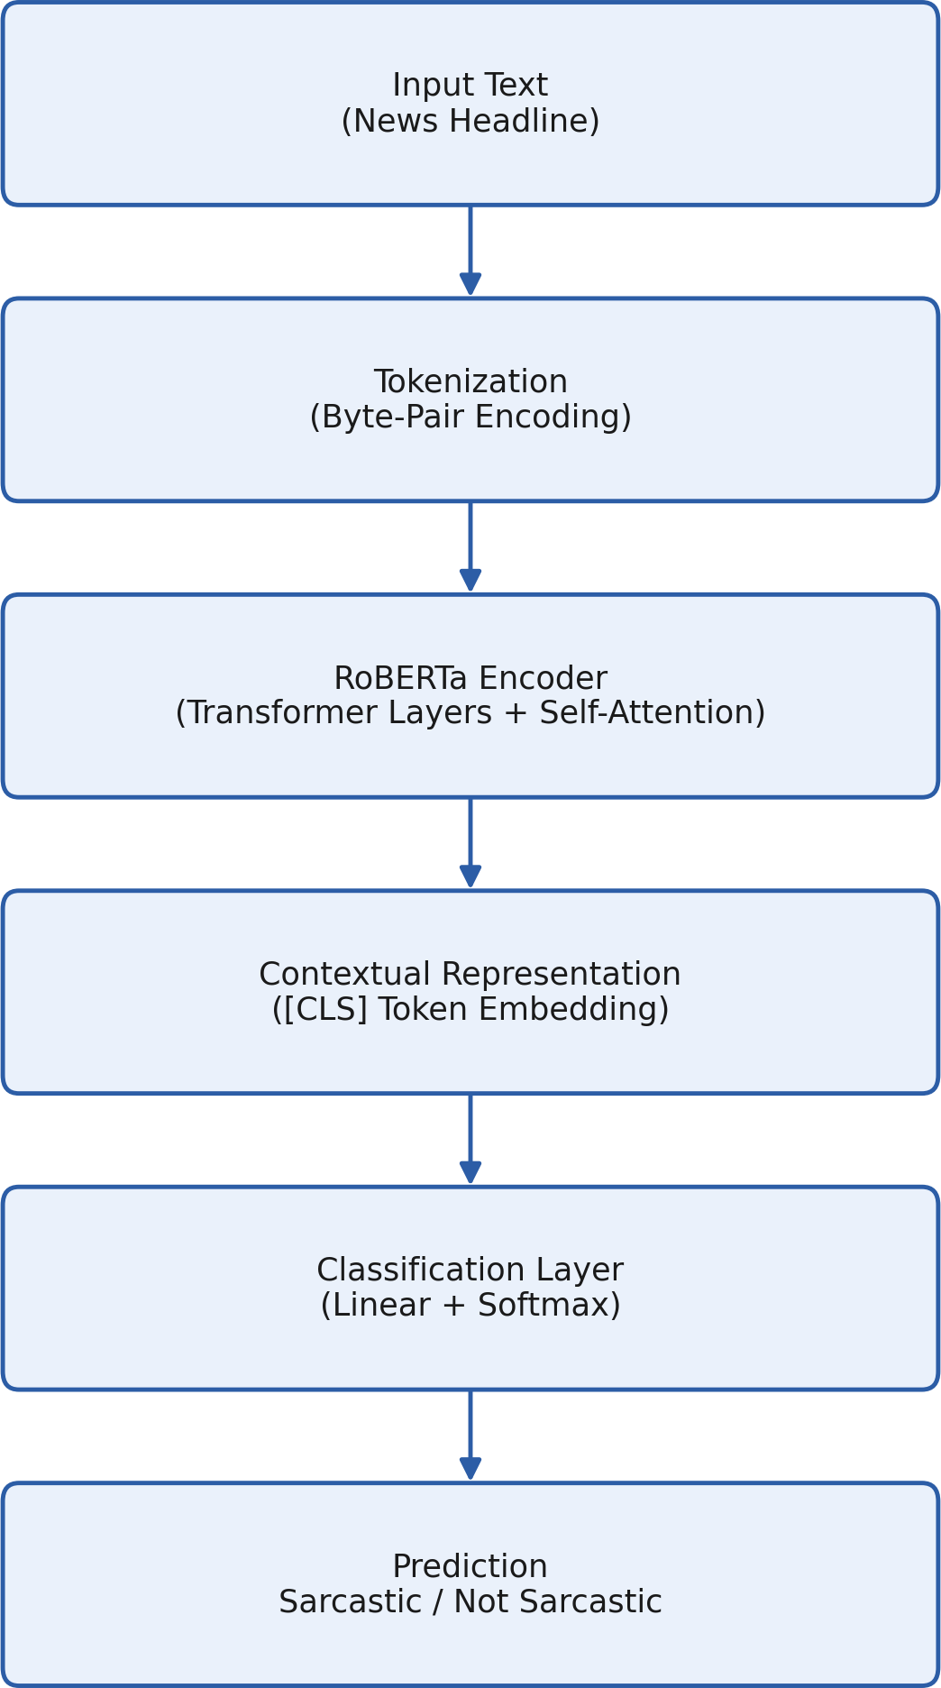

Figure 2: Simplified RoBERTa architecture used for sarcasm classification.

Tokenization
The input headline is first broken down into smaller sub-word units, called tokens, using a Byte-Pair Encoding (BPE) tokenizer. This allows the model to handle rare words and unfamiliar word forms by splitting them into smaller, previously seen sub-word pieces.

Transformer Encoder
The tokens are passed through a stack of transformer encoder layers. Each layer processes the entire sequence of tokens together, rather than one word at a time, allowing the model to build up a rich understanding of how words in the sentence relate to one another.

Self-Attention
Inside each transformer layer, a mechanism called self-attention allows every token to look at every other token in the sentence and determine how relevant they are to each other. This helps the model capture relationships between distant words, which is important for understanding sarcasm, where the sarcastic cue may appear far from the word or phrase it relates to.

Contextual Representation
After passing through the encoder layers, each token has a contextual representation, meaning its numeric representation depends on the surrounding words rather than being fixed. The representation of a special summary token is typically used to represent the meaning of the entire headline.

Classification Layer
This summary representation is passed through a simple linear classification layer, which produces a score for each of the two output classes. A softmax function converts these scores into probabilities.

Final Prediction
The class with the higher probability is selected as the model's final prediction: 0 = Not Sarcastic or 1 = Sarcastic.

Working of RoBERTa in This Project
In this project, each cleaned news headline is tokenized and passed through the pretrained RoBERTa-base encoder, with a classification head added on top. During fine-tuning, the model's parameters are adjusted using the labelled training data so that the classification layer learns to distinguish sarcastic headlines from non-sarcastic ones, using the contextual representations produced by the encoder.

Training Procedure
The RoBERTa model was fine-tuned on the 6,000-sample training subset using the configuration listed in Section 8 (Experimental Setup). Training was performed for a single epoch, using a learning rate of 2
× 10 with weight decay of 0.01, and a fixed random seed of 42 to keep the experiment reproducible. After training, the model was evaluated on a held-out test set that was not used during training.

Performance Evaluation
The models were evaluated using standard classification metrics: Accuracy, Precision, Recall, Macro-F1 score, and ROC-AUC (Area Under the Receiver Operating Characteristic Curve). Macro-F1 averages the F1-score across both classes equally, which is useful for checking that the model performs well on both the sarcastic and non-sarcastic classes rather than favouring one.

Results and Model Comparison
The overall test-set performance of both models is summarised in Table 2.

Model | Accuracy | Precision | Recall | Macro-F1 | ROC-AUC
TF-IDF + Logistic Regression | 77.13% | — | — | 77.13% | 85.81%
RoBERTa | 81.06% | 81.15% | 80.87% | 80.94% | 89.51%
Table 2: Overall test-set comparison between the baseline and RoBERTa.

RoBERTa outperformed the TF-IDF + Logistic Regression baseline across every metric, with the largest relative gain visible in ROC-AUC, indicating that RoBERTa is better at ranking sarcastic headlines above non-sarcastic ones across different decision thresholds.

RoBERTa Class-Wise Results

Class | Precision | Recall | F1-score | Support
Not Sarcastic | 0.80 | 0.85 | 0.82 | 2,243
Sarcastic | 0.82 | 0.77 | 0.79 | 2,033
Table 3: RoBERTa class-wise precision, recall, and F1-score on the test set.

The class-wise results show that RoBERTa is slightly better at recalling non-sarcastic headlines (0.85) than sarcastic ones (0.77), while precision is fairly balanced between the two classes (0.80 and 0.82 respectively).

Confusion Matrix Analysis
The confusion matrix below summarises RoBERTa's predictions on the test set, comparing the predicted class against the actual class for every example.

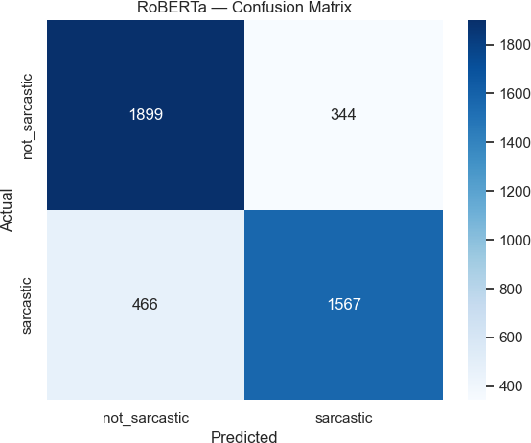

Figure 3: Confusion matrix for the RoBERTa model on the test set.

Outcome | Count | Meaning
True Negative (TN) | 1,899 | Non-sarcastic headlines correctly identified as not sarcastic.
True Positive (TP) | 1,567 | Sarcastic headlines correctly identified as sarcastic.
False Positive (FP) | 344 | Non-sarcastic headlines incorrectly predicted as sarcastic.
False Negative (FN) | 466 | Sarcastic headlines incorrectly predicted as not sarcastic.
Table 4: Interpretation of the confusion matrix outcomes.

In simple terms, the model correctly classified 3,466 out of 4,276 test headlines (1,899 true negatives plus 1,567 true positives), while it made 810 mistakes in total (344 false positives plus 466 false negatives). The number of false negatives is somewhat higher than false positives, suggesting the model is slightly more likely to miss a sarcastic headline than to mistakenly flag a genuine headline as sarcastic.

ROC Curve
The Receiver Operating Characteristic (ROC) curve plots the true positive rate against the false positive rate at different classification thresholds, and provides a threshold-independent view of model performance.

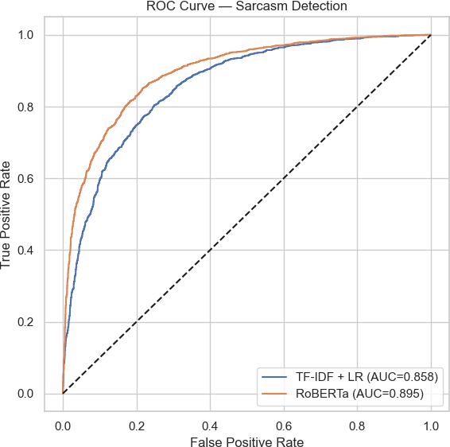

Figure 4: ROC curves for the baseline and RoBERTa models.

The ROC curve confirms the results in Table 2: the RoBERTa curve lies consistently above the TF-IDF
+ Logistic Regression curve, and its AUC of 0.895 is higher than the baseline's AUC of 0.858, meaning RoBERTa separates the two classes more effectively overall.

Error Analysis
The false positives and false negatives produced by RoBERTa were examined to better understand where the model struggles.
- False Positives are non-sarcastic headlines that the model incorrectly classified as sarcastic. These often occur when a genuine headline uses phrasing, wordplay, or an unusual structure that resembles the style of sarcastic headlines.
- False Negatives are sarcastic headlines that the model incorrectly classified as non-sarcastic. These often occur when the sarcasm is subtle, relies on missing context, or is expressed indirectly rather than through clearly ironic wording.
Overall, sarcasm detection remains a difficult task because some headlines have ambiguous wording, indirect meaning, or limited contextual information, which can make the intended tone hard to infer from the text alone — even for a strong pretrained model such as RoBERTa.

Strengths of RoBERTa
Provides better contextual understanding of text compared to TF-IDF, which treats words largely as independent features.
- Captures relationships between words across a sentence through self-attention, rather than relying on isolated word frequencies.
- Performed better than the TF-IDF + Logistic Regression baseline across every evaluation metric in this experiment.
- Well suited to context-dependent tasks such as sarcasm detection, where meaning often depends on how words relate to one another rather than the words themselves.

Limitations
- RoBERTa requires substantially more computational resources than a lightweight model such as TF-IDF + Logistic Regression.
- Training time for RoBERTa is considerably higher than training the baseline model.
- Only 6,000 training samples were used in this experiment, out of the roughly 28,619 available in the full dataset.
- The model was fine-tuned for only one epoch, which limits how much it could learn from the training data.
- Sarcasm can be ambiguous even for human readers, which places a natural ceiling on achievable accuracy.
- The dataset consists only of labelled examples from a specific domain (news headlines), so performance may not directly generalise to other types of text.

Suggestions for Improvement
The following are proposed as future improvements and were not implemented as part of this experiment:
- Train on the complete dataset of approximately 28,619 headlines rather than the 6,000-sample subset used here.
- Use more training epochs to allow the model to learn more thoroughly from the data.
- Tune the learning rate and batch size to search for a more optimal training configuration.
- Use larger and more diverse sarcasm datasets covering multiple text domains.
- Add more difficult, context-dependent examples to better challenge and evaluate the model.
- Perform systematic hyperparameter tuning to improve overall performance.

Additional Qualitative Analysis
Beyond the core evaluation metrics, the project also includes several supporting analyses: a confusion matrix and ROC curve (presented in Section 16), examples of correct predictions, examples of

false-positive and false-negative predictions, and predictions on a small set of custom, hand-written sentences to qualitatively probe the model's behaviour.
As a secondary, exploratory analysis, Amazon Unlocked Mobile Reviews were examined to observe how the model behaves on text from a different domain. Since this dataset does not contain sarcasm labels, this analysis is strictly qualitative and no sarcasm accuracy, precision, recall, or F1-score was computed for it. It is not a focus of this report and is mentioned only as a supporting, exploratory observation.
A pretrained sentiment analysis model and emotion analysis model were also used on a small number of selected examples to explore the idea of sentiment incongruence — that is, whether positive-sounding wording combined with a negative predicted emotion could serve as an additional signal for sarcasm. This analysis is exploratory in nature: it does not itself perform sarcasm classification and its outputs are not treated as ground-truth sarcasm labels.

Conclusion
This project successfully demonstrates a simple, end-to-end deep-learning workflow for sarcasm detection on news headlines. A RoBERTa-base model was fine-tuned for binary sarcasm classification and compared against a TF-IDF with Logistic Regression baseline. RoBERTa achieved 81.06% accuracy, 80.94% Macro-F1, and 89.51% ROC-AUC on the test set, outperforming the baseline model across all measured metrics.
These results indicate that RoBERTa's ability to build contextual representations of text provides a meaningful advantage over traditional bag-of-words approaches for sarcasm detection. At the same time, the error analysis shows that sarcasm remains a genuinely challenging problem, since a headline's literal wording and its intended meaning can differ in ways that are subtle even for a strong pretrained language model. With a larger training subset, more training epochs, and careful hyperparameter tuning, further gains in performance would be expected.
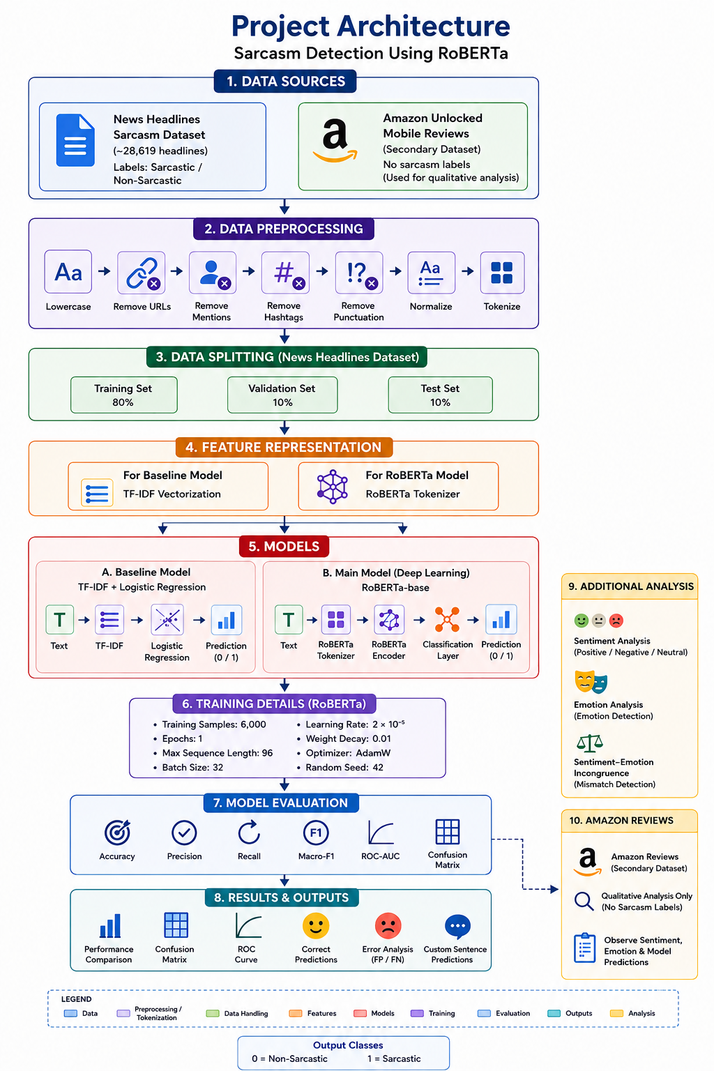

References
- Liu, Y., Ott, M., Goyal, N., Du, J., Joshi, M., Chen, D., Levy, O., Lewis, M., Zettlemoyer, L., & Stoyanov, V. (2019). RoBERTa: A Robustly Optimized BERT Pretraining Approach. arXiv preprint arXiv:1907.11692.
- Misra, R., & Arora, P. (2019). Sarcasm Detection using News Headlines Dataset. News Headlines Dataset for Sarcasm Detection.
- Pedregosa, F., et al. (2011). Scikit-learn: Machine Learning in Python. Journal of Machine Learning Research, 12, 2825–2830.
- Wolf, T., et al. (2020). Transformers: State-of-the-Art Natural Language Processing. Hugging Face / Transformers Library Documentation.
- Amazon Unlocked Mobile Reviews Dataset (secondary, exploratory cross-domain data source).

