SecureChat – Client and Server
Justin Rushin III
CS 1699 – FINAL DELIVERABLE
For this project I decided to test SecureChat – both the client and server. It's a chat appliation with encryption (although I did also test the unecrypted sample implementation) that I worked on for an algorithms class.
The encryption feature can use either an additive bit key or a substitution key – both are symmetric ciphers. The server is supposed to support up to 30 clients. Only the additive key functionality was tested.
For my tests, I decided to focus on performance and security. Performance was evaluated for encryption, server load handling, and response times. Security was evaluated for network security against sniffing type attacks.
Three new tests classes were added to test/
Add128PerfTest.java – working – generated logs uploaded
Add128SecTest.java – not working
SecureChatClientPerfTest.java – working – generated logs uploaded

Test Plan with Results
- Performance Testing
  - Response Time Testing - SecureChatClientPerfTest.java

    - Uses several util methods to test the amount of time it takes for:

      - Client to send the already encrypted message to the server.

      - Time for the server to receive, decrypt, process, re-encrypt, and send the message back to the sender.

      - Time for the client to acknowledge but not decrypt the message.

    - Hereafter referred to as the "response time."

    - The setup used to acheive this testing was as follows:

    - All instances of the client were run on my laptop: an Acer TimelineU M5 running Ubuntu 14.04 64 bit. Java 1.6 is used as this project was developed to meet Pitt unix server specs.

    - For these tests the server is running on a desktop workstation on my home network.

    - Each test is an averaging of 50 trials.
      - .responseTime50_wrapper()

        - Tests the response time of the network server vs a copy of the server running on localhost (laptop)

      - .responseTime50_load20()

        - Same as above, but creates 20 (vs server limit of 30) clients running on the laptop PER each server (40 + 2 sending messages total) and measures response time.

Response Time Results: Network Server LocalHost Server
Load Test: 16.98ms 9.505ms
Non Load Test: 18.09ms 7.501ms
See *resptimeLog.txt files for logs of these tests.

  - Memory Testing – Secure Chat Server
    - I observed the effects of the above load testing on the server on the network machine (not my laptop, the desktop workstation).
    - Connecting 25 clients from my laptop to the network server didn't produce any significant effects on used memore (blue line here) or cpu usage (red line here).
    - Interesting, when all the clients disconnect at once, CPU usages spikes. This was not something I anticpiated but it makes sense, essentially the server is bombarded with new data.
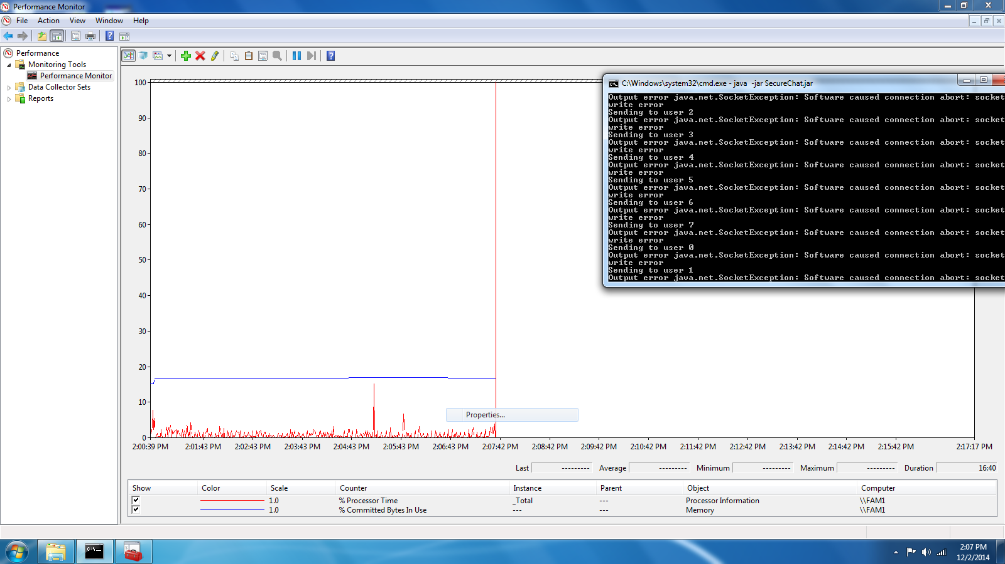
- Security Testing
  - Brute Force Keys of varying lengths and find – test/Add128SecTest.java
    - Not successfully implemented, no test data generated.
  - Tested ChatClient and ChatServer – WireShark attack
    - Client – another laptop
    - ChatServer -desktop
    - Attacker – my acer laptop
    - All three connected to my home wireless network.
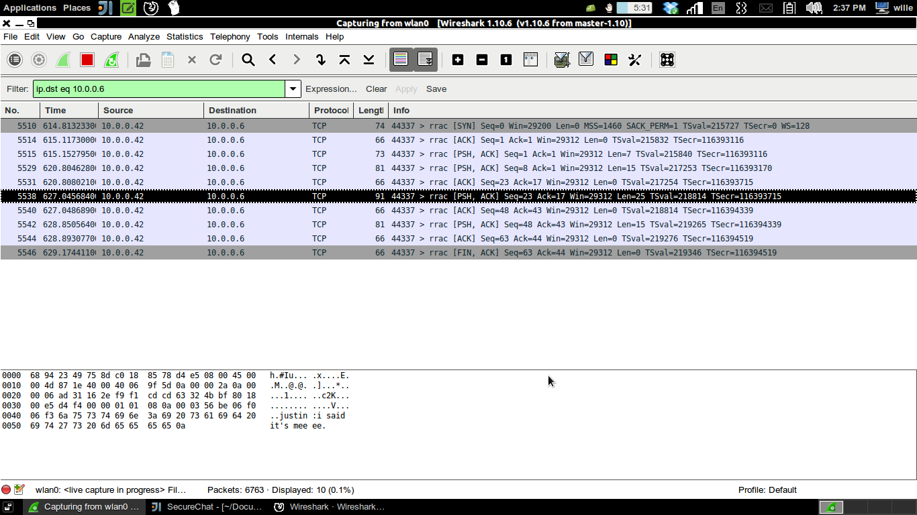
      - At first it was difficult to sniff packets between the two. I tried running in permiscuous mode with my laptop in 'network' wifi mode. No luck. I could only sniff from my own laptop if I operated the client.
          - See screen1.png
        - With several hours of learning wireshark, I was able to put my laptop in monitor mode and decrypt the wireless packets between client and server.
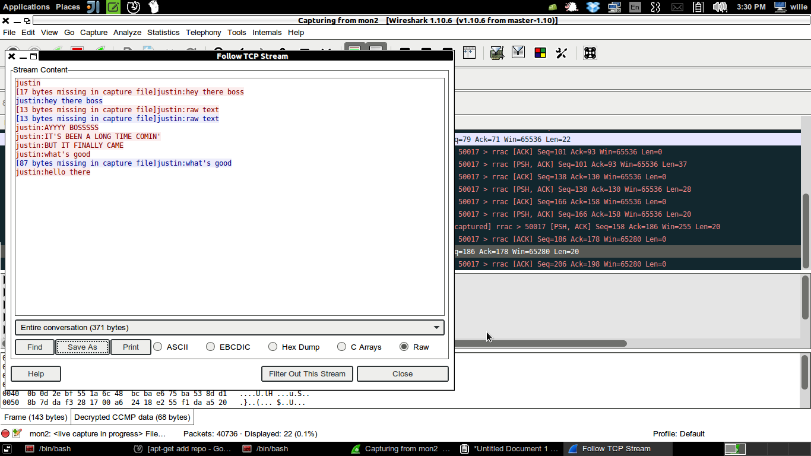
          - See screen2.png
          - See screen3client.jpg
          - Fairly conclusive proof that our client and server are only as secure as our encryption – and possibly less. Nothing I didn't anticipate already, but it was interesting to learn to pull the packets myself.
- 128 Bit Additive Encryption Performance testing - test/Add128PerfTest.java
  - See *PerfLog.txt for log of this test.
  - Performs multiple trials of timing for encrypting and decrypting with keys of various lengths and additionally creating the encryption keys.
  - Findings:
    - For additive byte encryption, key length doesn't make a lot of difference to the operation time of encrypting or decrypting a string of text .
    - Key length makes a large difference when generating the random keys.
      - If users don't mind a longer startup time, messages could be made more secure.

Changes Made to Original Program
- Made Add128 able to use different key lengths.
- Added accessor methods to the SecureChatClient.java for junit testing.

Evaluation
Performance
Overall, the client and server operate quite well. The original max number of clients is 30 – the server easily handled 27 concurrently. If this were used say, as a chat in a small to mid size office, I would be confident we're meeting the requirement. My laptop was easily able to run 42 instances of the client at once – with my IDE open. Performance is good, and we could easily afford to beef up encryption by several bits if clients don't mind a longer login time.
Security
Security wise, the application is lacking. Even though I was unable to perfrom the brute force testing of keys, the application is sending every message to every client. This means that if even one client is connected wirelessly to a compromised wireless network, the attacker gains access to every chat message. With a few hours of learning it was possible for someone with very little penetration testing experience to pull the data out of the air. I would recommend more encryption testing be done and the program design should be considered to see if a client could receive an acknowledgement of its message rather than each message it sends sent back to it. The program uses a one-time-pad encryption scheme essentially, which is not bad, but the attacker can capture all the packets and save them for later. I didn't even consider trying to attack the original RSA handshake, but this should probably be investigated too.
In the mean time, if the program designers were concerned about security, I would recommend increasing the default key size at the expense of performance, because the performance half of the program is free of problems. The project is working and the security features are active so I see no impediment to release, rather, room for improvement.

