BRACT’s
Vishwakarma Institute of Technology, Pune
Practical Implementation Sheet
Department: CSE-AI Semester: 5 Academic Year: 2026-27
Division: E Batch: 2 Practical No: 6
Roll no: 34 PRN No: 12412924 Name of Student: Rushikesh Subhash Rathod
Subject Name : Deep Learning

EXPERIMENT NO. 6
TITLE:
Design and Implementation of CNN for Apple Leaf Disease Classification

AIM:
To design and implement a Convolutional Neural Network (CNN) using TensorFlow for classification of apple leaf diseases.

DATASET:
Apple Leaf Disease Dataset
The dataset contains images of different apple leaf conditions such as:
1. Apple Scab
2. Apple Black Rot
3. Apple Cedar Apple Rust
4. Healthy Apple Leaf

PROCEDURE:
1. Load the Apple Leaf Disease dataset using TensorFlow.
2. Resize the images to 128 × 128 pixels.
3. Split the dataset into training and validation sets.
4. Use TensorFlow AUTOTUNE for efficient data loading.
5. Apply data augmentation to the training images.
6. Build a CNN using Conv2D, MaxPooling2D, Flatten and Dense layers.
7. Use KerasTuner RandomSearch for automatic hyperparameter tuning.
8. Train the best selected CNN model.
9. Evaluate the model using accuracy and loss.
10. Predict the disease class for a new apple leaf image.

AUTOTUNE CODE:
AUTOTUNE = tf.data.AUTOTUNE

train_ds = train_ds.cache().shuffle(1000).prefetch(
buffer_size=AUTOTUNE
)

val_ds = val_ds.cache().prefetch(
buffer_size=AUTOTUNE
)
Explanation
tf.data.AUTOTUNE automatically determines an efficient value for the data pipeline.
It improves:
- Data loading
- CPU/GPU utilization
- Training performance

CNN ARCHITECTURE:
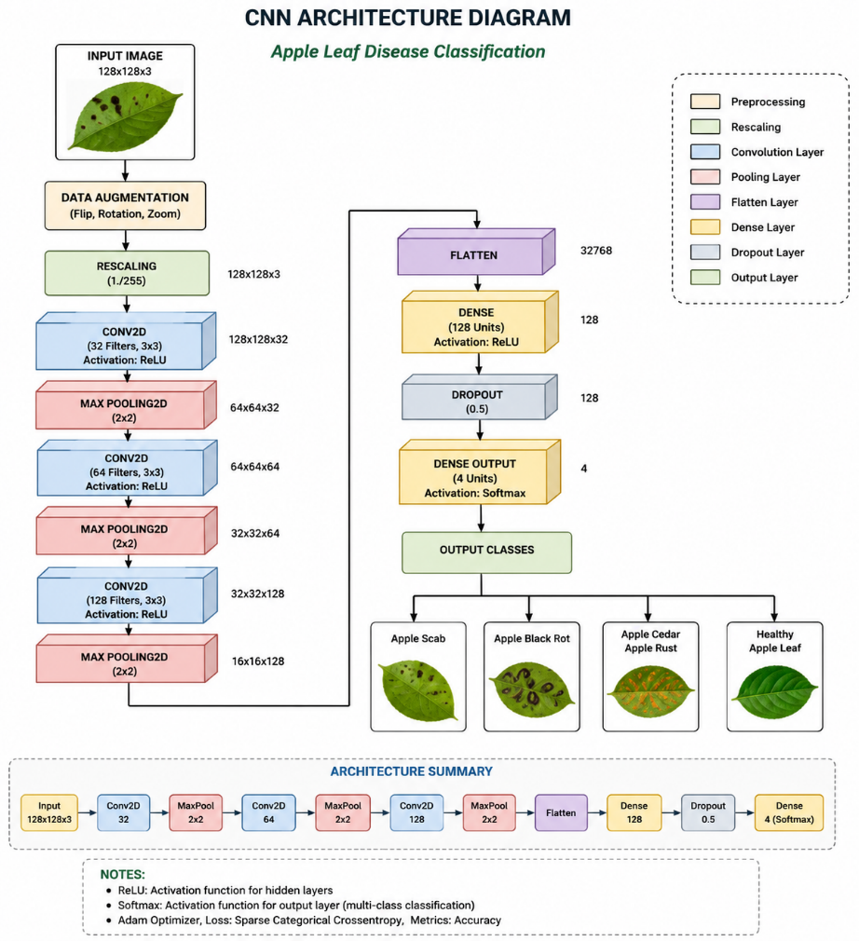

Screenshort Of Code And result
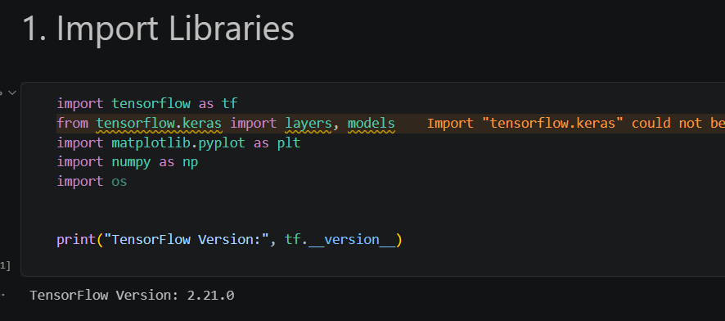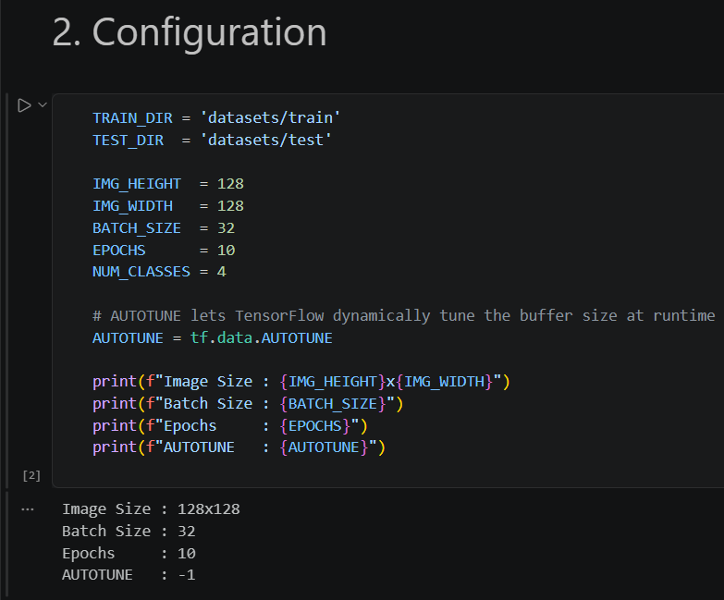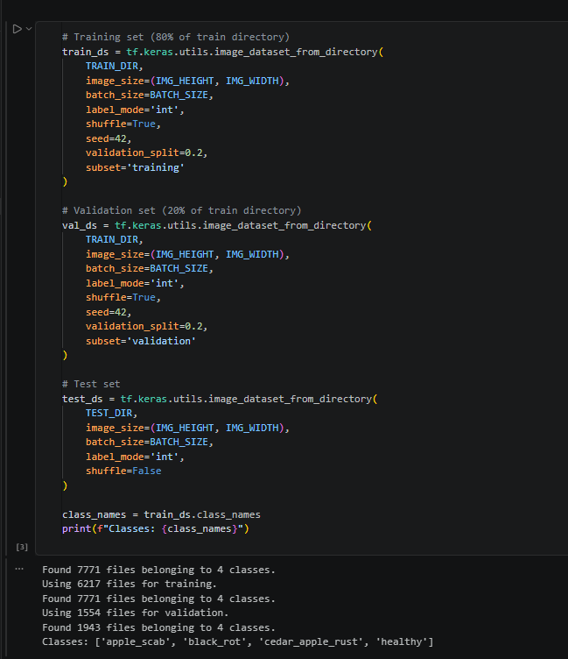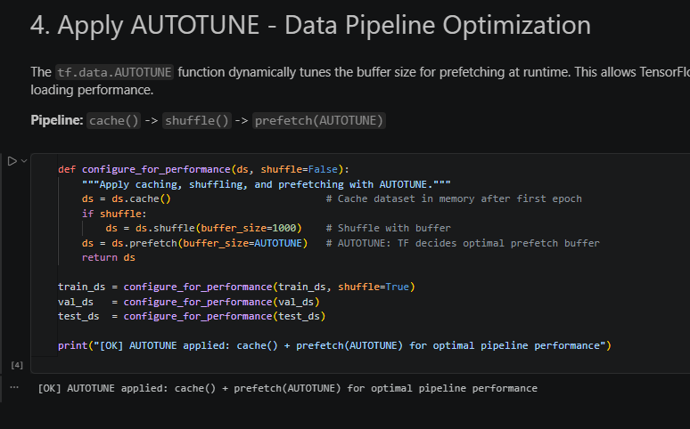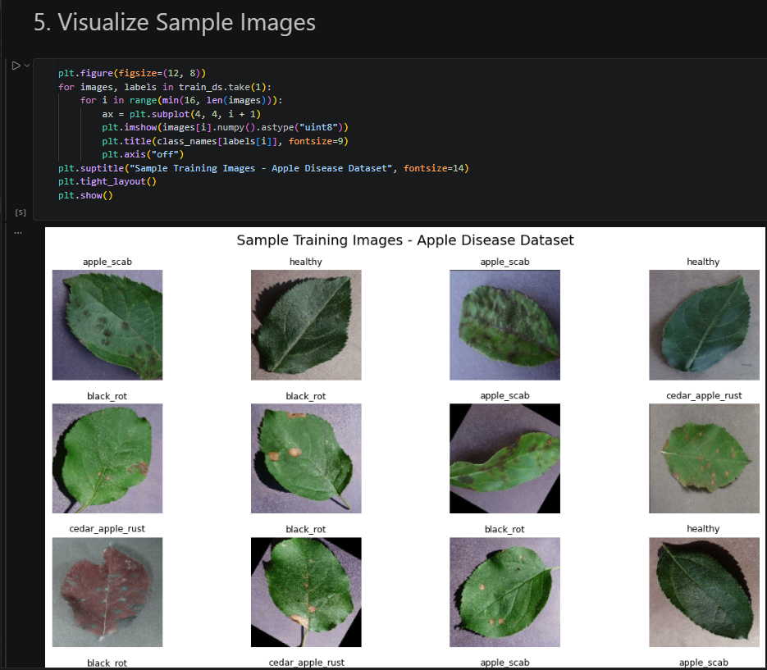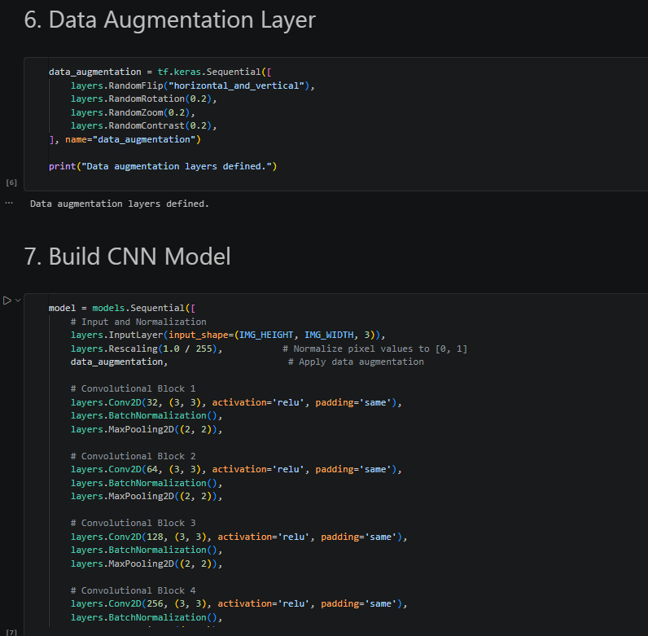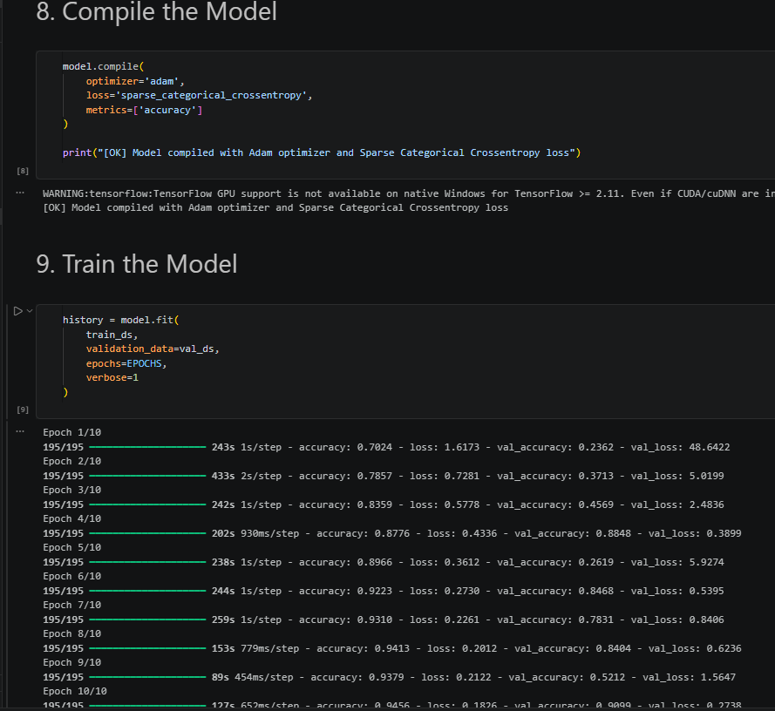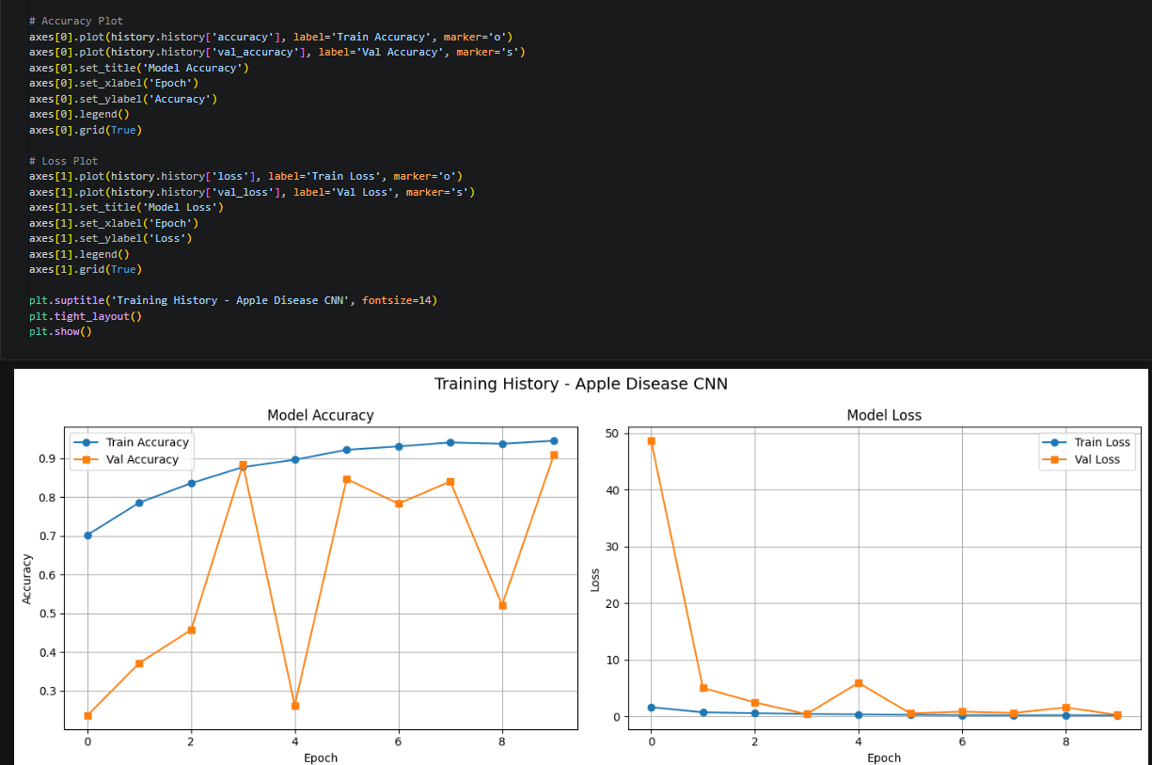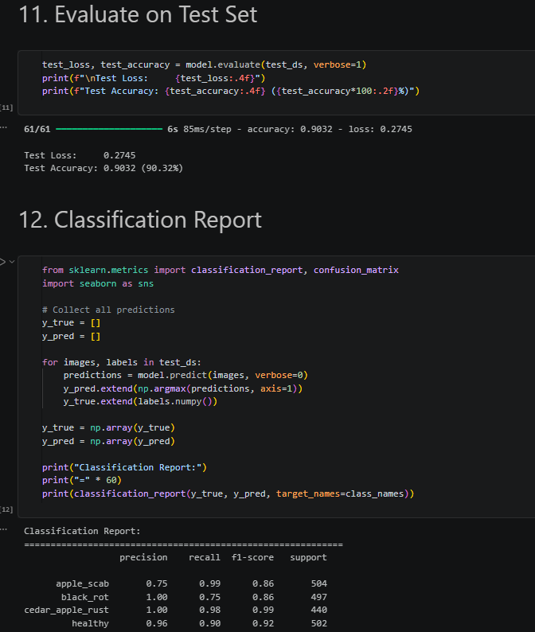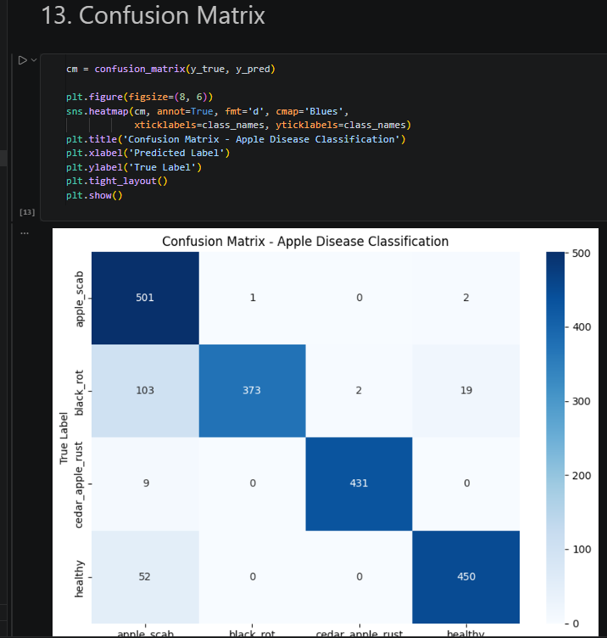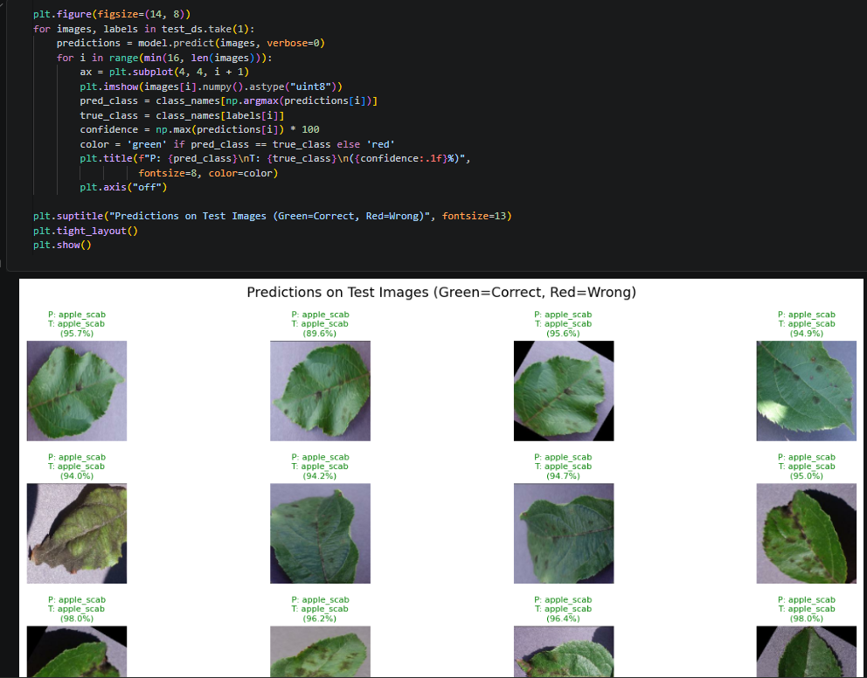
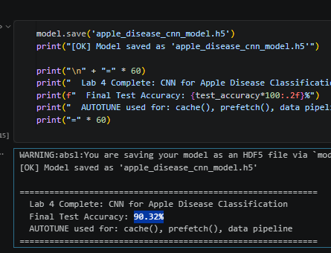
RESULT:
The CNN model was successfully implemented using TensorFlow for Apple Leaf Disease Classification. TensorFlow AUTOTUNE was used for efficient data loading and KerasTuner was used for automatic hyperparameter tuning.
Accuracy: 90.32%

CONCLUSION:
The CNN model successfully classified apple leaf images into their respective disease categories. AUTOTUNE improved the data pipeline efficiency, while KerasTuner helped in selecting suitable hyperparameters for the model.

