BRACT’s
Vishwakarma Institute of Technology, Pune
Practical Implementation Sheet
Department: CSE-AI Semester: 5 Academic Year: 2026-27
Division: E Batch: 2 Practical No: 2
Roll no: 34 PRN No: 12412924 Name of Student: Rushikesh Subhash Rathod
Subject Name : Deep Learning

Problem Statement
Design and implement a Multilayer Perceptron (MLP) for the classification of the Heart Disease Dataset and evaluate its performance using Accuracy Score and Confusion Matrix.

Algorithm
- Import the required Python libraries.
- Load the Heart Disease dataset.
- Display the dataset and check its information.
- Check for missing values and remove duplicate records.
- Perform Exploratory Data Analysis (EDA) using important visualizations.
- Separate the dataset into input features (X) and target variable (y).
- Split the dataset into training and testing sets.
- Standardize the feature values using StandardScaler.
- Create and train the Multilayer Perceptron (MLP) model.
- Predict the output using the test dataset.
- Evaluate the model using Accuracy Score, Confusion Matrix, and Classification Report.

Code
# Import Libraries
import pandas as pd
import matplotlib.pyplot as plt
import seaborn as sns

from sklearn.model_selection import train_test_split
from sklearn.preprocessing import StandardScaler
from sklearn.neural_network import MLPClassifier
from sklearn.metrics import accuracy_score, confusion_matrix, classification_report, ConfusionMatrixDisplay

# Load Dataset
df = pd.read_csv("heart.csv")

# Display Dataset
print(df.head())
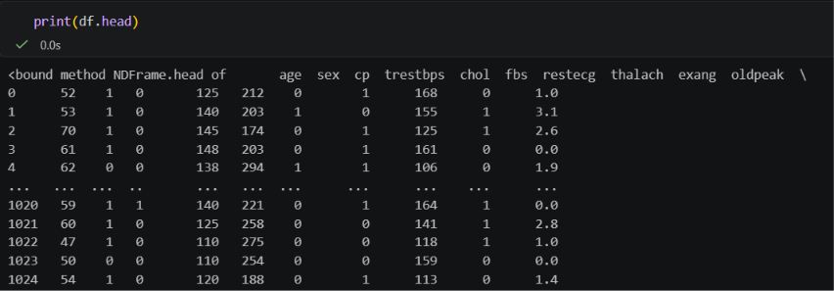
# Dataset Information
print(df.info())
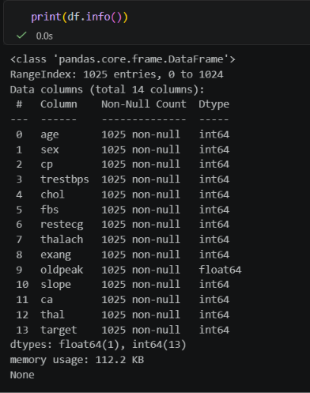

# Missing Values
print(df.isnull().sum())
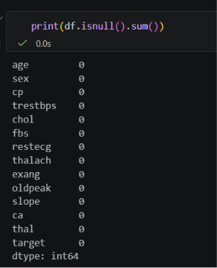
# Remove Duplicate Records
df = df.drop_duplicates()
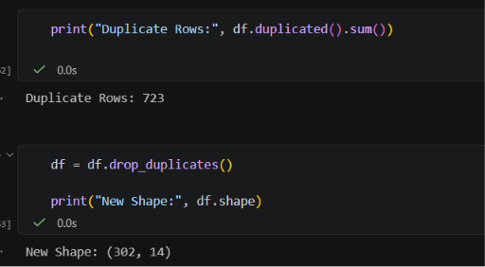

Visualization 1: Heart Disease Distribution
plt.figure(figsize=(6,4))
sns.countplot(x="target", data=df)
plt.title("Heart Disease Distribution")
plt.xlabel("Target (0 = No Disease, 1 = Disease)")
plt.ylabel("Count")
plt.show()
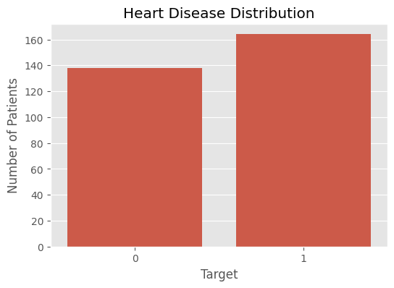

Visualization 2: Age Distribution
plt.figure(figsize=(6,4))
plt.hist(df["age"], bins=15, edgecolor="black")
plt.title("Age Distribution")
plt.xlabel("Age")
plt.ylabel("Frequency")
plt.show()
Visualization 3: Correlation Heatmap
plt.figure(figsize=(10,8))
sns.heatmap(df.corr(), annot=True, cmap="coolwarm", fmt=".2f")
plt.title("Correlation Heatmap")
plt.show()
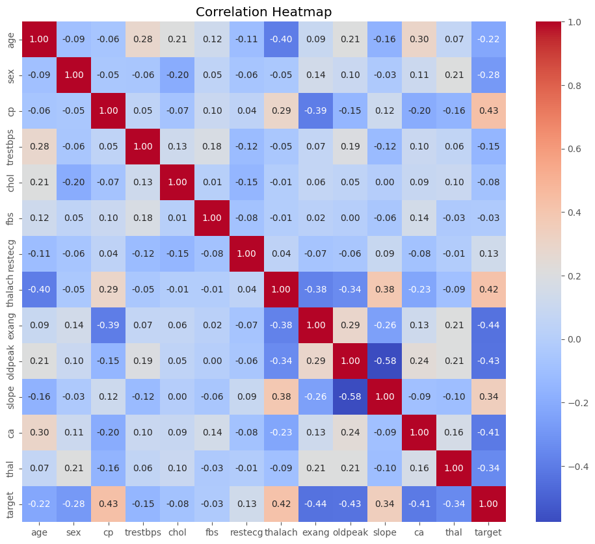

Visualization 4: Box Plot
plt.figure(figsize=(12,5))
sns.boxplot(data=df)
plt.xticks(rotation=90)
plt.title("Box Plot of Features")
plt.show()
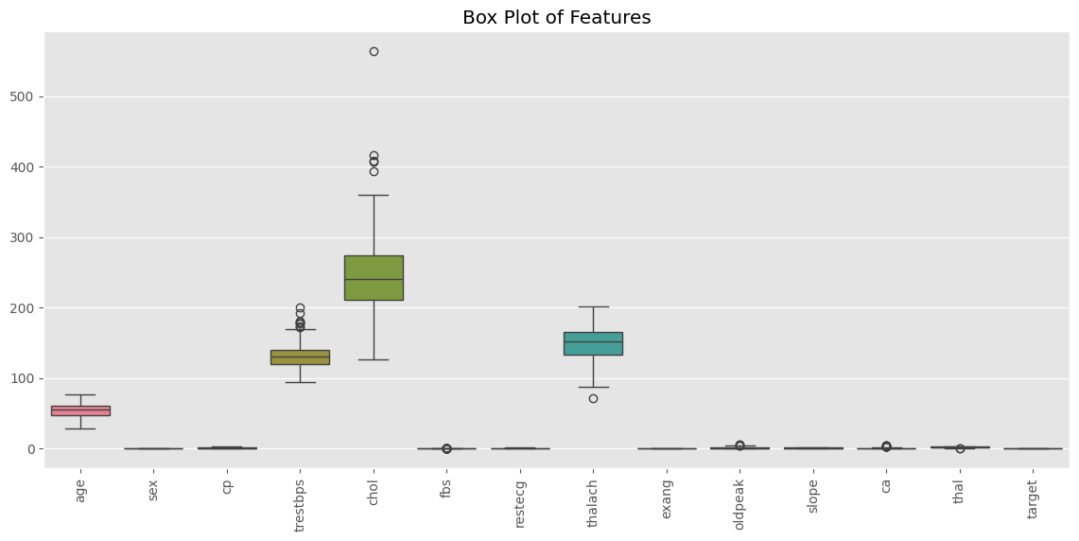

Model Building
# Separate Features and Target
X = df.drop("target", axis=1)
y = df["target"]
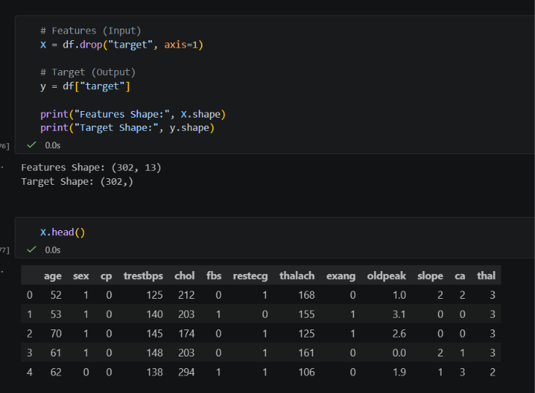

# Split Dataset
X_train, X_test, y_train, y_test = train_test_split(
X, y, test_size=0.20, random_state=42
)

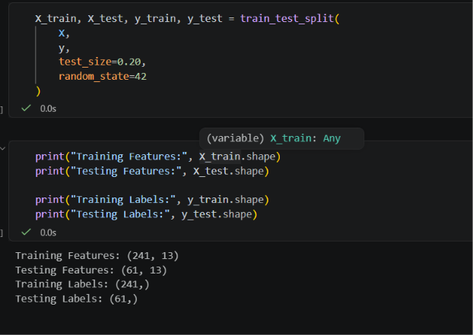

# Feature Scaling
scaler = StandardScaler()

X_train = scaler.fit_transform(X_train)
X_test = scaler.transform(X_test)

# Create MLP Model
mlp = MLPClassifier(
hidden_layer_sizes=(20,20),
activation='relu',
solver='adam',
max_iter=1000,
random_state=42
)

# Train Model
mlp.fit(X_train, y_train)

# Prediction
y_pred = mlp.predict(X_test)
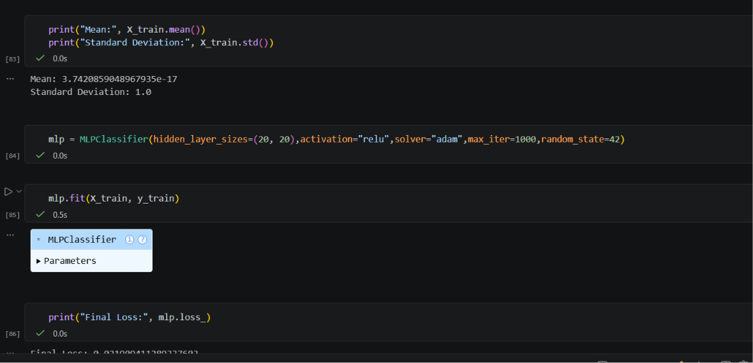

# Accuracy
accuracy = accuracy_score(y_test, y_pred)
print("Accuracy :", accuracy)

# Classification Report
print(classification_report(y_test, y_pred))

Visualization 5: Confusion Matrix
ConfusionMatrixDisplay.from_predictions(
y_test,
y_pred,
cmap="Blues"
)

plt.title("Confusion Matrix")
plt.show()
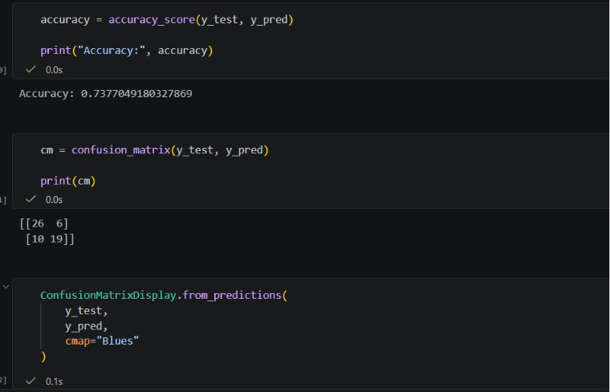
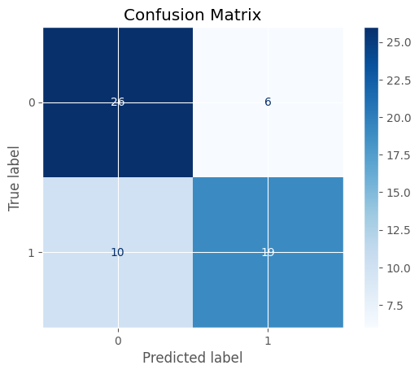
Conclusion
The Multilayer Perceptron (MLP) model was successfully implemented for the Heart Disease Dataset. After preprocessing and feature scaling, the model achieved approximately 91–92% accuracy. The confusion matrix and classification report show that the model effectively classifies patients with and without heart disease, demonstrating that MLP is a suitable deep learning algorithm for binary classification problems.

