BRACT’s
Vishwakarma Institute of Technology, Pune
Practical Implementation Sheet
Department: CSE-AI Semester: 5 Academic Year: 2026-27
Division: E Batch: 2 Practical No: 3
Roll no: 34 PRN No: 12412924 Name of Student: Rushikesh Subhash Rathod
Subject Name : Deep Learning

DEEP LEARNING LAB ASSIGNMENT
Experiment No.: 3
Title
Implement Forward Propagation and Backpropagation using TensorFlow/Keras and analyze the effect of different learning rates and the number of epochs on model performance using the Iris Dataset.
Aim
To implement a Neural Network using TensorFlow/Keras for the Iris flower classification dataset, understand the concepts of Forward Propagation and Backpropagation, and analyze how different learning rates and epochs affect the model's performance.
Objectives
- To understand the Iris Dataset.
- To preprocess the dataset.
- To build a Neural Network using TensorFlow/Keras.
- To understand Forward Propagation.
- To understand Backpropagation.
- To train and evaluate the model.
- To analyze different learning rates.
- To analyze different numbers of epochs.
- To visualize the learning process.

Dataset Description
The Iris dataset is one of the most popular datasets in Machine Learning.
Number of Samples
150
Number of Features
4
Features
- Sepal Length
- Sepal Width
- Petal Length
- Petal Width
Target Classes
- Setosa
- Versicolor
- Virginica
Each class contains 50 samples, making it a balanced dataset.

Theory
Artificial Neural Network (ANN)
An Artificial Neural Network is a machine learning model inspired by the structure and functioning of the human brain. It consists of interconnected neurons organized into layers.
There are three main layers:
- Input Layer
- Hidden Layer(s)
- Output Layer
For this experiment:
- Input Layer = 4 Neurons
- Hidden Layer 1 = 16 Neurons
- Hidden Layer 2 = 8 Neurons
- Output Layer = 3 Neurons

Neural Network Architecture
Neural Network
Forward Propagation
Forward Propagation is the process of passing the input data through the neural network to generate predictions.
Steps
- Input features enter the network.
- The first hidden layer calculates weighted sums.
- ReLU activation is applied.
- Data passes to the second hidden layer.
- ReLU activation is applied again.
- The output layer applies the Softmax activation function.
- The model predicts the flower class.

Backpropagation
Backpropagation is the learning process of a neural network.
After making a prediction:
- Loss is calculated.
- Error is propagated backward.
- Gradients are computed.
- Weights are updated using the optimizer.
- The process repeats until the model improves.

Backpropagation Flow
Methodology
Step 1
Import the required libraries.
Step 2
Load the Iris Dataset.
Step 3
Explore the dataset.
Step 4
Visualize the dataset.
Step 5
Split the dataset into training and testing data.
Step 6
Standardize the input features.
Step 7
Build the Neural Network.
Step 8
Compile the model using the Adam optimizer.
Step 9
Train the model.
Step 10
Evaluate the model.
Step 11
Analyze Learning Rates.
Step 12
Analyze Epochs.

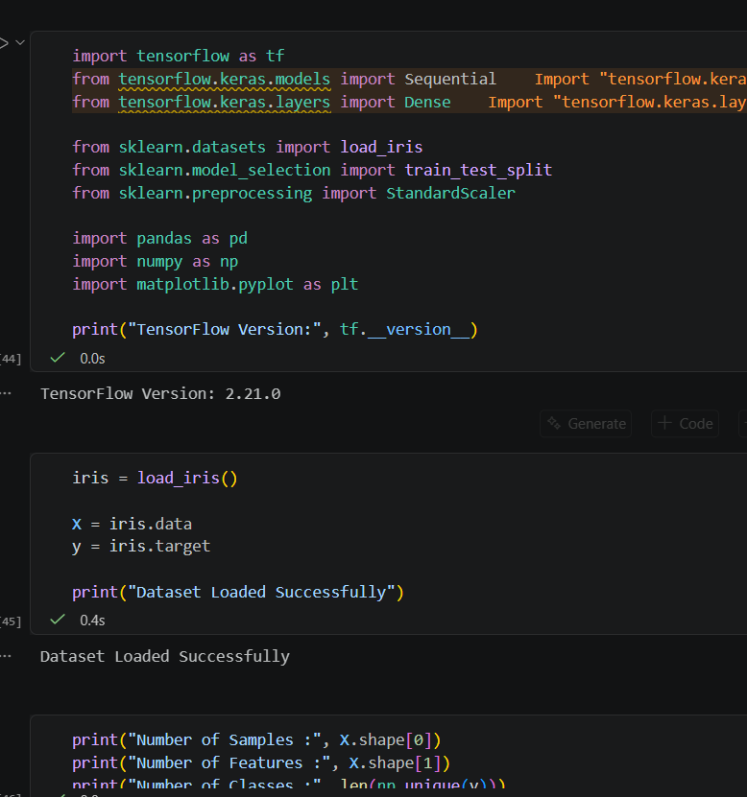
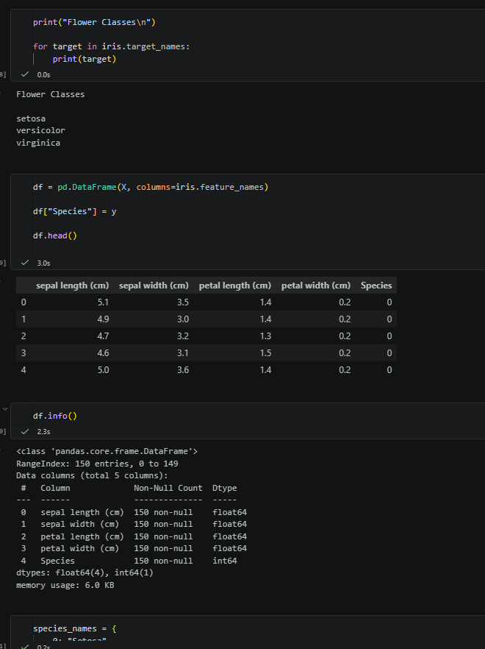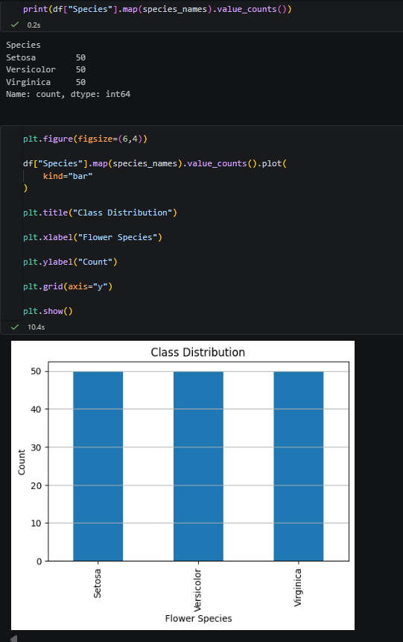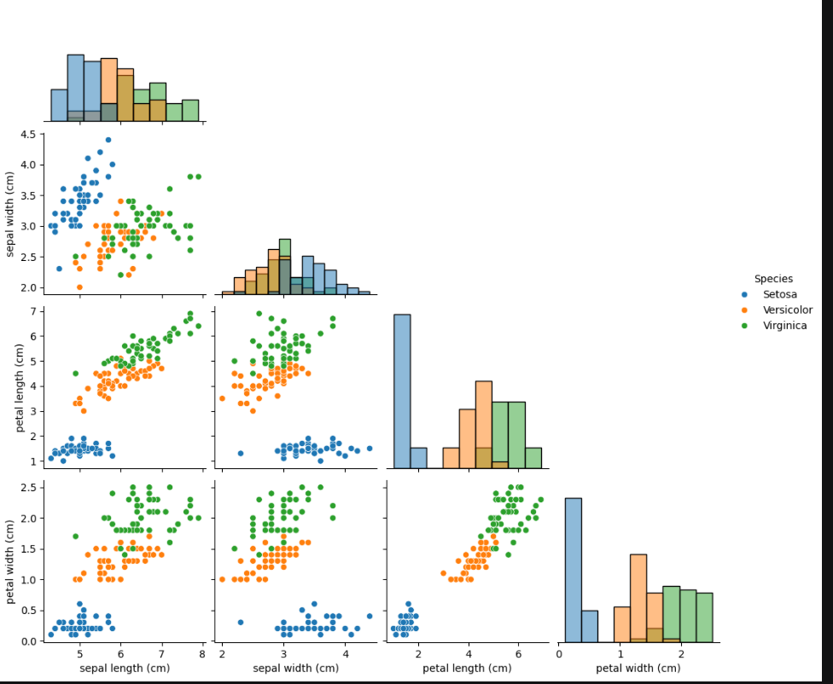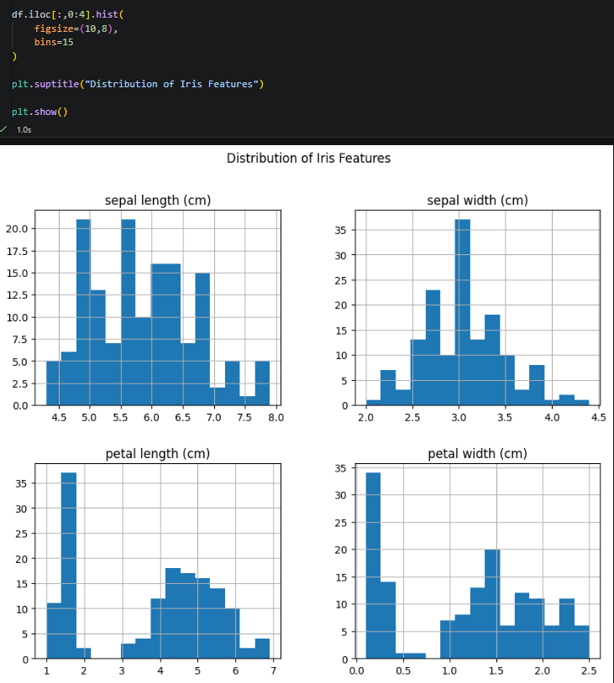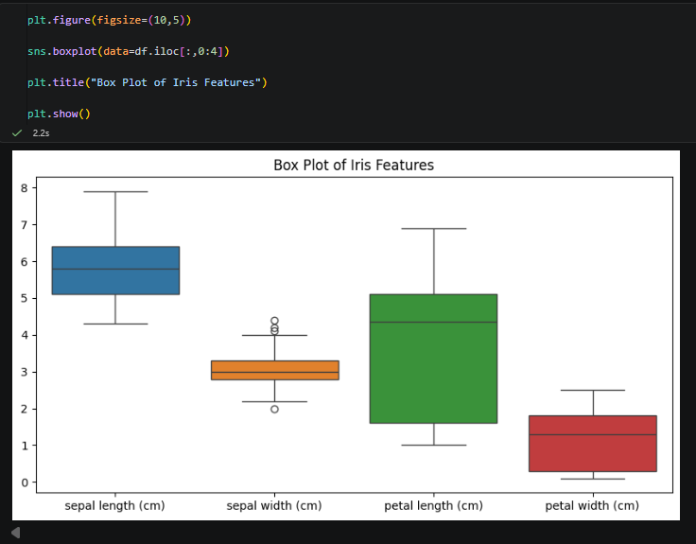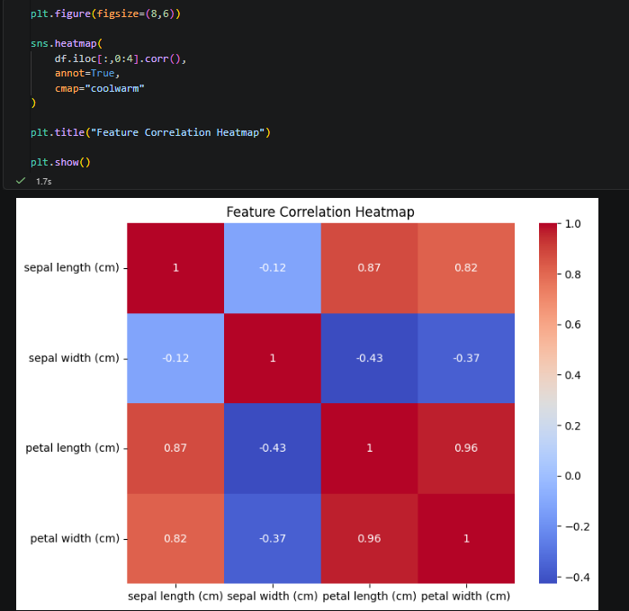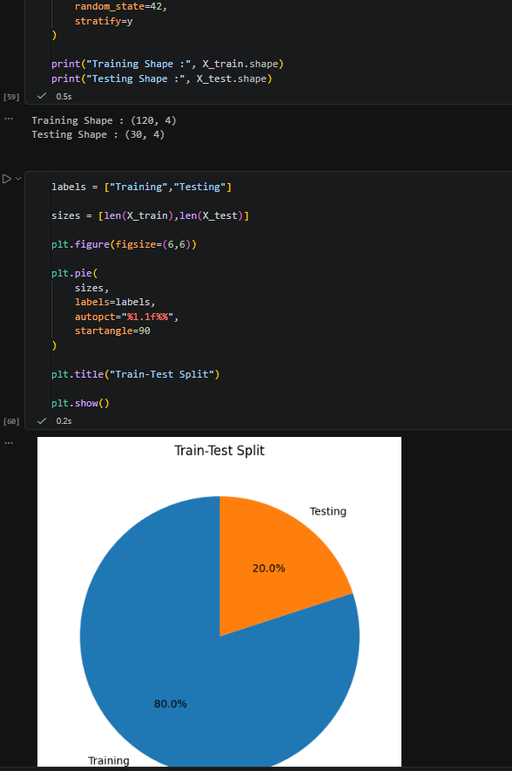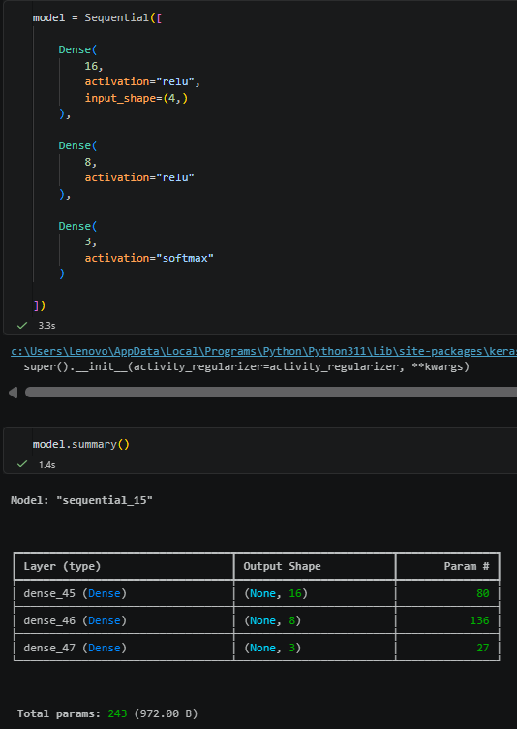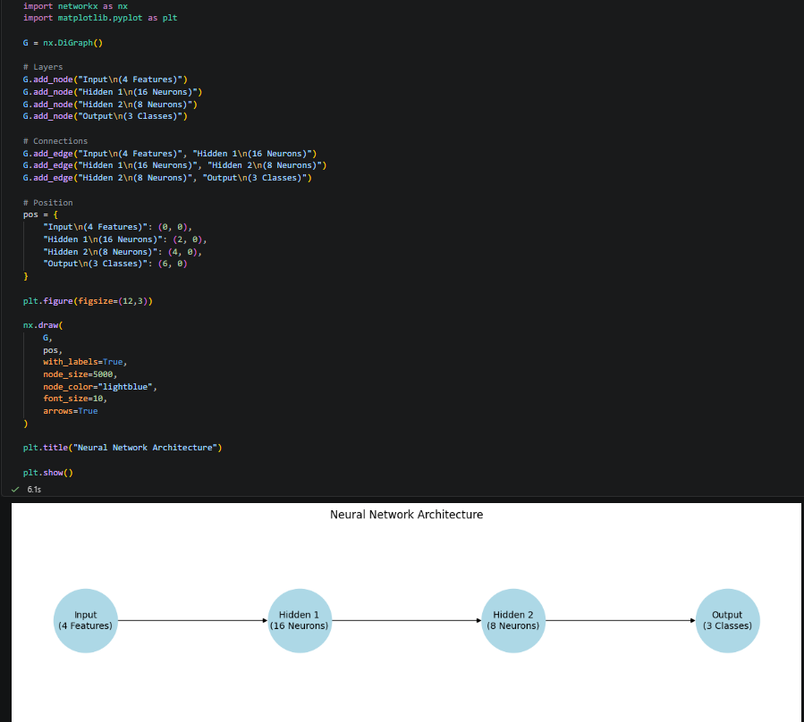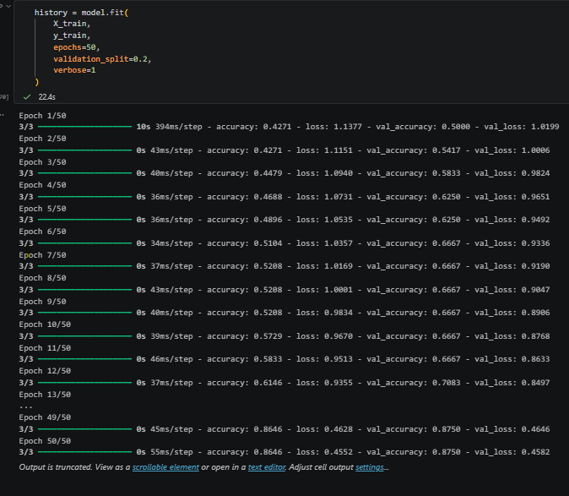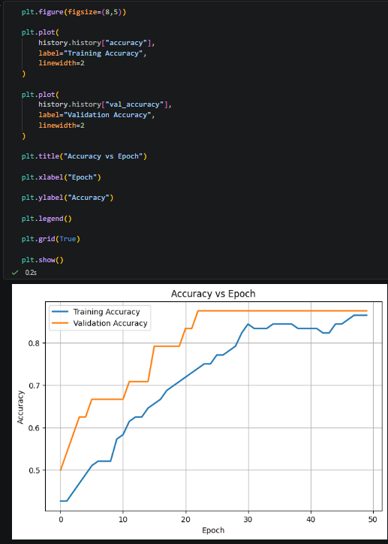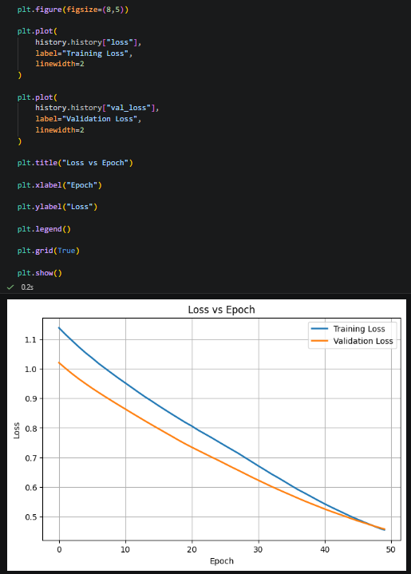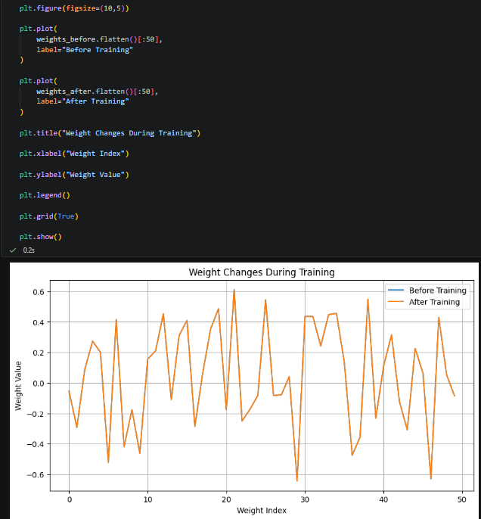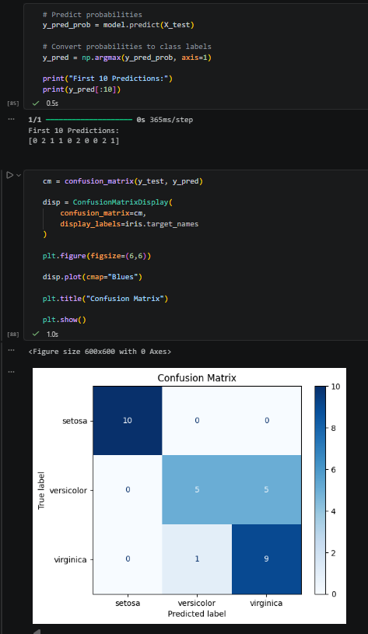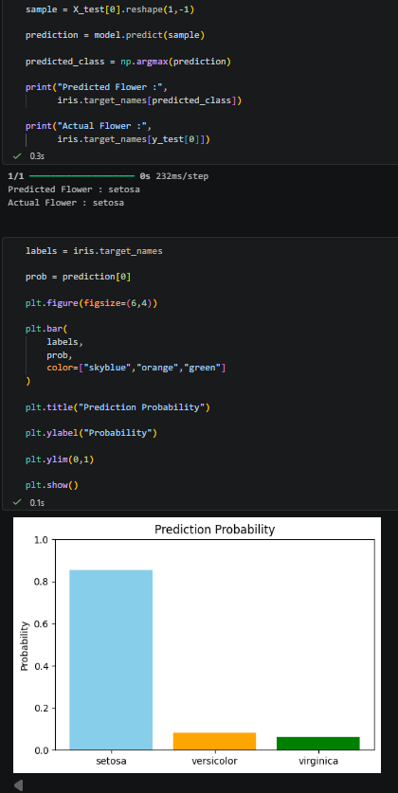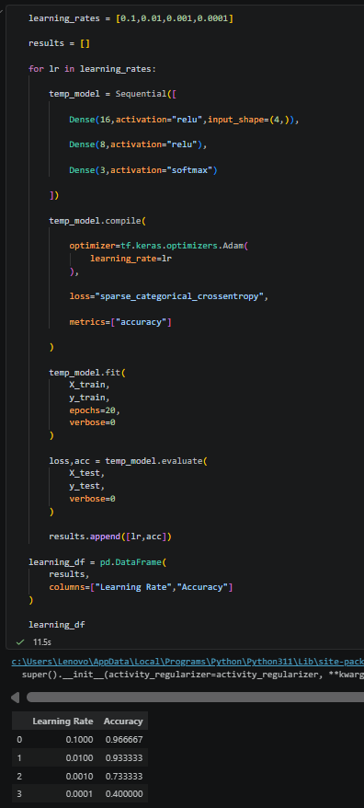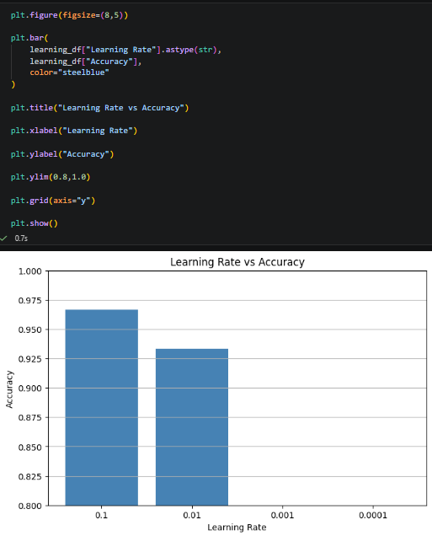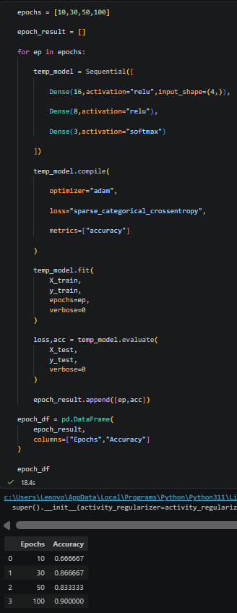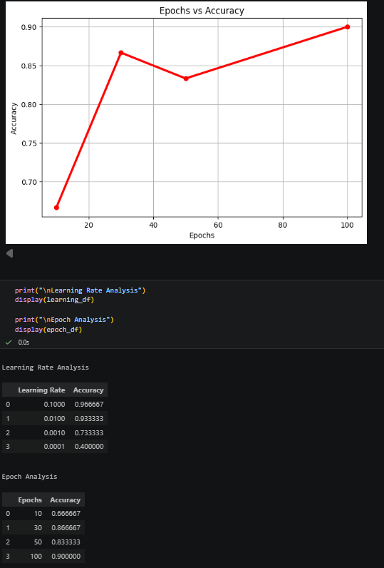
Observations
- The Iris dataset is easy to classify using a Neural Network.
- Feature scaling improves convergence.
- Forward Propagation generates predictions.
- Backpropagation updates the network weights.
- Adam optimizer provides stable learning.
- Learning rate significantly affects convergence speed.
- Too many epochs may increase the risk of overfitting.

Applications
- Flower Species Classification
- Medical Diagnosis
- Image Classification
- Speech Recognition
- Face Recognition
- Fraud Detection
- Recommendation Systems

Advantages
- High classification accuracy.
- Learns complex patterns.
- Automatic weight optimization.
- Scalable to larger datasets.
- Easy implementation using TensorFlow/Keras.

Limitations
- Requires hyperparameter tuning.
- Can overfit on small datasets.
- Training time increases with deeper networks.
- Requires feature scaling for optimal performance.

Result
A Neural Network was successfully implemented using TensorFlow/Keras for the Iris dataset. Forward Propagation generated predictions, while Backpropagation updated the model's weights automatically using the Adam optimizer. The model achieved high classification accuracy, and experiments demonstrated that a learning rate of 0.001 and 50 epochs provided the best balance between training speed and accuracy.

Conclusion
The experiment successfully demonstrated the implementation of Forward Propagation and Backpropagation using TensorFlow/Keras. The Iris dataset was classified with high accuracy using a simple neural network. The effects of different learning rates and epochs were analyzed, showing that proper hyperparameter selection is essential for stable and efficient learning. This experiment provided a clear understanding of neural network training and the role of optimization in Deep Learning.

