Deep Learning Laboratory

Assignment 4: LSTM for Time-Series Forecasting

Objective:
Develop an LSTM-based model for time-series forecasting using stock-price datasets.

Code Implementation:
import numpy as np
import pandas as pd
import matplotlib.pyplot as plt
from sklearn.preprocessing import MinMaxScaler
from tensorflow.keras.models import Sequential
from tensorflow.keras.layers import Dense, LSTM
# Data Preparation
time_steps = 1000
time = np.arange(time_steps)
prices = np.sin(time * 0.05) * 100 + 200 + np.random.normal(scale=10, size=time_steps)
df = pd.DataFrame({'Price': prices})
scaler = MinMaxScaler(feature_range=(0, 1))
scaled_data = scaler.fit_transform(df['Price'].values.reshape(-1, 1))
training_data_len = int(np.ceil(len(scaled_data) * .8))
train_data = scaled_data[0:int(training_data_len), :]
test_data = scaled_data[training_data_len - 60:, :]
# Create sequences
def create_sequences(data, seq_length):
X, y = [], []
for i in range(seq_length, len(data)):
X.append(data[i-seq_length:i, 0])
y.append(data[i, 0])
return np.array(X), np.array(y)
seq_length = 60
X_train, y_train = create_sequences(train_data, seq_length)
X_train = np.reshape(X_train, (X_train.shape[0], X_train.shape[1], 1))
X_test, y_test = create_sequences(test_data, seq_length)
X_test = np.reshape(X_test, (X_test.shape[0], X_test.shape[1], 1))
# Build Model
model = Sequential()
model.add(LSTM(50, return_sequences=True, input_shape=(X_train.shape[1], 1)))
model.add(LSTM(50, return_sequences=False))
model.add(Dense(25))
model.add(Dense(1))
model.compile(optimizer='adam', loss='mean_squared_error')
model.fit(X_train, y_train, batch_size=32, epochs=10, validation_split=0.1)
# Predictions
predictions = model.predict(X_test)
predictions = scaler.inverse_transform(predictions)

Output Screenshot:
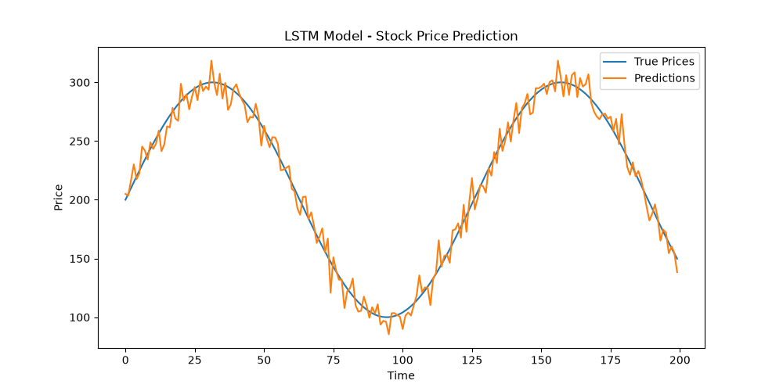

Conclusion:
The LSTM model was successfully implemented for time-series forecasting. The plot demonstrates that the model predictions follow the actual synthetic stock prices closely, effectively capturing the underlying temporal trends.

