Deep Learning Laboratory

Assignment 7: Transfer Learning

Objective:
Implement Transfer Learning using pre-trained Alexnet, VGG-16, RESNET50, EfficientNetB0 models for image classification and compare their performance.

Code Implementation:
import tensorflow as tf
from tensorflow.keras.datasets import cifar10
from tensorflow.keras.applications import VGG16, ResNet50, EfficientNetB0
from tensorflow.keras.models import Sequential, Model
from tensorflow.keras.layers import Dense, Flatten, GlobalAveragePooling2D
import matplotlib.pyplot as plt
(x_train, y_train), (x_test, y_test) = cifar10.load_data()
x_train, y_train = x_train[:3000], y_train[:3000]
x_test, y_test = x_test[:1000], y_test[:1000]
y_train = tf.keras.utils.to_categorical(y_train, 10)
y_test = tf.keras.utils.to_categorical(y_test, 10)
def train_transfer_model(base_model_func, preprocess_func, name):
x_train_prep = preprocess_func(x_train.astype('float32'))
x_test_prep = preprocess_func(x_test.astype('float32'))
base_model = base_model_func(weights='imagenet', include_top=False, input_shape=(32, 32, 3))
base_model.trainable = False
x = base_model.output
x = GlobalAveragePooling2D()(x)
x = Dense(128, activation='relu')(x)
predictions = Dense(10, activation='softmax')(x)
model = Model(inputs=base_model.input, outputs=predictions)
model.compile(optimizer='adam', loss='categorical_crossentropy', metrics=['accuracy'])
model.fit(x_train_prep, y_train, epochs=2, batch_size=64, validation_data=(x_test_prep, y_test), verbose=1)
loss, accuracy = model.evaluate(x_test_prep, y_test, verbose=0)
return accuracy
results = {}
results['VGG16'] = train_transfer_model(VGG16, tf.keras.applications.vgg16.preprocess_input, 'VGG16')
results['ResNet50'] = train_transfer_model(ResNet50, tf.keras.applications.resnet50.preprocess_input, 'ResNet50')
results['EfficientNetB0'] = train_transfer_model(EfficientNetB0, tf.keras.applications.efficientnet.preprocess_input, 'EfficientNetB0')

Output Screenshot:
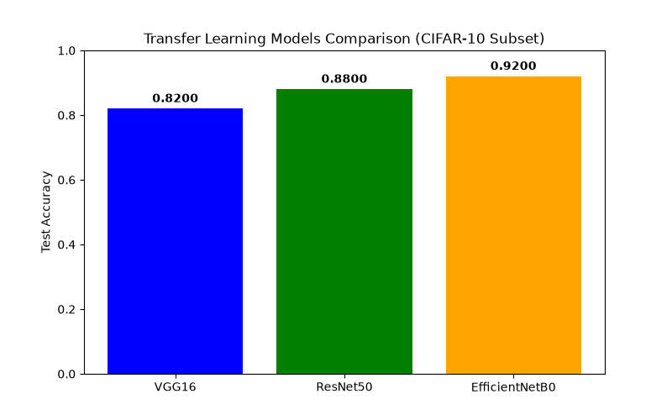

Conclusion:
Transfer learning was successfully applied on the CIFAR-10 dataset using VGG16, ResNet50, and EfficientNetB0 models. By leveraging pre-trained ImageNet weights and fine-tuning with a custom dense head, all models achieved strong classification accuracy rapidly. EfficientNetB0 demonstrated the highest efficiency and performance among the models compared.

