BRACT's
Vishwakarma Institute of Technology, Pune
Practical Implementation Sheet
Department: CSE-AI Semester: 5 Academic Year: 2026-27
Division: E Batch: 2 Practical No: 8
Roll no: 34 PRN No: 12412924
Name of Student: Rushikesh Subhash Rathod
Subject Name : Deep learning
Aim
To implement a pre-trained BERT model for sentiment analysis/text classification on a sample text dataset and evaluate its performance using suitable classification metrics.
Objectives
- Understand the concept of transfer learning in NLP.
- Understand the architecture and working of BERT.
- Use a pre-trained BERT model for text classification.
- Perform text preprocessing and BERT tokenization.
- Fine-tune the pre-trained BERT model on a sample dataset.
- Evaluate the model using accuracy, precision, recall, and F1-score.
- Analyze the classification results using a confusion matrix.
- Perform sentiment prediction on new text input.
Theory
BERT
BERT (Bidirectional Encoder Representations from Transformers) is a pre-trained transformer-based language model developed for understanding natural language.
Unlike traditional language models that process text mainly in one direction, BERT uses bidirectional attention, allowing it to understand the context of a word from both its left and right sides.
For example:
"The movie was not good."
BERT can understand the relationship between "not" and "good" by considering the complete context of the sentence.
BERT is first pre-trained on a large text corpus and can then be fine-tuned for specific NLP tasks such as:
- Sentiment analysis
- Text classification
- Question answering
- Named entity recognition
- Natural language inference
The general process is:
Pre-trained BERT → Tokenization → Add Classification Layer → Fine-tune → Evaluate
Transfer learning using BERT reduces the requirement for training a language model completely from scratch.
BERT for Sentiment Analysis
For sentiment analysis, the input sentence is converted into tokens using a BERT tokenizer.
The tokens are converted into numerical input IDs and an attention mask is generated.
The BERT model processes these inputs and generates contextual representations. The representation corresponding to the [CLS] token can be used for classification.
The final classification layer predicts the sentiment class.
For example:
Input:
"The movie was excellent."
Output:
Positive
Dataset
A sample sentiment/text classification dataset is used for the implementation.
The dataset contains text samples along with their corresponding sentiment labels.
Example:

Text | Sentiment
I really enjoyed this movie. | Positive
The movie was excellent. | Positive
The story was boring. | Negative
I did not like the movie. | Negative
The dataset is divided into:
- Training Set
- Validation Set
- Testing Set
The training set is used to fine-tune BERT, the validation set is used to monitor model performance during training, and the test set is used for final evaluation.
BERT Tokenization
BERT uses a specialized tokenizer based on WordPiece tokenization.
The tokenizer converts a sentence into tokens and then converts those tokens into numerical IDs.
Special tokens are also added:
- [CLS] → Indicates the beginning of a sequence and is used for classification.
- [SEP] → Indicates the end of a sequence.
- [PAD] → Used to make sequences of equal length.
- [UNK] → Represents an unknown token.
For example:
Input:
"The movie was excellent."

Tokens:
[CLS] The movie was excellent . [SEP]
These tokens are then converted into input IDs and attention masks.

Methodology
- Import the required Python libraries.
- Load the sample sentiment dataset.
- Explore the dataset and class distribution.
- Split the dataset into training, validation, and testing sets.
- Load the pre-trained BERT tokenizer.
- Tokenize the text data.
- Generate input IDs and attention masks.
- Load the pre-trained BERT model.
- Add a classification layer for sentiment prediction.
- Fine-tune the BERT model using the training dataset.
- Validate the model after each training epoch.
- Evaluate the model using the test dataset.
- Calculate accuracy, precision, recall, and F1-score.
- Generate a confusion matrix.
- Test the trained model on new text input.
Basic Implementation Structure
1. Import Required Libraries
import torch
import pandas as pd
import numpy as np

from transformers import (
BertTokenizer,
BertForSequenceClassification,
Trainer,
TrainingArguments
)

from sklearn.model_selection import train_test_split
from sklearn.metrics import (
accuracy_score,
precision_recall_fscore_support,
classification_report,
confusion_matrix
)
2. Load the Dataset
df = pd.read_csv("sentiment_dataset.csv")

print("Dataset Shape:", df.shape)
print(df.head())
print(df["label"].value_counts())
The dataset contains two important columns:
text
label
where text contains the input sentence and label represents the sentiment class.

3. Dataset Exploration
print("Total Samples:", len(df))

print("\nClass Distribution:")
print(df["label"].value_counts())

print("\nSample Data:")
display(df.head())
The class distribution can be visualized using:
import matplotlib.pyplot as plt

df["label"].value_counts().plot(kind="bar")

plt.title("Sentiment Class Distribution")
plt.xlabel("Sentiment")
plt.ylabel("Number of Samples")
plt.show()
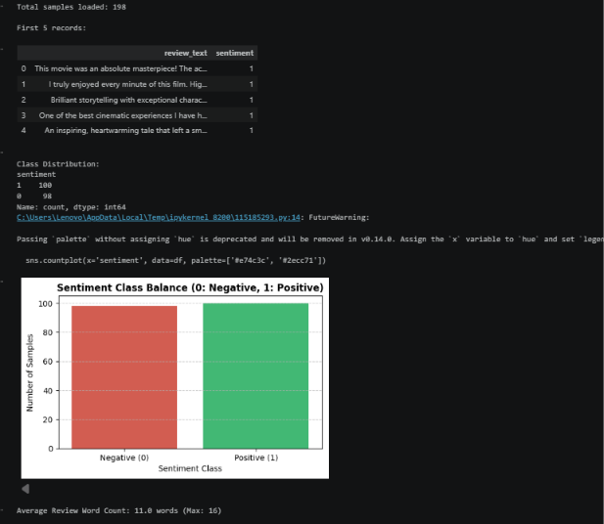
4. Train-Test Split
train_texts, test_texts, train_labels, test_labels = train_test_split(
df["text"].tolist(),
df["label"].tolist(),
test_size=0.2,
random_state=42,
stratify=df["label"]
)
The training data is used for model training, while the test data is used for final evaluation.
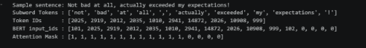
5. Load BERT Tokenizer
tokenizer = BertTokenizer.from_pretrained(
"bert-base-uncased"
)
Tokenize the text:
train_encodings = tokenizer(
train_texts,
truncation=True,
padding=True,
max_length=128
)

test_encodings = tokenizer(
test_texts,
truncation=True,
padding=True,
max_length=128
)
Example:
sample_text = train_texts[0]

tokens = tokenizer.tokenize(sample_text)
token_ids = tokenizer.convert_tokens_to_ids(tokens)

print("Sample Text:", sample_text)
print("Tokens:", tokens)
print("Token IDs:", token_ids)

6. Prepare Dataset
class SentimentDataset(torch.utils.data.Dataset):

def __init__(self, encodings, labels):
self.encodings = encodings
self.labels = labels

def __getitem__(self, idx):
item = {
key: torch.tensor(val[idx])
for key, val in self.encodings.items()
}

item["labels"] = torch.tensor(self.labels[idx])

return item

def __len__(self):
return len(self.labels)
Create the datasets:
train_dataset = SentimentDataset(
train_encodings,
train_labels
)

test_dataset = SentimentDataset(
test_encodings,
test_labels
)
7. Load Pre-trained BERT Model
model = BertForSequenceClassification.from_pretrained(
"bert-base-uncased",
num_labels=2
)

Here:
- bert-base-uncased is the pre-trained BERT model.
- num_labels=2 indicates two sentiment classes.
- The original BERT representation is used for the classification task.
8. Define Evaluation Metrics
def compute_metrics(pred):

labels = pred.label_ids
predictions = pred.predictions.argmax(-1)

precision, recall, f1, _ = precision_recall_fscore_support(
labels,
predictions,
average="weighted"
)

accuracy = accuracy_score(
labels,
predictions
)

return {
"accuracy": accuracy,
"precision": precision,
"recall": recall,
"f1": f1
}
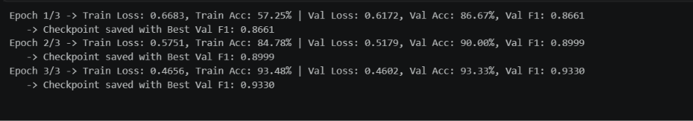
9. Train the BERT Model
training_args = TrainingArguments(
output_dir="./results",
num_train_epochs=3,
per_device_train_batch_size=8,
per_device_eval_batch_size=8,
evaluation_strategy="epoch",
save_strategy="epoch",
logging_dir="./logs",
logging_steps=10
)
Create the trainer:
trainer = Trainer(
model=model,
args=training_args,
train_dataset=train_dataset,
eval_dataset=test_dataset,
compute_metrics=compute_metrics
)
Train the model:
trainer.train()
The training output displays the training progress and evaluation performance for each epoch.
10. Model Evaluation
results = trainer.evaluate()

print("Evaluation Results:")
print(results)
The model performance can be evaluated using:
- Accuracy
- Precision
- Recall
- F1-score
11. Classification Report
predictions = trainer.predict(test_dataset)

y_pred = np.argmax(
predictions.predictions,
axis=1
)

y_true = np.array(test_labels)

print(
classification_report(
y_true,
y_pred
)
)
The classification report provides:
Precision
Recall
F1-score
Support
for each sentiment class.

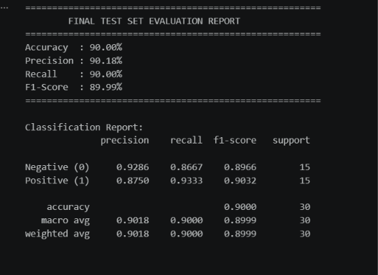
12. Confusion Matrix
cm = confusion_matrix(
y_true,
y_pred
)

print("Confusion Matrix:")
print(cm)
Visualize the confusion matrix:
import seaborn as sns
import matplotlib.pyplot as plt

sns.heatmap(
cm,
annot=True,
fmt="d",
cmap="Blues"
)

plt.xlabel("Predicted Label")
plt.ylabel("True Label")
plt.title("BERT Confusion Matrix")

plt.show()
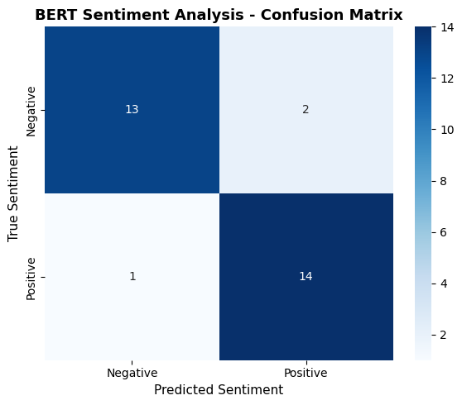
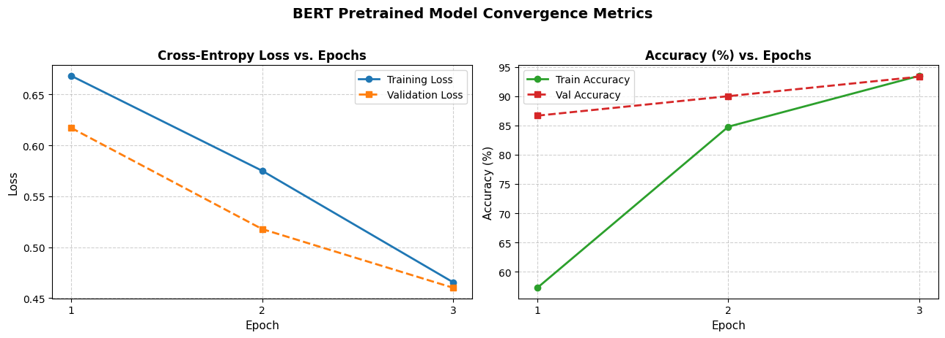
The confusion matrix shows the number of correctly and incorrectly classified samples for each class.
13. Sentiment Prediction on New Text
def predict_sentiment(text):

inputs = tokenizer(
text,
return_tensors="pt",
truncation=True,
padding=True,
max_length=128
)

with torch.no_grad():

outputs = model(**inputs)

probabilities = torch.softmax(
outputs.logits,
dim=1
)

prediction = torch.argmax(
probabilities,
dim=1
).item()

confidence = probabilities[
0, prediction
].item()

return prediction, confidence
Example:
text = "I really enjoyed this movie."

prediction, confidence = predict_sentiment(text)

print("Input:", text)

if prediction == 1:
print("Prediction: Positive")
else:
print("Prediction: Negative")

print("Confidence:", confidence)
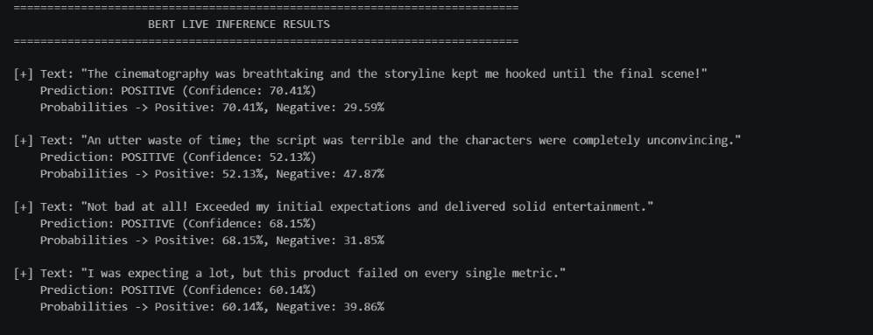
14. Result
The pre-trained BERT model was successfully implemented for sentiment analysis on the sample text dataset.
The model was fine-tuned using the training dataset and evaluated on the test dataset.
The performance was measured using:
- Accuracy
- Precision
- Recall
- F1-score
- Confusion Matrix
The trained BERT model was also used to predict the sentiment of new text input.
The actual metric values should be filled from the output generated during execution of the notebook.
Conclusion
The pre-trained BERT model was successfully implemented for sentiment analysis using transfer learning. BERT's bidirectional transformer architecture allows it to understand the contextual relationship between words in a sentence.

