BRACT's
Vishwakarma Institute of Technology, Pune
Practical Implementation Sheet
Department: CSE-AI Semester: 5 Academic Year: 2026-27
Division: E Batch: 2 Practical No: 9
Roll no: 34 PRN No: 12412924
Name of Student: Rushikesh Subhash Rathod
Subject Name : Deep learning
Aim
To perform image classification using a Pretrained Vision Transformer (ViT) model and compare its performance with a CNN model.
Objectives
- Understand the concept of Vision Transformer for image classification.
- Use a pretrained Vision Transformer model for image classification.
- Implement a CNN model for comparison.
- Fine-tune the pretrained ViT model on the selected dataset.
- Evaluate both models using accuracy, precision, recall, and F1-score.
- Compare the performance and training time of CNN and ViT.
Theory
A Vision Transformer (ViT) is a deep learning architecture that applies the Transformer architecture to image classification.
Unlike CNNs, which process images using convolutional filters, ViT divides an image into small fixed-size patches. These patches are converted into embeddings and passed through Transformer encoder layers. The self-attention mechanism allows the model to learn relationships between different parts of an image.
The general process is:
Input Image → Image Patches → Patch Embeddings → Transformer Encoder → Classification Head → Output Class
A pretrained ViT is first trained on a large image dataset such as ImageNet. Its learned features can then be adapted to another classification task through fine-tuning. This can provide better performance than training a model completely from scratch.

Models Used
Model | Description
CNN | A custom Convolutional Neural Network using convolution, ReLU, max-pooling, dropout, and fully connected layers.
Pretrained ViT | Vision Transformer Base model with 16×16 image patches, pretrained on ImageNet and fine-tuned for CIFAR-10 classification.

Dataset
The CIFAR-10 dataset was used for image classification.
It contains 60,000 RGB images belonging to 10 classes:
- Airplane
- Automobile
- Bird
- Cat
- Deer
- Dog
- Frog
- Horse
- Ship
- Truck
The dataset contains:
- 50,000 training images
- 10,000 testing images
For the CNN, images were processed at their original 32 × 32 resolution. For ViT, images were resized to 224 × 224 to match the input requirements of the pretrained model.
Methodology
- Load the CIFAR-10 image dataset.
- Perform image preprocessing and normalization.
- Create the CNN model.
- Train the CNN model on the training dataset.
- Evaluate the CNN on the test dataset.
- Load the pretrained google/vit-base-patch16-224 model.
- Modify the classification head for 10 CIFAR-10 classes.
- Fine-tune the pretrained ViT model.
- Evaluate the ViT on the test dataset.
- Calculate accuracy, precision, recall, and F1-score.
- Generate confusion matrices for both models.
- Compare CNN and ViT based on performance and training time.
Basic Implementation Structure
CNN
class CNNModel(nn.Module):
def __init__(self):
super(CNNModel, self).__init__()

self.features = nn.Sequential(
nn.Conv2d(3, 32, 3, padding=1),
nn.ReLU(),
nn.MaxPool2d(2),

nn.Conv2d(32, 64, 3, padding=1),
nn.ReLU(),
nn.MaxPool2d(2),

nn.Conv2d(64, 128, 3, padding=1),
nn.ReLU(),
nn.MaxPool2d(2)
)

self.classifier = nn.Sequential(
nn.Flatten(),
nn.Linear(128 * 4 * 4, 256),
nn.ReLU(),
nn.Dropout(0.5),
nn.Linear(256, 10)
)

def forward(self, x):
x = self.features(x)
return self.classifier(x)

Pretrained Vision Transformer
from transformers import ViTForImageClassification
vit_model = ViTForImageClassification.from_pretrained(
"google/vit-base-patch16-224",
num_labels=10,
ignore_mismatched_sizes=True
)
The model was trained using the AdamW optimizer and Cross Entropy Loss.
Result
The CNN and pretrained ViT were successfully implemented and evaluated on the CIFAR-10 dataset.
Metric | CNN | Pretrained ViT
Accuracy | 76.49% | 98.22%
Precision | 76.64% | 98.23%
Recall | 76.49% | 98.22%
F1 Score | 76.33% | 98.22%
Training Time | 177.39 sec | 8487.36 sec
Performance Comparison
CNN vs Pretrained ViT Performance
Comparison of classification performance on CIFAR-10.
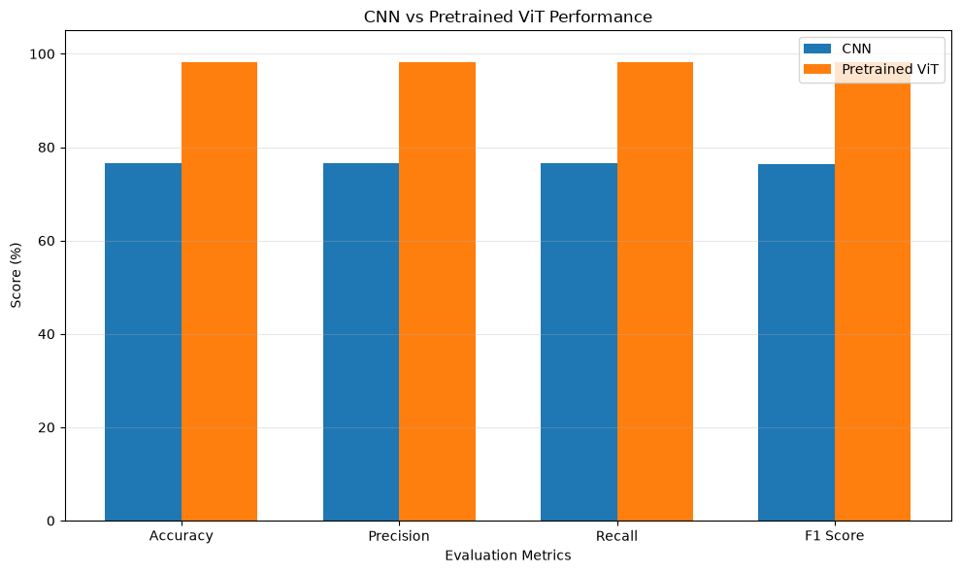
Training Time
- CNN: 177.39 seconds
- Pretrained ViT: 8487.36 seconds
- ViT training time: approximately 2.36 hours on CPU
Conclusion
The pretrained Vision Transformer achieved significantly better classification performance than the CNN on the CIFAR-10 dataset. The ViT achieved an accuracy of 98.22%, while the CNN achieved 76.49%.

