BRACT's
Vishwakarma Institute of Technology, Pune
Practical Implementation Sheet
Department: CSE-AI Semester: 5 Academic Year: 2026-27
Division: E Batch: 1 Practical No: 5
Roll no: 34 PRN No: 12412924
Name of Student: Rushikesh Subhash Rathod
Subject Name : Deep learning
Assignment 5: Sequence Classification using RNN, LSTM and GRU.
Aim / Objective
Objective:
Implement and compare RNN, LSTM, and GRU models for sequence classification using the IMDB dataset and analyze their performance using validation accuracy and convergence speed.

2. Import Libraries
import numpy as np
import matplotlib.pyplot as plt

from tensorflow.keras.datasets import imdb
from tensorflow.keras.preprocessing.sequence import pad_sequences

from tensorflow.keras.models import Sequential
from tensorflow.keras.layers import Embedding, SimpleRNN, LSTM, GRU, Dense

import time

3. Define Parameters
max_features = 10000
maxlen = 500
Here:
- max_features = 10000 means the vocabulary is limited to 10,000 words.
- maxlen = 500 means each review is limited/padded to 500 words.

4. Load IMDB Dataset
(input_train, y_train), (input_test, y_test) = imdb.load_data(
num_words=max_features
)
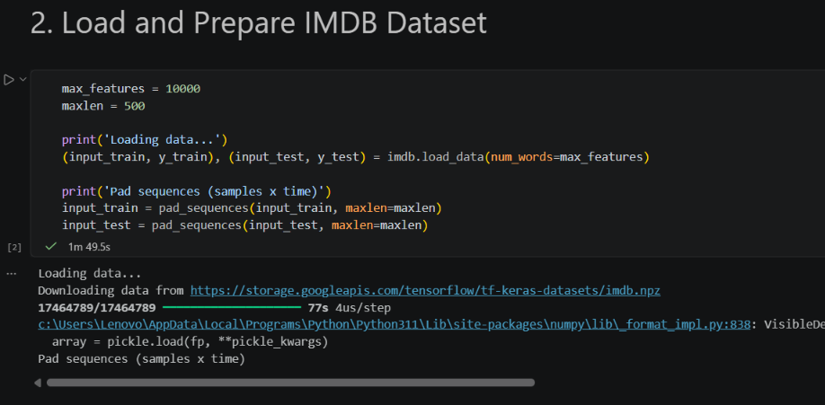
5. Pad the Sequences
input_train = pad_sequences(
input_train,
maxlen=maxlen
)

input_test = pad_sequences(
input_test,
maxlen=maxlen
)

6. Build RNN, LSTM and GRU Models
def build_model(cell_type):

model = Sequential()

model.add(
Embedding(
max_features,
32
)
)

if cell_type == 'RNN':
model.add(
SimpleRNN(32)
)

elif cell_type == 'LSTM':
model.add(
LSTM(32)
)

elif cell_type == 'GRU':
model.add(
GRU(32)
)

model.add(
Dense(
1,
activation='sigmoid'
)
)

model.compile(
optimizer='rmsprop',
loss='binary_crossentropy',
metrics=['acc']
)

7. Create the Three Models
model_rnn = build_model('RNN')

model_lstm = build_model('LSTM')

model_gru = build_model('GRU')
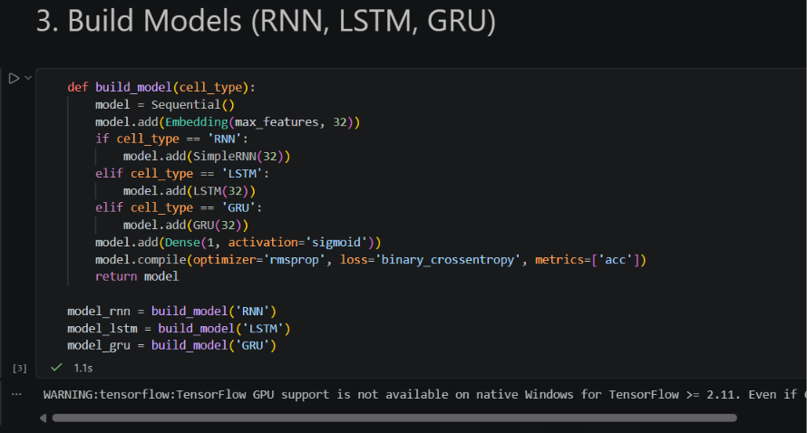
8. Set Training Parameters
epochs = 5
batch_size = 128

9. Train RNN Model
history_rnn = model_rnn.fit(
input_train,
y_train,
epochs=epochs,
batch_size=batch_size,
validation_split=0.2
)

10. Train LSTM Model
history_lstm = model_lstm.fit(
input_train,
y_train,
epochs=epochs,
batch_size=batch_size,
validation_split=0.2
)

11. Train GRU Model
history_gru = model_gru.fit(
input_train,
y_train,
epochs=epochs,
batch_size=batch_size,
validation_split=0.2
) 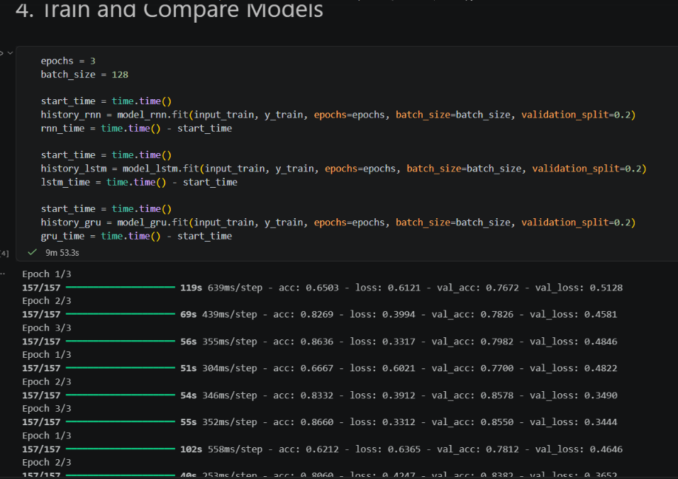
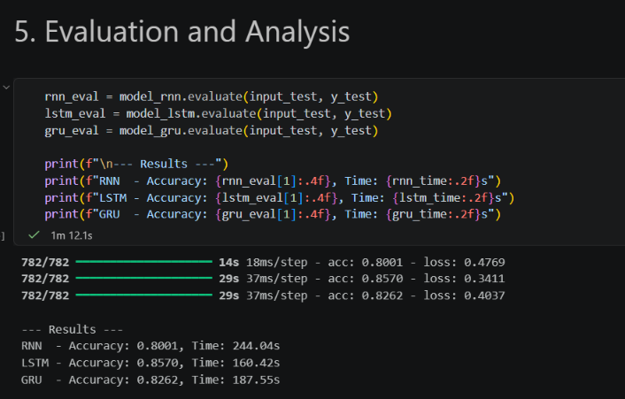
12. Compare Validation Accuracy
plt.figure(figsize=(10, 6))

plt.plot(
history_rnn.history['val_acc'],
label='RNN Val Acc'
)

plt.plot(
history_lstm.history['val_acc'],
label='LSTM Val Acc'
)

plt.plot(
history_gru.history['val_acc'],
label='GRU Val Acc'
)

plt.title('Validation Accuracy Comparison')

plt.xlabel('Epoch')

plt.ylabel('Accuracy')

plt.legend()

plt.show()
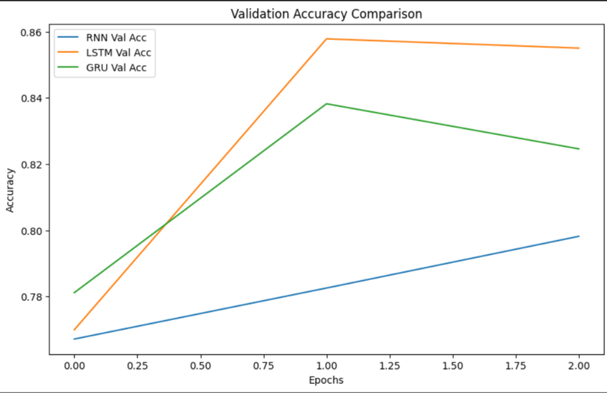
13. Conclusion
Conclusion:
All three sequence models, RNN, LSTM, and GRU, were successfully implemented for sentiment classification using the IMDB dataset. The comparison shows that LSTM and GRU achieved higher validation accuracy and better convergence than SimpleRNN. This is related to their ability to handle the vanishing-gradient issue more effectively when learning dependencies in sequences.

