GUAVA LEAF DISEASE DETECTION SYSTEM
Real System Architecture and End-to-End Technical Flow
PyTorch + EfficientNet-B3 / ResNet-50 + Streamlit + Grad-CAM
This document describes the architecture that is actually represented by the current project structure and Streamlit application. It is written as the system architecture of the project itself. The Streamlit code shows the user interface, model loading, preprocessing, prediction, confidence calculation, and Grad-CAM explainability path.

Project Technology Stack
Technology / Component | Details
User Interface | Streamlit
Image Handling | PIL, NumPy, OpenCV
Deep Learning | PyTorch + torchvision
Models | EfficientNet-B3 and ResNet-50
Model Artifacts | efficientnet_best.pt and resnet50_best.pt
Explainable AI | Grad-CAM
Input Size | 224 × 224
Supported Input | JPG, JPEG, PNG
Prediction Classes | canker, dot, healthy, mummification, rust
Execution Device | CUDA GPU when available; otherwise CPU

1. What "System Architecture" Means in This Project
System architecture is the high-level structure of the complete software system. It explains which major components exist, what each component does, how components communicate, and how data moves from the user's input to the final output.
For this Guava Disease Detection System, the architecture is not simply the CNN architecture. EfficientNet-B3 and ResNet-50 are model architectures inside the larger system. The system architecture includes the dataset pipeline, preprocessing, trained model files, Streamlit application, prediction engine, and Grad-CAM explainability module.
SYSTEM ARCHITECTURE
=
User Input
↓
Streamlit Interface
↓
Image Validation / Loading
↓
Preprocessing
↓
Selected Trained Deep-Learning Model
↓
Prediction Probabilities
↓
Predicted Disease + Confidence
↓
Grad-CAM Explainability
↓
Final Result Shown in Streamlit

Complete System Architecture Diagram
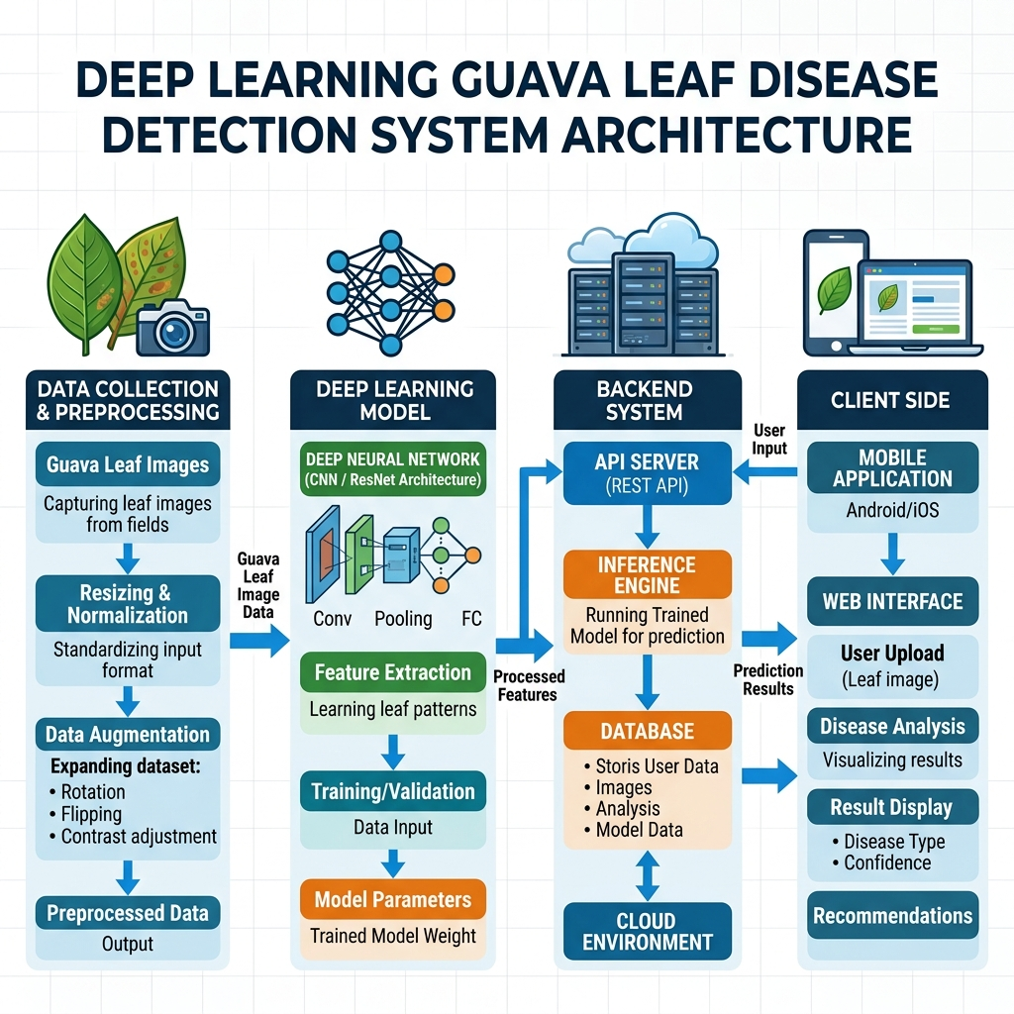
Figure 1. Complete architecture of the Guava Leaf Disease Detection System

2. Current Project Structure and Its Architectural Role
The project folder contains app, data, models, notebooks, results, src, config.yaml, README.md, and requirements.txt. The src folder contains the data and training modules, while the models/saved_models folder contains the trained PyTorch checkpoints.
guava-leaf-disease-detection/
├── app/ → application-related project area
├── data/ → dataset storage / processed data
├── models/
│ └── saved_models/
│ ├── efficientnet_best.pt
│ └── resnet50_best.pt
├── notebooks/ → experimentation / analysis
├── results/ → experiment outputs
├── src/
│ ├── augmentation.py
│ ├── data_loader.py
│ ├── evaluate.py
│ ├── merge_datasets.py
│ ├── preprocessing.py
│ ├── split_data.py
│ ├── train.py
│ ├── utils.py
│ └── models/
├── config.yaml
├── README.md
└── requirements.txt
The current Streamlit application is the presentation and inference layer. It imports the model-construction functions from src/models and loads the trained .pt checkpoints from models/saved_models.

3. Architectural Layers
Layer | Component | Main Responsibility
1 | Dataset Layer | Stores guava images organized by disease/healthy class.
2 | Data Preparation Layer | Merges, normalizes, splits, preprocesses, and augments images.
3 | Model Layer | Provides EfficientNet-B3 and ResNet-50 classification models.
4 | Training Layer | Trains models and saves best validation checkpoints.
5 | Model Storage Layer | Stores trained .pt model artifacts.
6 | Streamlit Presentation Layer | Provides upload, configuration, and result interface.
7 | Inference Layer | Preprocesses uploaded image and produces class probabilities.
8 | Explainability Layer | Uses Grad-CAM to visualize image regions influencing prediction.
9 | Output Layer | Displays disease prediction, confidence, and Grad-CAM image.

4. Data Preparation Architecture

4.1 Dataset Integration
The dataset integration stage combines source datasets into a common structure. merge_datasets.py performs folder traversal, recognizes image extensions, normalizes category names, and copies images into standardized class directories.
Raw / Source Datasets
↓
Folder Traversal
↓
Category Name Normalization
↓
Supported Image Check
↓
Unique / Collision-Safe Filename
↓
Standardized Raw Dataset

4.2 Disease Classes
Class | Meaning in classifier
canker | Guava disease class
dot | Guava disease class
healthy | Healthy reference class
mummification | Guava disease class
rust | Guava disease class

4.3 Dataset Splitting
The dataset is divided into training (80%), validation (10%), and test (10%) subsets with a fixed random seed of 42 for parameter learning, monitoring generalization, and final evaluation.

5. Image Preprocessing Architecture
The same basic deterministic preprocessing used for model inference is compatible with the training pipeline. In Streamlit, the uploaded PIL image is converted to RGB, resized to 224×224, converted to a PyTorch tensor, and normalized using ImageNet statistics.
Preprocessing step | Why it is used
RGB conversion | Ensures a consistent 3-channel color representation.
Resize 224×224 | Matches the input size expected by the trained pipeline.
ToTensor | Converts image pixels into a PyTorch tensor.
ImageNet normalization | Matches the normalization used with ImageNet-pretrained models.
Batch dimension | Creates the model input shape for one image.
Device transfer | Places the tensor on the same device as the model.

6. Model Training Architecture
The training layer supports EfficientNet-B3 and ResNet-50. Both use ImageNet-pretrained weights and replace the final classification layer with a five-class output.
PREPROCESSED IMAGE
↓
EfficientNet-B3 OR ResNet-50
↓
Custom 5-class head
↓
Five class logits
↓
CrossEntropyLoss
↓
Adam Optimizer
↓
Updated parameters
During training, when validation accuracy exceeds the previous best value, the model state is saved (e.g., efficientnet_best.pt). The Streamlit app loads these checkpoints for prediction.

7. Streamlit Application Architecture
The Streamlit application is the user-facing layer. The UI, model loading, preprocessing, inference, and Grad-CAM generation are executed through the Streamlit Python application.
Browser
↓
Streamlit Application
↓
File Upload & UI Configuration
↓
PyTorch Model + Saved .pt Weights

8. Model Loading and Runtime Architecture
Selection | Model constructor | Checkpoint
EfficientNet-B3 | get_efficientnetb3(num_classes=5) | efficientnet_best.pt
ResNet-50 | get_resnet50(num_classes=5) | resnet50_best.pt

9. Complete Prediction / Inference Flow
- 1. The user selects Leaf and model architecture.
- 2. User uploads a JPG, JPEG, or PNG image.
- 3. Image is opened using PIL and converted to RGB, resized to 224×224.
- 4. Converted to tensor and normalized.
- 5. Tensor moved to available device (GPU/CPU).
- 6. Trained model performs forward pass (torch.no_grad()).
- 7. Raw logits converted to probabilities using softmax.
- 8. Highest probability class is identified (canker, dot, healthy, mummification, rust).
- 9. Grad-CAM generated to provide visual explanation of focus.
- 10. Result displayed with Predicted Disease, Confidence %, and Grad-CAM.

10. Explainable AI Architecture – Grad-CAM
Grad-CAM provides a heatmap showing regions of the leaf that contributed to the model's prediction.
Model | Grad-CAM target layer used
ResNet-50 | model.layer4[-1]
EfficientNet-B3 | model.features[-1]

11. Final Output Architecture
Output | Current implementation
Predicted disease | Displayed with st.success().
Confidence | Displayed as percentage with two decimal places.
Grad-CAM | Displayed as a heatmap overlay.
Uploaded image | Displayed before analysis.

12. Source File to System Component Mapping
Source / Folder | Role in the architecture
src/merge_datasets.py | Integrates source datasets and standardizes categories.
src/preprocessing.py | Dedicated preprocessing module.
src/train.py | Training loop, validation and checkpointing.
src/models/*.py | Builds deep learning models (EfficientNet/ResNet).
models/saved_models/*.pt | Trained PyTorch checkpoints.
streamlit_app.py | Presentation + inference + Grad-CAM application layer.

