GUAVA LEAF & FRUIT DISEASE DETECTION SYSTEM
Real System Architecture and End-to-End Technical Flow
PyTorch + EfficientNet-B3 / ResNet-50 + Streamlit + Grad-CAM
This document describes the comprehensive system architecture for both Guava Leaf and Guava Fruit disease detection applications. It outlines the project structure, user interface, model loading, preprocessing, prediction, confidence calculation, and Grad-CAM explainability paths.

System Technology Stack
Technology / Component | Details
User Interface | Streamlit
Image Handling | PIL, NumPy, OpenCV
Deep Learning | PyTorch + torchvision
Models | EfficientNet-B3 and ResNet-50
Explainable AI | Grad-CAM
Input Size | 224 × 224
Supported Input | JPG, JPEG, PNG
Execution Device | CUDA GPU when available; otherwise CPU

1. System Architecture Overview
System architecture is the high-level structure of the complete software system. It explains which major components exist, what each component does, how components communicate, and how data moves from the user's input to the final output.
The architecture includes the dataset pipeline, preprocessing, trained model files, Streamlit application, prediction engine, and Grad-CAM explainability module, extending across both leaf and fruit analysis paths.
END-TO-END DATA JOURNEY
=
User Input (Image Upload)
↓
Streamlit Interface
↓
Image Validation / Loading
↓
Preprocessing (Resize, Normalize)
↓
Selected Trained Deep-Learning Model
↓
Prediction Probabilities
↓
Predicted Disease + Confidence
↓
Grad-CAM Explainability Heatmap
↓
Final Result Shown to User

PART I: GUAVA LEAF DISEASE DETECTION
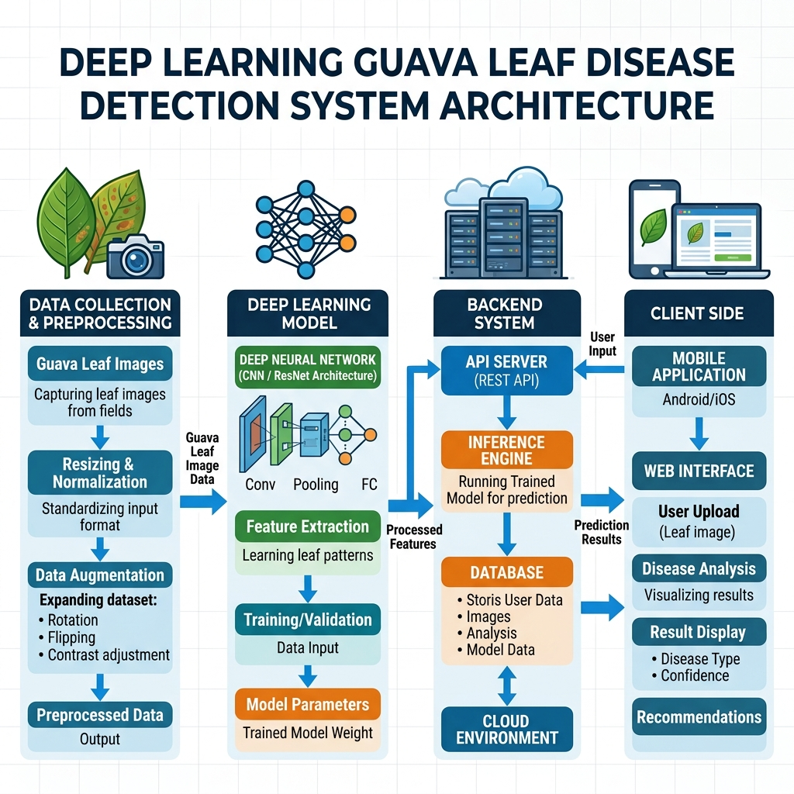
Figure 1. Complete architecture of the Guava Leaf Disease Detection System

Leaf Disease Classes
Class | Meaning in classifier
canker | Guava leaf disease class
dot | Guava leaf disease class
healthy | Healthy leaf reference class
mummification | Guava leaf disease class
rust | Guava leaf disease class

PART II: GUAVA FRUIT DISEASE DETECTION
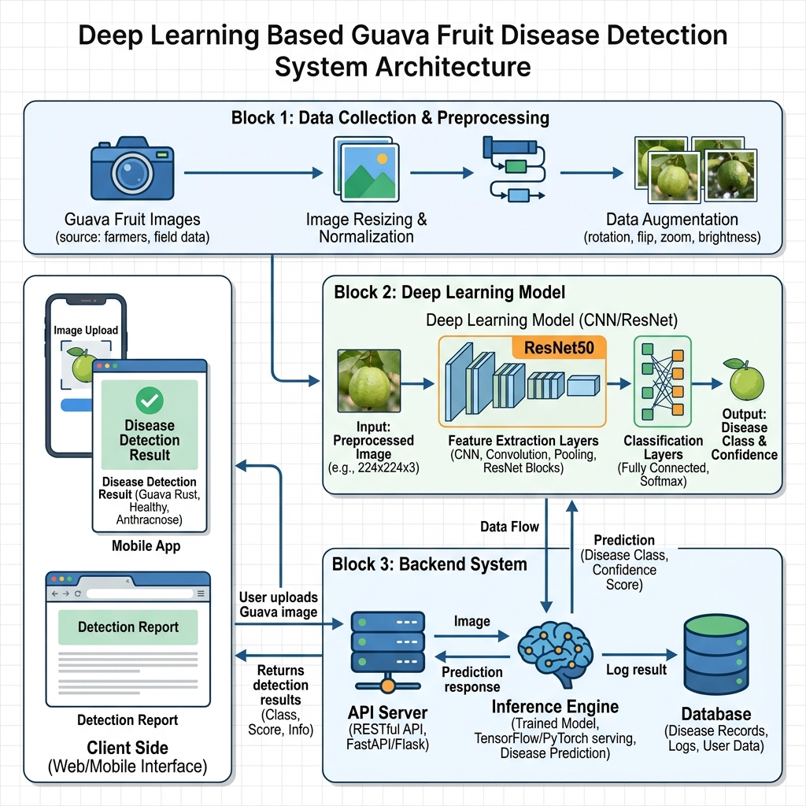
Figure 2. Complete architecture of the Guava Fruit Disease Detection System

Fruit Disease Analysis
The system utilizes the identical robust architecture for guava fruit disease detection. The user selects the "Fruit" analysis mode, triggering the parallel pipeline specifically trained on fruit pathologies.
Fruit Disease Pipeline | Details
Fruit Image Upload | Direct upload via Streamlit or mobile gateway.
Preprocessing | RGB conversion, 224x224 resize, ImageNet normalization.
Fruit CNN/ResNet Model | Dedicated weights trained on guava fruit diseases (e.g., Anthracnose, Scab).
Output | Fruit pathology prediction, confidence score, and Grad-CAM visualization.

CORE ARCHITECTURAL LAYERS & PIPELINE (Leaf & Fruit)

Architectural Layers
Layer | Component | Main Responsibility
1 | Dataset Layer | Stores images organized by disease/healthy class.
2 | Data Preparation Layer | Merges, normalizes, splits, preprocesses, and augments images.
3 | Model Layer | Provides EfficientNet-B3 and ResNet-50 classification models.
4 | Training Layer | Trains models and saves best validation checkpoints.
5 | Model Storage Layer | Stores trained .pt model artifacts.
6 | Streamlit Presentation Layer | Provides upload, configuration, and result interface.
7 | Inference Layer | Preprocesses uploaded image and produces class probabilities.
8 | Explainability Layer | Uses Grad-CAM to visualize image regions influencing prediction.
9 | Output Layer | Displays disease prediction, confidence, and Grad-CAM image.

Image Preprocessing Architecture
The deterministic preprocessing used for model inference is identical to the training pipeline. The uploaded image is converted to RGB, resized to 224×224, converted to a PyTorch tensor, and normalized using ImageNet statistics.
Preprocessing step | Why it is used
RGB conversion | Ensures a consistent 3-channel color representation.
Resize 224×224 | Matches the input size expected by the trained pipeline.
ToTensor | Converts image pixels into a PyTorch tensor.
ImageNet normalization | Matches the normalization used with ImageNet-pretrained models.
Batch dimension | Creates the model input shape for one image.
Device transfer | Places the tensor on the same device as the model.

Model Execution & Inference Architecture
The training and inference layers support EfficientNet-B3 and ResNet-50. Both use ImageNet-pretrained weights and replace the final classification layer with a multi-class output.
PREPROCESSED IMAGE
↓
EfficientNet-B3 OR ResNet-50
↓
Custom Classification Head
↓
Multi-class Logits
↓
Softmax Activation
↓
Predicted Class + Confidence Probability

Explainable AI Architecture – Grad-CAM
Grad-CAM provides a visual heatmap overlay, revealing the specific regions of the leaf or fruit that most strongly influenced the neural network's prediction decision.
Model | Grad-CAM target layer used
ResNet-50 | model.layer4[-1]
EfficientNet-B3 | model.features[-1]

Final Output Architecture
Output | Current implementation
Predicted disease | Displayed with st.success().
Confidence | Displayed as percentage with two decimal places.
Grad-CAM | Displayed as a heatmap overlay.
Uploaded image | Displayed before analysis.

