GUAVA LEAF & FRUIT DISEASE DETECTION SYSTEM
Real System Architecture and End-to-End Technical Flow
PyTorch + EfficientNet-B3 / ResNet-50 + Streamlit + Grad-CAM
This document describes the comprehensive system architecture for both Guava Leaf and Guava Fruit disease detection applications. It outlines the project structure, user interface, model loading, preprocessing, prediction, confidence calculation, and Grad-CAM explainability paths.

System Technology Stack
Technology / Component | Details
User Interface | Streamlit
Image Handling | PIL, NumPy, OpenCV
Deep Learning | PyTorch + torchvision
Models | EfficientNet-B3 and ResNet-50
Explainable AI | Grad-CAM
Input Size | 224 × 224
Supported Input | JPG, JPEG, PNG
Execution Device | CUDA GPU when available; otherwise CPU

1. System Architecture Overview
System architecture is the high-level structure of the complete software system. It explains which major components exist, what each component does, how components communicate, and how data moves from the user's input to the final output.

PART I: GUAVA LEAF DISEASE DETECTION
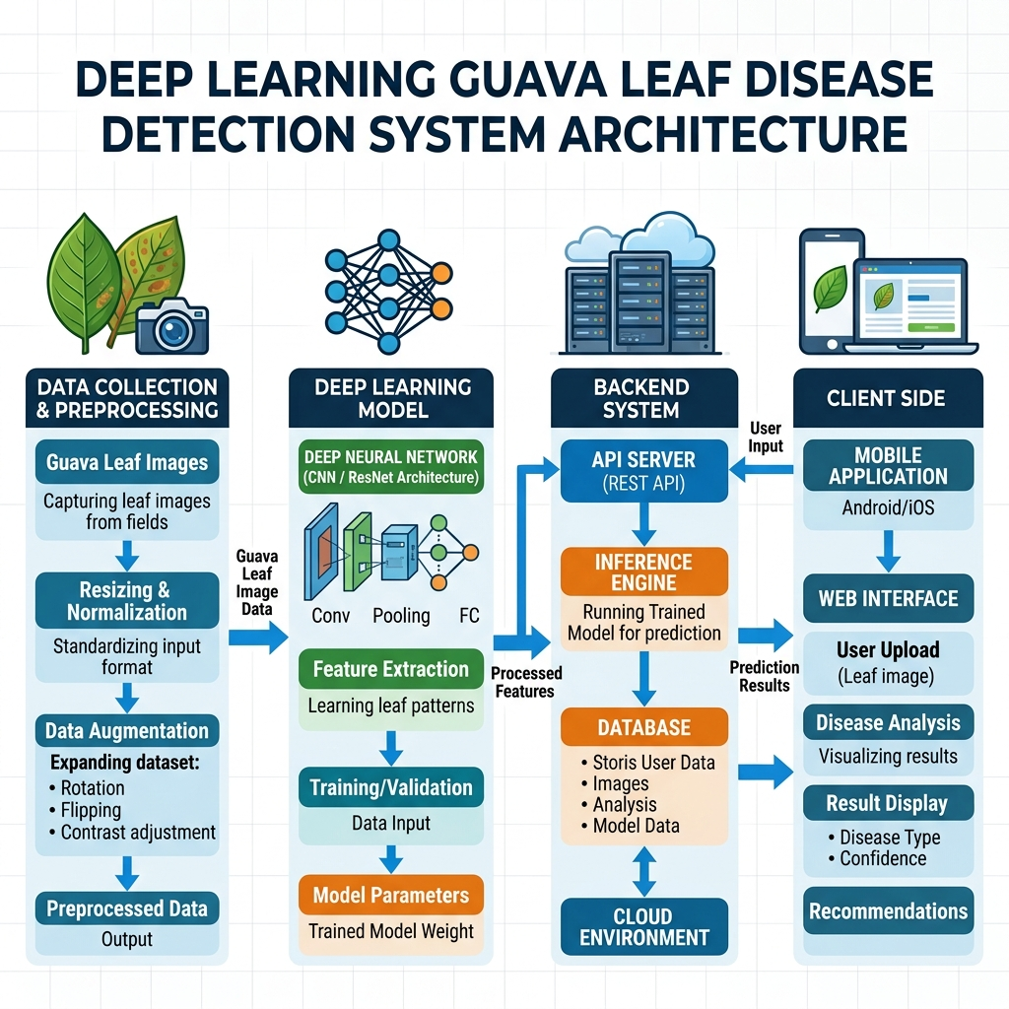
Figure 1. Complete architecture of the Guava Leaf Disease Detection System

Leaf Disease Classes
Class | Meaning in classifier
canker | Guava leaf disease class
dot | Guava leaf disease class
healthy | Healthy leaf reference class
mummification | Guava leaf disease class
rust | Guava leaf disease class

PART II: GUAVA FRUIT DISEASE DETECTION

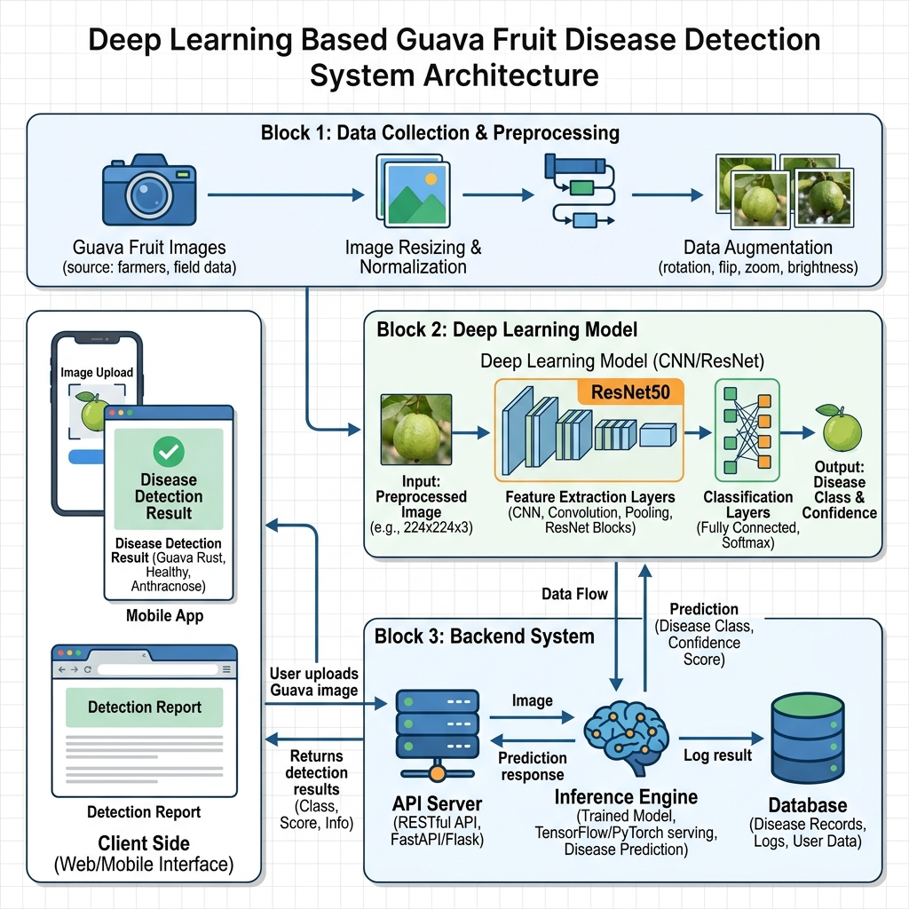
Figure 2. Complete architecture of the Guava Fruit Disease Detection System

CORE ARCHITECTURAL LAYERS & PIPELINE (Leaf & Fruit)
Layer | Component | Main Responsibility
1 | Dataset Layer | Stores images organized by disease/healthy class.
2 | Data Preparation Layer | Merges, normalizes, splits, preprocesses, and augments images.
3 | Model Layer | Provides EfficientNet-B3 and ResNet-50 classification models.
4 | Training Layer | Trains models and saves best validation checkpoints.
5 | Model Storage Layer | Stores trained .pt model artifacts.
6 | Streamlit Presentation Layer | Provides upload, configuration, and result interface.
7 | Inference Layer | Preprocesses uploaded image and produces class probabilities.
8 | Explainability Layer | Uses Grad-CAM to visualize image regions influencing prediction.
9 | Output Layer | Displays disease prediction, confidence, and Grad-CAM image.

SYSTEM EXECUTION FLOWCHART
The following flowchart illustrates the complex end-to-end technical sequence of execution in a highly readable format.
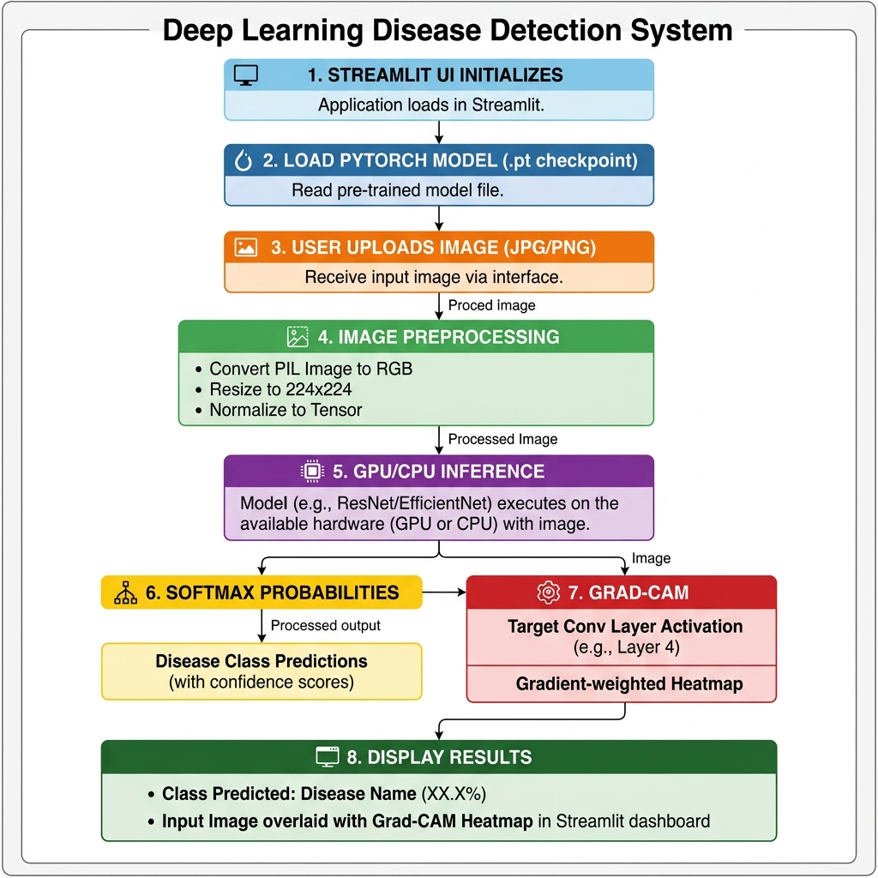
Figure 3. Step-by-step execution flowchart of the System

Step-by-Step Flowchart Explanation
- Step 1: Streamlit UI Initializes - The system sets the page configuration, UI layout, and detects if CUDA (GPU) or CPU is available for execution.
- Step 2: Load PyTorch Model (.pt checkpoint) - Based on user selection (EfficientNet or ResNet), the system constructs the model and loads the pre-trained weights into memory, setting model.eval().
- Step 3: User Uploads Image - The user selects a JPG or PNG image of a Guava leaf or fruit through the Streamlit uploader.
- Step 4: Image Preprocessing - The PIL image is converted to RGB, resized to exactly 224x224, converted to a PyTorch Tensor, and normalized using standard ImageNet statistics.
- Step 5: GPU/CPU Inference - The preprocessed image tensor is passed into the Deep Learning model for a forward pass (under torch.no_grad()) to extract deep visual features.
- Step 6: Softmax Probabilities - The raw logits from the model are passed through a Softmax function to convert them into a percentage-based probability distribution. The class with the highest probability is selected (Argmax).
- Step 7: Grad-CAM Explainability - The system selects the target Convolutional Layer (e.g., layer4 for ResNet) and generates a Gradient-weighted Class Activation Mapping (Grad-CAM) heatmap to explain the model's focus.
- Step 8: Display Final Results - The Streamlit UI displays the Predicted Disease Class, the Confidence Percentage, and overlays the Grad-CAM heatmap on the original image for the user to interpret.

