Guava Leaf & Fruit Disease Detection System
Comprehensive UML System Architecture Diagrams
This document contains the exact UML diagrams representing the real, self-contained architecture of the project (Streamlit, PyTorch, EfficientNet/ResNet, Grad-CAM). No unnecessary external components (like separate databases or REST APIs) have been included.

1. Use Case Diagram
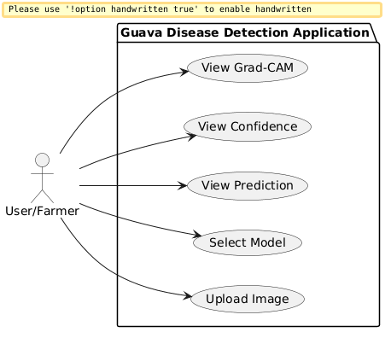

2. Class Diagram
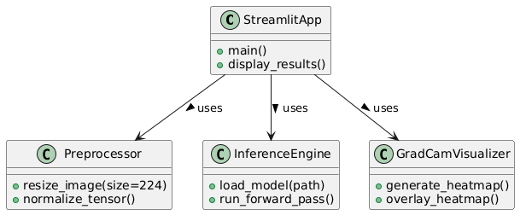

3. Activity Diagram
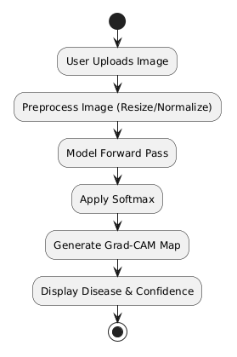

4. Sequence Diagram
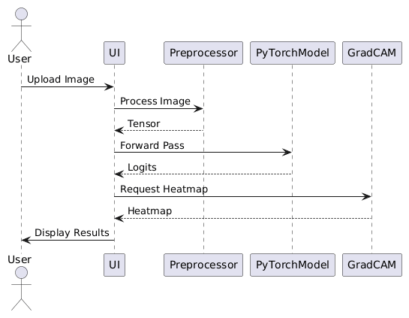

5. Component Diagram
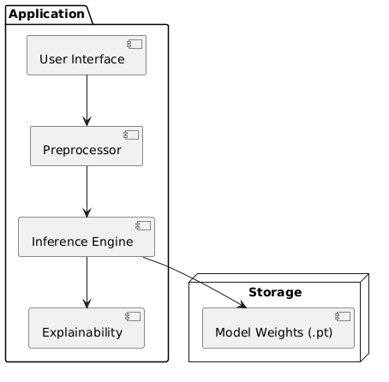

6. Deployment Diagram
