Guava Leaf Disease Detection
UML System Architecture Diagrams

1. UML Use Case Diagram
This diagram illustrates the interactions between the primary actors (User/Farmer, Admin) and the system use cases such as Uploading Images, Running Inference, and Managing Datasets.
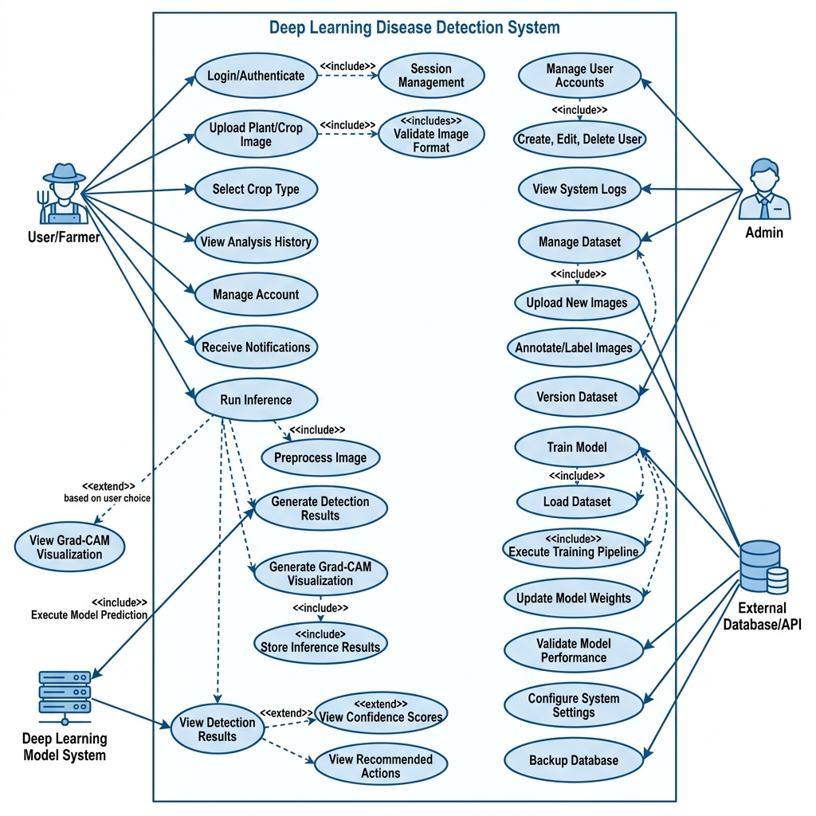

2. UML Class Diagram
This diagram represents the static structure of the application, detailing the Python classes such as StreamlitApp, ModelLoader, Preprocessor, InferenceEngine, and GradCamGenerator with their attributes and relationships.
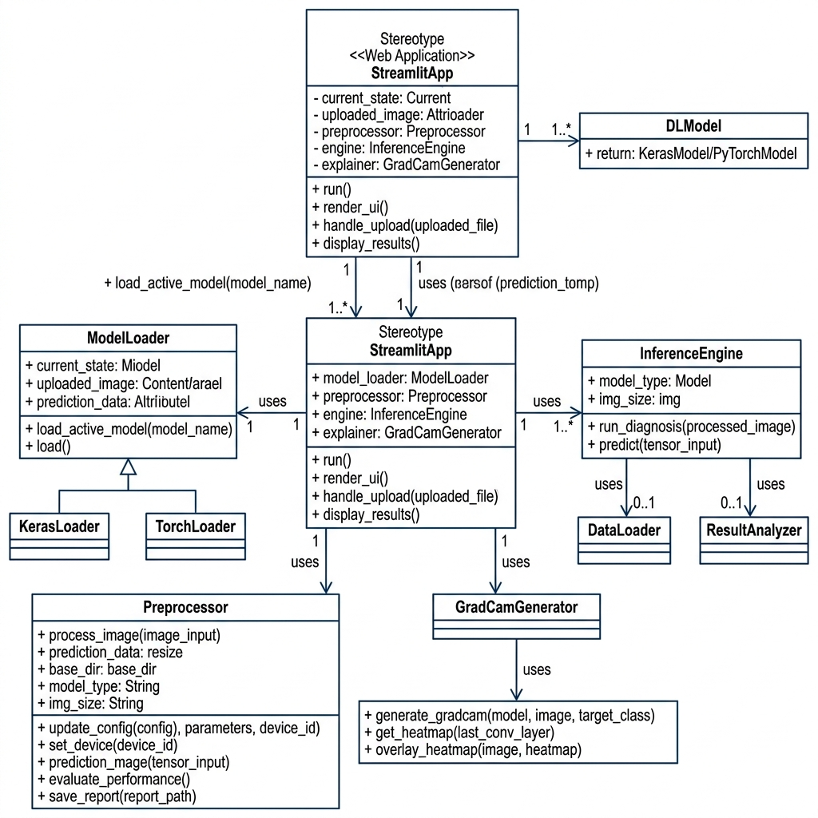

3. UML Activity Diagram
This diagram maps out the dynamic workflow of the image prediction process, from the start node and image upload through preprocessing, model inference, and displaying the final Grad-CAM result.
