Guava Fruit Disease Detection
UML Reference Diagrams
This document contains the UML diagrams strictly modeled after the provided reference architecture, including all specified components (Database, API Server, Mobile App, etc.). Each diagram is rendered in high resolution on its own page.

1. Use Case Diagram
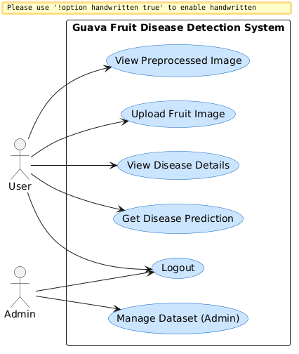

2. Class Diagram
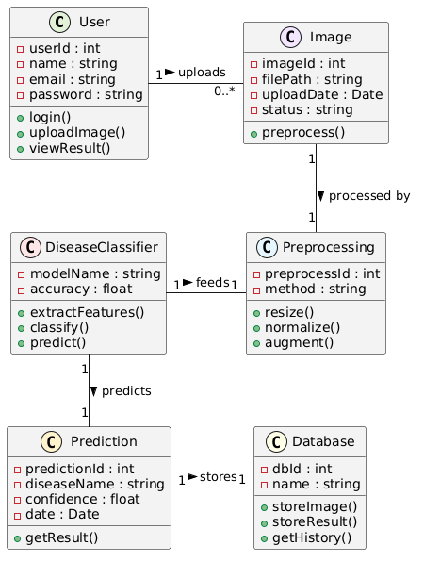

3. Activity Diagram
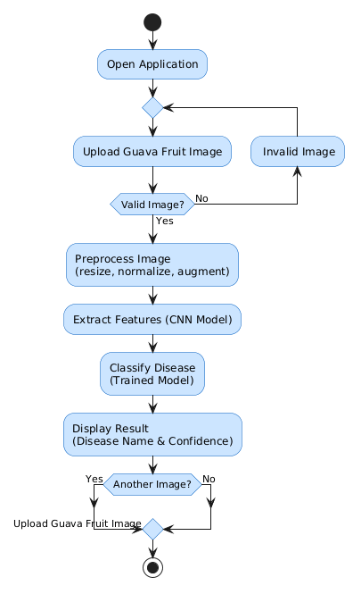

4. Sequence Diagram
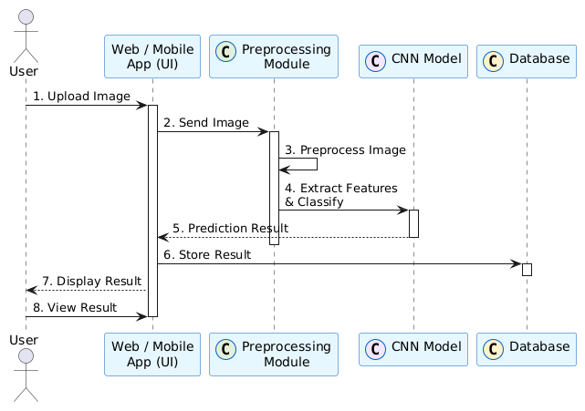

5. Component Diagram
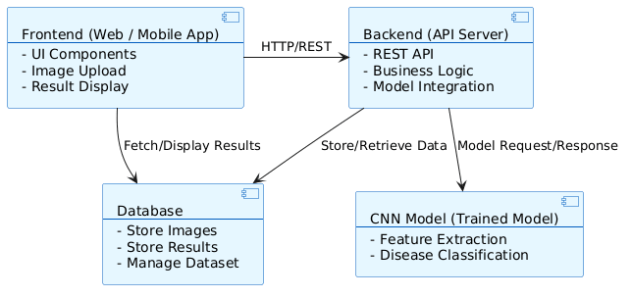

6. Deployment Diagram
