System Architecture: Guava Leaf Disease Detection
This document outlines the step-by-step deep system architecture for the Guava Leaf Disease Detection application. The architecture is designed to handle user requests, process images, predict disease presence using a deep learning model, and return actionable results.

System Architecture Diagram
The following diagram illustrates the complete data flow and components involved in the system.
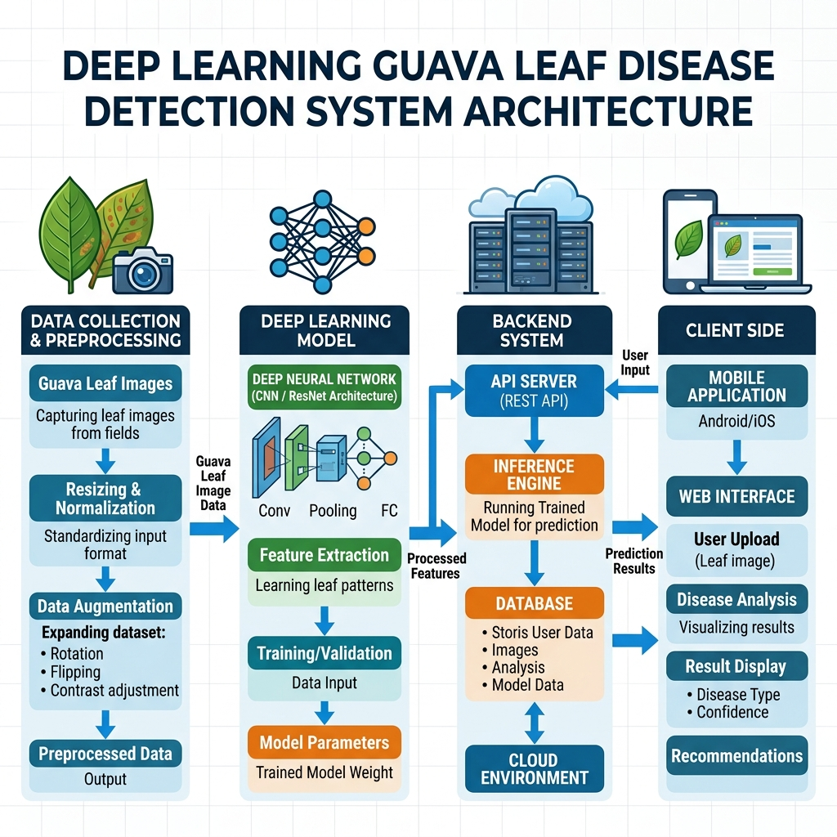

Step-by-Step Architecture Explanation

1. Client Side (User Interface)
The client side is the entry point for the user. It can be a web interface or a mobile application (Android/iOS).
Step-by-step flow:
- The user opens the application and selects an image of a guava leaf suspected of having a disease.
- The interface compresses the image slightly for efficient transmission if necessary.
- An HTTP POST request is triggered, sending the image payload to the Backend API server.

2. Backend System (API Server & Inference Engine)
The backend acts as a bridge between the client application and the deep learning model. It is typically built using RESTful frameworks like Flask or FastAPI.
Step-by-step flow:
- The API receives the image file, validates the file format, and securely saves it temporarily.
- The request is passed to the Inference Engine, which loads the pre-trained Deep Learning Model.
- The Backend may log the request and user details into a Database for history and analytics.
- After prediction, the Backend formulates a JSON response containing the predicted disease, confidence score, and recommended actions.

3. Data Preprocessing Pipeline (Model Input Preparation)
Before the model can process the image, it must be transformed into the correct numerical format.
Step-by-step flow:
- Resizing: The image is resized to match the input dimensions expected by the model (e.g., 224x224 pixels).
- Normalization: Pixel values (0-255) are scaled down (e.g., 0 to 1) to help the neural network converge quickly.
- Tensor Conversion: The image matrix is converted into a multi-dimensional array (Tensor) ready for the neural network.

4. Deep Learning Model (CNN Feature Extraction & Classification)
This is the core intelligence of the system, typically a Convolutional Neural Network (CNN) like ResNet or Custom CNN.
Step-by-step flow:
- Convolutional Layers: Extract low-level features (edges, colors) and high-level features (disease spots, lesions) from the leaf image.
- Pooling Layers: Downsample the feature maps to reduce computational load and control overfitting.
- Fully Connected Layers (Dense): Flatten the features and use learned weights to classify the image into specific disease categories (e.g., Canker, Rust, Healthy).
- Softmax Output: Outputs the probability score for each class.

5. Result Delivery and Display
Closing the loop by presenting the results to the user.
Step-by-step flow:
- The API sends the JSON response back over the network to the Client App.
- The UI parses the response and dynamically displays the result (Disease Name, Confidence %).
- It also renders the Recommended Treatments specific to the identified disease for the farmer to take action.

