import matplotlib.pyplot as plt

import numpy as np

import os

import tensorflow as tf

_URL = 'https://storage.googleapis.com/mledu-datasets/cats_and_dogs_filtered.zip'

path_to_zip = tf.keras.utils.get_file('cats_and_dogs.zip', origin=_URL, extract=True)

PATH = os.path.join(os.path.dirname(path_to_zip), 'cats_and_dogs_filtered')

train_dir = os.path.join(PATH, 'train')

validation_dir = os.path.join(PATH, 'validation')

BATCH_SIZE = 32

IMG_SIZE = (160, 160)

train_dataset = tf.keras.utils.image_dataset_from_directory(train_dir,shuffle=True,batch_size=BATCH_SIZE,image_size=IMG_SIZE)

validation_dataset = tf.keras.utils.image_dataset_from_directory(validation_dir,

                                                                 shuffle=True,

                                                                 batch_size=BATCH_SIZE,

                                                                 image_size=IMG_SIZE)

class_names = train_dataset.class_names

plt.figure(figsize=(10, 10))

for images, labels in train_dataset.take(1):

  for i in range(9):

    ax = plt.subplot(3, 3, i + 1)

    plt.imshow(images[i].numpy().astype("uint8"))

    plt.title(class_names[labels[i]])

    plt.axis("off")

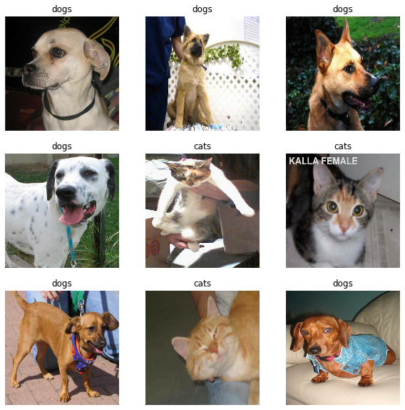val_batches = tf.data.experimental.cardinality(validation_dataset)

test_dataset = validation_dataset.take(val_batches // 5)

validation_dataset = validation_dataset.skip(val_batches // 5)

print('Number of validation batches: %d' % tf.data.experimental.cardinality(validation_dataset))

print('Number of test batches: %d' % tf.data.experimental.cardinality(test_dataset))

AUTOTUNE = tf.data.AUTOTUNE

train_dataset = train_dataset.prefetch(buffer_size=AUTOTUNE)

validation_dataset = validation_dataset.prefetch(buffer_size=AUTOTUNE)

test_dataset = test_dataset.prefetch(buffer_size=AUTOTUNE)

data_augmentation = tf.keras.Sequential([

  tf.keras.layers.RandomFlip('horizontal'),

  tf.keras.layers.RandomRotation(0.2),

])

for image, _ in train_dataset.take(1):

  plt.figure(figsize=(10, 10))

  first_image = image[0]

  for i in range(9):

    ax = plt.subplot(3, 3, i + 1)

    augmented_image = data_augmentation(tf.expand_dims(first_image, 0))

    plt.imshow(augmented_image[0] / 255)

    plt.axis('off')

for image, _ in train_dataset.take(1):

  plt.figure(figsize=(10, 10))

  first_image = image[0]

  for i in range(9):

    ax = plt.subplot(3, 3, i + 1)

    augmented_image = data_augmentation(tf.expand_dims(first_image, 0))

    plt.imshow(augmented_image[0] / 255)

    plt.axis('off')

# Create the base model from the pre-trained model

IMG_SHAPE = IMG_SIZE + (3,)

base_model = tf.keras.applications.MobileNetV2(input_shape=IMG_SHAPE,

                                               include_top=False,

                                               weights='imagenet')

image_batch, label_batch = next(iter(train_dataset))

feature_batch = base_model(image_batch)

print(feature_batch.shape)

(32, 5, 5, 1280)

base_model.trainable = False

Model: "mobilenetv2_1.00_160"

__________________________________________________________________________________________________

Layer (type) Output Shape Param # Connected to

==================================================================================================

input_1 (InputLayer) [(None, 160, 160, 3 0 []

)]

Conv1 (Conv2D) (None, 80, 80, 32) 864 ['input_1[0][0]']

bn_Conv1 (BatchNormalization) (None, 80, 80, 32) 128 ['Conv1[0][0]']

Conv1_relu (ReLU) (None, 80, 80, 32) 0 ['bn_Conv1[0][0]']

expanded_conv_depthwise (Depth (None, 80, 80, 32) 288 ['Conv1_relu[0][0]']

wiseConv2D)

expanded_conv_depthwise_BN (Ba (None, 80, 80, 32) 128 ['expanded_conv_depthwise[0][0]']

tchNormalization)

expanded_conv_depthwise_relu ( (None, 80, 80, 32) 0 ['expanded_conv_depthwise_BN[0][0

ReLU) ]']

expanded_conv_project (Conv2D) (None, 80, 80, 16) 512 ['expanded_conv_depthwise_relu[0]

[0]']

...

Total params: 2,257,984

Trainable params: 0

Non-trainable params: 2,257,984

inputs = tf.keras.Input(shape=(160, 160, 3))

x = data_augmentation(inputs)

x = preprocess_input(x)

x = base_model(x, training=False)

x = global_average_layer(x)

x = tf.keras.layers.Dropout(0.2)(x)

outputs = prediction_layer(x)

model = tf.keras.Model(inputs, outputs)

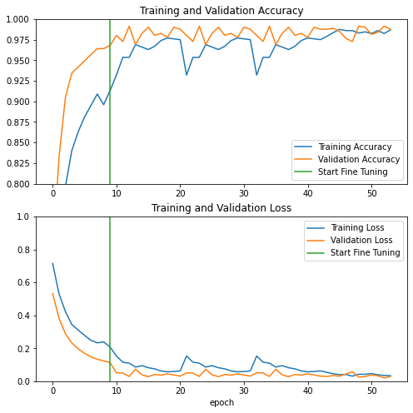

# Retrieve a batch of images from the test set

image_batch, label_batch = test_dataset.as_numpy_iterator().next()

predictions = model.predict_on_batch(image_batch).flatten()

# Apply a sigmoid since our model returns logits

predictions = tf.nn.sigmoid(predictions)

predictions = tf.where(predictions < 0.5, 0, 1)

print('Predictions:\n', predictions.numpy())

print('Labels:\n', label_batch)

plt.figure(figsize=(10, 10))

for i in range(9):

  ax = plt.subplot(3, 3, i + 1)

  plt.imshow(image_batch[i].astype("uint8"))

  plt.title(class_names[predictions[i]])

  plt.axis("off")

