

PROJECT REPORT
ON
STUDENT PERFORMANCE ANALYSIS
AS
A PARTIAL REQUIREMENT FOR THE DEGREE
OF
BACHELOR OF COMPUTER APPLICATION (BCA)

FOR SUBJECT
602 DATA ANALYSIS WITH PYTHON

Submitted by:
MITI A. PATEL (6305)
AMEE R. DESAI (6096)

Guided by:
Asst. Prof. Twinkle S. Panchal
Sutex Bank College of Computer Applications and Science, Amroli
PROJECT Completion Certificate

Acknowledgement

I would like to express my sincere thanks to my project guide, Asst. Prof. Twinkle S. Panchal, for her valuable guidance, support, and encouragement throughout the completion of this project. Her suggestions and clear explanations helped me understand the practical concepts of Data Analysis using Python in a better way.
I am also thankful to Sutex Bank College of Computer Applications and Science, Amroli, for providing me the opportunity and necessary resources to successfully complete this project. The academic environment and facilities provided by the college were very helpful during my project work.
I would like to extend my gratitude to all faculty members for their support and guidance. I am also thankful to my classmates and friends for their cooperation and helpful discussions, which made this project easier to complete.

INDEX

Sr. No. | Chapter title | Page no.
1 | Project Definition
2 | Dataset Details
3 | Python tools and libraries used
4 | Understanding data
5 | Understanding Spread of Data
6 | Automating EDA using Python
7 | Handling missing data and outliers
8 | Univariate Analysis
9 | Bivariate Analysis
10 | Multivariate Analysis
11 | Data Visualization
12 | Python Code
13 | Conclusion
14 | Reference

CH : 1 PROJECT DEFINATION :
Understanding Student performances in education
- Understanding student performance is very important for improving the quality of education. By analyzing student data, we can identify factors that affect academic results and overall performance.
- In this project, we analyze Student Performance Dataset using Python to find useful insights that can help teachers, institutions, and students.
- The dataset contains information like marks, attendance, study habits, and other academic details. By performing data analysis, we try to understand patterns and relationships that impact student success.
We aim to answer the following questions through this analysis:
- What is the distribution of student exam scores?
- What is the attendance distribution among students?
- Which diet quality category has the highest number of students?
- How are students distributed based on mental health ratings?
- Do students who study more hours perform better in exams?
- Does attendance percentage impact exam performance?
- Does diet quality influence academic results?
- Do students from different age groups perform differently in exams?
- How are students distributed across diet quality categories based on gender?
- Which student(s) achieved the highest exam score?

CH : 2 DATASET DETAILS :
Dataset Name: Student performance analysis
Dataset Source: https://www.kaggle.com/datasets/jayaantanaath/student-habits-vs-academic-performance
Dataset Type: Structured CSV dataset
Dataset Domain: Student Performance Analysis
Dataset Description :
The dataset contains information about:
- Student Id
- Student Name
- Age
- Gender
- Daily Study Hours
- Daily social media hours
- Sleep duration
- Attendance Percentage
- Diet quality
- Mental health rating
- Exam Score

This dataset is ideal for:
- EDA (Univariate, Bivariate, Multivariate)
- Handling missing values and outliers
- Data analysis using line chart, histogram, countplot, boxplot, heatmap etc.

Ch-3: Python tools and libraries used

Python 310
Python is a programming language widely used by Data Scientists. Python has in-built mathematical libraries and functions, making it easier to calculate mathematical problems and to perform data analysis.
Pandas
Pandas is a fundamental, open-source Python library for data manipulation and analysis, providing fast, flexible, and expressive data structures like DataFrames (2D tables) and Series (1D arrays) to handle tabular data efficiently, making it ideal for cleaning, transforming, exploring, and analyzing large datasets in data science, machine learning, and analytics. It simplifies tasks like reading/writing files (CSV, Excel), handling missing data, filtering, grouping, merging, and performing statistical analysis, integrating seamlessly with other tools like NumPy and Matplotlib.
NumPy
NumPy (Numerical Python) is a foundational Python library for data science, primarily used for its efficient multi-dimensional array object (the ndarray) and high-performance mathematical functions. It is a core component of the Python data science ecosystem, serving as the backbone for other major libraries like Pandas, Matplotlib, and scikit-learn.
Matplotlib
Matplotlib is a foundational, powerful Python library for creating a wide range of static, animated, and interactive visualizations in data science. It provides extensive customization options and serves as the backbone for many other visualization libraries like Seaborn.
Seaborn
Seaborn is a powerful Python library for statistical data visualization, built on Matplotlib, that creates attractive, informative plots with minimal code, seamlessly integrating with pandas DataFrames to reveal trends, relationships, and patterns in data, making it essential for Exploratory Data Analysis (EDA). It offers high-level functions for complex plots (like distributions, regressions, heatmaps, violin plots) with beautiful default styles, color palettes, and themes, simplifying the process of understanding data structures and distributions.
Scikit-learn
Scikit-learn (sklearn) is the most popular, open-source Python library for classical machine learning, providing simple and efficient tools for predictive data analysis. It is built on top of the scientific Python stack (NumPy, SciPy, Matplotlib) and is an essential tool for data scientists.

CH : 4 Understanding Data
# Step 1 : Importing necessary python libraries
import pandas as pd
import numpy as np
import matplotlib.pyplot as plt
import seaborn as sns

# Step 2: Creating the data frame
dataframe = pd.read_csv("student_perfomance.csv")

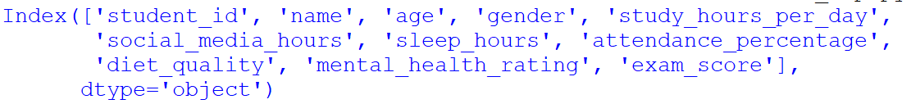

# Setting pandas display option to display all columns
pd.set_option('display.max_columns', None)
#display top few rows of the dataset
Print(dataframe.head(6))

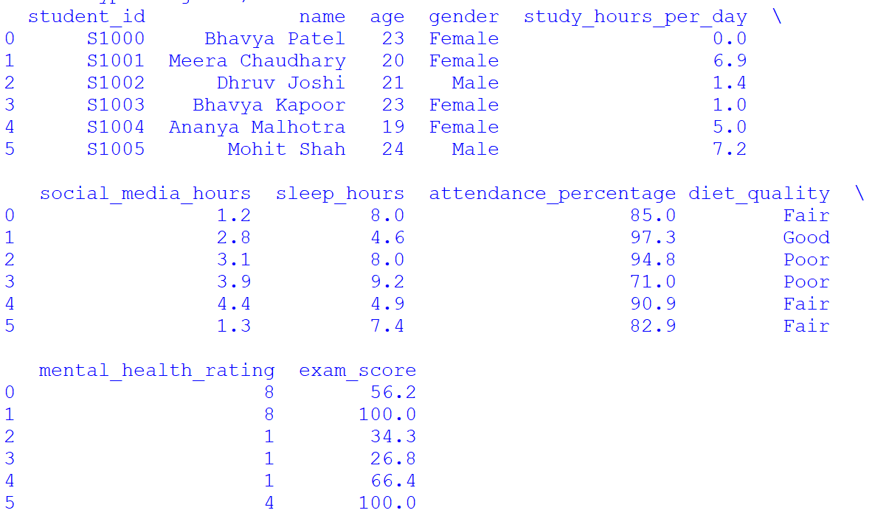

#display shape of dataset

# Step 3: Getting summary of the dataframe using df.info()
print("----------Dataset summary------------------")
dataframe.info()
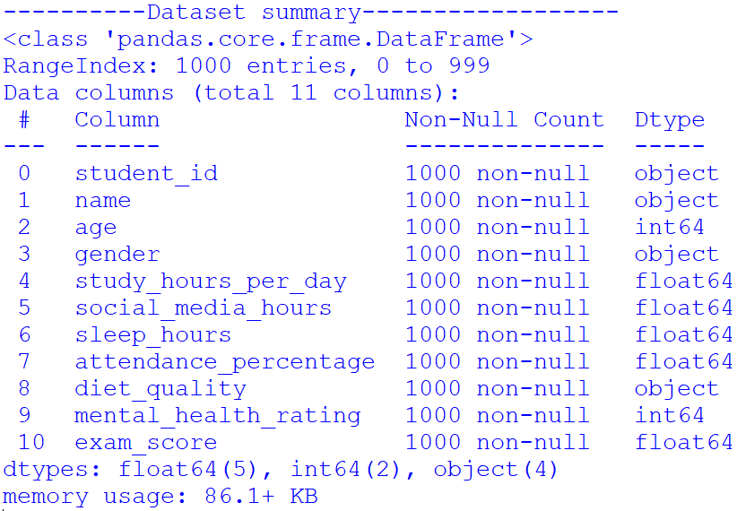

CH : 5 Understanding spread of data
To understand the distribution of student exam scores, we used a histogram with KDE. The histogram shows how many students fall into different score ranges, while the KDE curve shows the overall trend of the data. This helps in identifying whether most students scored low, average, or high marks.

# step 6: Visualize the distribution of 'exam_score' using Histogram with KDE
plt.figure(figsize=(8, 5))
sns.histplot(dataframe['exam_score'],bins=10,kde=True)
plt.title("Distribution and Spread of Student Exam Scores")
plt.xlabel("Exam Score")
plt.ylabel("Number of Students")
plt.show()
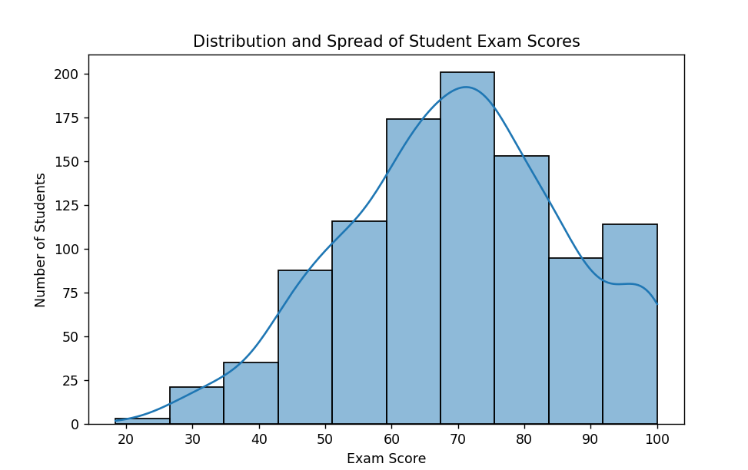
# Step 6.1 : Compare the spread of 'exam_score' across 'gender' using Box Plot
Further we have used boxplot to understand data spread of “Exam Score” across “Gender ” categories.
plt.figure(figsize=(8, 5))
sns.boxplot(x='gender',y='exam_score',data=dataframe)
plt.title("Exam Score Spread by Gender")
plt.xlabel("Gender")
plt.ylabel("Exam Score")
plt.show()
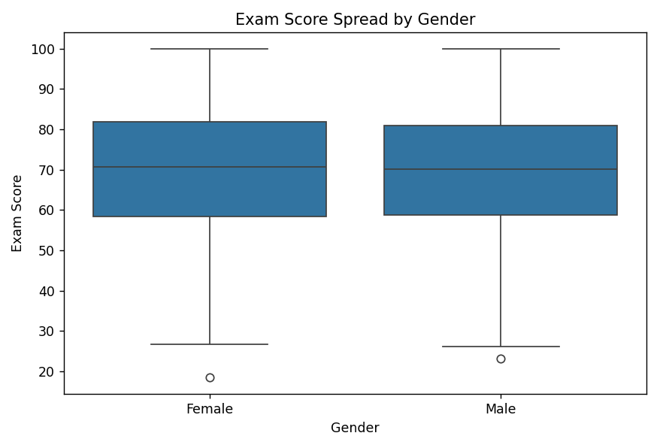

Ch-6: Automating EDA using python
Automating Exploratory Data Analysis (EDA) in Python is achieved using specialized libraries that generate comprehensive, interactive reports with just a few lines of code.
In Python's pandas library, df.info() and df.describe() are fundamental methods for performing initial exploratory data analysis (EDA).
df.info(): Provides a concise structural summary of the DataFrame. It provides following information about dataset:
- Data Types (Dtypes),
- Non-Null Counts,
- Column Names, Memory Usage,
- Total Entries/Rows df.describe(): Offers a statistical summary of the numerical data.
- Count: The number of non-null observations in each column.
- Mean: The average value.
- Std: The standard deviation (spread of data).
- Min: The minimum value.
- 25%, 50%, 75%: The first quartile, median (50th percentile), and third quartile.
- Max: The maximum value.
These functions help data analysts quickly understand the dataset's composition and spot potential issues like missing values or outliers without manually sifting through rows.

# Step : 3 Getting summary of the dataframe using df.info()
print("----------Dataset summary------------------")
dataframe.info()



# Step 3.1: Getting description of the dataframe using df.describe()
print("----------Dataset description------------------")
print(dataframe.describe())
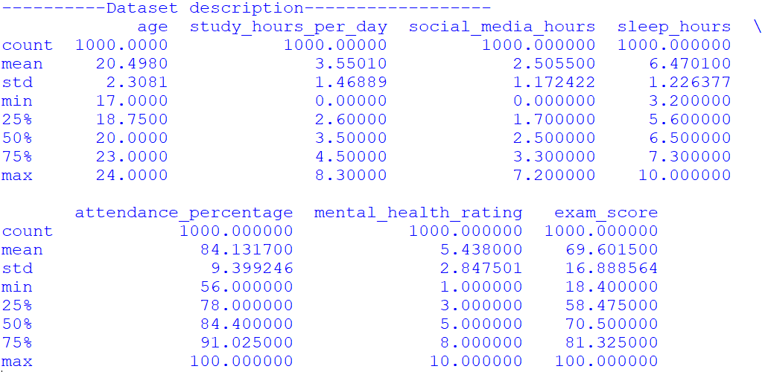

CH : 7 Handling missing data and outliers (Data cleaning and preparation)
Data Cleaning
Data cleaning is the process of identifying and correcting errors, missing values, and unwanted data present in the dataset. It ensures that the dataset is accurate, consistent, and ready for analysis.
Before starting exploratory data analysis, data cleaning and preparation were performed on the dataset. This step is important because raw data may contain missing values, incorrect formats, or unwanted noise which can affect analysis results.
In our Student Performance dataset, all columns were already available in structured format. Numerical columns such as study hours, attendance percentage, sleep hours, mental health rating, and exam scores were present in proper numeric data types. Therefore, no string conversion or noise removal was required.

Handling Missing Values
Missing values refer to empty or null entries present in the dataset. These values can create problems during statistical analysis and visualization.
#Step 4: To check missing values, the following pandas function was used:
print("---------Checking for missing or null values")
print(dataframe.isnull().sum())
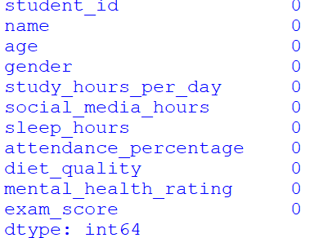
After executing this step, it was observed that no missing values were present in the dataset. Hence, no data removal or replacement techniques were required.

Outlier Detection
Outliers are extreme values that differ significantly from other observations. These values may affect the accuracy of analysis.
#Step 5: To identify outliers in exam scores, boxplot visualization was used:
sns.boxplot(dataframe["exam_score"])
plt.title("Outlier Detection in Exam Scores")
plt.show()
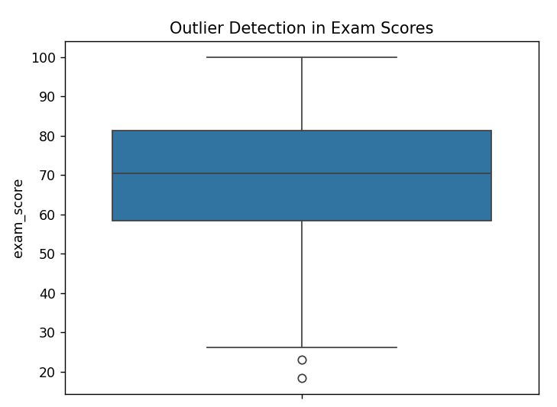
The boxplot helps in identifying minimum, maximum, median, and extreme values visually. After analysis, no major outliers impacting the dataset were observed.

CH : 8 Univariate analysis
Here we are exploring students’ diet quality distribution as a part of univariate analysis under Exploratory Data Analysis (EDA). This helps us understand how students are categorized based on their daily diet habits and identify the most common diet quality group.
We are using countplot() for this purpose.
countplot() using Seaborn is commonly used in EDA to visualize categorical data. A countplot shows the count (frequency) of each unique category in a categorical variable using bars. It helps in understanding how data is distributed across different groups.

# Step 7: Exploring Diet Quality Distribution (EDA – Univariate Analysis)
sns.countplot(x=dataframe['diet_quality'])
plt.title("Count of Students by Diet Quality")
plt.xlabel("Diet Quality")
plt.ylabel("Count")
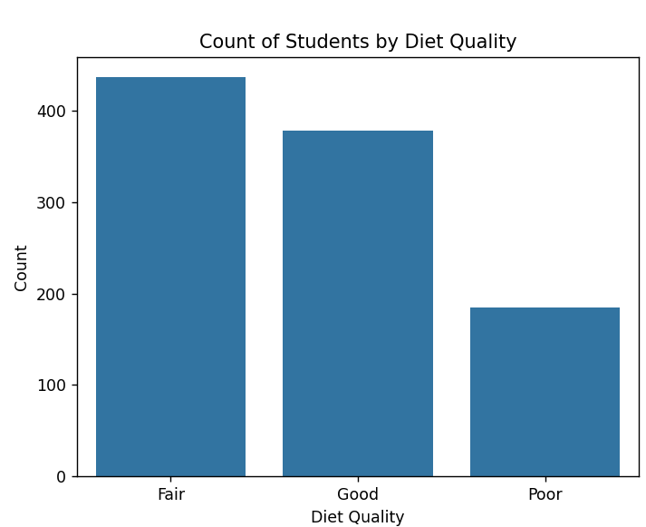
Conclusion:
The majority of the students fall under the “Average” diet quality category.

# Step 8 : Identify the Highest Scoring Student(EDA-Univariate Analysis)
max_score = dataframe['exam_score'].max()
student_with_max_score = dataframe.loc[dataframe['exam_score'] == max_score, 'name']
print("Student(s) with the highest exam score:")
print(student_with_max_score)
Conclusion:
The output shows the names of students who achieved the highest exam score in the dataset. It indicates that multiple students have secured the top score.

# Step 9: Mental Health Rating Distribution(EDA-Univariate Analysis)
Here we analyze mental health rating distribution using countplot. It shows how students are categorized based on their mental health levels.
sns.countplot(x=dataframe['mental_health_rating'])
plt.title("Mental Health Rating Distribution")
plt.xlabel("Mental Health Rating")
plt.ylabel("Number of Students")
plt.show()
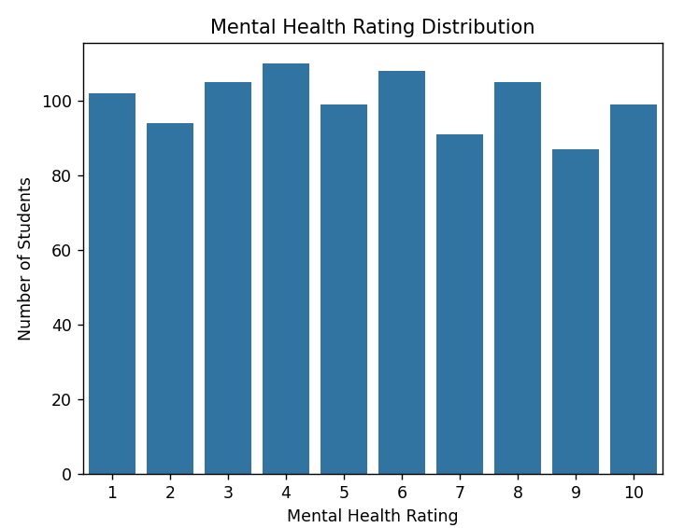
Conclusion:
Most students fall under the mid mental health rating category.
# Step 10 : Analyze Exam Score Distribution(EDA-Univariate Analysis)
plt.hist(dataframe['exam_score'], bins=5)
plt.title("Exam Score Distribution")
plt.xlabel("Exam Score")
plt.ylabel("Number of Students")
plt.show()
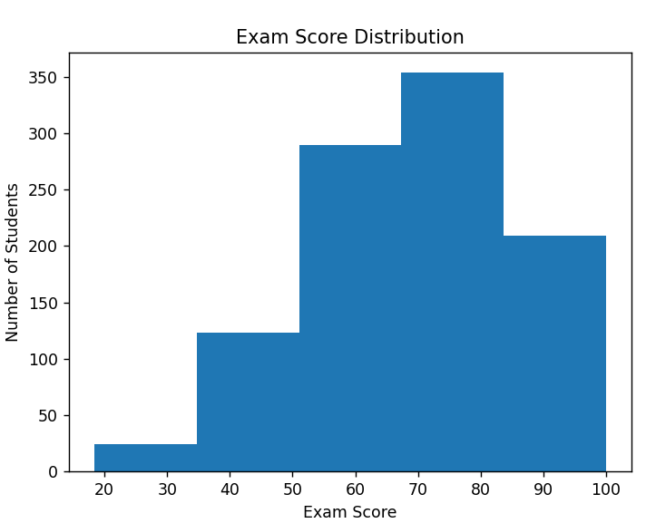
Conclusions:
Most students scored between 60 and 80 marks, indicating overall average to good performance.
#step 11: Analysing attendance percentage distribution(EDA-Univariate Analysis)
sns.histplot(dataframe['attendance_percentage'], bins=10)
plt.title("Attendance Percentage Distribution")
plt.xlabel("Attendance Percentage")
plt.ylabel("Number of Students")
plt.show()
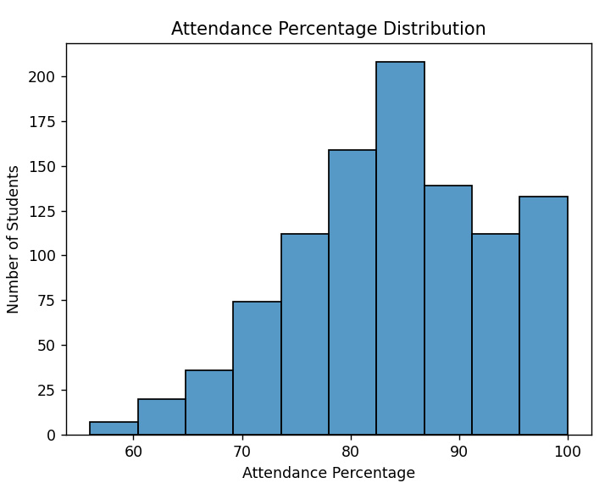

Conclusion:
Most students have attendance between 70% and 90%.

CH : 9 Bivariate analysis
Here we are exploring study hours by exam score as a part of bivariate analysis under Exploratory Data Analysis. This will answer our question: Do students who study more hours score better in exams.
First, we are selecting a sample of 500 records from the dataset for clear visualization. Then we are using the groupby() function to find study hours wise average exam score data. Finally, we are using a line chart to represent this data visually.
# Step 12 : Exploring Study Hours by Exam Score (EDA - Bivariate Analysis)
sample_data=dataframe.sample(500,random_state=1)
grouped_data=sample_data.groupby('study_hours_per_day')['exam_score'].mean()
print(grouped_data)
result=pd.DataFrame({'exam_score':grouped_data})
print(result)
plt.plot(result,marker='o',c='green')
plt.xlabel('Study Hours Per Day')
plt.ylabel('Average Exam Score')
plt.title('Study Hours vs Exam Score')
plt.show()
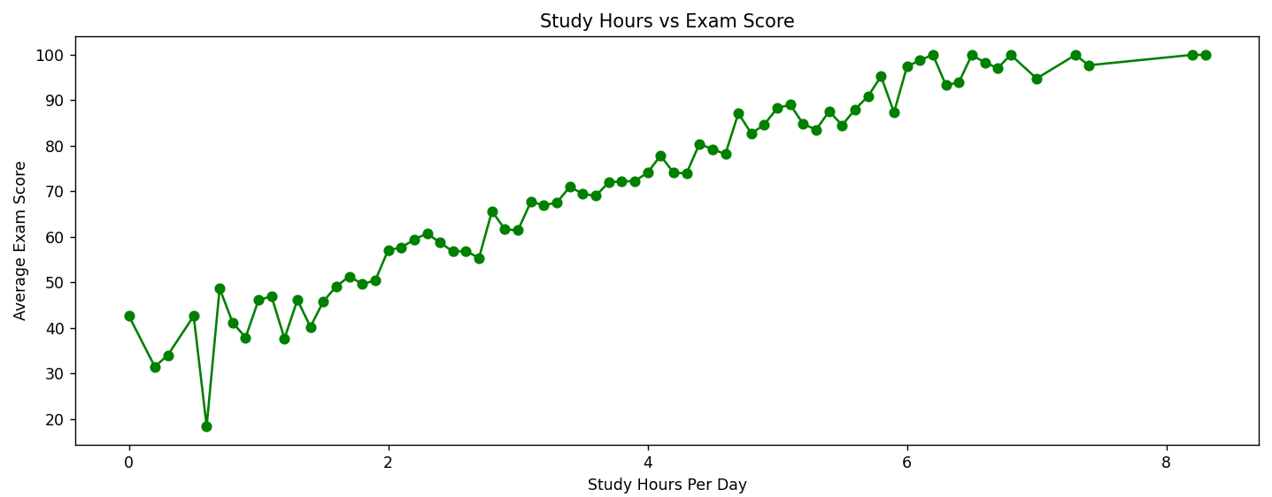
Conclusion:
Students who study around 6 to 8 hours per day achieve the highest average exam scores, while students studying fewer hours score comparatively lower marks.

# Step 13 : Exam Score Comparison - Diet Quality(EDA-Bivariate Analysis)
Here we are comparing exam scores by diet quality as a part of bivariate analysis under Exploratory Data Analysis.
This will answer our question:
Do students with better diet quality perform better in exams?
plt.figure(figsize=(6,6))
sns.boxplot(x='diet_quality',y='exam_score',data=dataframe)
plt.xlabel('Diet Quality')
plt.ylabel('Exam Score')
plt.title('Exam Score Comparison by Diet Quality')
plt.show()
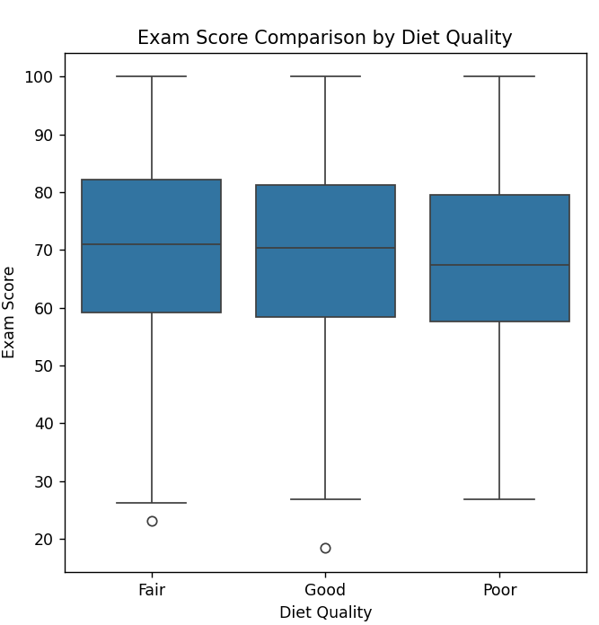
Conclusion:
Students with good diet quality tend to achieve higher exam scores compared to other diet groups.

# Step 14: Exploring Exam Score by Age Group (EDA – Bivariate Analysis)
dataframe['age_group']=pd.cut(dataframe['age'],bins=[17,18,19,20,21],labels=['17-18','18-19','19-20','20-21'])
sns.boxplot(x='age_group',y='exam_score',data=dataframe)
plt.xlabel('Age Group')
plt.ylabel('Exam Score')
plt.title('Exam Score by Age Group')
plt.show()
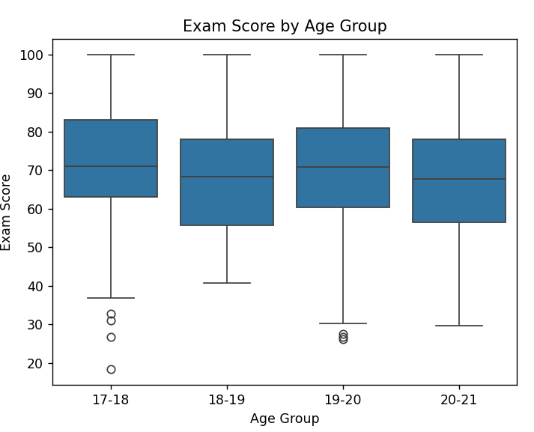
Conclusion:
The boxplot shows that exam performance is fairly similar across all age groups. There is no significant difference in scores, indicating that age has minimal impact on student academic performance.
CH : 10 Multivariate analysis
X`# Step 15: Gender Distribution by Diet Quality(EDA-Multivariate Analysis)
pivot_table=dataframe.pivot_table(index='diet_quality',columns='gender',aggfunc='size',fill_value=0)
sns.heatmap(pivot_table,annot=True,cmap='YlGnBu',fmt='d')
plt.title('Gender Distribution by Diet Quality')
plt.xlabel('Gender')
plt.ylabel('Diet Quality')
plt.show()
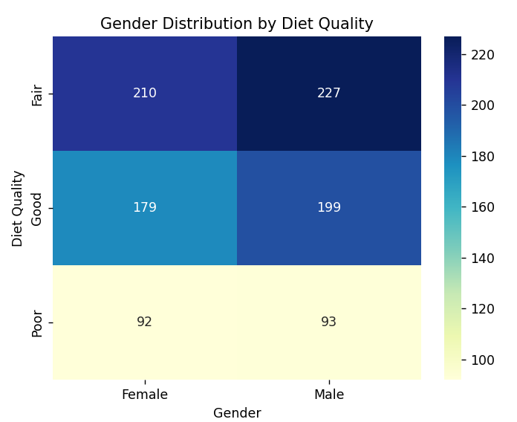
Conclusion:
With this analysis, we can say that most students fall under the Fair diet quality category across both genders. Male students are slightly higher in number in all diet groups, while the Poor diet category has the lowest student count. This suggests that diet quality distribution is fairly similar between male and female students, with a majority maintaining a fair level diet.

CH 11: Data Visualization
Data visualization plays a crucial role in understanding patterns, trends, and relationships in the dataset. Visual representations make complex numerical data easier to interpret and analyze.
In this project, various visualization techniques were used to explore student performance and related factors.
- Visualize the spread of ‘exam_score’ using Histogram


- Compare exam score by gender using Boxplot

- Visualize diet quality distribution using Countplot
Conclusion:
The majority of the students fall under the “Average” diet quality category.

- Visualize mental health rating distribution using Countplot

Conclusion:
Most students fall under the mid mental health rating category.

- Visualize the spread of ‘exam_score’ using Histogram

Conclusion:
Most students scored between 60 and 80 marks, indicating overall average to good performance.

- Visualize the spread of ‘attendance_percentage’ using Histogram

Conclusion:
Most students have attendance between 70% and 90%.


- Visualize study hours vs exam score using Line Chart
Conclusion:
Students who study around 6 to 8 hours per day achieve the highest average exam scores, while students studying fewer hours score comparatively lower marks.

- Compare exam score by diet quality using Boxplot

Conclusion:
Students with good diet quality tend to achieve higher exam scores compared to other diet groups.

- Compare exam score by age group using Boxplot

Conclusion:
The boxplot shows that exam performance is fairly similar across all age groups. There is no significant difference in scores, indicating that age has minimal impact on student academic performance.

- Visualize gender distribution by diet quality using Heatmap

Conclusion:
With this analysis, we can say that most students fall under the Fair diet quality category across both genders. Male students are slightly higher in number in all diet groups, while the Poor diet category has the lowest student count. This suggests that diet quality distribution is fairly similar between male and female students, with a majority maintaining a fair level diet.
CH : 12 Python Code

# Step 1 : Importing necessary python libraries
import pandas as pd
import numpy as np
import matplotlib.pyplot as plt
import seaborn as sns

# Step 2: Creating the data frame
dataframe = pd.read_csv("student_perfomance.csv")
print(dataframe.columns)

#Setting pandas display option to display all columns
pd.set_option('display.max_columns', None)

#display top few rows of the dataset
print(dataframe.head(6))

#display shape of dataset
print(dataframe.shape)

#step 3: Getting summary of the dataframe using df.info()
print("----------Dataset summary------------------")
dataframe.info()

# Step 3.1: Getting description of the dataframe using df.describe()
print("----------Dataset description------------------")
print(dataframe.describe())

#step 4: checking and handling missing values
print("---------Checking for missing or null values")
print(dataframe.isnull().sum())

#step 5: handling outliers of exam score
sns.boxplot(dataframe["exam_score"])
plt.title("Outlier Detection in Exam Scores")
plt.show()

#step 6: Visualize the distribution of 'exam_score' using Histogram with KDE
plt.figure(figsize=(8, 5))
sns.histplot(dataframe['exam_score'],bins=10,kde=True)
plt.title("Distribution and Spread of Student Exam Scores")
plt.xlabel("Exam Score")
plt.ylabel("Number of Students")
plt.show()

#step 6.1: Compare the spread of 'exam_score' across 'gender' using Box Plot
plt.figure(figsize=(8, 5))
sns.boxplot(x='gender',y='exam_score',data=dataframe)
plt.title("Exam Score Spread by Gender")
plt.xlabel("Gender")
plt.ylabel("Exam Score")
plt.show()

# Step 7: Exploring Diet Quality Distribution (EDA – Univariate Analysis)
sns.countplot(x=dataframe['diet_quality'])
plt.title("Count of Students by Diet Quality")
plt.xlabel("Diet Quality")
plt.ylabel("Count")
plt.show()

# Step 8: Identify the Highest Scoring Student(EDA-Univariate Analysis)
max_score = dataframe['exam_score'].max()
student_with_max_score = dataframe.loc[dataframe['exam_score'] == max_score, 'name']
print("Student(s) with the highest exam score:")
print(student_with_max_score)

# Step 9: Mental Health Rating Distribution(EDA-Univariate Analysis)
sns.countplot(x=dataframe['mental_health_rating'])
plt.title("Mental Health Rating Distribution")
plt.xlabel("Mental Health Rating")
plt.ylabel("Number of Students")
plt.show()

# Step 10: Analyze Exam Score Distribution(EDA-Univariate Analysis)
plt.hist(dataframe['exam_score'], bins=5)
plt.title("Exam Score Distribution")
plt.xlabel("Exam Score")
plt.ylabel("Number of Students")
plt.show()

#step 11: Analysing attendance percentage distribution(EDA-Univariate Analysis)
sns.histplot(dataframe['attendance_percentage'], bins=10)
plt.title("Attendance Percentage Distribution")
plt.xlabel("Attendance Percentage")
plt.ylabel("Number of Students")
plt.show()

# Step 12: Exploring Study Hours by Exam Score (EDA - Bivariate Analysis)
sample_data=dataframe.sample(500,random_state=1)
grouped_data=sample_data.groupby('study_hours_per_day')['exam_score'].mean()
print(grouped_data)
result=pd.DataFrame({'exam_score':grouped_data})
print(result)
plt.plot(result,marker='o',c='green')
plt.xlabel('Study Hours Per Day')
plt.ylabel('Average Exam Score')
plt.title('Study Hours vs Exam Score')
plt.show()

# Step 13: Exam Score Comparison - Diet Quality(EDA-Bivariate Analysis)
plt.figure(figsize=(6,6))
sns.boxplot(x='diet_quality',y='exam_score',data=dataframe)
plt.xlabel('Diet Quality')
plt.ylabel('Exam Score')
plt.title('Exam Score Comparison by Diet Quality')
plt.show()

# Step 14: Exploring Exam Score by Age Group (EDA – Bivariate Analysis)
dataframe['age_group']=pd.cut(dataframe['age'],bins=[17,18,19,20,21],labels=['17-18','18-19','19-20','20-21'])
sns.boxplot(x='age_group',y='exam_score',data=dataframe)
plt.xlabel('Age Group')
plt.ylabel('Exam Score')
plt.title('Exam Score by Age Group')
plt.show()

# Step 15: Gender Distribution by Diet Quality(EDA-Multivariate Analysis)
pivot_table=dataframe.pivot_table(index='diet_quality',columns='gender',aggfunc='size',fill_value=0)
sns.heatmap(pivot_table,annot=True,cmap='YlGnBu',fmt='d')
plt.title('Gender Distribution by Diet Quality')
plt.xlabel('Gender')
plt.ylabel('Diet Quality')
plt.show()

CH : 13 Conclusion
By applying different data analysis techniques, and based on the statistical and visual results, we have reached on following conclusions:
- The majority of the students scored between 60 to 80 marks in exams.
- Students who study more hours tend to achieve higher exam scores.
- Students with higher attendance percentage generally perform better academically.
- The majority of the students fall under the “Fair” diet quality category.
- Students with good diet quality tend to score slightly higher than others.
- Mental health ratings of most students fall in the average to good range.
- Exam performance is fairly similar across both gender categories.
- Students from different age groups show almost similar academic performance.
- The highest exam scores are achieved by students who maintain consistent study hours and attendance.
- The heatmap analysis shows that most students across both genders fall into the Fair diet category, while the Poor diet category has the lowest count.

CH : 14 Reference
- Python Official Documentation: https://docs.python.org/3/
- Pandas Official Documentation: https://pandas.pydata.org/docs/
- NumPy Official Documentation: https://numpy.org/doc/
- Seaborn Official Documentation: https://seaborn.pydata.org/
- Matplotlib Official Documentation: https://matplotlib.org/stable/index.html
- Kaggle Dataset Source: https://www.kaggle.com/

