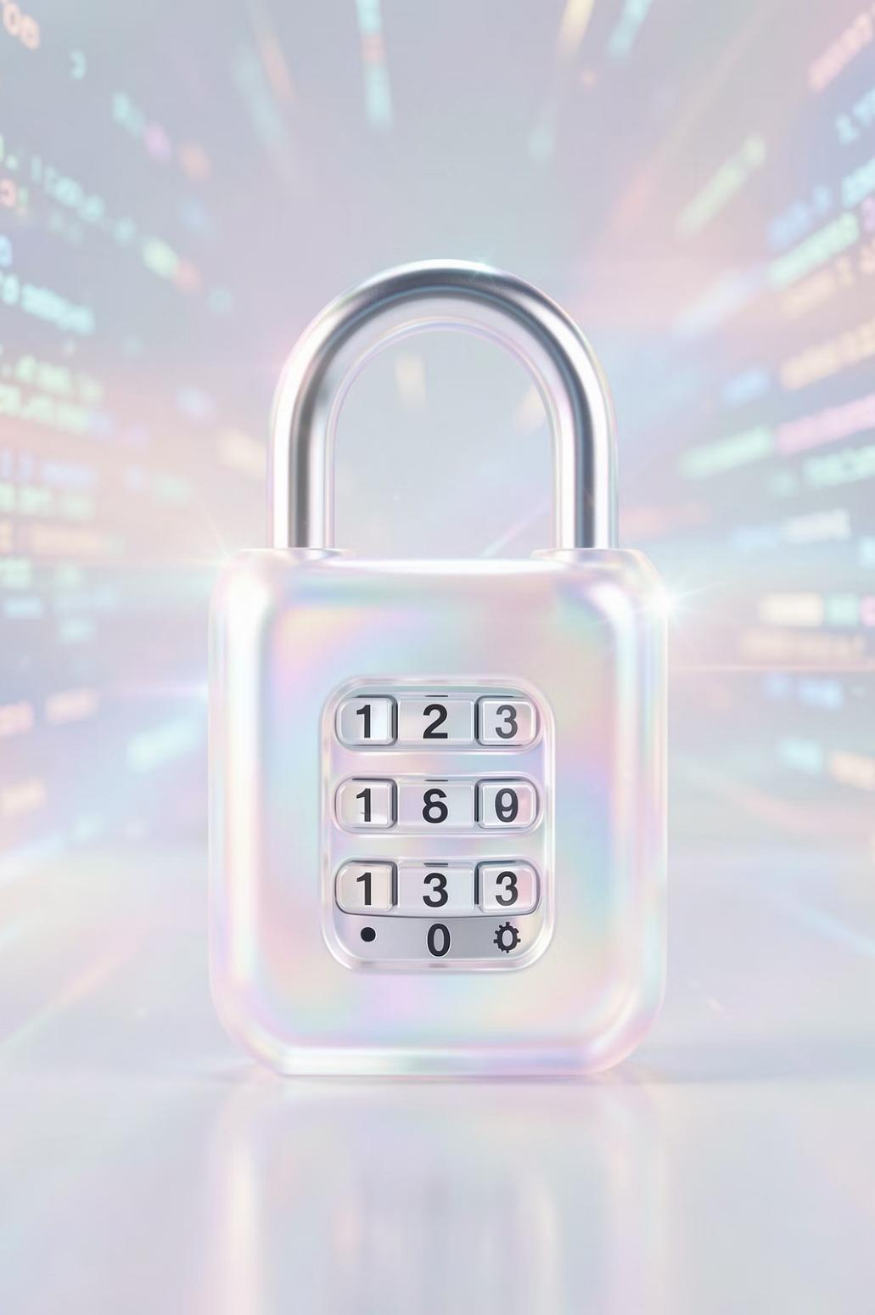

Cyber security Made Easy: Protecting Yourself Online
In today's interconnected world, understanding cyber security isn't just for tech experts – it's for everyone. This presentation will guide you through simple steps to safeguard your digital life, ensuring your online experience remains safe and secure.



Why Cybersecurity Matters

1

Constant Ǐhreat
A cybercrime occurs every 7 minutes globally, highlighting the pervasive nature of online risks.
2

Business Impact
Small businesses face significant financial losses, averaging $40,000 per cyber attack, threatening their very existence.
3

Personal Risk
Cyber attacks can compromise your money, sensitive data, and privacy, leading to identity theft and financial ruin.






Who Are Cyber Criminals?
Cyber criminals are diverse, but often share common motivations. Understanding them is the first step in defense.
Outsiders Primarily: Most attackers are external individuals or groups focused on financial gain or disruption.
Common Motives: Their goals typically include stealing money, corporate espionage, or simply causing chaos and damage.
Organized Crime: Over half of all cyber attacks are orchestrated by sophisticated organized crime groups, making them highly dangerous.

Common Cyber Ǐhreats You Should Know

 Phishing
Deceptive emails designed to trick you into revealing personal information, like passwords or bank details.

Malware
Malicious software like viruses or spyware that can damage your device, steal data, or spy on your activities.

 Ransomware
A type of malware that encrypts your files and demands a ransom payment to restore access.

 Business Email Compromise (BEC)
Sophisticated scams where attackers impersonate executives to trick employees into making fraudulent money transfers or sharing sensitive data.



How Phishing Works: A Real Example
Phishing attacks are one of the most common and effective ways cyber criminals gain access. Here’s a typical scenario:





Malicious Link
Redirects to spoofed site

Fake Email
Seemingly legitimate message

Stolen Credentials
Attacker captures login details


This example illustrates how easily a user can be misled by a seemingly legitimate email, emphasizing the need for constant vigilance.

Simple Steps to Stay Safe Online

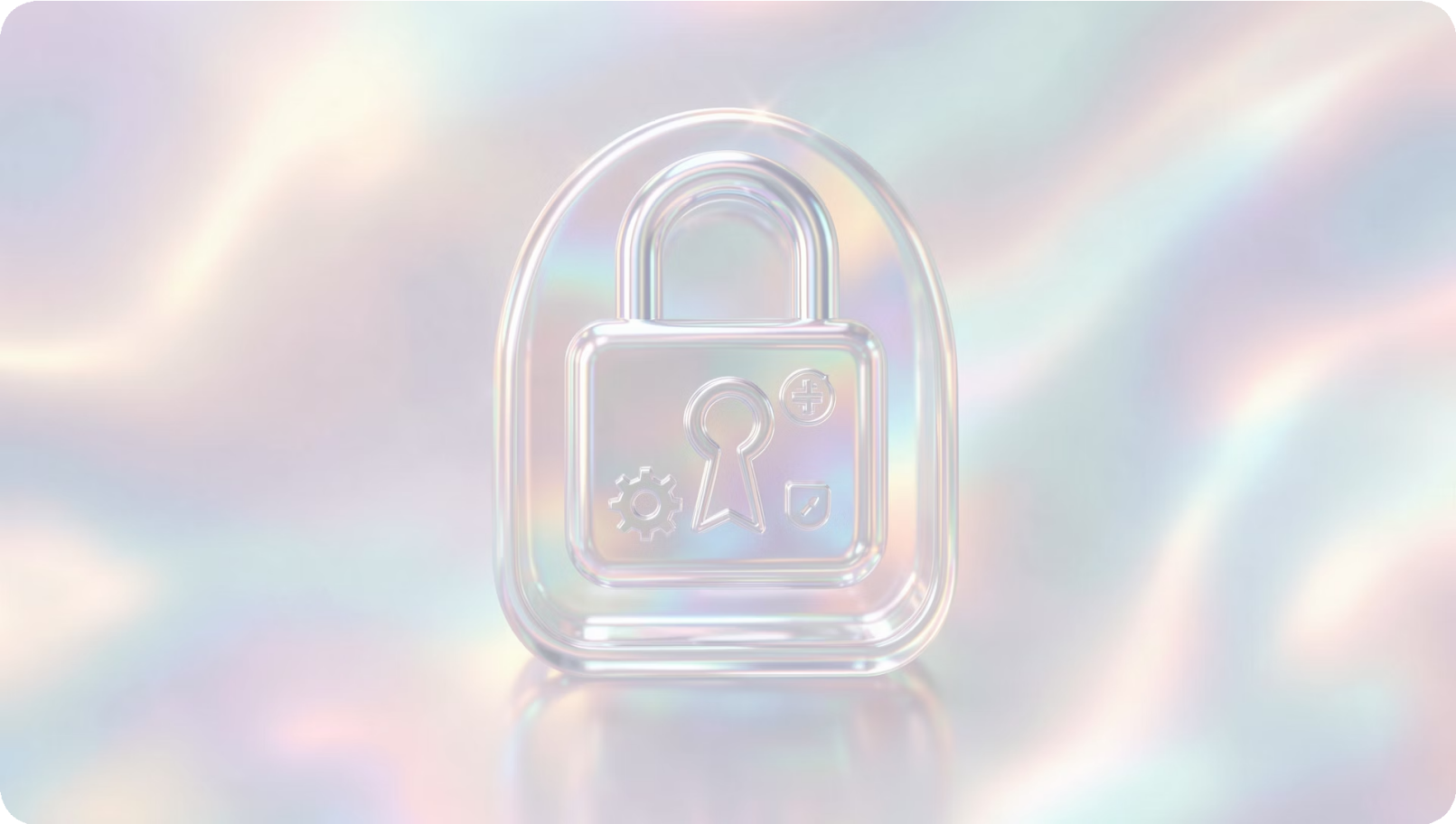
Strong, Unique Passwords: Create complex passwords for each account using a mix of letters, numbers, and symbols. Consider a password manager.
Multi-Factor Authentication (MFA): Enable MFA wherever possible for an extra layer of security, often requiring a code from your phone in addition to your password.
Automatic Software Updates: Keep your operating system, applications, and antivirus software up to date. Enable automatic updates to patch vulnerabilities as soon as they're discovered.
Think Before You Click: Always hover over links to check their true destination and scrutinize email attachments before opening them. If something feels off, it probably is.

Protect Your Data with Backups

Data loss can be devastating, whether from a cyber attack, hardware failure, or accidental deletion. Implementing a robust backup strategy is your best defense.
Regular Saves: Consistently save copies of all your critical files. This includes documents, photos, videos, and any important business data.
Offline or Cloud: Store backups either on an external hard drive (offline) or use a reputable cloud storage service for accessibility and off- site protection.
Test Your Backups: Periodically verify that your backup files are intact and can be successfully restored. A backup that doesn't work when you need it is no backup at all.

Cyber Hygiene: Daily Habits Ǐhat Help





Keep Secrets Safe
Never share your passwords or sensitive personal information with anyone, even if they claim to be from a trusted organization.

Log Out Properly
Always log out of your accounts, especially on shared or public computers, to prevent unauthorized access.

Public Wi-Fi Caution
Avoid conducting sensitive activities like online banking on public Wi-Fi. If you must, use a Virtual Private Network (VPN).

Smart Downloading
Be extremely careful about what you download or install. Only use trusted sources and check reviews if unsure.



What Ǐo Do If You Suspect a Cyber Attack
Quick action is crucial in minimizing damage from a cyber attack. Follow these steps:
Disconnect: Immediately unplug your device from the internet (disconnect Wi-Fi or Ethernet cable).
Change Passwords: On a secure, clean device, change all compromised passwords, prioritizing critical accounts like email and banking.
Report: Notify your IT department, if applicable, or report the incident to relevant authorities like the FBI's IC3 or local police.
Do Not Engage: Never pay ransom or respond to demands from attackers. This can encourage further attacks and doesn't guarantee data recovery.

Stay Cyber Smart Every Day

Shared Responsibility
Cybersecurity is not just an IT department's job; it's a collective effort that starts with each individual.
Spread Awareness
Empower your family, friends, and colleagues by sharing these essential cybersecurity tips and best practices.
Continuous Learning
The threat landscape constantly evolves. Stay informed about new threats and security measures to protect your digital life.
Caution is Key
A small amount of vigilance and common sense can go a long way in preventing most cyber incidents.

Thank You
I hope this presentation has provided you with valuable insights and practical steps to enhance your online safety. Your vigilance is the first line of defense against cyber threats.
Stay safe, stay vigilant!

