INDEX

NO | CONTENT | PAGE NO
1 | Introduction  - ProjectDescription  - ProjectProfile
2 | Objectives
3 | SystemFlowDiagram
4 | DFD/UMLDiagram
5 | ERDiagram
6 | DatabaseDesign
7 | SystemDesign


1.Introduction

ProjectDescription

    - The FixItNow is an online platform for submitting and tracking complaints about public services or community issues.
    - This system is fully responsive, mobile friendly,andfeaturesareattractiveuser interface.
    - TheBookReviewSystemconsistsoftwo panels :
      - AdminPanel
      - UserPanel

- UserPanel:-

  - Require login with an user account.
  - New User must be done registration.
  - A User can view details on dashboard where their active, pending, and resolved grievances.
  - User can track the real-time status of their grievance and receive notifications about any updates.
ProjectProfile

ProjectTitle | "FixItNow: Digital Grievance Portal"
ProjectDefinition | FixItNow is an online platform for submitting and tracking complaints about public services or community issues. It ensures quick resolution, improves transparency, and enhances communication between citizens and authorities.
FrontEndTechnology | React.js,HTML,CSS,BOOTSTRAP
BackEnd Technology | PHP
Database | MYADMIN
Modules Details | login/registrastion/dashboard/Complaint Tracking
GroupMember |  | Roll No | Name
 |  | 601 | AMEE DESAII
 |  | 617 | JIYA PANSURIYA
 |  | 622 | FORAM PIPALIYA
Guidename | Ms. Twinkal Panchal


2.Objectives

The objective of the FixItnow Website project is to build a role-basedonline platform where:

- The main objective of the FixItNow website is to provide a simple
and digital platform where people can register their complaints
related to public services like electricity, water, roads, health,
education, and other civic issues.

- Instead of visiting offices again and again, citizens can easily submit
their Problems online anytime and from anywhere.

- Admins can manage user complaints by adding,editing,and deleting complaints,as well as tracking complaints.

- Userscanregister,login,view details on dashboard where their active, pending, and resolved grievances.

- Another important objective is to ensure transparency and accountability. When a user submits a grievance, the system generates a unique complaint ID.

- users can track the real-time progress of their complaint until it is
resolved. This helps people trust the system because they can clearly
see who is handling their issue and what steps are being taken.

- In short, the objectives of FixItNow are to empower citizens, make
grievance redressal faster, increase transparency, and improve
public service delivery with the help of digital technology.
.


3.SystemFlowDiagram

- AdminProcessFlowDiagram
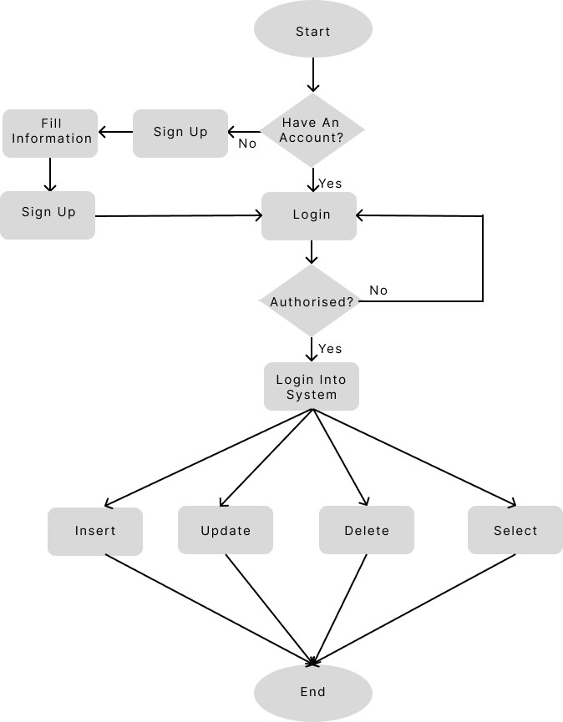

- UserProcessFlowDiagram

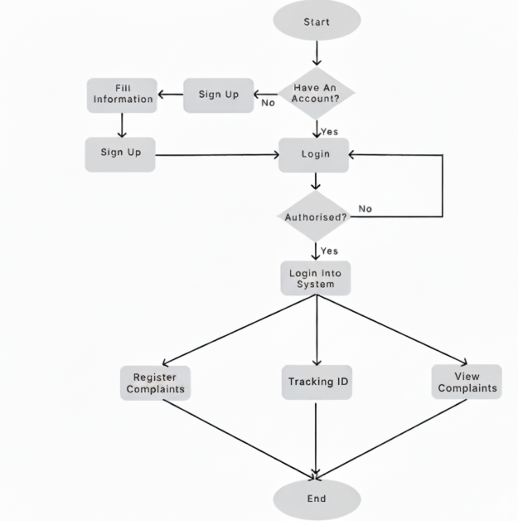


4.DFD/UMLDiagram
- 0LevelDiagram(ContextDiagram):

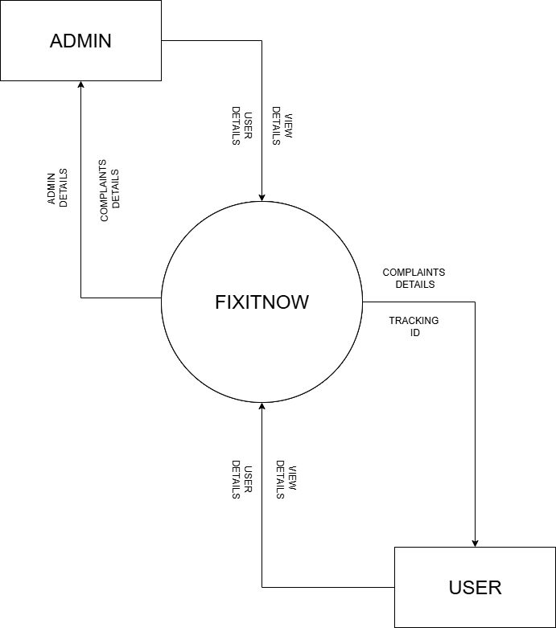

- 1levelAdminDiagram:

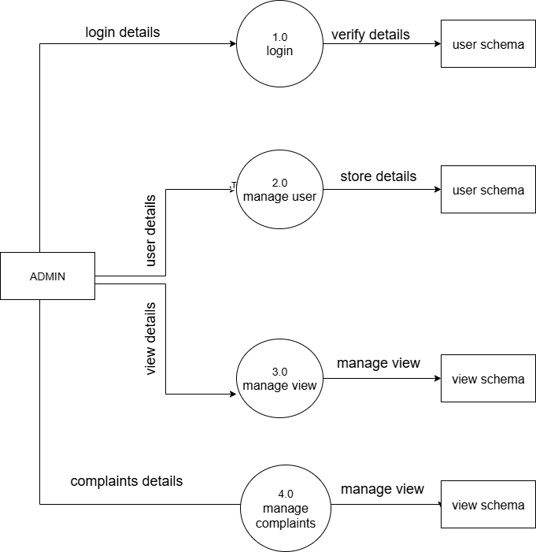


5.ERDiagram
BookReviewWebsite-DatabaseSchema
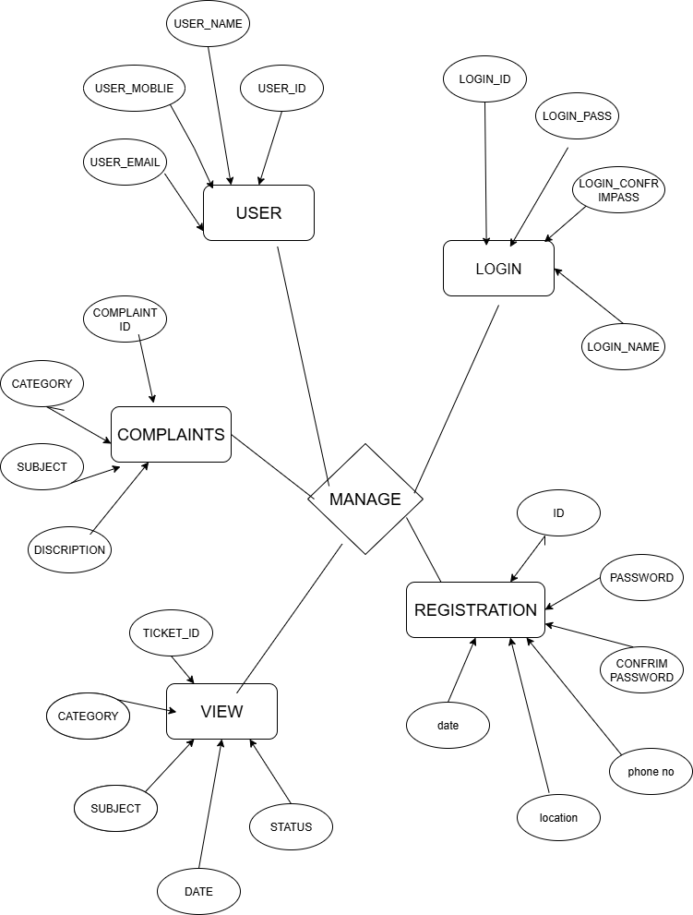

UserCollection
6.DatabaseDesign

Field | Type | Description
_id | ObjectId | Unique identifier for the user
name | String | Full name of the user
email | String | Unique email,used for login
phoneNumber | String | Unique phone number
password | String | Hashed password
createdAt | Date | Timestamp(autoby Mongoose)
Confirm password | string | Hashed password
Field | Type | Description
_id | ObjectId | Unique identifier for the user
name | String | Fullnameofthe user
email | String | Uniqueemail,usedforlogin

ComplaintCollection

Field | Type | Description
_id | ObjectId | Unique identifier for complain
category | String | Complain category
subject | String | Subject of complain
description | String | description
location | String | Location
Priority level | Date | Priority level of complain
Name | String | Name of person
Contact method | ObjectId | Contact of person

createdAt | Date | Timestamp
updatedAt | Date | Timestamp

ReviewCollection

Field | Type | Description
Ticket_id | ObjectId | Unique identifier for the  Review complain
subject | string | Review subject of complain
category | string | Review category of complain
date | date | Review date of complain created
status | String | Review status of complain
createdAt | Date | Timestamp


7.SystemDesign
Homepage
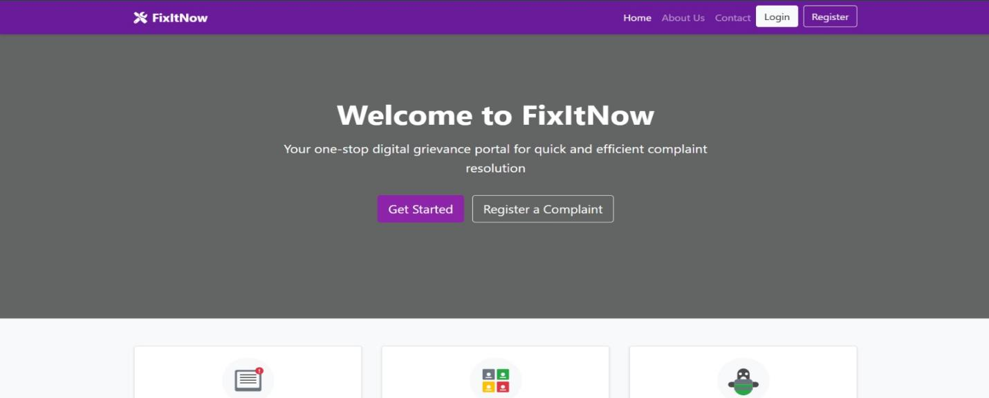

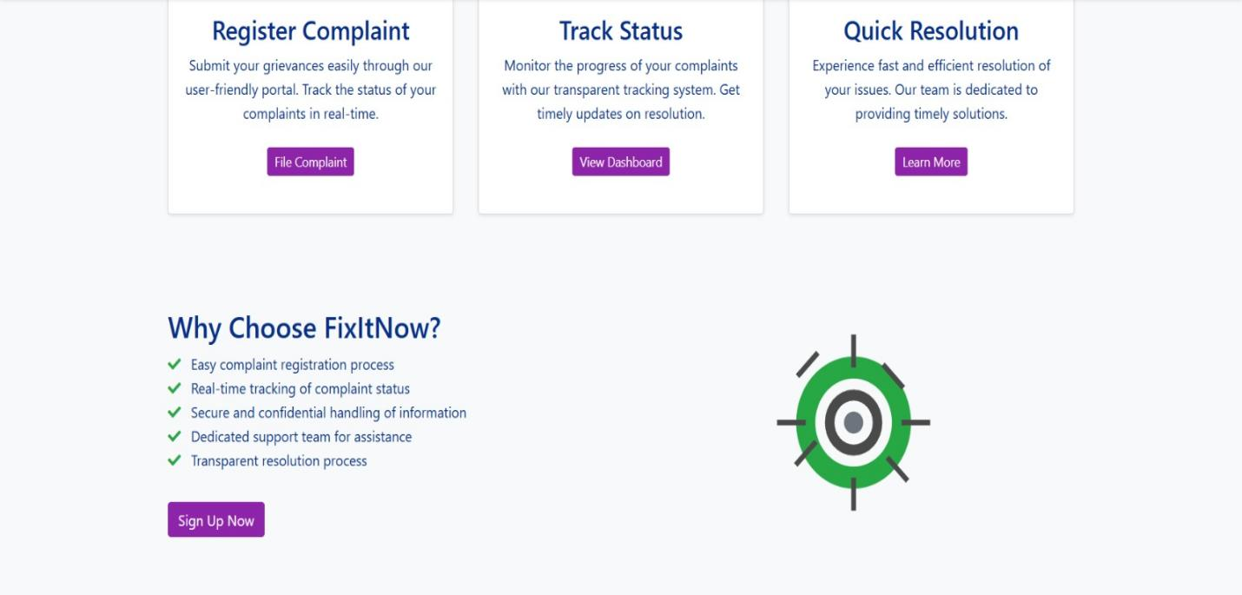

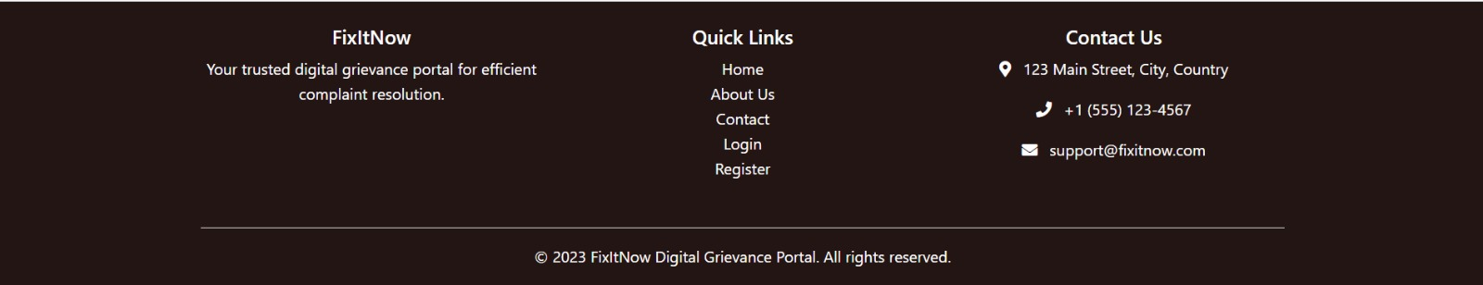

Loginpage

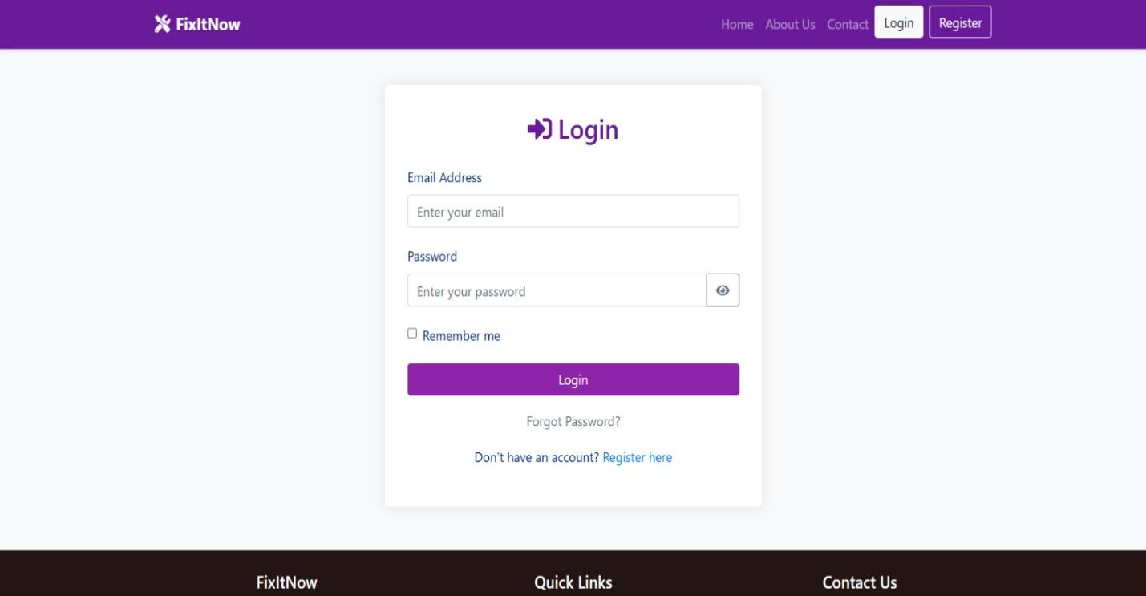

Registrationpage

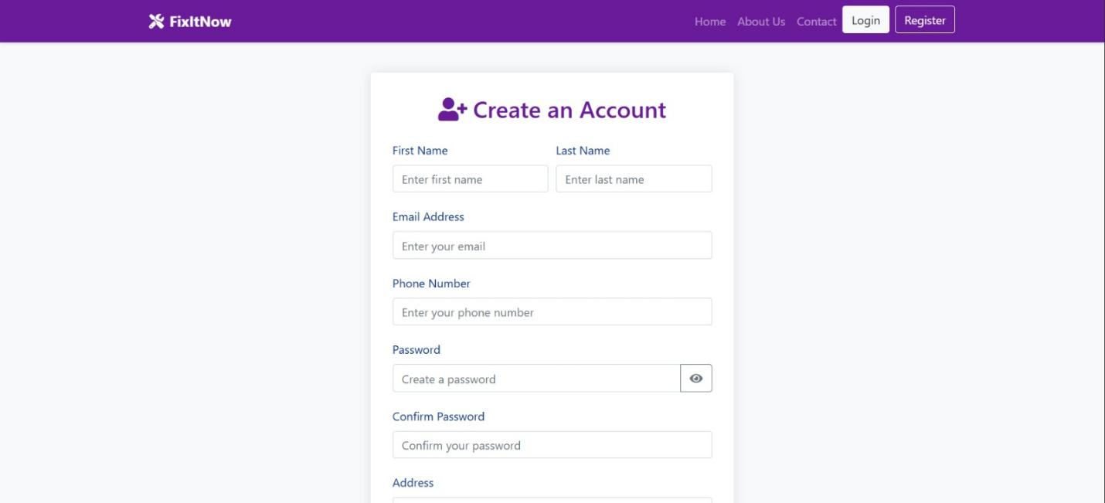

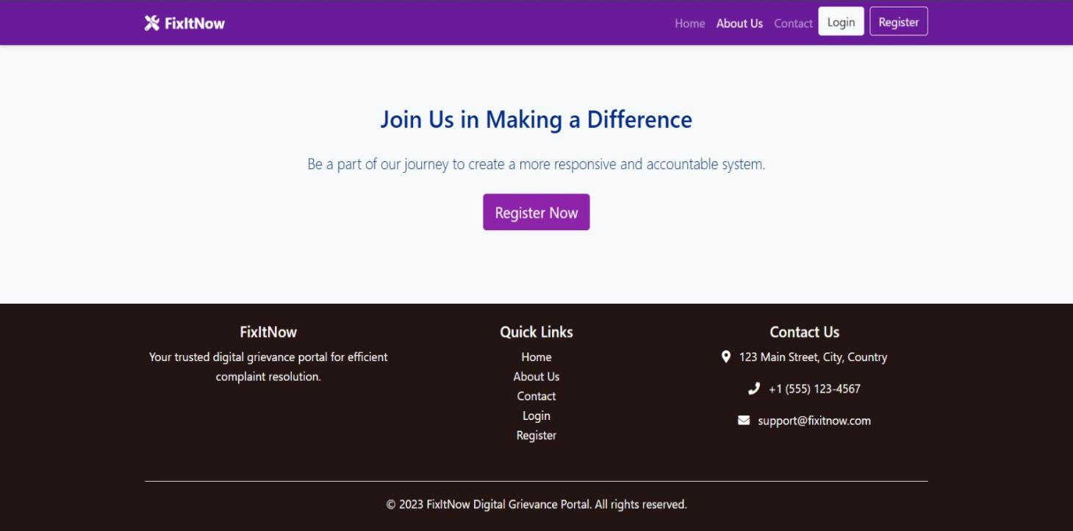

Dashboard

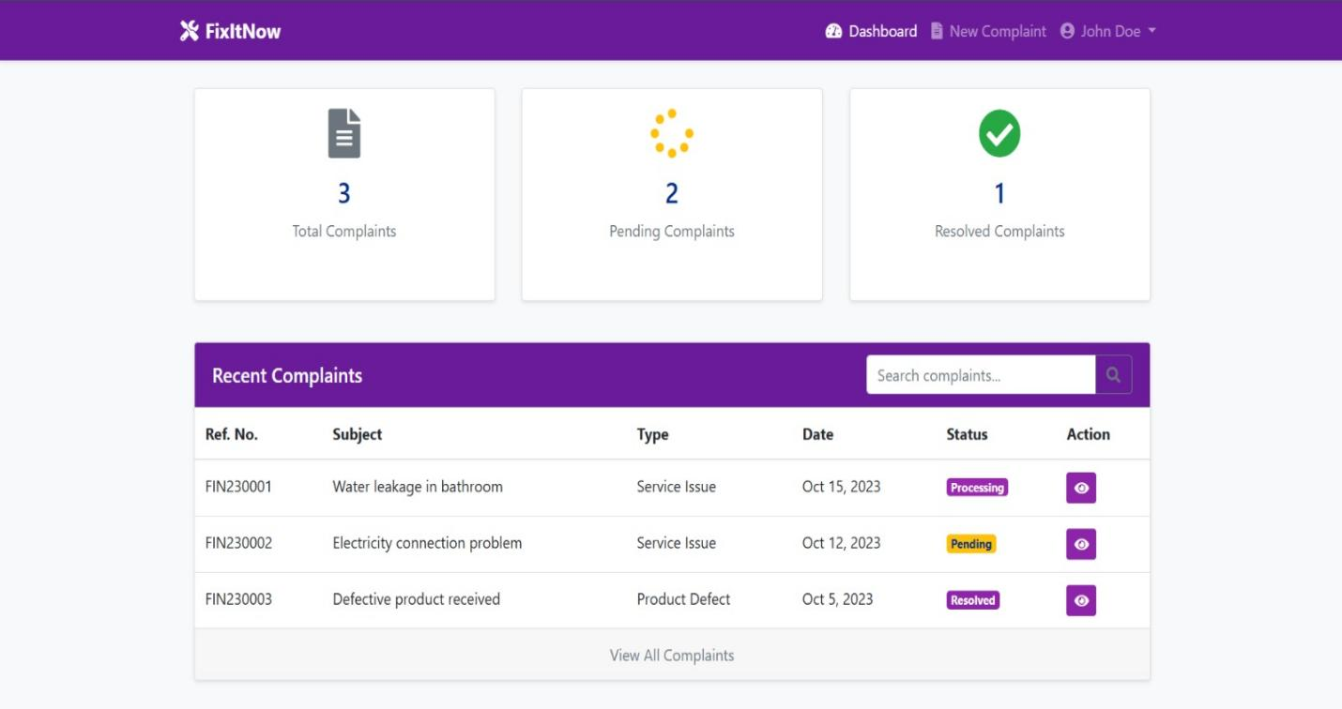

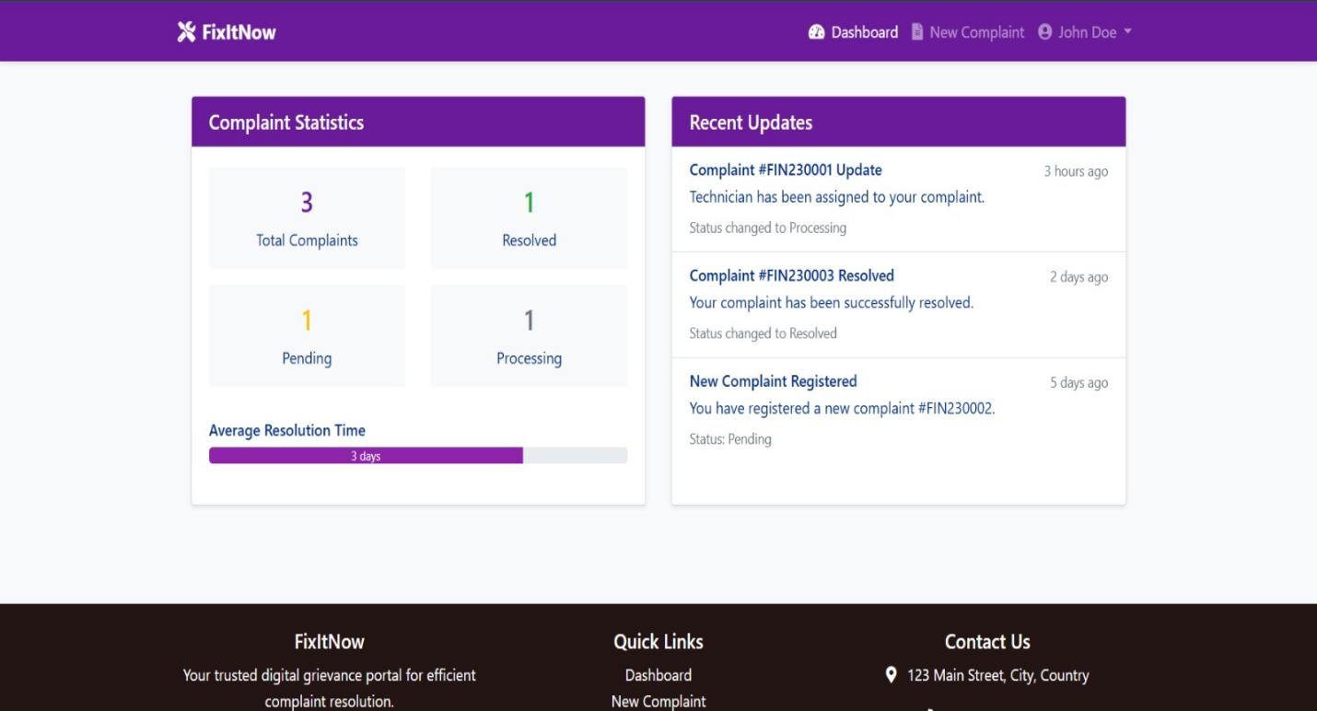

Registration complaint

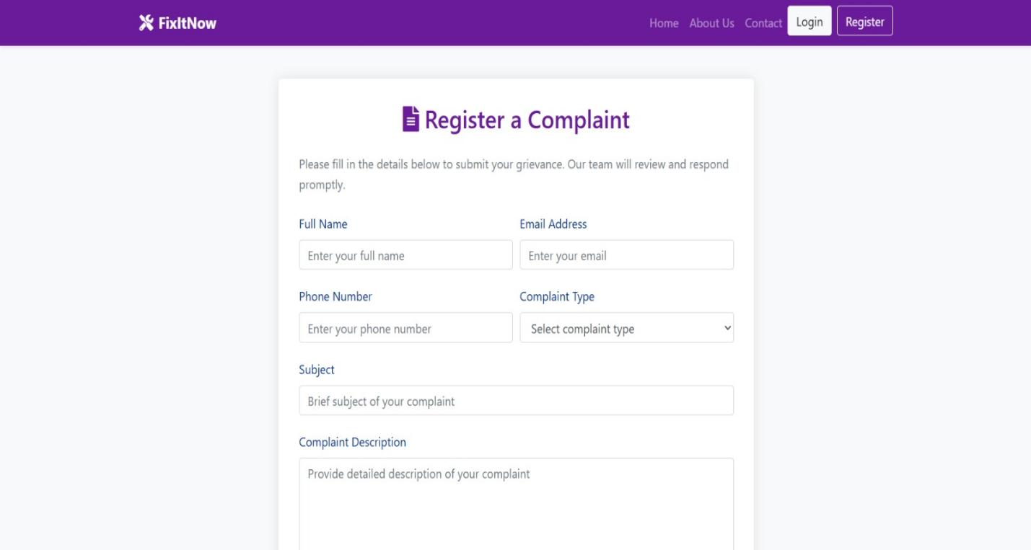

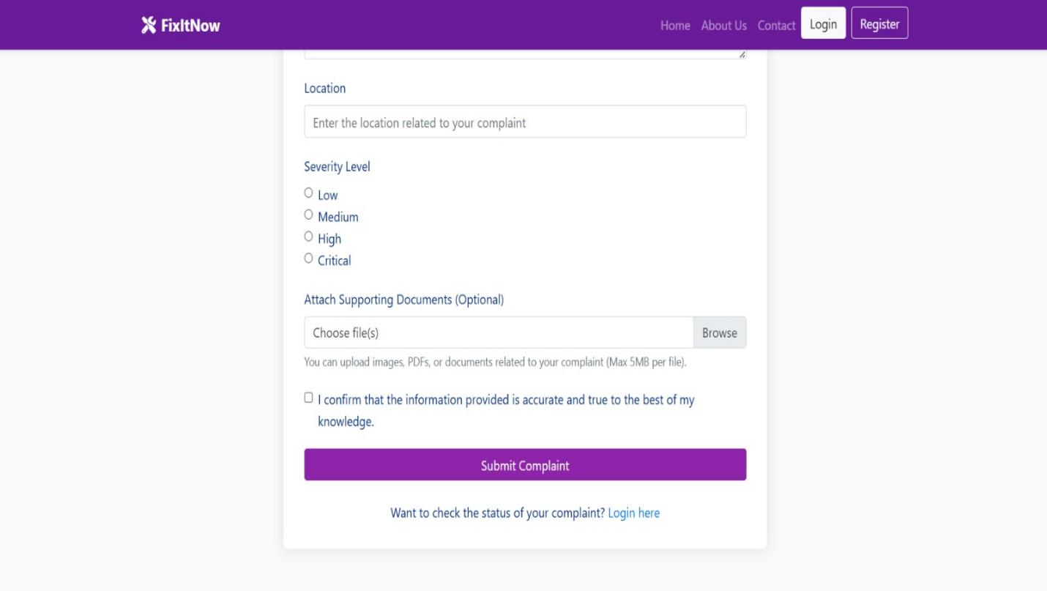

Reference :

https://www.w3schools.com/php/
https://stackoverflow.com/
https://dev.mysql.com/doc/
https://youtube.com

