**1 . What is software? What is software engineering?**

**Software:** Software is a collection of programs and data that tell a computer how to perform specific tasks. Software often includes associated software documentation. This is in contrast to hardware, from which the system is built and which actually performs the work.

**Example**: operating system, spreadsheet software etc.

**Software engineering**: Software engineering is the branch of computer science that deals with the design, development, testing, and maintenance of software applications.

**2. Explain types of software.**

**Application software**: application software is a computer software package that performs a specific function for a user, or in some cases, for another application. An application can be self-contained, or it can be a group of programs that run the application for the user.

**Examples**: office suites, graphics software, databases and database management programs, web browsers, word processors, software development tools, image editors and communication platforms.

**System software:** These software programs are designed to run a computer's application programs and hardware. System software coordinates the activities and functions of the hardware and software. In addition, it controls the operations of the computer hardware and provides an environment or platform for all the other types of software to work in.

**Example**: Operating System

**Driver software:** Also known as device drivers, this software is often considered a type of system software. Device drivers control the devices and peripherals connected to a computer, enabling them to perform their specific tasks.

**Example**: USB storage devices, keyboards, headphones and printers.

**Middleware**: The term middleware describes software that mediates between application and system software or between two different kinds of application software.

**Example**: middleware enables Microsoft Windows to talk to Excel and Word.

**Programming software**: Computer programmers use programming software to write code. Programming software and programming tools enable developers to develop, write, test and debug other software programs.

**Examples**: compilers, debuggers and interpreters**.**

**3. What is SDLC? Explain each phase of SDLC.**

**SDLC:** The software development lifecycle (SDLC) is the cost-effective and time-efficient process that development teams use to design and build high-quality software. The goal of SDLC is to minimize project risks through forward planning so that software meets customer expectations during production and beyond.

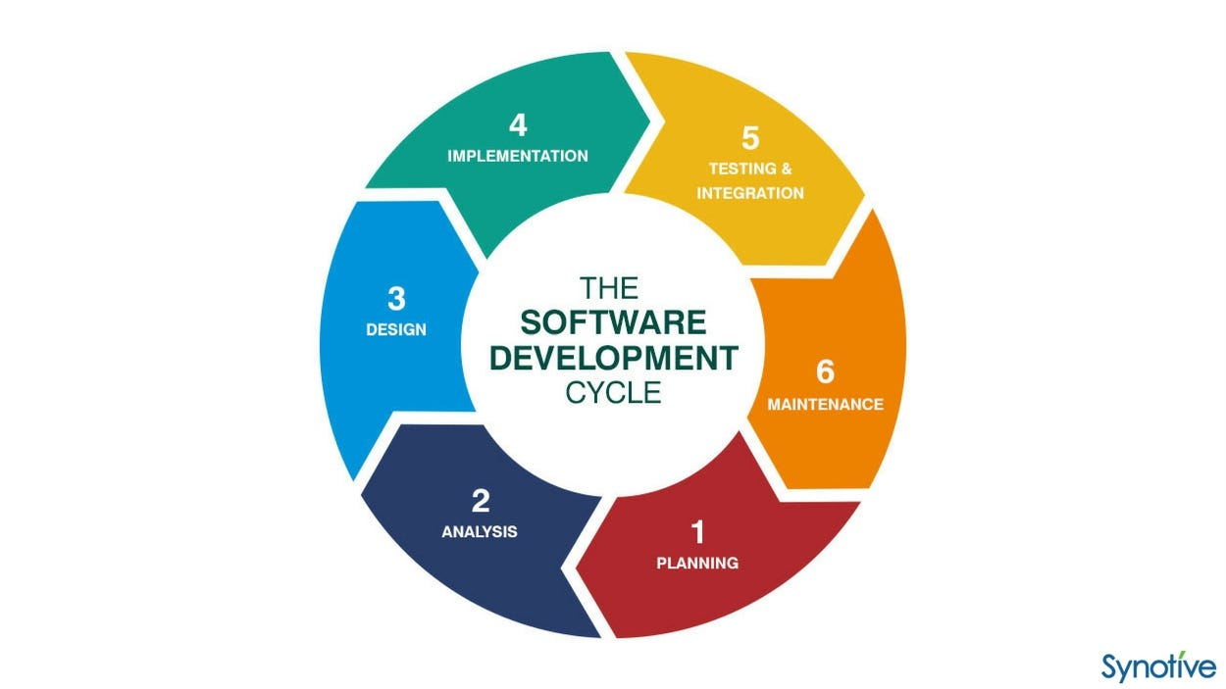

**1**. **Requirements gathering and analysis:** This phase involves gathering information about the software requirements from stakeholders, such as customers, end-users, and business analysts.

**2. Design:** In this phase, the software design is created, which includes the overall architecture of the software, data structures, and interfaces. It has two steps:

High-level design (HLD): It gives the architecture of software products.

Low-level design (LLD): It describes how each and every feature in the product should work and every component.

**3. Implementation or coding:** The design is then implemented in code, usually in several iterations, and this phase is also called as Development.

This is the longest phase in SDLC model.

This phase consists of Front end + Middleware + Back-end.

In front-end: Development of coding is done even SEO settings are done.

In Middleware: They connect both the front end and back end.

In the back-end: A database is created.

**4. Testing:** The software is thoroughly tested to ensure that it meets the requirements and works correctly.

**5. Deployment:** After successful testing, The software is deployed to a production environment and made available to end-users.

**6. Maintenance:** This phase includes ongoing support, bug fixes, and updates to the software.

**4. What is DFD? Create a DFD diagram on Flipkart.**

**DFD:** A data flow diagram (DFD) maps out the flow of information for any process or system. It uses defined symbols like rectangles, circles and arrows, plus short text labels, to show data inputs, outputs, storage points and the routes between each destination.

**DFD diagram on Flipcart**

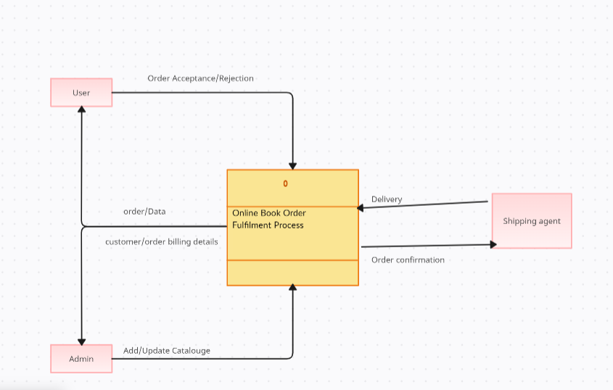

**5. What is Flow chart? Create a flowchart to make addition of two numbers.**

**Flow chart**: A flowchart is a diagram that depicts a process, system or computer algorithm. They are widely used in multiple fields to document, study, plan, improve and communicate often complex processes in clear, easy-to-understand diagrams.

Flow chart to make addition of two numbers:

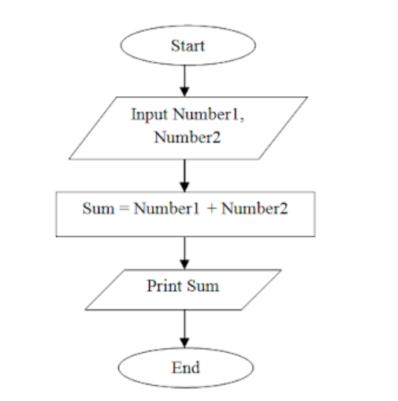

**6. What is Use case Diagram? Create a use-case on bill payment on paytm.**

**Use case Diagram:** A use case diagram is a graphical depiction of a user's possible interactions with a system. A use case diagram shows various use cases and different types of users the system has and will often be accompanied by other types of diagrams as well.

**Create a use-case on bill payment on paytm.**

