**SQL ASSIGNMENT**

**Que -1) Create Table Name : Student and Exam**

CREATE DATABASE assignment;

**STUDENT TABLE**

**QUERY** - CREATE TABLE Student(Rollnumber int primary key auto_increment not null,

Name varchar(20),

Branch Varchar(30)

);

INSERT INTO student(Rollnumber,Name,Branch)VALUES(1,"JAY","Computer Science"),

(2,"suhani","electronic and comm"),

( 3,"prince","electronic and comm");

**EXAM TABLE**

**QUERY** - CREATE TABLE Exam(Rollnumber int NOT null,

S_code varchar(10),

Marks int ,

p_code varchar(10),

FOREIGN KEY(Rollnumber) REFERENCES student(Rollnumber)

);

INSERT INTO exam(Rollnumber,S_code,Marks,p_code) VALUES

(1,"CS11",50,"CS"),

(1,"CS12",60,"CS"),

(2,"ES101",66,"EC"),

(2,"EC102",70,"EC"),

(3,"EC101",45,"EC"),

(3,"EC102",50,"EC");

**Student Table Exam table**

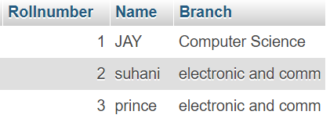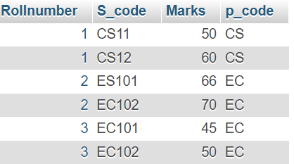

**QUE -2 ) Create table given below: Employee and IncentiveTable**

**Employee Table**

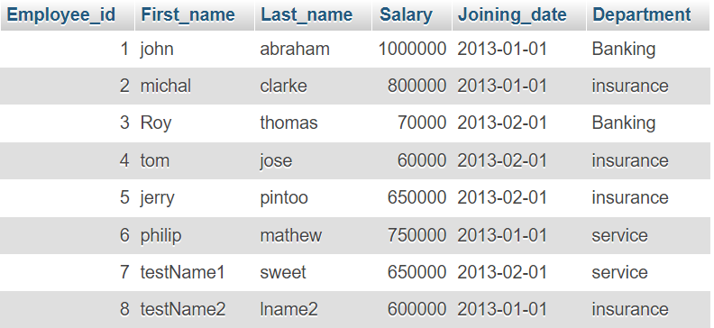

CREATE TABLE EMPLOYEES(Employee_id int PRIMARY KEY AUTO_INCREMENT NOT null,

First_name varchar(20),

Last_name varchar(20),

Salary int,

Joining_date date,

Department varchar(20)

) ;

**Incentive Table**

CREATE TABLE Incentive(Employee_ref_id int,

incentive_date date,

incentive_amount int);

INSERT INTO incentive(Employee_ref_id,incentive_date,incentive_amount)

VALUES(1,2013-02-01,5000),

(2,2013-02-01,3000),

(3,2013-02-01,4000),

(1,2013-01-01,4500),

(2,2013-01-01,3500);

**QUE -3 ) Get First_Name from employee table using Tom name “Employee Name”.**

**Query :-** SELECT First_name FROM employees WHERE First_name = "TOM";

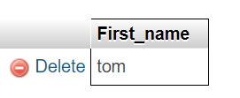

**QUE -4 ) Get FIRST_NAME, Joining Date, and Salary from employee table.**

**Query :-** SELECT First_name,Joining_date,Salary FROM employees;

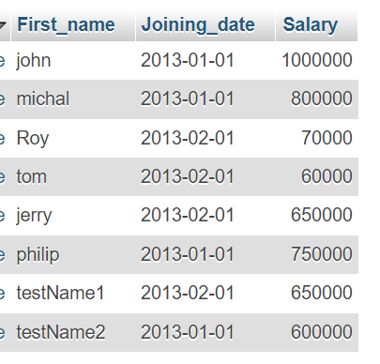

**QUE -5) Get all employee details from the employee table order by First_Name Ascending and Salary descending?**

**Query :-** SELECT * FROM employees ORDER BY First_name ASC , Salary DESC;

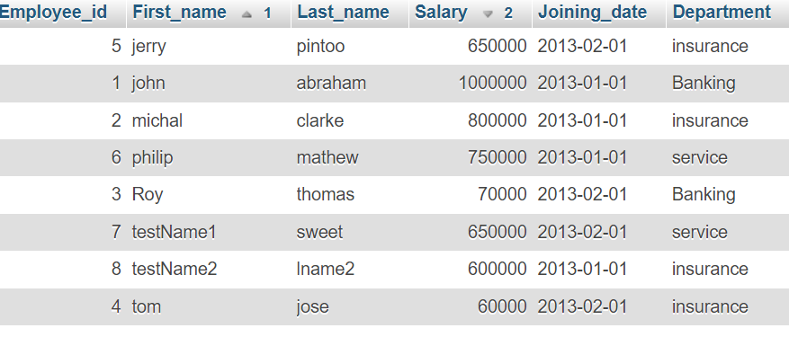

**QUE – 7) Get employee details from employee table whose first name contains ‘J’.**

**Query :-** SELECT * FROM employee WHERE First_name like "%J%";

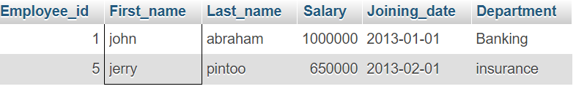

**QUE -8) Get department wise maximum salary from employee table order by salaryascending?**

**Query :-** SELECT Department, max(SALARY) MAXSALARY FROM employee GROUP BY Department ORDER BY MAXSALARY ASC;

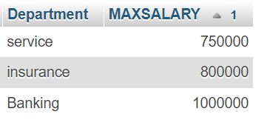

**QUE – 9) Select first_name, incentive amount from employee and incentives table forthose employees who have incentives and incentive amount greater than 3000**

**Query :-** SELECT employees.First_name , incentive.incentive_amount FROM employees LEFT JOIN incentive ON employees.Employee_id = incentive.Employee_ref_id WHERE incentive.incentive_amount > 3000;

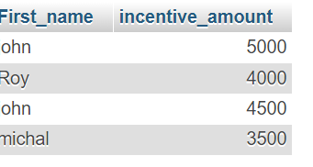

**QUE – 10) Create After Insert trigger on Employee table which insert records in viewtable**

**QUE – 11)Create table given below: Salesperson and Customer**

CREATE TABLE Salesperson(SNO INT PRIMARY KEY NOT null,

SNAME VARCHAR(20),

CITY VARCHAR(20),

COMM numeric(3,2);

**Salesperson Table**

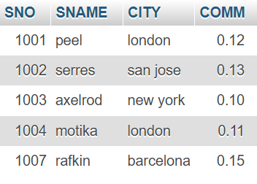￼**￼**

INSERT INTO salesperson(SNO,SNAME,CITY,COMM) VALUES (1001,"peel","london",0.12),

(1002,"serres","san jose",0.13),

(1004,"motika","london",0.11),

(1007,"rafkin","barcelona",0.15),

(1003,"axelrod","new york",0.1);

CREATE TABLE Customer(CNM INT PRIMARY KEY NOT NULL,

CNAME VARCHAR(20),

CITY VARCHAR(20),

RATING INT,

SNO INT,

FOREIGN KEY(SNO) REFERENCES salesperson(SNO));

INSERT INTO customer(CNM,CNAME,CITY,RATING,SNO) VALUES (201,"Hoffman","London",100,1001),

(202,"Giovanne","Roe",200,1003),

(203,"Liu","San Jose",300,1002),

(204,"Grass","Barcelona",100,1002),

(206,"Clemens","London",300,1007),

(207,"Pareira","Roe",100,1004);

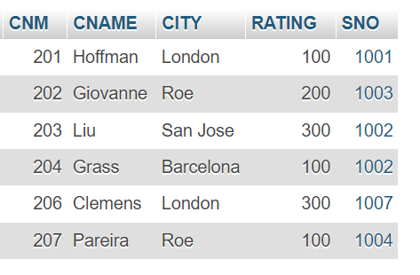

**QUE – 12 )All customer rating for more than 100.**

**Query :-** SELECT CNAME, RATING FROM `customer` WHERE Rating > 100;

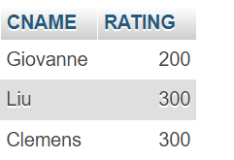

**QUE – 13) Names and cities of all salespeople in London with commission above 0.12**

**Query :-** SeLECT SNAME ,CITY FROM salesperson WHERE CITY = "london" AND COMM >0.12;

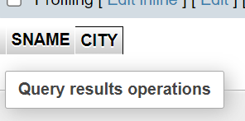

**QUE – 14) All salespeople either in Barcelona or in London**

**Query :-** SELECT * FROM salesperson WHERE CITY = "Barcelona" Or CITY = "London";

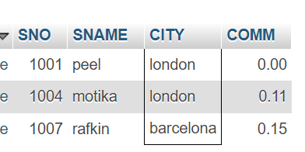

**QUE – 15) All salespeople with commission between 0.10 and 0.12.**

**Query :-** SELECT * FROM salesperson WHERE COMM BETWEEN 0.10 AND 0.12;

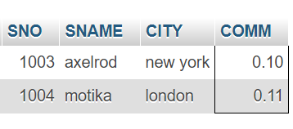

**QUE – 16) All customers excluding those with rating <= 100 unless they are located inRome**

**Query :-** SELECT * FROM customer WHERE Rating <= 100;

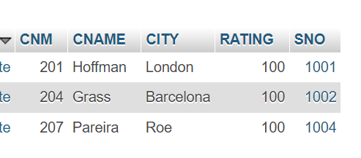

**QUE – 17) Write a SQL statement that displays all the information about all salespeople**

**Query :-** Select * from salesperson

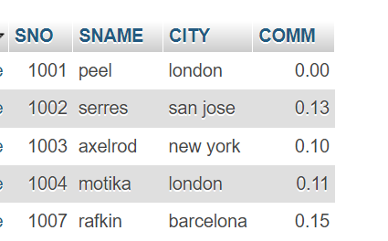

**QUE – 18)From the following table, write a SQL query to find orders that are delivered by a salesperson with ID. 5001. Return ord_no, ord_date, purch_amt.**

**Query :-** CREATE TABLE Orders(order_no INT PRIMARY KEY NOT null,

putch_amt numeric(5,2),

ord_date date,

customer_id int,

salesman_id int );

SELECT order_no, ord_date, putch_amt

FROM orders

WHERE salesman_id = 5001;

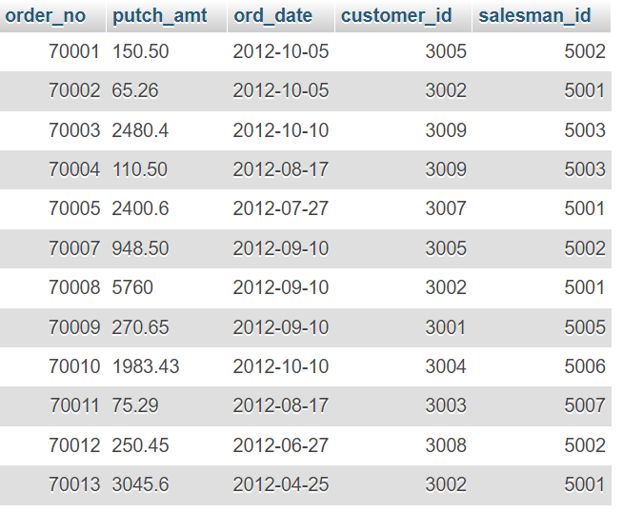

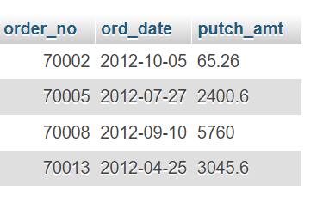

**QUE – 19) From the following table, write a SQL query to select a range of products whose price is in the range Rs.200 to Rs.600. Begin and end values are included. Return pro_id, pro_name, pro_price, and pro_com.**

CREATE TABLE item_mast(PRO_ID INT PRIMARY KEY NOT null,

PRO_NAME VARCHAR(20),

PRO_PRICE NUMERIC(7,2),

PRO_COM int );

**Query :-** SELECT PRO_ID , PRO_NAME,PRO_PRICE , PRO_COM FROM item_mast WHERE PRO_PRICE BETWEEN 200 AND 600 ;

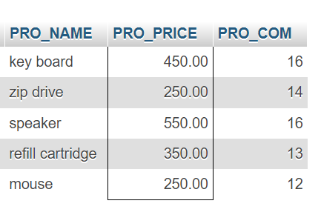

**QUE – 20) From the following table, write a SQL query to calculate the average price for a manufacturer code of 16. Return avg.**

**Query :-** SELECT AVG(PRO_PRICE) FROM item_mast WHERE PRO_COM = 16;

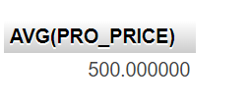

**QUE – 21) From the following table, write a SQL query to display the pro_name as 'Item Name' and pro_priceas 'Price in Rs.'**

**Query :-** SELECT PRO_NAME as "Item Name", PRO_PRICE AS "Price in Rs." FROM item_mast;

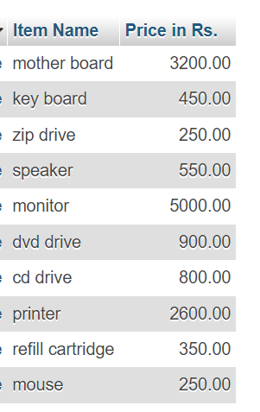

**QUE – 22) From the following table, write a SQL query to find the items whose prices are higher than or equal to $250. Order the result by product price in descending, then product name in ascending. Return pro_name and pro_price.**

**Query : -** SELECT PRO_NAME,PRO_PRICE FROM item_mast WHERE PRO_PRICE >= 250 ORDER by PRO_PRICE DESC ,PRO_NAME ASC;

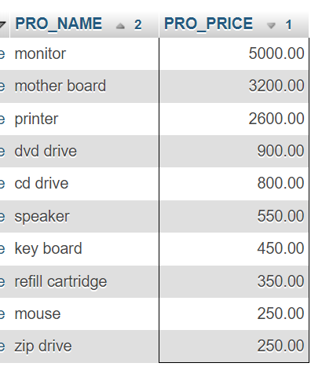

**QUE – 23)From the following table, write a SQL query to calculate average price of the items for each company. Return average price and companycode**

**Query :-** SELECT AVG(PRO_PRICE) FROM item_mast;

