

INTERIM PROJECT PROGRESS REPORT

ASTRA PICO
Humanoid Robot

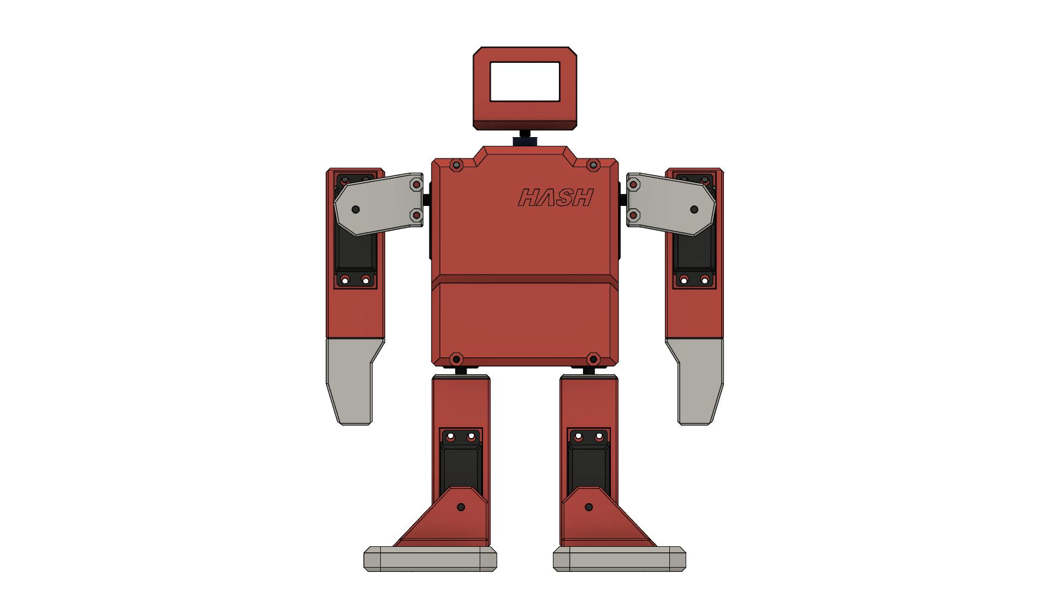

Report Type | Interim Progress Report
Project Status | 🔧 In Progress
Team Name | Team Astra
Project Name | Astra Pico Humanoid Robot
Platform | Raspberry Pi Pico
Language | MicroPython
Date | April 2026

TEAM MEMBERS
Name | Enrollment No.
Rushikesh Vaibhav Wagh | FW24EC001
Daksh Pradip Damsutkar | FS24EC92
Kaivalya Santosh Ghadigaonkar | FS24EC29
Sharmin Dhiraj Tambe | FS24EC064

1. Introduction
This report documents the current status and ongoing development of the Astra Pico Humanoid Robot — a fully 3D-printed, servo-actuated humanoid robot being developed by Team Astra. The robot is designed to perform bipedal walking, expressive arm gestures, directional navigation, and dynamic facial expressions via an OLED display.

The Astra Pico robot is built around the Raspberry Pi Pico microcontroller and is being programmed in MicroPython. Remote control via Bluetooth using a custom MIT App Inventor Android application is currently under development. This project integrates mechanical design, embedded electronics, and software engineering into a cohesive robotic platform.

This is an interim progress report submitted to document work completed so far, highlight ongoing tasks, and outline the remaining development plan.

2. Project Objectives
The primary objectives of this project are as follows:
- Design and fabricate a humanoid robot body structure using 3D printed components.
- Implement bipedal walking, turning, and gesture movements using servo motors.
- Develop and program expressive facial animations using an OLED display.
- Enable wireless Bluetooth remote control via a custom Android application.
- Establish a reliable communication architecture using UART and I2C protocols.
- Demonstrate stable and repeatable movement sequences through fine-tuned servo programming.

3. Overall Project Progress
The table below summarizes the current completion status of each major project phase:

# | Phase / Task | Status | Completion
1 | Component Procurement | ✅ Completed | 100%
2 | 3D Design (CAD Modelling) | ✅ Completed | 100%
3 | 3D Printing of Parts | ✅ Completed | 100%
4 | Mechanical Assembly | ⏳ In Progress | 65%
5 | Electronics Wiring & Integration | ⏳ In Progress | 50%
6 | MicroPython Firmware (Movements) | ✅ Completed | 100%
7 | MicroPython Firmware (Expressions) | ✅ Completed | 100%
8 | Bluetooth App Development | ⏳ In Progress | 75%
9 | System Integration & Testing | ❌ Pending | 20%
10 | Fine-Tuning & Calibration | ❌ Pending | 0%
11 | Final Documentation | ⏳ In Progress | 60%

Overall estimated project completion: approximately 70%

4.1 Bill of Materials
All components listed below have been procured and are available for integration:

# | Component | Specification | Quantity
1 | Raspberry Pi Pico | RP2040, Dual-core ARM Cortex-M0+ | 1
2 | PCA9685 Servo Driver | 16-channel, 12-bit PWM, I2C interface | 1
3 | SG90 Servo Motors | 9g micro servo, 180° rotation | 8
4 | MG90S Servo Motors | Metal gear, 9g, 180° rotation | 8
5 | OLED Display (SH1106) | 1.3 inch, 128x64 pixels, I2C | 1
6 | LM2596 Buck Converter | DC-DC step-down, 12V to 5V/3.3V | 1
7 | 12V LiPo Battery | Rechargeable, lightweight power supply | 1
8 | HC-05 Bluetooth Module | UART serial Bluetooth, master/slave | 1
9 | 3D Printed Parts | PLA/ABS: body, head, limbs, joints | 1 set
10 | PCB / Protoboard | Custom wiring board | 1
11 | Jumper Wires | Male-female, male-male | Assorted
12 | MG995 Servo Horns | Custom designed & 3D printed | 4

4.2 Planned System Architecture
The planned hardware architecture connects the Raspberry Pi Pico as the central controller. It will communicate with the PCA9685 servo driver over the I2C bus (SDA: GP0, SCL: GP1) to drive up to 16 servo channels simultaneously. The OLED display (SH1106) will also share the I2C bus. The HC-05 Bluetooth module will be interfaced via Pico UART1 for wireless command reception.

Subsystem | Planned Interface
PCA9685 → 16 Servos | I2C (0x40)
SH1106 OLED Display | I2C (0x3C)
HC-05 Bluetooth Module | UART1 (GP4/GP5, 9600 baud)
LM2596 Buck Converter | Power regulation (12V → 5V)
Power Supply (12V) | LiPo Battery

5. Mechanical Design & 3D Printed Parts
The robot body has been fully designed from scratch using Fusion 360 and all parts have been successfully 3D printed. This phase is now complete. Physical assembly of the printed parts is currently underway.

5.1 Body Structure Modules
The complete 3D model is organized into the following modular assemblies. All parts have been printed successfully:

# | Component | Specification | Quantity
1 | Body Assembly | Front, back, left, right, top, base panels | 6 parts
2 | Head Assembly | Head base + head top housing for OLED | 2 parts
3 | Left Arm (Hand 1) | Upper arm segment — 3 parts | 3 parts
4 | Left Arm (Hand 2) | Forearm segment — 3 parts | 3 parts
5 | Right Arm (Hand 1) | Upper arm segment — 3 parts | 3 parts
6 | Right Arm (Hand 2) | Forearm segment — 3 parts | 3 parts
7 | Left Leg (Leg 1) | Upper leg segment — 3 parts | 3 parts
8 | Left Leg (Leg 2) | Lower leg segment — 3 parts | 3 parts
9 | Right Leg (Leg 1) | Upper leg segment — 3 parts | 3 parts
10 | Right Leg (Leg 2) | Lower leg segment — 3 parts | 3 parts
11 | Inside Mount (Front) | Internal servo mounting bracket | 1 part
12 | Inside Mount (Back) | Internal servo mounting bracket | 1 part
13 | MG995 Servo Horn | Custom horn — F3D + STL + STEP provided | 4 parts

5.2 Work-in-Progress Photos
The following photos show the current state of the robot build:


Figure 1: Astra Pico — 3D Printed Body Parts (Assembly in Progress)
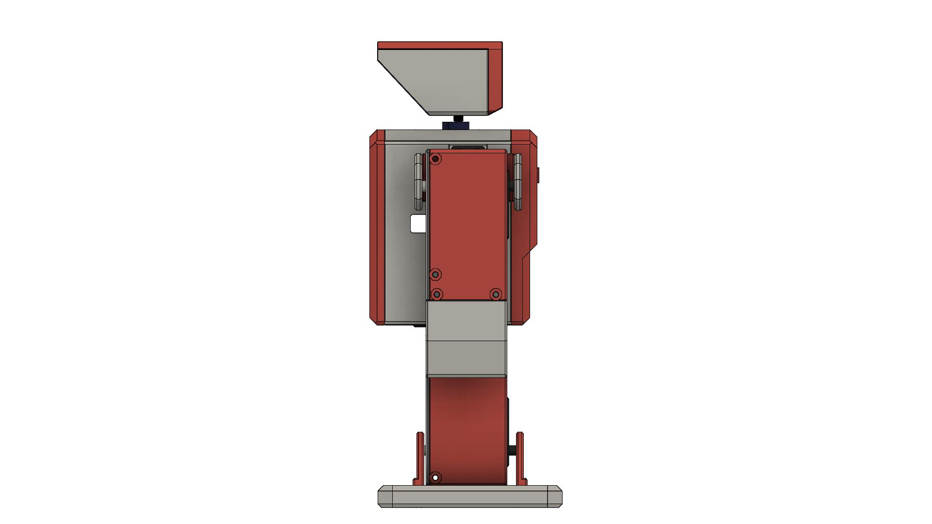
Figure 2: Astra Pico — Limb & Joint Assembly (In Progress)
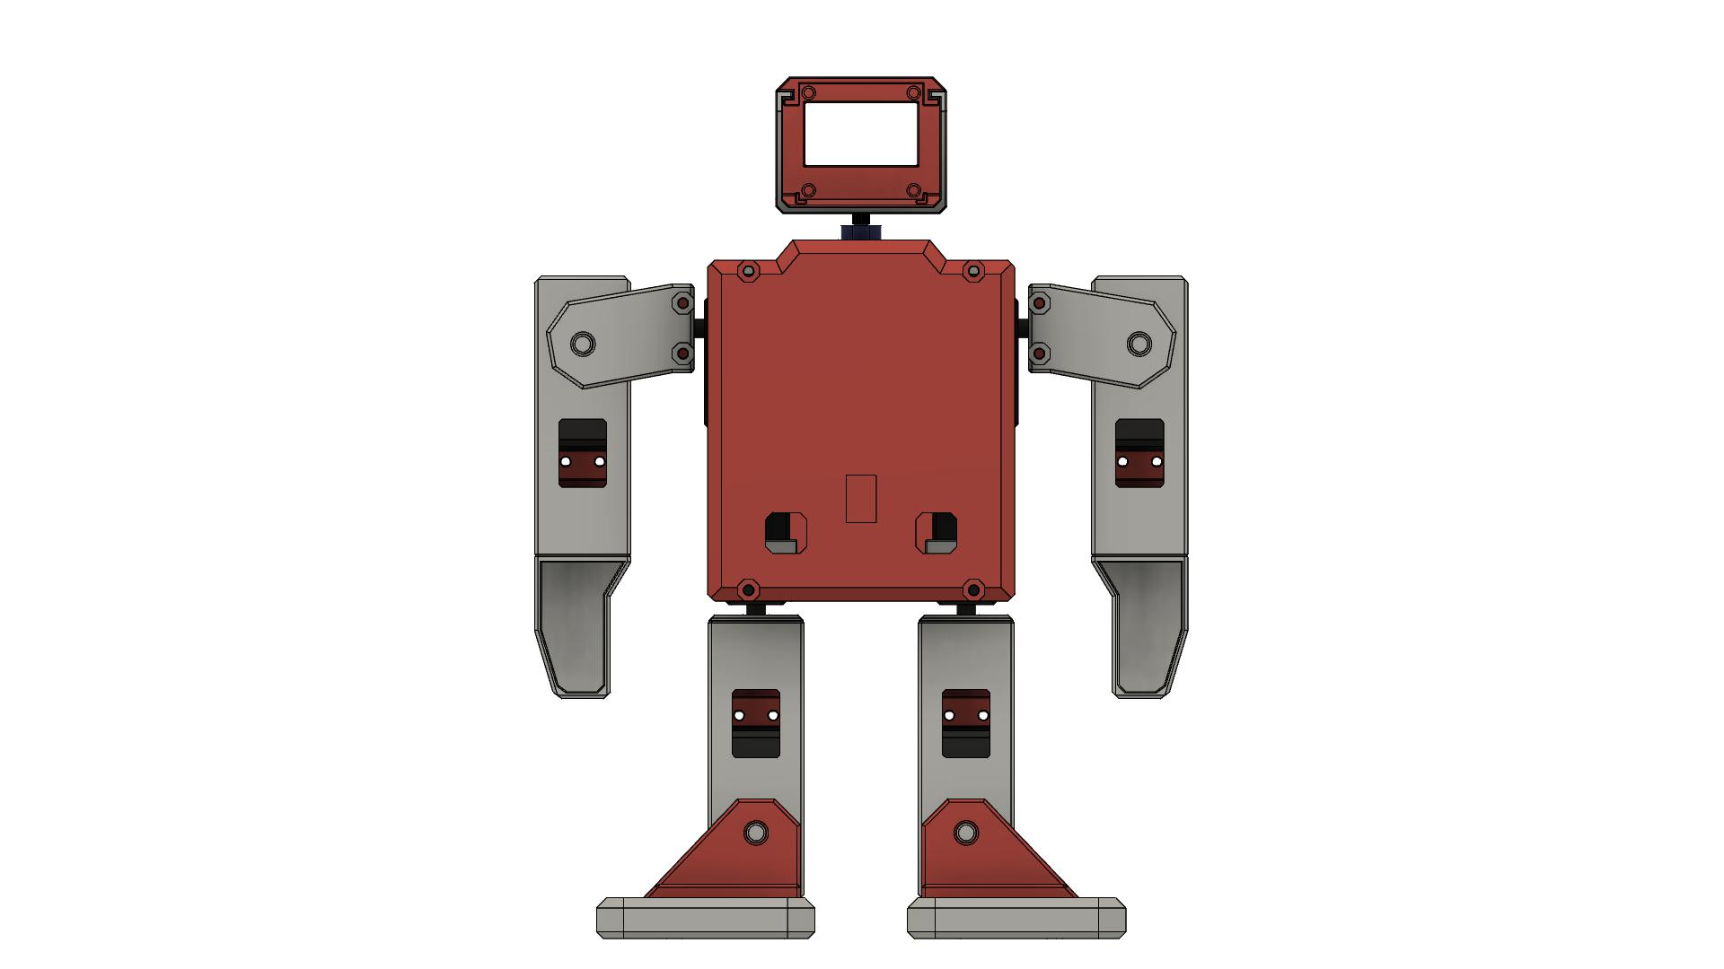
Figure 3: Astra Pico — Structural Overview (Partial Assembly)

6. Software Development (Completed)

6.1 Firmware Overview
The robot firmware has been written in MicroPython and is ready for deployment on the Raspberry Pi Pico. The software is fully modularized, with each file responsible for a specific subsystem. Firmware development is complete and is currently pending hardware integration for full testing.

File | Responsibility
main.py | Entry point; UART listener; command dispatcher
hashmoves.py | All movement sequences (walking, gestures, balance)
hashfacialexp.py | OLED facial expressions (happy, sad, angry, etc.)
pca9685.py | PCA9685 PWM driver (I2C low-level control)
servo.py | High-level servo abstraction (angles, coordinated movement)
sh1106.py | SH1106 OLED display driver
i2caddrfind.py | Utility to scan I2C bus for connected devices
imagetobytearray.py | Utility to convert images to byte arrays for OLED

6.2 Planned Command Protocol
The designed command protocol sends string codes over UART1 (Bluetooth). The main loop will poll uart.any() continuously and dispatch actions accordingly. Commands are split into two categories — facial expressions (A-series) and movements (B-series):

Command Code | Action
A01 | Default (neutral) face
A02 | Happy face expression
A03 | Sad face expression
A04 | Eyes closed face
A05 | Blink animation (3x)
A06 | Sleep face animation
A07 | Wink face
A08 | Hard cry animation
A09 | Love / heart eyes face
A10 | Angry face
A11 | Shocked face
B01 | Move forward (5 steps)
B02 | Turn left (5 steps)
B03 | Return to initial position
B04 | Turn right (5 steps)
B05 | Move backward (5 steps)
B06 | Say hi gesture
B07 | Hands up
B08 | Hands down
B09 | Side move left
B10 | Flying move animation
B11 | Side move right
B12 | Left slide wave
B13 | Leg and head shake
B14 | Right slide wave
B15 | Leg shake
B16 | Hand straight shake
B17 | Jump
B18 | Left hand balance
B19 | Side shake
B20 | Right hand balance

6.3 Movement Logic
Movement sequences have been coded as coordinated PWM arrays targeting all 16 PCA9685 channels. Each function accepts time (ms) and count (repetitions) parameters. The servo.moveservo() routine will interpolate positions smoothly. Movements are ready but pending calibration on the physical robot.

7. Bluetooth Control Application (In Progress)
A custom Android application is being developed using MIT App Inventor (Hash_Robotics.aia). The app is designed to communicate with the robot via Bluetooth serial (HC-05 module) using the command codes in Section 6.2. The UI layout is complete; end-to-end Bluetooth integration with the robot is currently being tested.

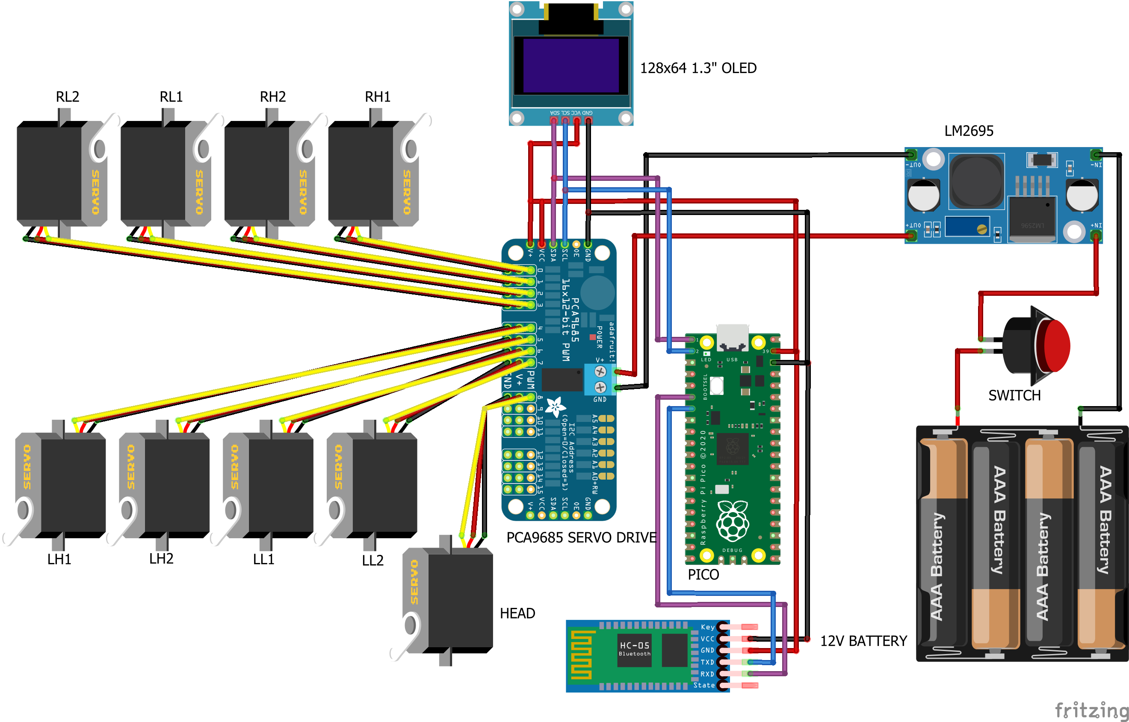
Figure 4: Astra Pico Bluetooth Control App — UI Layout (In Progress)

7.1 Planned App Features
- Bluetooth device pairing and connection management.
- Dedicated control buttons for all 20 movement commands (B01–B20).
- Dedicated expression buttons for all 11 facial expressions (A01–A11).
- Clean, intuitive grid-based user interface for ease of operation.
- Real-time Bluetooth serial communication at 9600 baud.

8. Assembly & Wiring — Current Status

8.1 Steps Completed
- ✅ All 3D parts printed successfully — body, head, all limbs and mounts.
- ✅ MicroPython firmware written and tested on bench (simulation).
- ✅ Android app UI designed and command protocol defined.
- ✅ All electronic components procured and verified.

8.2 Steps In Progress
- ⏳ Mounting servo motors at leg and arm joints — approximately 65% complete.
- ⏳ Wiring PCA9685, OLED, and Pico inside body cavity — approximately 50% complete.
- ⏳ Connecting HC-05 Bluetooth module and testing UART communication.
- ⏳ Android app Bluetooth pairing test with HC-05 module.

8.3 Steps Pending
- ❌ Full system power-up and I2C bus verification.
- ❌ Uploading firmware to Pico and performing initial movement tests.
- ❌ Servo angle calibration for all 16 channels.
- ❌ End-to-end Bluetooth remote control testing.
- ❌ Fine-tuning walking stability and gait smoothness.

9. Testing Status
Full system testing has not yet been performed as hardware assembly is still in progress. The table below reflects the current testing status for each module:

Test Category | Status | Notes
Firmware — Movement Code (Bench) | ✅ Passed | Code logic verified
Firmware — Facial Expressions (Bench) | ✅ Passed | OLED rendering confirmed
I2C Bus Scan (PCA9685 + OLED) | ⏳ Pending | Awaiting full wiring
Servo Motor Initialisation | ⏳ Pending | Awaiting wiring completion
Bipedal Walking (Forward/Backward) | ❌ Not Started | Requires full assembly
Directional Turning (Left/Right) | ❌ Not Started | Requires full assembly
Gesture Movements | ❌ Not Started | Requires full assembly
OLED Facial Expressions (Live) | ❌ Not Started | Requires hardware integration
Bluetooth Control End-to-End | ⏳ In Progress | App-HC05 pairing being tested
Power Management & Stability | ❌ Not Started | Requires full assembly

10. Challenges & Remaining Work Plan

10.1 Current Challenges
- Servo angle calibration is expected to require significant trial-and-error iteration for stable walking gait.
- Routing wires cleanly inside the compact body cavity is proving time-intensive.
- HC-05 Bluetooth module pairing stability needs further testing at different distances.

10.2 Remaining Work Plan
Task | Target Completion
Complete mechanical assembly & servo mounting | Week 1
Full electronics wiring & power testing | Week 1
Firmware upload & I2C bus verification | Week 2
Servo calibration & initial movement tests | Week 2
Bluetooth end-to-end testing with app | Week 2
Walking gait fine-tuning & stability tests | Week 3
Full system integration & demo run | Week 3
Final documentation & submission | Week 4

11. Future Scope
- Improve walking stability using gyroscope/accelerometer feedback (e.g., MPU-6050).
- Add Wi-Fi control via Raspberry Pi Pico W for extended wireless range.
- Implement AI-based voice command recognition using an onboard microphone.
- Develop autonomous obstacle avoidance using ultrasonic sensors.
- Upgrade to a rechargeable battery management system (BMS) for safer operation.
- Improve leg geometry for smoother, more human-like bipedal gait.
- Expand OLED animations library with complex, multi-frame face sequences.

12. Current Status Summary
The Astra Pico Humanoid Robot project is currently estimated at approximately 70% completion. Significant progress has been made in three major areas: all 3D-printed parts have been fabricated, the complete MicroPython firmware for movements and facial expressions has been written, and the Android Bluetooth control application UI is fully designed.

The remaining work is focused on physical assembly, electronics integration, wiring, and calibration. The team is confident that the project will be completed as planned within the remaining timeline. Full system testing and demonstration will be conducted once assembly is finalized.

13. Project File Manifest (Current)

13.1 Software Files (astra.zip)
# | Component | Specification | Quantity
1 | main.py | Main controller — UART listener & command dispatcher | Ready
2 | hashmoves.py | 20 movement sequences (walking, gestures, dance) | Ready
3 | hashfacialexp.py | 11 OLED facial expression functions | Ready
4 | pca9685.py | PCA9685 servo driver library | Ready
5 | servo.py | High-level servo control abstraction | Ready
6 | sh1106.py | SH1106 OLED display driver | Ready
7 | i2caddrfind.py | I2C bus scanner utility | Ready
8 | imagetobytearray.py | Image-to-bytearray conversion tool | Ready
9 | Hash_Robotics.aia | MIT App Inventor Android app source | In Progress
10 | pico_hash_bluetooth_control.png | Android app screenshot | Ready

13.2 3D Design Files (Pico_Hash_3D_Files.zip)
- pico_hash_f3d.f3d — Complete Fusion 360 parametric design source ✅
- pico_hash_step.step — Full assembly STEP file for CAD import ✅
- body/ — 6 STL files for main body panels ✅ (printed)
- head/ — 2 STL files for head assembly ✅ (printed)
- left_hand_1/, left_hand_2/ — Left arm segments ✅ (printed)
- right_hand_1/, right_hand_2/ — Right arm segments ✅ (printed)
- left_leg_1/, left_leg_2/ — Left leg segments ✅ (printed)
- right_leg_1/, right_leg_2/ — Right leg segments ✅ (printed)
- inside_mount_front/, inside_mount_back/ — Internal mounting brackets ✅ (printed)
- mg995_servo_horn/ — Custom servo horn ✅ (printed)
- pico_hash_1.jpg to pico_hash_7.jpg — Build progress photos ✅

14. References
[1] Hash Robotics YouTube Channel — Project demonstrations, assembly tutorials, and movement showcases: https://youtube.com/@hashrobotics
[2] Raspberry Pi Foundation — Raspberry Pi Pico documentation and MicroPython SDK: https://www.raspberrypi.com/documentation/microcontrollers/raspberry-pi-pico.html
[3] PCA9685 16-Channel PWM Servo Driver — Adafruit datasheet & I2C usage guide: https://www.adafruit.com/product/815
[4] MIT App Inventor — Android application development platform: https://appinventor.mit.edu
[5] MicroPython Documentation — Language reference and library guide: https://docs.micropython.org

— End of Report —
Team Astra | Astra Pico Humanoid Robot | Interim Progress Report | April 2026

