SOFTWARE REQUIREMENTS SPECIFICATION
for
Dominos Voice Calling Agent

Version: | 1.0 approved
Prepared by: | Rushna Awan
Organization: | SMIT (Saylani Mass IT Training)
Course: | Artificial Intelligence & Data Science (AI&DS)
Date: | 12 April 2026

Table of Contents
Table of Contents ii
Revision History ii

1. Introduction 1
1.1 Purpose 1
1.2 Document Conventions 1
1.3 Intended Audience and Reading Suggestions 1
1.4 Product Scope 1
1.5 References 1

2. Overall Description 2
2.1 Product Perspective 2
2.2 Product Functions 2
2.3 User Classes and Characteristics 2
2.4 Operating Environment 2
2.5 Design and Implementation Constraints 2
2.6 User Documentation 2
2.7 Assumptions and Dependencies 3

3. External Interface Requirements 3
3.1 User Interfaces 3
3.2 Hardware Interfaces 3
3.3 Software Interfaces 3
3.4 Communications Interfaces 3

4. System Features 4
4.1 Voice Order Placement 4
4.2 Table Reservation Management 5
4.3 Special Event Booking 6
4.4 Menu & FAQ Support 6

5. Other Nonfunctional Requirements 7
5.1 Performance Requirements 7
5.2 Safety Requirements 7
5.3 Security Requirements 7
5.4 Software Quality Attributes 7
5.5 Business Rules 7

6. Other Requirements 8

Appendix A: Glossary 8
Appendix B: Analysis Models 9
Appendix C: To Be Determined List 9

Revision History
Name | Date | Reason For Changes | Version
Rushna Awan | 12-04-2026 |  | 1.0

Introduction

Purpose
This Software Requirements Specification (SRS) describes the functional and non-functional requirements for the Dominos Voice Calling Agent, an AI-powered voice assistant named "Mike" built for Dominos Pizza Pakistan. This document covers the complete scope of the system including order placement, reservation management, and customer support via voice calls.
This SRS is written for Version 1.0 of the system and serves as the primary reference for design, development, and evaluation of the project within the AI&DS course at SMIT.

Document Conventions
This document follows the IEEE 830-1998 SRS standard. The following conventions apply throughout:
- Bold text denotes section headings or key terms.
- REQ-XXX identifiers uniquely tag each functional requirement.
- Priority levels are: High (critical for operation), Medium (important but not blocking), Low (nice to have).
- PKR denotes Pakistani Rupees, the currency used for all pricing.
- "Agent" refers to the AI voice assistant named Mike.

Intended Audience and Reading Suggestions
This document is intended for the following readers:
- Course Instructors & Evaluators: Review Sections 1, 2, and 4 for scope and functional coverage.
- Developers: Focus on Sections 3, 4, and 5 for technical implementation details.
- Testers: Refer to Section 4 (System Features) for test case derivation.
- Project Stakeholders: Sections 1 and 2 provide a high-level overview.

Product Scope
The Dominos Voice Calling Agent is an AI-powered telephone assistant that allows customers to interact with Dominos Pizza Pakistan via phone call. The agent, named "Mike", handles end-to-end order placement and table reservation workflows entirely through natural voice conversation.
The system integrates with the Twilio telephony API for call handling, VAPI for AI voice processing, and a Dominos website (built for demonstration purposes) as the customer-facing front end. The agent operates within Pakistan and supports the Dominos menu, including pizzas, sides, desserts, drinks, and deals, all priced in PKR.
The primary objectives of this product are to automate customer service calls, reduce wait times, and demonstrate a practical AI voice agent use case in the food and beverage industry.

References
- IEEE Std 830-1998: IEEE Recommended Practice for Software Requirements Specifications.
- VAPI Documentation: https://docs.vapi.ai
- Twilio Voice API Documentation: https://www.twilio.com/docs/voice
- Dominos Pakistan Official Menu — used as the basis for pricing and product listings.
- AI&DS Course Guidelines — SMIT, 2026.

Overall Description

Product Perspective
The Dominos Voice Calling Agent is a standalone AI-powered voice system developed as a course project for the AI&DS program at SMIT. It is not a replacement for an existing Dominos system, but rather a proof-of-concept demonstrating how AI voice agents can automate food ordering and reservation workflows.
The system sits between the customer (calling via phone) and the Dominos backend (represented by the demo website). The overall architecture consists of three main layers:
- Telephony Layer: Twilio receives inbound calls and bridges audio to the VAPI platform.
- AI Voice Layer: VAPI processes speech, runs the agent (Mike), and generates voice responses using the defined agent script.
- Presentation Layer: A Dominos demo website built to represent the restaurant interface.
The agent operates independently of human staff during a call, handling the entire interaction from greeting to order confirmation.

Product Functions
At a high level, the Dominos Voice Calling Agent performs the following major functions:
- Voice-based order placement (pizza, sides, drinks, desserts, deals).
- Voice-based table reservation management with availability checking.
- Menu information and deals inquiry handling.
- Special event booking support (birthdays, anniversaries, private events).
- Customer FAQ responses (delivery time, payment methods, opening hours).
- Confirmation and summary delivery for all transactions.

User Classes and Characteristics
User Class | Description | Technical Level
End Customer | Calls to place orders or make reservations. Primary user of the voice agent. | Non-technical. No app or device knowledge required.
System Admin / Developer | Configures VAPI agent, Twilio phone number, and manages the demo website. | Technical. Familiar with APIs, web development, and AI tools.
Course Evaluator | Reviews the project demonstration and this SRS document. | Academic. Evaluates design, completeness, and presentation.

Operating Environment
- Platform: Cloud-based (VAPI + Twilio infrastructure).
- Telephony: Twilio Voice — requires a valid Twilio account with a Pakistan-capable phone number.
- AI Voice Engine: VAPI — cloud-hosted, no local GPU or server required.
- Demo Website: Hosted web application (HTML/CSS/JS or equivalent framework) representing the Dominos Pakistan interface.
- Network: Stable internet connection required for all API communications.
- Operating Hours: Agent is available 11:00 AM – 11:00 PM (matching Dominos Pakistan business hours).
- Browser/Device: Agent is phone-call-based; no specific browser or OS requirement for end users.

Design and Implementation Constraints
- The agent can only respond in English as defined in the agent script.
- Agent response time must not exceed 10 seconds per reply turn.
- The system relies on Twilio and VAPI cloud services; downtime of either service renders the agent unavailable.
- Menu prices and items are hardcoded in the agent script (PKR); no live database integration is implemented in v1.0.
- Availability checking for reservations is script-logic-based; no real-time calendar backend is integrated.
- The project is a course demonstration and is not deployed to production infrastructure.

User Documentation
- Agent Script (internal): Defines all conversation flows, menu items, and response logic — included as Appendix B.
- Demo Website: Visual representation of the Dominos Pakistan menu and branding.
- This SRS Document: Primary project documentation artifact.
- Course Presentation Slides (if applicable): Used during project demo evaluation.

Assumptions and Dependencies
- It is assumed that the Twilio account is active and the assigned phone number is reachable in Pakistan.
- It is assumed that VAPI processes voice with sufficient accuracy for standard English speech.
- The menu, prices, and deals listed are assumed to reflect the Dominos Pakistan menu as of April 2026.
- Availability conflict detection assumes no real-time backend; conflicts are managed within the agent conversation logic.
- The project depends on continued access to VAPI and Twilio free/trial tier accounts for demonstration purposes.

External Interface Requirements

User Interfaces
The primary user interface is voice-based. The end customer interacts entirely through a standard phone call with no visual interface required. The agent (Mike) speaks and listens, guiding the customer step by step through the order or reservation flow.
A secondary interface is the Dominos Demo Website, which provides a visual representation of the restaurant for demonstration and presentation purposes. It displays the menu, branding, and contact information consistent with the agent script.

Hardware Interfaces
No proprietary hardware is required. The system operates via:
- Customer's telephone (landline or mobile) for inbound calling.
- Twilio's cloud telephony infrastructure, which handles audio input/output and PSTN connectivity.
- Developer's internet-connected computer for configuration and deployment of VAPI and Twilio settings.

Software Interfaces
Component | Version/Type | Role in System
VAPI | Cloud API | AI voice agent platform. Hosts the Mike agent, manages STT/TTS, and processes conversation turns.
Twilio Voice API | REST API | Telephony provider. Handles inbound phone calls and bridges audio stream to VAPI.
Dominos Demo Website | Web App (HTML/JS) | Visual front-end representation of Dominos Pakistan for demo/presentation use.
VAPI Agent Script | JSON/Prompt Config | Defines the agent persona, menu data, conversation flows, and response rules.

Communications Interfaces
- PSTN / VoIP: Customer calls are received over the public switched telephone network via Twilio.
- HTTPS REST: VAPI and Twilio communicate via secure HTTPS API calls for session management and audio routing.
- WebRTC / Audio Streaming: VAPI processes real-time audio streams for speech-to-text and text-to-speech.
- HTTP/HTTPS: The demo website is served over standard HTTP/HTTPS protocol.
- No email or SMS communication interfaces are implemented in v1.0 (customer name and email are collected verbally and stored in session context only).

System Features
The following features represent the major capabilities of the Dominos Voice Calling Agent. Each feature includes a description, stimulus/response sequences, and itemized functional requirements.

Voice Order Placement
4.1.1 Description and Priority
The agent allows customers to place a complete pizza order via voice call. This is the core feature of the system. Priority: High.
4.1.2 Stimulus/Response Sequences
- Customer calls the Dominos number → Agent greets and asks the purpose of the call.
- Customer says they want to order → Agent asks for pizza flavour.
- Customer states flavour → Agent confirms and asks for size (Small/Medium/Large).
- Customer states size → Agent confirms and asks for crust type.
- Customer states crust → Agent offers toppings (optional).
- Agent suggests sides/drinks once → Customer accepts or declines.
- Agent asks delivery or pickup → Customer specifies.
- If delivery: Agent asks for address → Customer provides address.
- Agent checks availability → Agent reads back full order summary and asks for confirmation.
- Customer confirms → Agent asks for name, then email → Agent finalizes order.
4.1.3 Functional Requirements
Req ID | Requirement Description | Priority
REQ-01 | The agent shall greet the customer and identify the purpose of the call (order, reservation, or question). | High
REQ-02 | The agent shall ask for pizza flavour from the defined menu (Chicken Tikka, BBQ Chicken, Pepperoni Passion, Tex Mex, Legend Ranch, Hot & Spicy, Hawaiian, Cheese). | High
REQ-03 | The agent shall ask for pizza size: Small (PKR 499), Medium (PKR 1,299), or Large (PKR 1,799). | High
REQ-04 | The agent shall ask for crust type: Hand Tossed, Pan, or Thin Crust. | High
REQ-05 | The agent shall offer additional toppings once and accept or skip based on customer response. | Medium
REQ-06 | The agent shall suggest sides and drinks once per order (Garlic Bread, Cheesy Bread, Potato Wedges, Chicken Wings, Kickers, Lava Cake, Cinnastix, Drinks). | Medium
REQ-07 | The agent shall ask the customer to choose between delivery and pickup. | High
REQ-08 | If delivery is chosen, the agent shall ask for and record the delivery address. | High
REQ-09 | The agent shall read back the full order (items, size, crust, sides, delivery/pickup, address) before confirming. | High
REQ-10 | After confirmation, the agent shall collect the customer's name and email. | High
REQ-11 | The agent shall finalize the order and close the call with the standard closing message. | High

Table Reservation Management
4.2.1 Description and Priority
The agent handles end-to-end table reservation requests including availability checking, seating type selection, and special event setups. Priority: High.
4.2.2 Stimulus/Response Sequences
- Customer says they want to make a reservation → Agent asks number of people.
- Agent asks for preferred date and time.
- Agent asks for seating type preference.
- Agent checks availability for the requested time slot.
- If unavailable: Agent apologizes and offers alternative time.
- If available: Agent asks for any special requests.
- Agent repeats full reservation details and asks for confirmation.
- Customer confirms → Agent collects name and email → Finalizes reservation.
4.2.3 Functional Requirements
Req ID | Requirement Description | Priority
REQ-12 | The agent shall ask for the number of guests for the reservation. | High
REQ-13 | The agent shall ask for the preferred reservation date and time. | High
REQ-14 | The agent shall offer seating type options: Regular, Family, Window, Quiet Zone, or Private (VIP). | High
REQ-15 | The agent shall check availability before confirming any reservation slot. | High
REQ-16 | If the requested time slot is already booked, the agent shall apologize and ask the customer to choose a different time. | High
REQ-17 | The agent shall ask if the customer has any special requests. | Medium
REQ-18 | The agent shall repeat all reservation details (guests, date, time, seating, special requests) and ask for confirmation. | High
REQ-19 | After confirmation, the agent shall collect the customer's name and email and finalize the reservation. | High

Special Event Booking
4.3.1 Description and Priority
If a customer mentions a special occasion, the agent proactively offers appropriate event packages and setups. Priority: Medium.
4.3.2 Stimulus/Response Sequences
- Customer mentions birthday, anniversary, or special event during the call.
- Agent offers relevant package: Birthday (decor + cake + group deals), Anniversary (quiet/private seating + dessert), or Private seating.
- Agent asks for event type, number of guests, and decoration/setup needs.
- Agent incorporates event details into the reservation flow.
4.3.3 Functional Requirements
Req ID | Requirement Description | Priority
REQ-20 | The agent shall detect keywords indicating a special event (birthday, anniversary, celebration). | Medium
REQ-21 | The agent shall offer a birthday package including decor, cake, and group deals when a birthday is mentioned. | Medium
REQ-22 | The agent shall offer quiet or private seating with a dessert for anniversary bookings. | Medium
REQ-23 | The agent shall ask for the number of guests and decoration requirements for special events. | Medium

Menu & FAQ Support
4.4.1 Description and Priority
The agent answers common customer questions about menu items, prices, deals, delivery time, payment methods, and operating hours. Priority: Medium.
4.4.2 Stimulus/Response Sequences
- Customer asks about a menu item or price → Agent answers with the correct item and price.
- Customer asks about deals → Agent lists available deals (One & Only PKR 599, Hungry One PKR 899, Too Good For Two PKR 1,399, Fix for Four PKR 2,399).
- Customer asks about delivery time → Agent responds: 30–45 minutes, may vary.
- Customer asks about payment → Agent responds: Cash on delivery and online payment available.
- Customer asks about hours → Agent responds: Open 11 AM to 11 PM.
4.4.3 Functional Requirements
Req ID | Requirement Description | Priority
REQ-24 | The agent shall answer menu questions using the defined menu items and PKR prices. | Medium
REQ-25 | The agent shall provide current deals information when asked. | Medium
REQ-26 | The agent shall state delivery time as 30–45 minutes when asked. | Low
REQ-27 | The agent shall confirm accepted payment methods: cash on delivery and online payment. | Low
REQ-28 | The agent shall state operating hours as 11:00 AM to 11:00 PM when asked. | Low

Other Nonfunctional Requirements

Performance Requirements
- REQ-NF-01: The agent shall generate and deliver each voice response within 10 seconds of the customer finishing their utterance.
- REQ-NF-02: The system shall support at minimum one concurrent active voice call for demonstration purposes.
- REQ-NF-03: The agent shall complete a full order or reservation flow within an average of 3–5 minutes per call.
- REQ-NF-04: Speech-to-text processing latency shall not exceed 3 seconds per utterance under normal conditions.

Safety Requirements
- REQ-NF-05: The agent shall not accept or process credit card numbers, PINs, or sensitive financial information verbally.
- REQ-NF-06: If the agent cannot understand a customer after three consecutive attempts, it shall apologize and end the call gracefully.
- REQ-NF-07: The agent shall not make commitments it cannot fulfill (e.g., confirming a reservation time that is already booked).

Security Requirements
- REQ-NF-08: All API communications between Twilio and VAPI shall be conducted over HTTPS/TLS encrypted connections.
- REQ-NF-09: Customer name and email collected during calls shall only be retained within the session context and not persisted to an external database in v1.0.
- REQ-NF-10: Twilio API keys and VAPI credentials shall not be exposed in public-facing code repositories.

Software Quality Attributes
- Usability: The agent uses short (1–2 sentence) responses and asks exactly one question at a time to minimize cognitive load on callers.
- Reliability: The agent shall follow the defined script flows without deviation for standard order and reservation scenarios.
- Maintainability: The agent script is stored as a configurable prompt in VAPI, allowing menu or flow updates without code changes.
- Availability: The system is available during Dominos operating hours (11 AM – 11 PM). VAPI and Twilio uptime SLAs govern extended availability.
- Robustness: The agent handles unclear or unexpected input by asking the customer to repeat, without crashing or terminating the call.

Business Rules
- The agent shall always check availability before confirming any reservation.
- The agent shall suggest sides and drinks exactly once per order — not repeatedly.
- All prices are in PKR and fixed as defined in the agent script for v1.0.
- The agent shall always end every call with: "Thank you for calling Dominos. Have a great day!"
- The agent shall confirm full order or reservation details before collecting customer name and email.

Other Requirements
The following additional requirements apply to the Dominos Voice Calling Agent:
- Localization: The agent is designed specifically for Dominos Pakistan. All prices are in PKR. English is the only supported language in v1.0.
- Scalability: While v1.0 is designed for demonstration, the architecture (Twilio + VAPI) supports scaling to multiple concurrent lines with appropriate account upgrades.
- Legal: As a course project, the system is not commercially deployed and does not require compliance with PTA telecom regulations or PCI-DSS payment standards at this stage.
- Demo Website: The accompanying Dominos website is for visual presentation purposes only and does not process real orders or payments.

Appendix A: Glossary
Term | Definition
VAPI | Voice AI Platform — a cloud service used to build, deploy, and manage AI voice agents.
Twilio | A cloud communications platform providing telephony APIs including voice calling (PSTN/VoIP).
Agent / Mike | The AI voice assistant named Mike, configured on VAPI to handle Dominos customer calls.
SRS | Software Requirements Specification — this document.
STT | Speech-to-Text — the process of converting spoken audio into written text.
TTS | Text-to-Speech — the process of converting written text into spoken audio.
PKR | Pakistani Rupee — the currency used for all menu pricing.
PSTN | Public Switched Telephone Network — the traditional telephone infrastructure.
Availability Check | The agent's process of verifying whether a requested reservation time slot is free before confirming.
Seating Types | The five categories of table seating offered: Regular, Family, Window, Quiet Zone, Private (VIP).
AI&DS | Artificial Intelligence & Data Science — the course under which this project was developed at SMIT.
SMIT | Saylani Mass IT Training — the educational organization where this project was developed.

Appendix B: Analysis Models
The following describes the key analysis models for the Dominos Voice Calling Agent system.
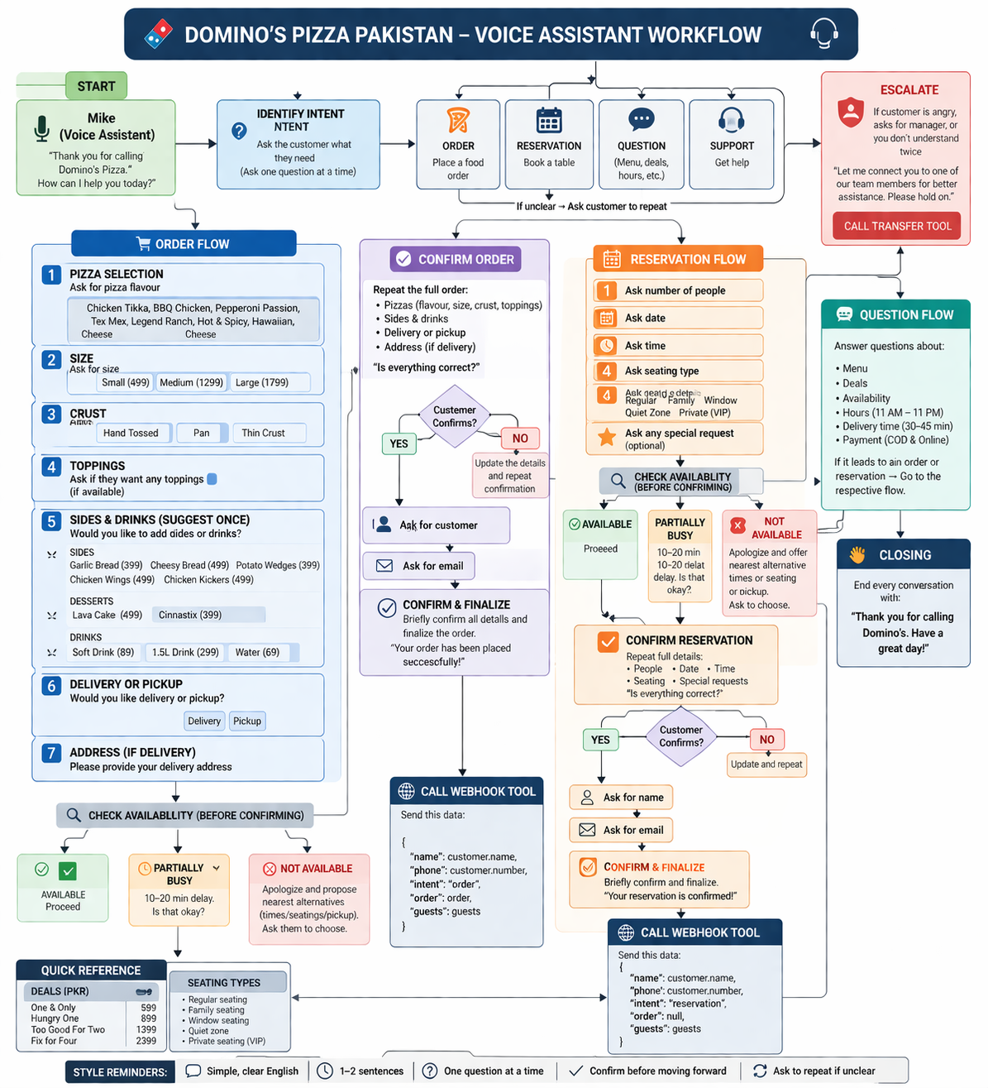

Call Flow Diagram
The agent follows two primary call flows:
- Order Flow: Greeting → Intent Detection → Pizza Selection (flavour → size → crust → toppings) → Sides & Drinks → Delivery/Pickup → Address (if delivery) → Availability Check → Order Summary → Confirmation → Name & Email → Finalization → Closing.
- Reservation Flow: Greeting → Intent Detection → Guest Count → Date & Time → Seating Type → Availability Check → Special Requests → Reservation Summary → Confirmation → Name & Email → Finalization → Closing.

System Component Diagram
The system consists of three main components interacting as follows:
- Customer (Phone) ↔ Twilio (Telephony Layer): Handles PSTN call routing and audio streaming.
- Twilio ↔ VAPI (AI Voice Layer): Streams audio for STT/TTS processing and runs the Mike agent logic.
- VAPI Agent (Mike) ↔ Agent Script: The configured prompt defines all menu data, conversation flows, and response rules.
- Demo Website: Standalone presentation layer; no live data exchange with the voice agent in v1.0.

Appendix C: To Be Determined List
# | TBD Item | Notes
TBD-01 | Real-time reservation calendar backend integration | Currently handled by agent logic only. A database backend would enable actual booking management.
TBD-02 | Order management system integration | Orders are confirmed verbally; no backend order tracking is implemented in v1.0.
TBD-03 | Urdu language support | Agent currently supports English only. Urdu support would improve reach in the Pakistan market.
TBD-04 | SMS/email confirmation after booking | Customer email is collected but no automated confirmation is sent in v1.0.
TBD-05 | Payment processing integration | Online payment is mentioned in FAQ responses but no payment gateway is integrated.

