Aptura Tech Solution
Batch 3 Internship — Week 1 — Python
Task 1: Student Record System
Project Report

1. Objective
The objective of this task was to design and implement a Student Record System in Python, applying industry best practices for code structure, data persistence, error handling, and documentation. The system runs entirely in the terminal (command-line interface) and allows a user to add, view, search, update, and delete student records.

2. Tools & Technologies
- Language: Python 3
- Data storage: JSON file (students.json)
- Standard library modules: json, os, logging, dataclasses, typing
- No external/third-party dependencies required

3. Project Structure
The project is organised into three modules to follow the single-responsibility principle, rather than placing all logic into one script:
- student.py — defines the Student data model using a Python dataclass, along with to_dict()/from_dict() helpers for JSON serialisation.
- storage.py — handles reading from and writing to the JSON data file, isolating persistence logic from the rest of the app.
- main.py — contains the menu-driven command-line interface and orchestrates add/view/search/update/delete operations.

4. Features Implemented
Feature | Description
Add Student | Prompts for Roll No, Name, Age, Course and Marks, validates input, and prevents duplicate Roll Numbers.
View All Students | Displays all records in a neatly formatted table with a total record count.
Search Student | Looks up a single student instantly by Roll No.
Update Student | Edits any field of an existing record; blank input keeps the current value.
Delete Student | Removes a record after an explicit (y/n) confirmation prompt.
Data Persistence | All changes are saved immediately to students.json so data survives program restarts.
Logging | Key actions and errors are written to app.log for traceability.

5. Best Practices Applied
- Separation of concerns across three modules (model / storage / UI).
- Type hints and docstrings on all functions for readability and maintainability.
- Defensive input validation loops instead of allowing the program to crash on bad input.
- try/except error handling around file I/O and the main menu loop, with a friendly error message shown to the user.
- Use of Python dataclasses to reduce boilerplate in the data model.
- No hard-coded 'magic' file paths — the data file path is resolved relative to the script location.

6. Testing
The application was tested end-to-end by simulating a full user session: adding two students, viewing all records, searching by Roll No, updating a record's course and marks, deleting a record, and confirming the final record count. All operations produced the expected output and the JSON file correctly reflected every change. Edge cases tested included empty input, invalid (non-numeric) age/marks input, searching/updating/deleting a non-existent Roll No, and attempting to add a duplicate Roll No.

7. Sample Output (Screenshots)
Below are sample terminal screenshots demonstrating the core operations. Additional screenshots are provided in the screenshots/ folder.
Adding a new student record:
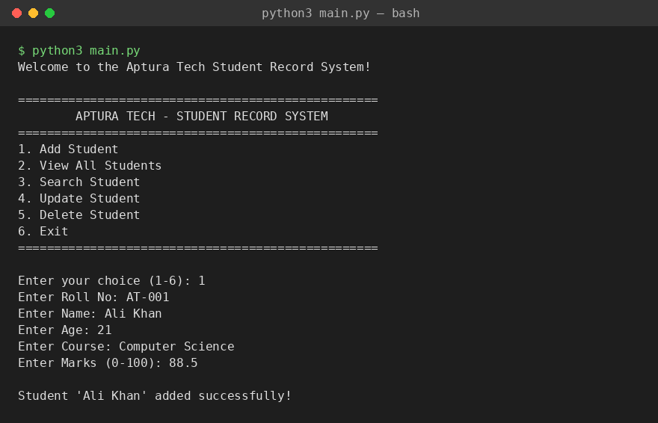
Viewing all student records:
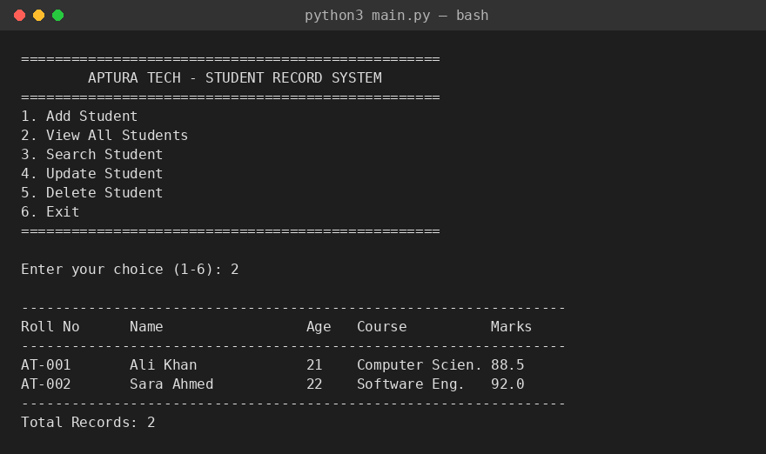

8. Deliverables Checklist
- Source files — student.py, storage.py, main.py
- Report — this document (report.docx)
- Screenshots — screenshots/ folder (5 images covering all CRUD operations)
- README — README.md with setup and usage instructions

9. Conclusion
This task successfully delivers a fully functional, terminal-based Student Record System in Python that meets the stated objective of applying industry best practices. The modular structure, input validation, persistent JSON storage, and logging make the application robust, easy to test, and straightforward to extend with future features such as CSV export or a graphical interface.

