TankAttack - Design

by Ruslan Ardashev (’15)

**CS 308**

**Assignment 1, Part 1**

Table Of Contents

VISION 2

GENRE 3

TITLE 3

GOAL 3

BASIC MECHANICS 3

HOW LEVELS DIFFER 3

IMPLEMENTATION DETAILS 4

ROLE OF “TankAttack” – MAIN CLASS 4

WORLDS 4

SPRITES 4

# VISION

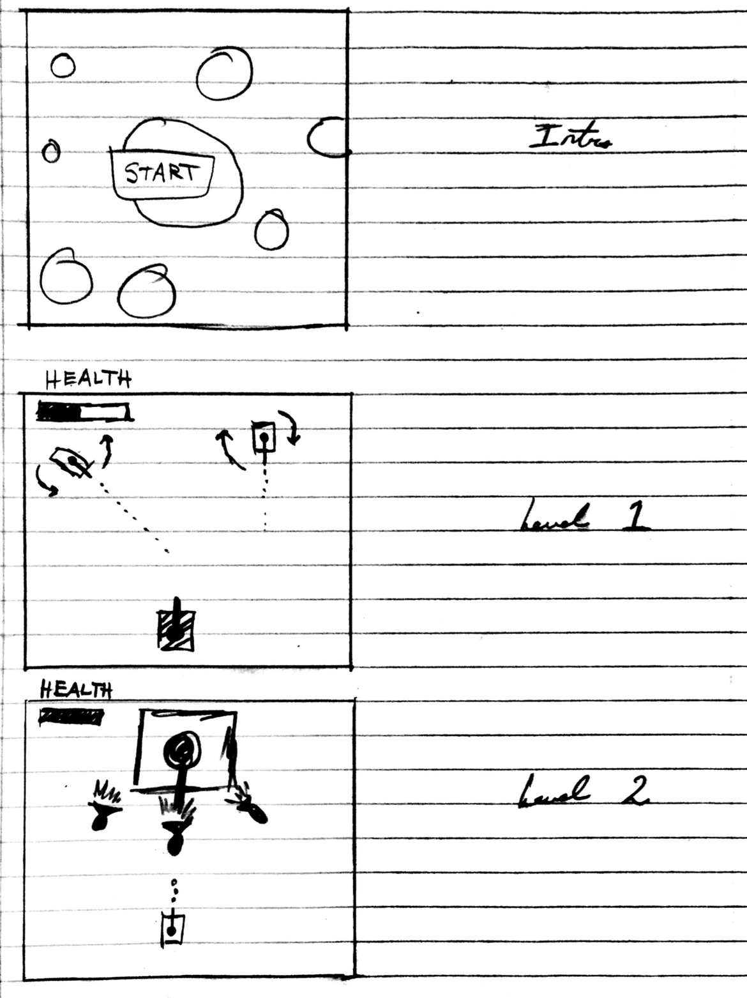

# GENRE

The genre of the game is “Top-Down Shooter.”

# TITLE

“TankAttack” -- The title originates from my obsession with a game called “Tanks” as a little boy, and also stems from my continued interest in the first popular iPhone game, “Tanks” (creative title). I figured “TankAttack” is at least marginally more exciting than “Tanks.”

# GOAL

**Destroy all enemy tanks.**

# BASIC MECHANICS

**CONTROLS**

UP, DOWN, LEFT, RIGHT to move about.

SPACE to fire.

**CHEATS**

Pressing “H” freezes all opponent tanks.

Pressing “F” restores your health.

# HOW LEVELS DIFFER

**Level 1**

Defeat all rogue tanks in Level 1. These are novices that have their gears stuck and / or do not really know how to operate a tank.

**Level 2**

Defeat the boss tank. Not only does he possess a very powerful, large tank, but is intelligent and skilled. Oh, and his tank can fire three K.O. missiles at once.

# IMPLEMENTATION DETAILS

The following is a high-level description of how the game will be implemented:

## ROLE OF “TankAttack” – MAIN CLASS

The *TankAttack* class which extends a JavaFX2 Application will be primarily responsible for:

* Switching Levels and anything to do with the stage
* Creating instances of Worlds / Initializing

TankAttack has important, public, static variables such as:

* Frames per second
* Game width
* Game height

## WORLDS

Worlds are responsible for:

* Animation
* Containing an ArrayList<Sprite>
* Updating on each cycle

Two subclasses of World:

* FirstWorld
* SecondWorld

World inherits from nothing, and is an abstract class.

## SPRITES

Three subclasses of Sprite (currently as of this writing):

* Player
* Bullet
* Enemy

Sprite inherits from the JavaFX2 ImageView and is an abstract class.