Analysing Crime Patterns, Identifying

High-Risk Areas, and Predicting Crime

Trends Using UK Police Open Data

Table of Contents
Analysing Crime Patterns, Identifying 1
High-Risk Areas, and Predicting Crime 1
Trends Using UK Police Open Data 1
1. Project Overview 2
2. Dataset Description 3
3. Exploratory Data Analysis 3
3.1 Monthly Crime Trend 3
3.2 Seasonal Crime Pattern 4
3.3 Top 10 Crime Types 5
3.4 Top Outcome Categories 5
3.5 Spatial Distribution of Crimes 6
4. Hotspot Detection Using Clustering (RQ1) 6
4.1 KMeans Results 7
4.2 DBSCAN Results 7
5. Crime Forecasting (RQ2) 7
5.1 Linear Regression Results 8
5.2 Random Forest Results 8
5.3 Overfitting Check 8
5.4 Regularised Random Forest 8
5.5 Actual vs Predicted Plot 9
5.6 Residual Distribution 9
6. Feature Selection 9
7. Model Interpretability Using SHAP (RQ3) 9
7.1 SHAP Summary Plot 9
7.2 SHAP Feature Importance 10
8. Final Conclusion 10

1. Project Overview
This project studies crime patterns using UK Police open data. The aim is to understand how crime changes over time, where high-risk areas are located, and whether we can predict future crime levels.
The project has three main parts:
- Exploratory Data Analysis
- Hotspot detection using clustering
- Crime forecasting using machine learning
The dataset was taken from UK Police open crime records. It includes crime data from City of London Police and West Midlands Police.

2. Dataset Description
The original data contains street-level crime records. There are 772,974 records in total.
The dataset includes:
- Crime type
- Outcome category
- Month and year
- Latitude and longitude
- LSOA code
For modelling, the data was aggregated to LSOA-month level. This resulted in 47,098 records. Each row represents one LSOA in one month with total crime count.

3. Exploratory Data Analysis
EDA was performed to understand crime behaviour before building models.

3.1 Monthly Crime Trend
Figure 1 shows that crime levels change over time. Crime decreased at the start of 2025 and increased during mid-2024. This shows that crime is not stable and varies across months.

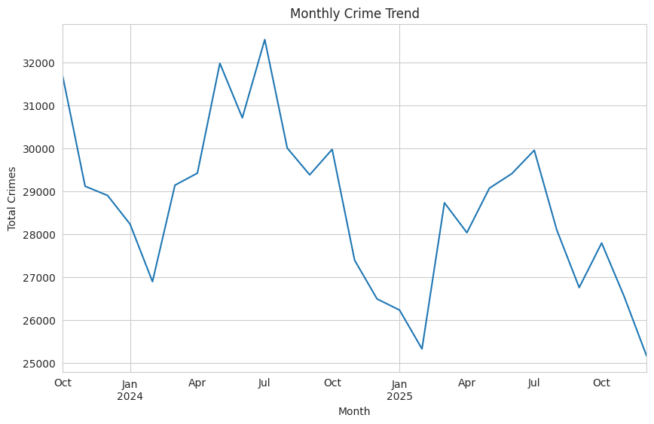
Figure ‎0.1: Monthly Crime Trend

3.2 Seasonal Crime Pattern
Figure 2 shows that crime appears higher in months 10, 11, and 12. This suggests that crime may increase toward the end of the year. Seasonality is important for forecasting models.
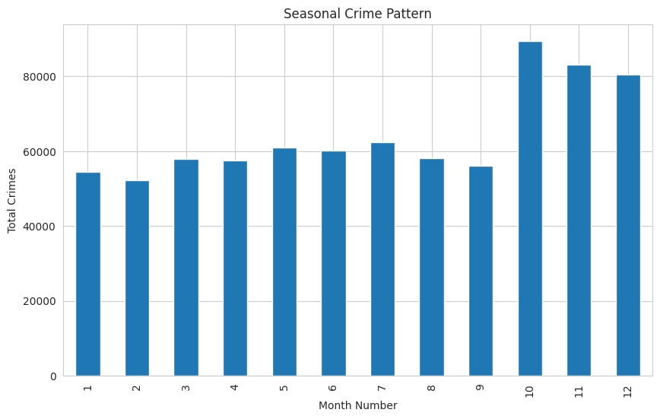
Figure ‎0.2: Seasonal Crime Pattern

3.3 Top 10 Crime Types
Figure 3 shows violence and sexual offences is the most common crime type. Other common crimes include shoplifting and vehicle crime. This shows that crime composition varies across areas.
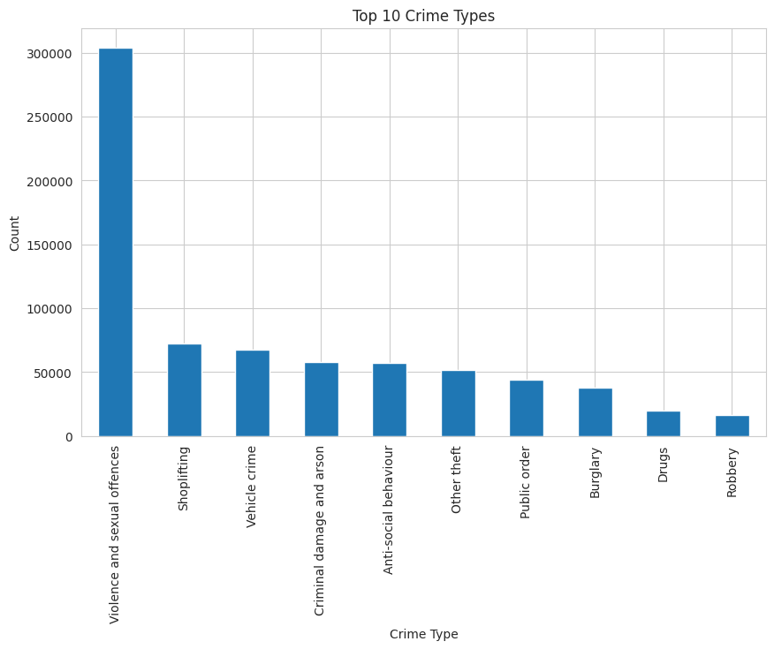
Figure ‎0.3: Top 10 Crime Types

3.4 Top Outcome Categories
Figure 4 shows the most common outcome is “Unable to prosecute suspect”. This suggests that many crimes do not lead to conviction.
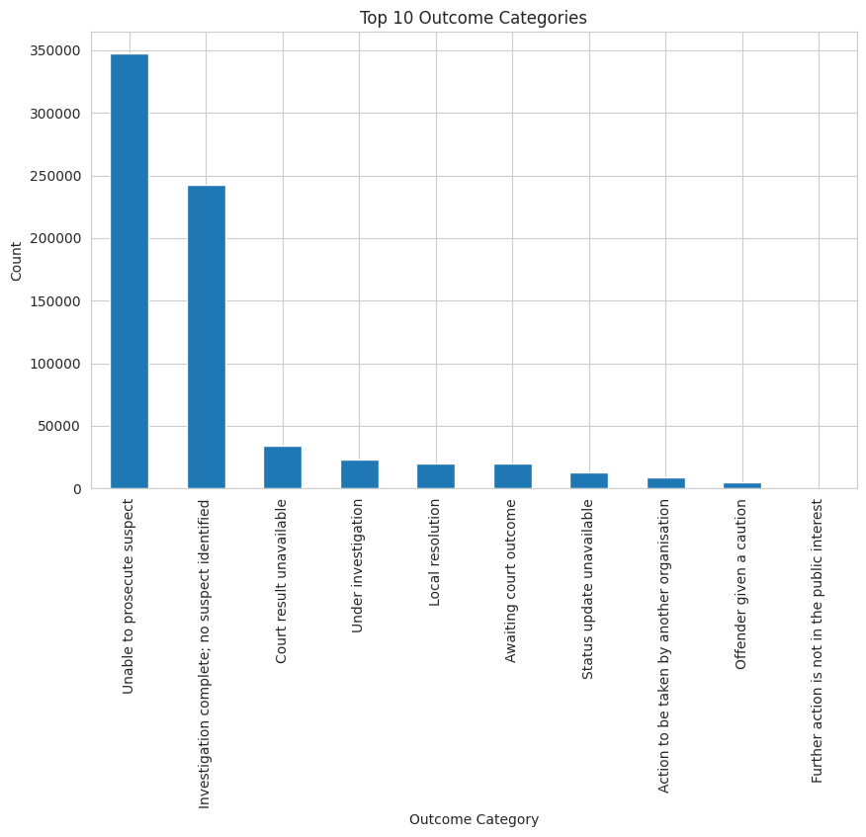
Figure ‎0.4: Top Outcome Categories

3.5 Spatial Distribution of Crimes
Figure 5 shows that crime is concentrated in specific urban areas. This supports the need for hotspot detection.
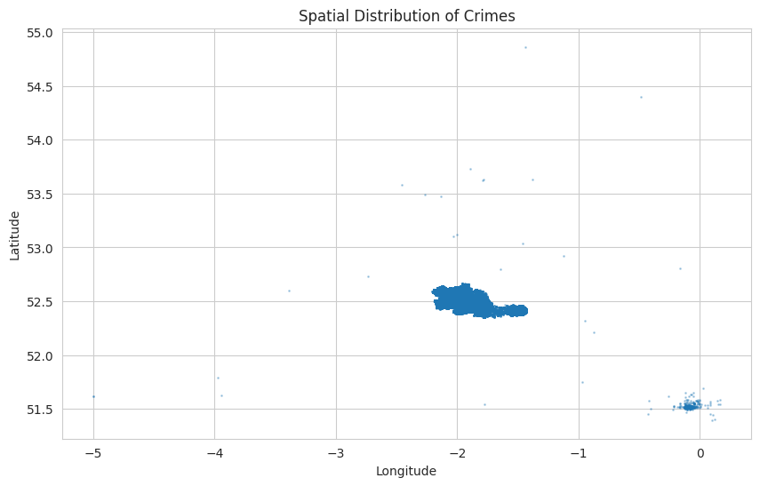
Figure ‎0.5: Spatial Distribution of Crimes

4. Hotspot Detection Using Clustering (RQ1)
Two clustering methods were used:
• KMeans
• DBSCAN
Features used for clustering:
• Log crime count
• Latitude
• Longitude
• Month number
All features were standardised before clustering.

4.1 KMeans Results
Silhouette Score: 0.265
Figure 6 shows that KMeans grouped areas broadly but did not clearly isolate extreme high-crime areas. The silhouette score indicates moderate clustering quality.
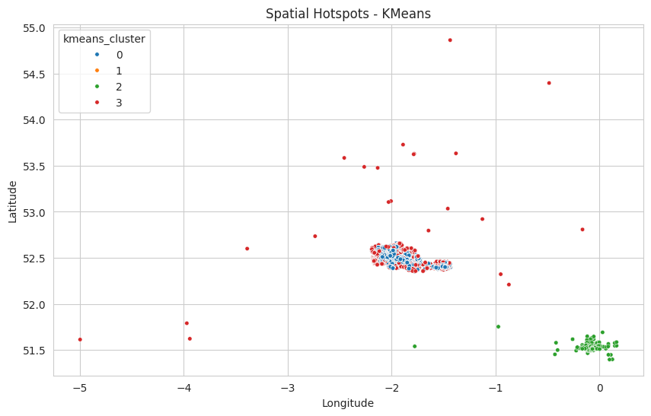
Figure ‎0.1: Spatial Hotspots - KMeans

4.2 DBSCAN Results
Silhouette Score: 0.742
DBSCAN identified a small cluster with extremely high crime intensity. One cluster had an average crime count of 498 crimes per month, which is much higher than other clusters.
These extreme hotspots were mainly located in the City of London Police area.
DBSCAN performed better than KMeans because it can detect dense and irregular shaped clusters.

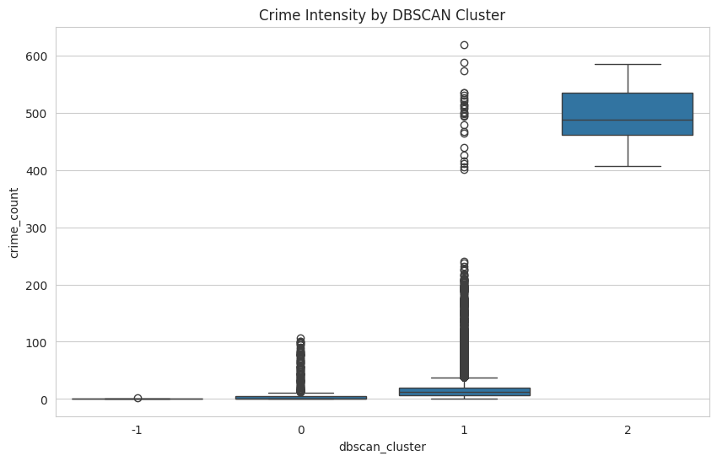
Figure ‎0.2: Spatial Hotspots - DBSCAN

5. Crime Forecasting (RQ2)
The goal was to predict crime count per LSOA per month.
Target variable:
crime_count
Features included:
• lag_1 (previous month crime)
• year
• month_num
• is_winter
• Latitude
• Longitude
• dominant_type_count
• lsoa_encoded
Data was split by time:
Training data: before 2025
Testing data: 2025

5.1 Linear Regression Results
RMSE: 5.35
MAE: 3.52
Linear Regression assumes a linear relationship between features and crime count. It provides a baseline model.

5.2 Random Forest Results
RMSE: 4.84
MAE: 3.11
Random Forest performed better than Linear Regression. This shows that crime patterns are non-linear and complex.

5.3 Overfitting Check
Training RMSE: 1.84
Testing RMSE: 4.84
There is a large gap between training and testing error. This indicates overfitting.

5.4 Regularised Random Forest
After limiting tree depth and leaf size:
Training RMSE: 3.98
Testing RMSE: 4.86
The gap between training and testing error decreased. This shows improved generalisation.

5.5 Actual vs Predicted Plot
The scatter plot shows that predictions follow the actual crime counts closely, especially for medium values. Some larger values are slightly underestimated.
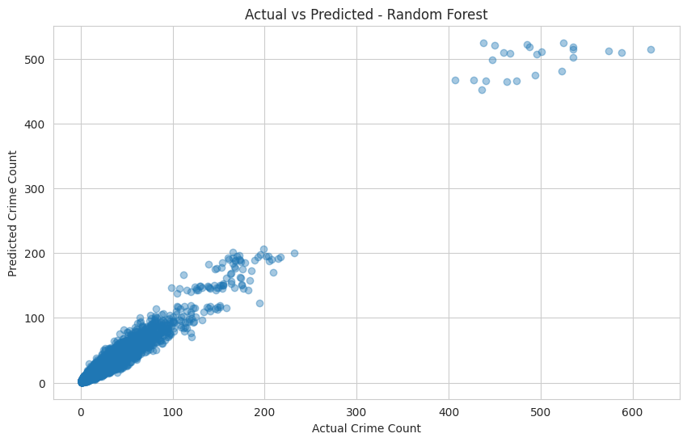
Figure 8: Actual vs Predicted Crime Count

5.6 Residual Distribution
The residual plot shows the error distribution. Most errors are centered around zero, indicating that the model is not strongly biased as shown in figure 9.
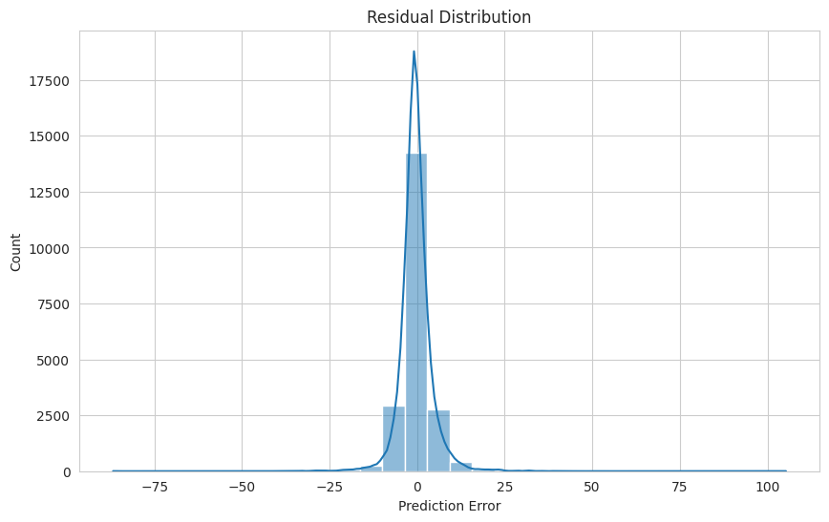
Figure 9: Residual Distribution

6. Feature Selection
SelectKBest was used to rank feature importance.
Top features were:
- lag_1
- dominant_type_count
- Longitude
- Latitude
- lsoa_encoded
Year and month number had very low importance.
After selecting the top 5 features, RMSE improved slightly to 4.82. This shows that a simpler model can perform well.

7. Model Interpretability Using SHAP (RQ3)
SHAP was used to explain how each feature affects predictions.

7.1 SHAP Summary Plot
Figure 10 plot shows that:
• lag_1 strongly increases future crime when previous crime is high
• dominant_type_count increases prediction when high
• spatial features influence predictions differently across areas

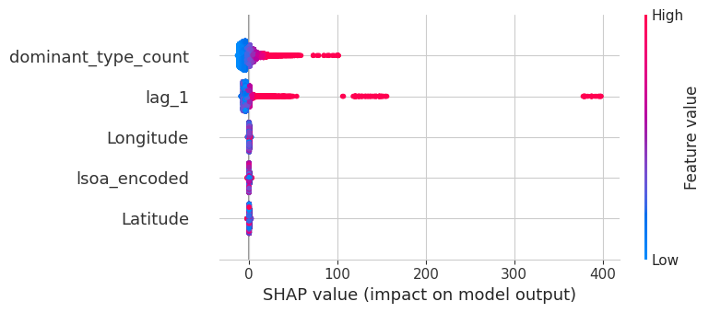
Figure 10: SHAP Summary Plot

7.2 SHAP Feature Importance
The most important features are:
- dominant_type_count
- lag_1
This confirms that crime risk is both temporally persistent and composition-based as shown in figure 11.

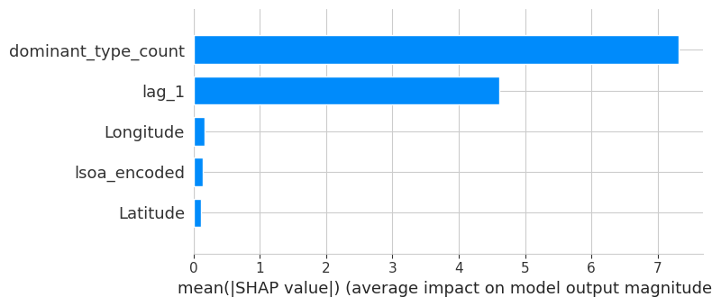
Figure 1‎0.1: SHAP Feature Importance (Bar Plot)

8. Final Conclusion
This project shows that crime changes over time and follows clear seasonal patterns. Crime is not evenly spread across areas, but instead is concentrated in specific geographic locations. The clustering results show that DBSCAN is better than KMeans for identifying extreme high-risk hotspots because it can detect dense and unusual patterns in the data. In the forecasting task, Random Forest performed better than Linear Regression, which shows that crime patterns are complex and not purely linear. The results also show that the previous month’s crime level is the strongest predictor of future crime, meaning crime tends to continue in areas where it is already high. Crime composition also plays an important role, as areas with higher dominant crime types tend to have higher future crime levels. Overall, crime risk is both temporally persistent and spatially structured, which means it depends on time patterns and geographic location.

