Contributor: *Luka Anicin*

Data Scientist: *Ruslan S.*

**CAPSTONE FINAL REPORT: Sentiment Analyses**

**MODEL PERFORMANCE (chosen/final model number 4):**

* Model name: ‘model_4’
* Model performance on average:
  + Accuracy is 77%
  + Precision (macro/weighted average) is 77%
  + Recall (macro/weighted average) is 77%
  + F1-score (macro/weighted average) is 77%
* Class 0 (negatives)
  + Precision is 77%
  + Recall is 77%
  + F1-score is 77%
* Class 1 (positives)
  + Precision is 77%
  + Recall is 77%
  + F1-score is 77%
* Confusion matrix:
  + Actual ‘negatives’ and predicted ‘negatives’ is 77%
  + Actual ‘positives’ and predicted ‘positives’ is 77%
  + Actual ‘positives’ but predicted ‘negatives’ is 23%
  + 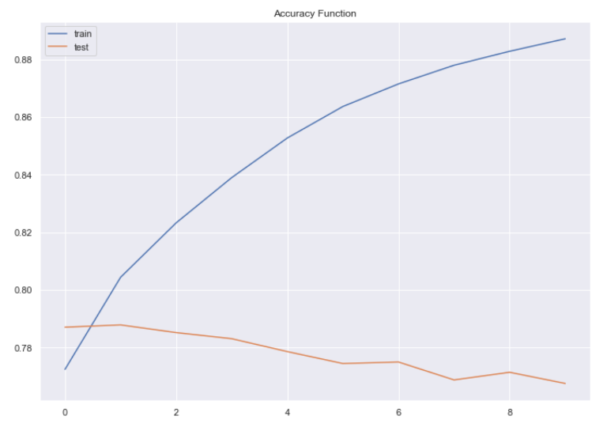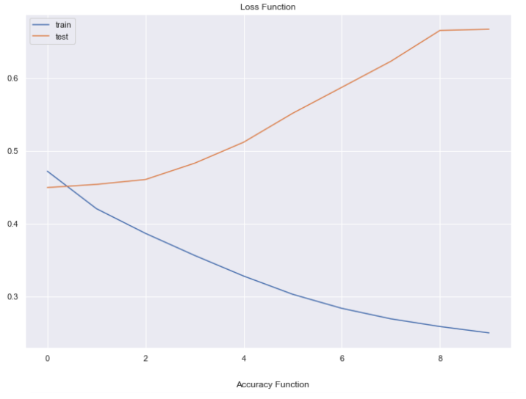Actual ‘negatives’ but predicted ‘positives’ is 23%

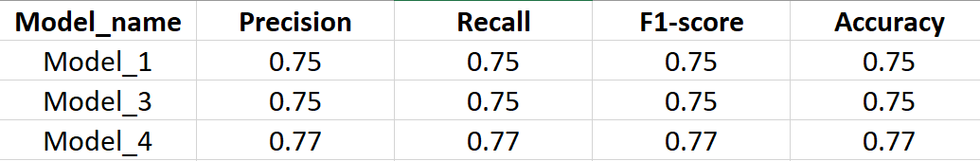**PERFORMENS OF ALL TRAINED MODELS**: Metrics of all trained models.