LAB3 CEG2136
ARITHMETIC LOGIC UNIT

PRELAB

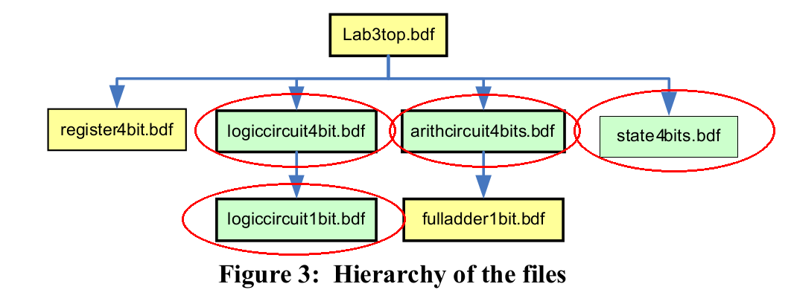

OPTIONAL: A 4-bit register made from D Flip Flops. The Diagram is already provided in Figure 8 on page 6 of the lab manual.

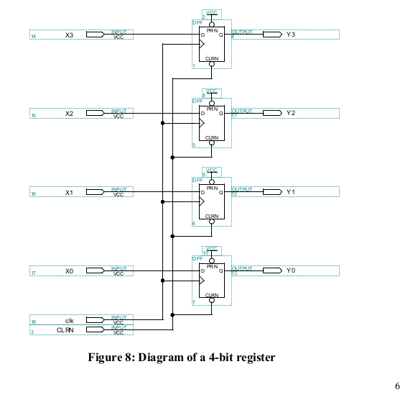

5.3.1 REQUIRED: Show a 1 bit Logic and Shift Circuit (logiccircuit1bit.bdf )

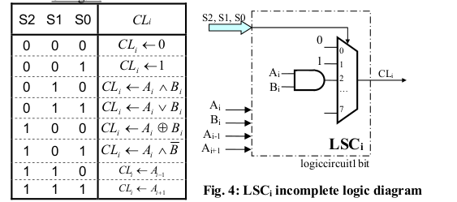

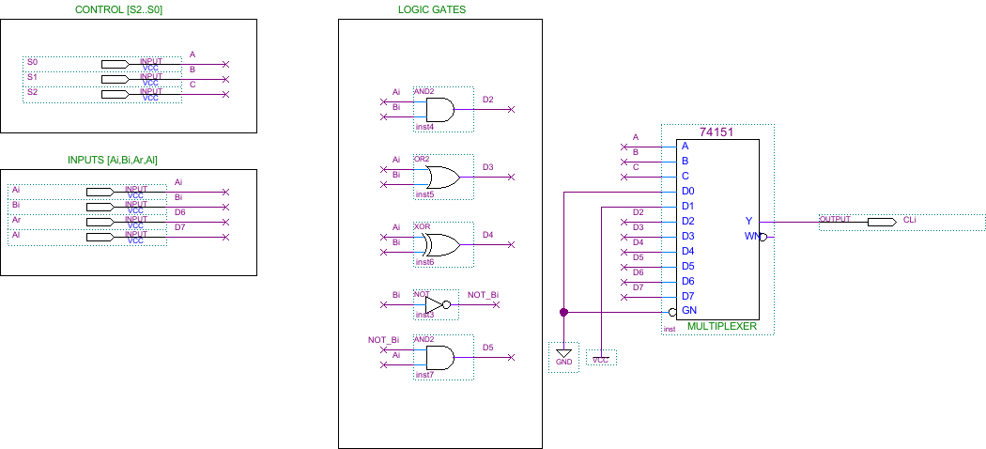

5.3.2 REQUIRED: Show a 4-bits Logic and Shift Circuit (logiccircuit4bits.bdf )
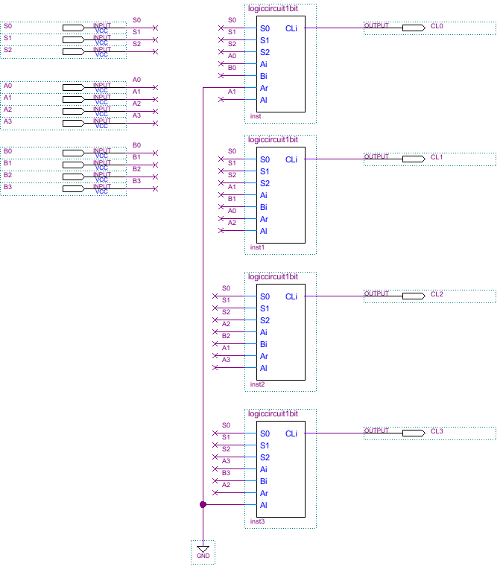

OPTIONAL: Show a 1-bit Full Adder (fulladder1bit.bdf ). The diagram is already provided in Figure 9 on page 7 of the lab manual.

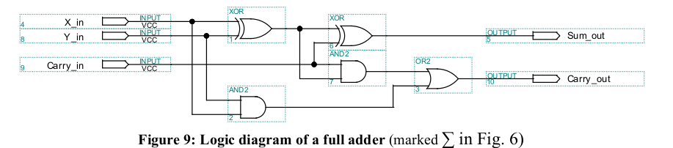

5.4.1 REQUIRED: Complete the Truth table for a 1-bit Arithmetic Circuit (AC or 1-bitfulladder) corresponding to Figure 5 on Page 4

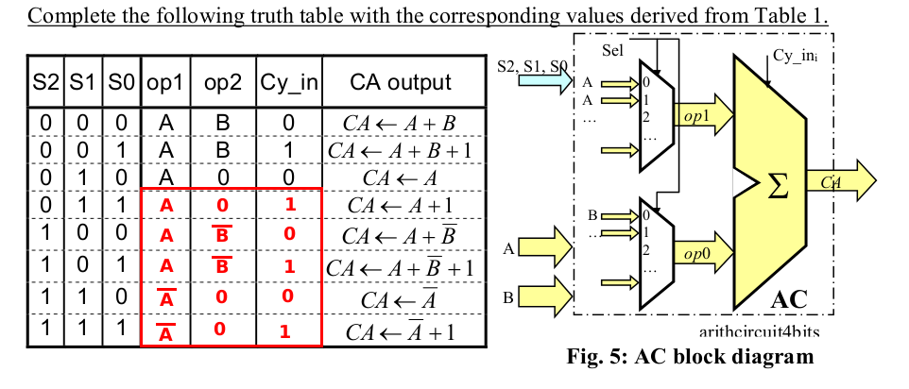

5.4.2 REQUIRED: Two possible ways.

First Alternative (Not Efficient): Using two 8-to-1 multiplexers with S0,S1 and S2 as Select
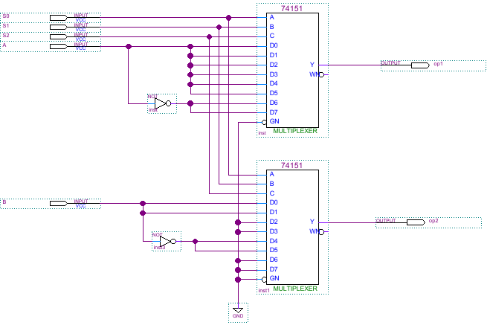

5.4.2 REQUIRED (CONT.)
Second Alternative (Efficient): Using two 4-to-1 multiplexers with S2 and S1 as Select

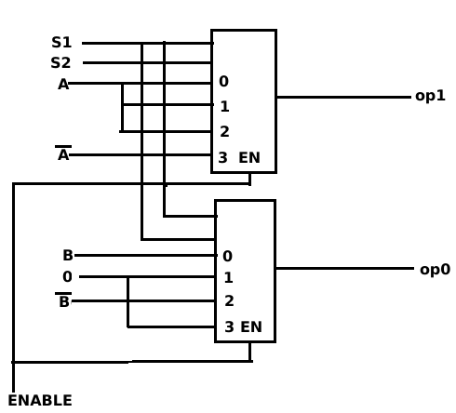

5.4.3. REQUIRED. Equation for Cy (Can be obtained from K-maps for example)

Cy=S0

5.4.4 REQUIRED. Complete block diagram for ACi

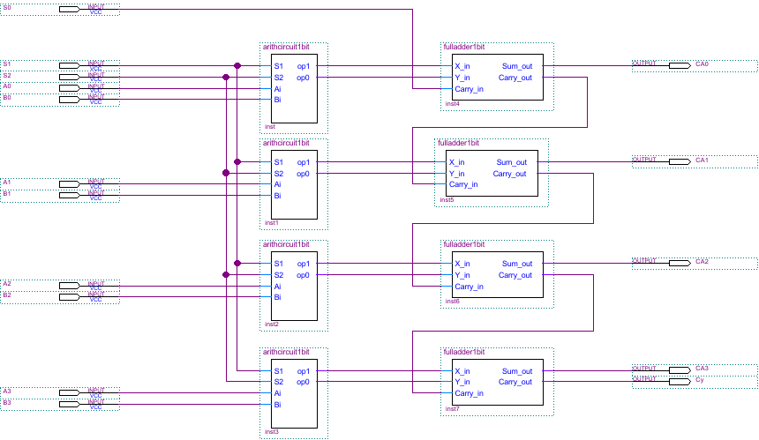

5.5 REQUIRED. Complete block diagram for Aci

Z=(C3 OR C2 OR C1 OR C0)'
S=C3
Cy=S3 AND Cy_in
V=Cy_in1 XOR Cy_in2

