Technical Solution Description

CONTENT

DESCRIPTION 1

USED TECHNOLOGIES AND FRAMEWORKS 1

DATA MODEL 2

Data Model Diagram 2

Tables Description 3

APPLICATION MODULES 4

USER INTERFACE 5

FUNCTIONALITY 6

Common User functionality 6

Registration 6

Login 6

View contract detail 6

Block contract 6

Unblock contract 6

Change rate 6

Manage option set 6

Operator functionality 6

Login 6

Add person 7

Add contract 7

Manage contracts 7

Manage rates 7

Manage options 7

# DESCRIPTION

OP!SYSTEM – is the web system for telecom companies, which provides telecommunication service. It allows for staff create new contracts with persons, manage person contracts. Add new rates and options. It allows for person login in account and manage his contract by himself.

# USED TECHNOLOGIES AND FRAMEWORKS

IDE – IntelliJ IDEA 2016.3.4

JDK 1.8

WildFly 10 Final

JSP/JSTL

Oracle Database

Spring 4

Apache Maven 3.5.0

JPA 2.1 / Hibernate 5.1

Log4j 2

HTML, CSS

JavaScript, jQuery

Bootstrap

# DATA MODEL

## Data Model Diagram

The scheme OPSYSTEM of Oracle Database consist of 13 tables. All tables have a primary key with corresponding sequence and trigger for increment and generate unique identifier, when new record inserting.

## Tables Description

**ACCOUNTS** – contains information about all accounts in system. Common users, employees and admins have unique accounts. Each record consist from login, password and role information. For common users login is equal to phone number. For employees login is ‘operator’ and for admin login is ‘admin’. ACCOUNTS table have relation with tables: OPSYSTEM_ROLES, PERSONS.

**BLOCKING_TYPES** – contains information about type of block mode. Now system support two mode of blocking: ‘O’ - operator block, ‘C’ - common user block. Each record consists from type of blocking mode and description. BLOCKING_TYPES table have relation with tables: CONTRACTS.

**CONTRACTS** – contain information about all contracts in system. Each record consist from person identifier, rate identifier, phone number identifier and flag defining that contract is blocked or not. CONTRACTS table have relation with tables: PERSONS, BLOCKING_TYPES, RATES, PHONE_NUMBERS, OPTIONS via CONTRACTS_OPTIONS_LINK table with many-to-many relation.

**CONTRACTS_OPTIONS_LINK** – contain information about contracts and options dependencies. Each record consist from contract and option identifiers and define that contract have one or another option. CONTRACTS_OPTIONS_LINK table have relation with tables: CONTRACTS, OPTIONS.

**EXCLUDE_OPTIONS** – contain information about options dependencies. It table linked options between themselves. Each record consist from two identifiers of two options, which have dependency and define that one option can not be turned on if second option is turned on. EXCLUDE_OPTIONS table have relation with tables: OPTIONS with twice many-to-many relation.

**INCLUDE_OPTIONS** – contain information about options dependencies. It table linked options between themselves. Each record consist two identifiers of two options, which have dependency and define that one option can be turned on only if second option is turned on. INCLUDE_OPTIONS table have relation with tables: OPTIONS with twice many-to-many relation.

**OPSYSTEM_ROLES** – contain information about all roles uses in OP!SYSTEM. Each record consist from role identifier, role name and role description. OPSYSTEM_ROLES table have relation with tables: ACCOUNTS.

**OPTIONS** – contain information about all rates options. Each record consist from identifier, name of option, price, add coast, flag which determine that option is active or not, and flag which determine that option is use as default option for rates. OPTIONS table have relation with tables: INCLUDE_OPTIONS, EXCLUDE_OPTIONS, CONTRACTS_OPTIONS_LINK, RATES_OPTIONS_LINK.

**PHONE_NUMBERS** – contain information about all phone numbers in system. Phone number is represent a real hardware sim-card. Is expected that information about phone numbers import to PHONE_NUMBERS table from external system. Each record consist from identifier, unique phone number, flag which determine that phone number is issued or not and identifier of contract with which it is linked for reverse relation. PHONE_NUMBERS table have relation with tables: CONTRACTS.

**PERSONS** – contain information about all persons in system. Each record consist from identifier and general person information. At that passport series and passport number must be unique. PERSONS table have relation with tables: CONTRACTS and ACCOUNTS.

**RATES** – contain information about all rates in system. Each record consist from identifier, name of rate, price and flag which determine that rate is deleted or not. RATES table have relation with tables: CONTRACTS, RATES_OPTIONS_LINK, RATES_PRICES_HISTORY.

**RATES_PRICES_HISTORY** – contain information about changes price of rates. Each record consist from identifier, rate identifier, date when price was changed and information about old price. RATES_PRICES_HISTORY table have relation with tables: RATES.

**RATES_OPTIONS_LINK** – contain information about rates and options dependencies. It use for link options with rates. Each record consist from unique pair of rate and option identifiers. RATES_OPTIONS_LINK table have relation with tables: RATES and OPTIONS.

# APPLICATION MODULES

Application composed from two modules. Main application module ‘mainapp’ which contain main configuration classes, controllers, views, static resources, front-end scripts, css styles and fonts. Configuration classes and controllers included in packages “com.tsystems.jschool20” and “com.tsystems.jschool20.controllers” accordingly.  
And second module “srvengine” which contain services API, services implementations, entities, transport classes and repositories which implemented JPA repository interfaces.

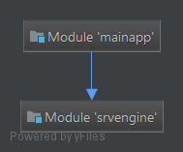

# USER INTERFACE

Front-end user interface based on standard lightweight bootstrap css framework with JQuery, java-script technologies.

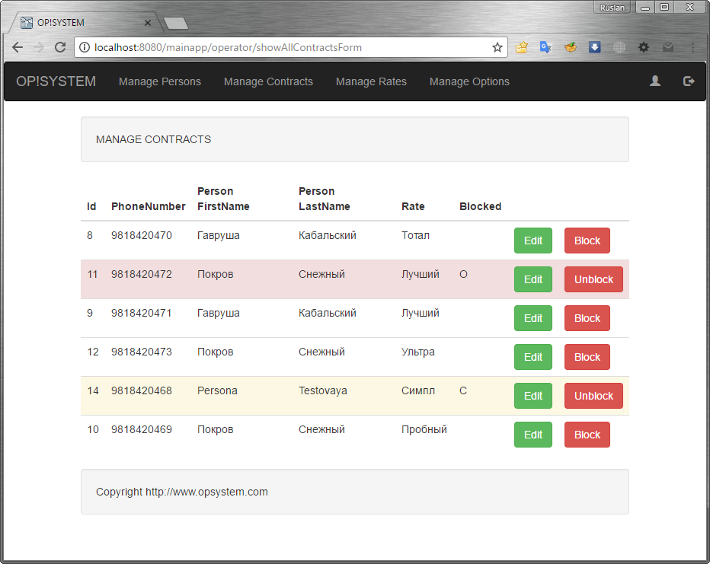

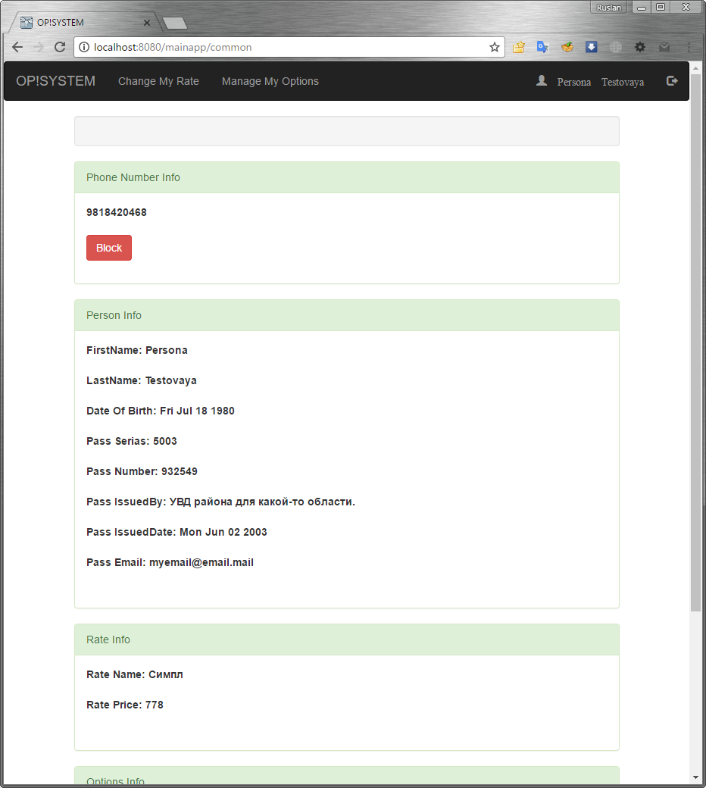

# FUNCTIONALITY

## Common User functionality

### Registration

The user must register before logging in. To do this, he must go to the new user registration form. On registration form he must enter his phone number and password and then confirm password.

### Login

If user has registered account he can login in system. In login form he must enter his login, which corresponded with phone number and enter a password.

### View contract detail

After user login to system and was authorized he redirect to contract detail page. On that page he can view detail information about his personal info and current contract details: rate and options set.

### Block contract

If user want to block his contract he can click on button “Block”. After that contract will immediately blocked.

### Unblock contract

If contract was blocked by user, than he can unblock contract himself. To do user can click on button “Unblocked” on contract detail page.

### Change rate

For change rate user can click on “Change my rate” in main menu. After that he will redirected on page with available rates list. For each rate in list will be button with label “Change”. User can click on button for immediately change rate for current contract.

### Manage option set

User can change options set for contract. For that he can click on “Manage options” in main menu. After click he will redirect to page with available options list for contract rate. On that page user can turn on or turn off options.

## Operator functionality

### Login

If operator has registered account he can login in system. In login form he must enter his login and enter a password.

### Add person

Before operator can add new contract he must add person. To do that he must select “Manage persons” in main menu фтв click on “Add new” button. In add new person form enter required fields and click on “Add” button.

### Add contract

For add new contract operator can go to page with persons list and click on “Add contract” button in the row corresponding person. System redirect to add new contract form. After enter required information he must click on “Add” button.

### Manage contracts

For manage contracts operator can click on “Manage contracts” button in main menu. When he click system redirect to contracts list form. On contracts list form operator can block and unblock contracts, edit contracts.

### Manage rates

For manage rates operator can click on “Manage rates” button in main menu. When he click system redirect to rates list form. On rates list form operator can click on “Add new” for add new rate or click on “Edit” button for edit rate.

### Manage options

For manage options operator can click on “Manage options” button in main menu. When he click system redirect to options list form. On options list form operator can click on “Add new” for add new option or click on “Edit” button for edit option.