***Gas Detection***

***& Ventilation System***

* *Rus Rares Tudor*
* *Group 30432*

*Contents:*

1. *Introduction . . . . . . . . . . .. . . . . . .. . . . . . . . . . . . . . . . . . . . . . . . . . . . . . . . . . . . . . . . . . . . . . . . . . . . . . . . . . . . . . . .*
2. *Design . . . . . . . . . . .. . . . . . .. . . . . . . . . . . . . . . . . . . . . . . . . . . . . . . . . . . . . . . . . . . . . . . . . . . . . . . . . . . . . . . . . . . . . .*
3. *Implementation . . . . . . . . . . .. . . . . . .. . . . . . . . . . . . . . . . . . . . . . . . . . . . . . . . . . . . . . . . . . . . . . . . . . . . . . . . . . .*
4. *Results . . . . . . . . . . .. . . . . . .. . . . . . . . . . . . . . . . . . . . . . . . . . . . . . . . . . . . . . . . . . . . . . . . . . . . . . . . . . . . . . . . . . . . . .*
5. *Conclusions . . . . . . . . . . .. . . . . . .. . . . . . . . . . . . . . . . . . . . . . . . . . . . . . . . . . . . . . . . . . . . . . . . . . . . . . . . . . . . . . . .*

1. Introduction

A gas detector is a device that detects the presence of [gases](https://en.wikipedia.org/wiki/Gas) in an area, often as part of a safety system. This type of equipment is used to detect a [gas leak](https://en.wikipedia.org/wiki/Gas_leak) or other emissions and can interface with a [control system](https://en.wikipedia.org/wiki/Control_system) so a process can be automatically shut down. A gas detector can sound an alarm to operators in the area where the leak is occurring, giving them the opportunity to leave. This type of device is important because there are many gases that can be harmful to organic life, such as humans or animals.

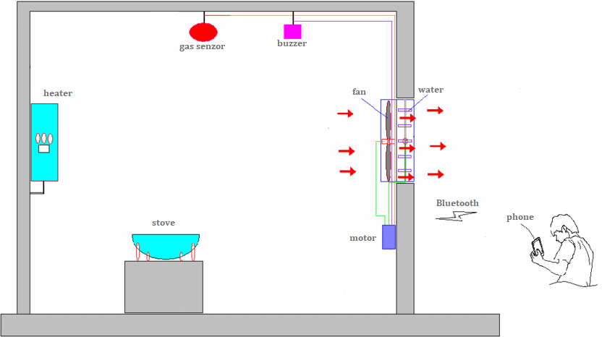The goal of this project is to design and implement a system for monitoring the gas leaks or other emissions and informs the user in real time about air quality. In case of emergencies, the user can power on a ventilation and/or irrigation system, in order to remove the threat.

2. Design

In order to achieve our goal, we will use an Arduino UNO board and some compatibles modules specific to the problems encountered in creating the system. The software used is the Arduino IDE. In the following, are presented all the compotes used.

* Arduino UNO r3 ATmega328P

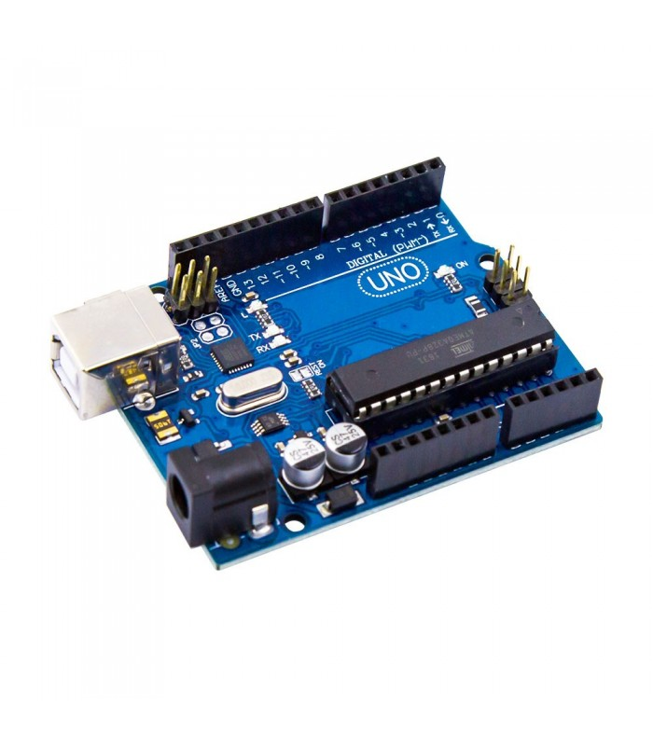

* Bluetooth HC-05 module

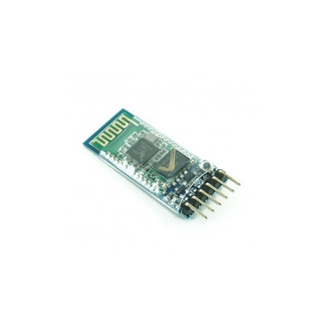

* Relay 1 channel 5V module

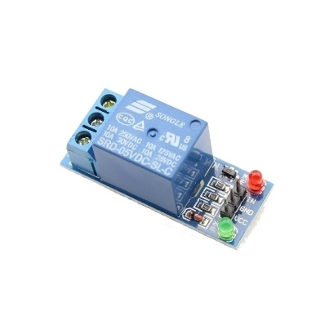

* RTC DS3231 AT24C32

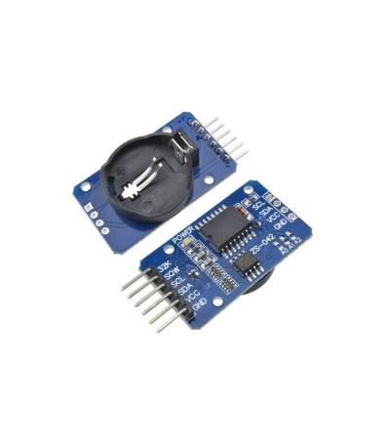

* LCD 2004 with Blue I2C

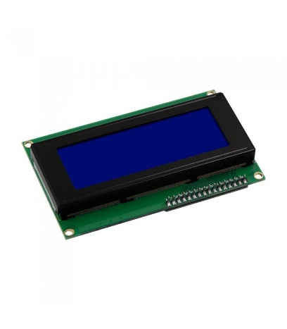

* Gas Detector Sensor MQ-135 module

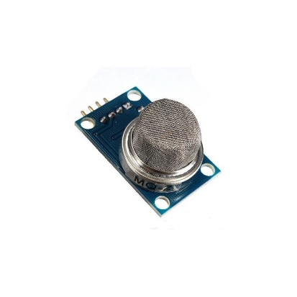

* Buzzer module

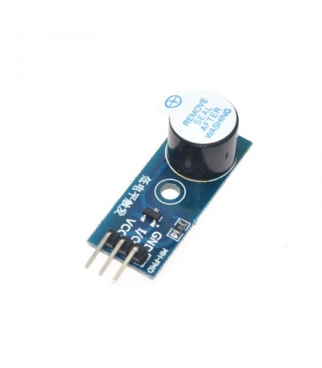

* Breadboard

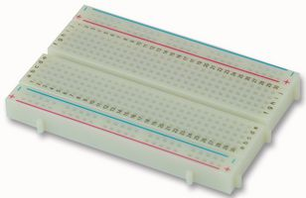

* Wires

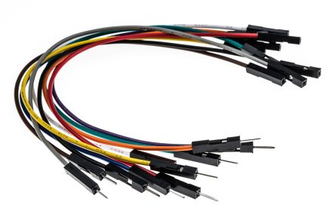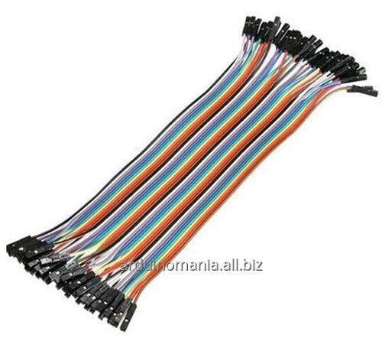

3. Implementation

Firstly, the block system diagram is done in TINKERCAD and presented below.

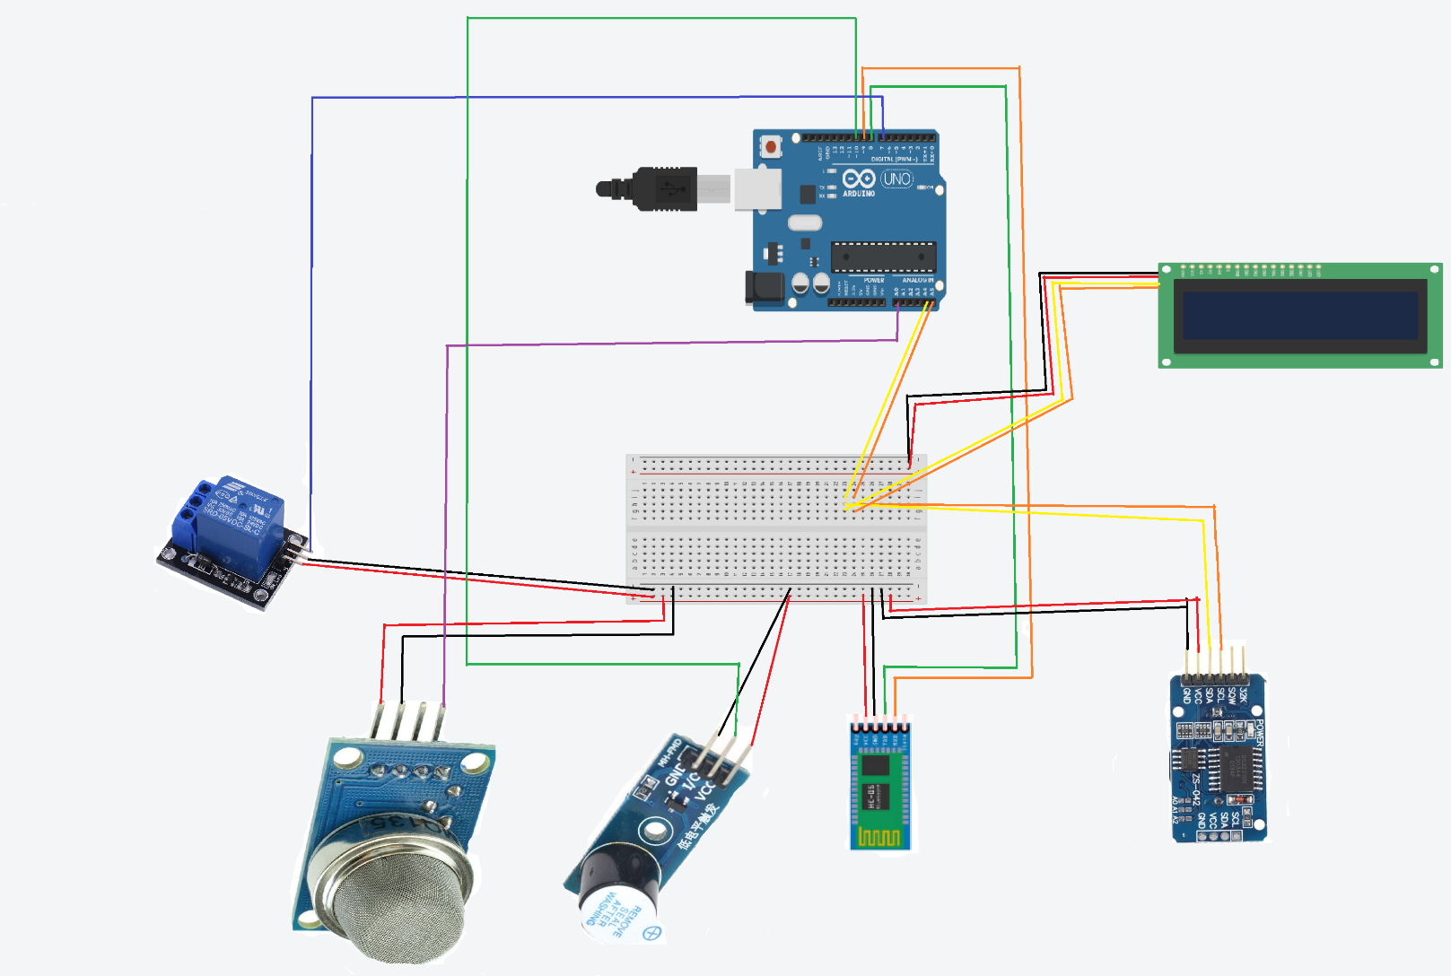

Secondly, the code is explained below.

* Here are the libraries need.

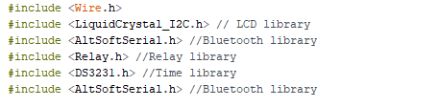

* The setup() function. 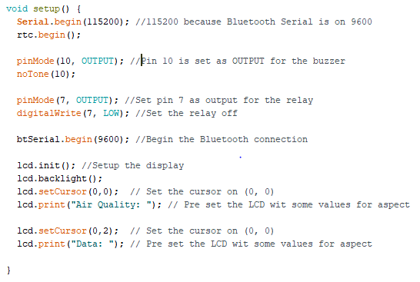
* The loop() function.

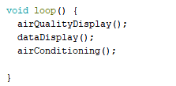

In the loop() function are only calls for other function that are explained in the following.

* airQualityDisplay();

This function is the core of the project, is where data from the sensor is read from the specified analog pin and converted to digital data.

After digital data from the sensor is received. Based on some alarm levels the values are cataloged in three different categories: LOW, GOOD, TOXIC.

* + - * LOW means that the air flow is not enough and the room where the system is installed needs to be ventilated.
      * GOOD when everything about the air quality is fine.
      * TOXIC when the air pollution is so bad that the room needs to be evacuated and the air needs to be drastically cleaned.
* dataDisplay();

This function displays the data, day of the week and the current time.

* airConditioning();

The function called by the user to clean the air.

4. Results

My target was to implement such a system that can be implemented in small rooms due to the low power of the motors available but there were some complications and the ventilation system was replaced with a relay module, so I can exemplify how a user can interact with the final product.

Here are some photos of the final product.

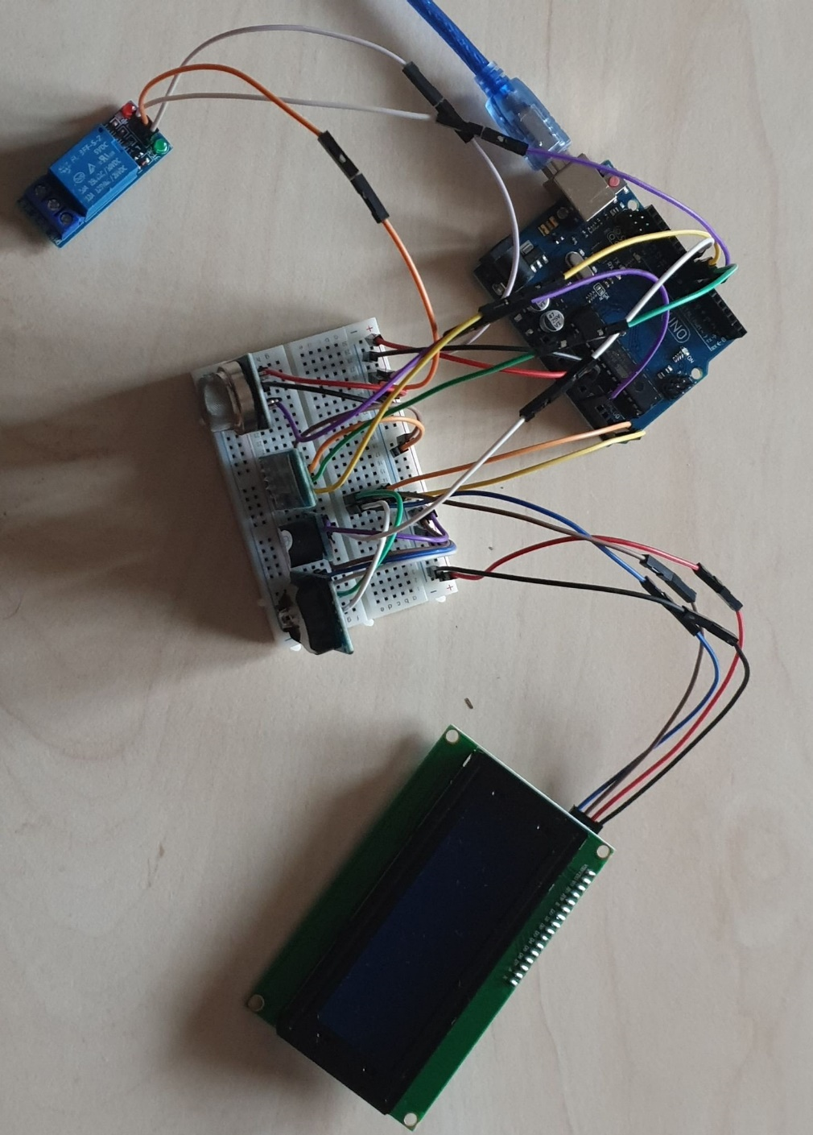

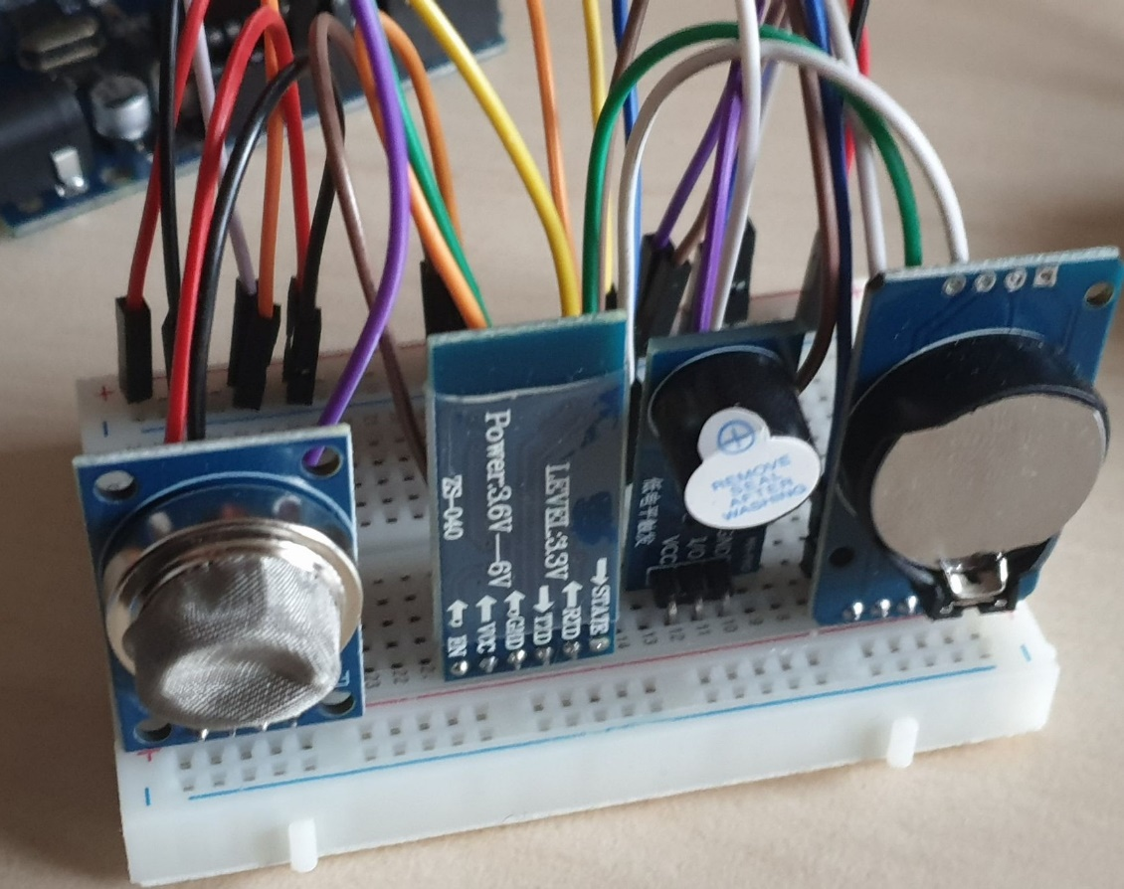

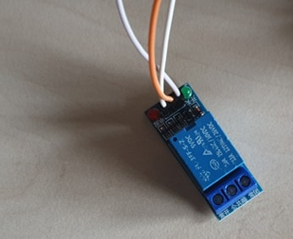

5. Conclusions

Even if the project did not meet all the targets initially proposed, the result was close to expectations. I am satisfied because I managed to better understand the material taught in the laboratories and because I had the opportunity to work with real components and see how it works.