**Assignment 1**

**Request-Reply Communication Paradigm**

**Student: Rus Renato**

**Grupa: 30642**

1. **Arhitectura conceptuala a sistemului distribuit**

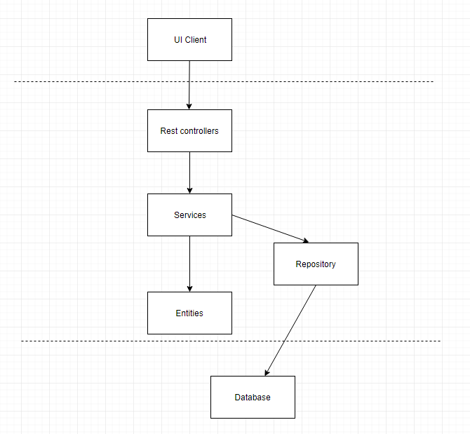

**2.Diagram bazei de date**

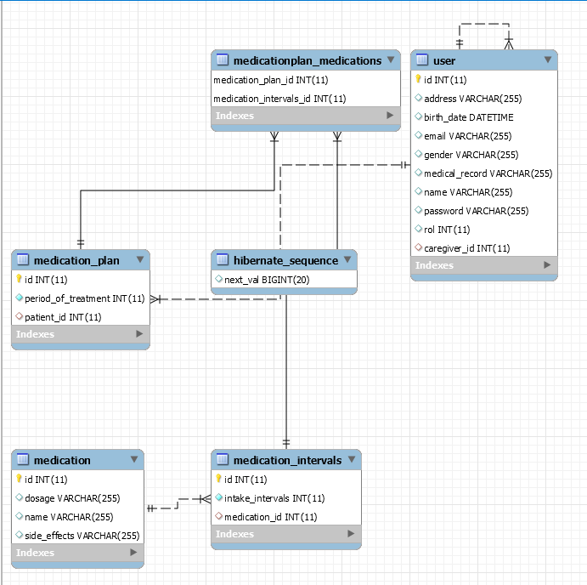

**3.Deployment diagram**

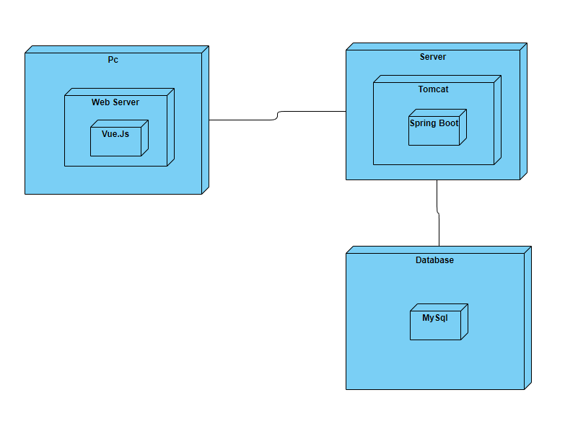

**4. Reademe.md**

**Project Setup (after clone)**

1. Clone the project to your computer

2. Import the project in InteliJ (or your IDE)

3. Create a database schema "medicalplatform" in MySQL

4. Change the line 26 from application.properties file located in /src/main/resources to allow table creation in the DB: spring.jpa.hibernate.ddl-auto = create

5. Run the application

6. Run again

7. Change the line 26 from application.properties file located in /src/main/resources to allow table creation in the DB: spring.jpa.hibernate.ddl-auto = validate