Russell Anderson

[Version 2.1]

American Video Game Company
Software Project Proposal
Customer Relationship Management System

Contents
A. Introduction 3
A.1. Purpose Statement 3
A.2. Overview of the Problem 3
A.3. Goals and Objectives 3
A.4. Prerequisites 3
A.5. Scope 3
A.6. Environment 3
B. Requirements 4
B.1. Business Requirements 4
B.2. User Requirements 4
B.3. Functional Requirements 4
B.4. NonFunctional Requirements 4
C. Software Development Methodology 5
C.1. Advantages of the waterfall method 5
C.2. Disadvantages of the waterfall method 5
C.3. Advantages of {a different method} 5
C.4. Disadvantages of {a different method} 5
C.5. Best suited 5
D. Design 6
D.1. Storyboard or Flowchart (Change title to fit needs) 6
D.2. UML Diagram (Change title to fit needs) 7
D.3. GUI (Change title to fit needs) 8
E. Testing 9
E.1. Testing Type (change name to fit your needs) 9
E.1.1. Test Name 1 9
E.1.2. Test Name 2 9
E.1.3. Test Name 3 10
F. Sources 12

Introduction
Our team has reviewed the requirements provided by American Video Game Company (from now on referred to as: ‘(the) client(s)’) and feel confident we can deliver a solution which will solve the business issues the client is currently facing. The client is in need of a new Customer Relations Management System (from now on referred to as a CRM), best described as combination of practices, strategies and technologies that companies use to manage and analyze customer interactions and data with the goal of retaining existing customers and bringing on new ones all while improving customer service relationships and assisting in customer retention and driving sales growth (Rouse, 2019). The system we are proposing will significantly improve the internal operations of the client by providing a central platform to manage existing and potential clients, reporting, sales tracking, opportunity management among other critical business requirements. The CRM we would like to propose for integration with the client’s existing system is a Hubspot – a COTS (commercial off-the-shelf) product. We have used this particular CRM in the past and are certain it would integrate with the client’s existing system, effectively solving all the challenges a growing company like the clients must face.

A.1. Purpose Statement
The purpose of this document is to provide a concise and thorough walk-through of everything our team will accomplish to satisfy the needs of the client, focusing on five unique requirements, compare and contrast of ideal software development methodology for this project, visual mock ups of the customized system and finally testing of requirements and features by use-case techniques.

A.2. Overview of THE PROBLEM
The client has experienced significant sales increase over the past two years and have outgrown their current methods for managing contacts, business data and other critical processes. Their current environment is a collected of antiquated in-house built tools, spreadsheet programs, other database management systems and various manual processes. The current system has became unmanageable and unproductive. Our proposed system will give the client useful and intuitive ways create and display reports, assign users privileges that control certain features of the system, manage orders and contacts and track sales more effectively.

A.3. Goals and Objectives
When the integration is complete, we expect to provide the client with a web-based CRM solution that will allow for the better management of internal business processes. Goals and objectives are as follows:
- Strengthen all contact and business data
- Visual reports of company activity and contact interaction
- Allow access permissions to the system by defined roles of internal and remote company users
- Sales tracking and activity management
- Ability to be enhanced and scaled in the future
- Must be simple to use, user friendly and user intuitive
- Compatible with client’s internal hosting environment
- In the future, can be modified, extended and further integrated by non-technical users
- Provide easily accessible maintenance and support structure
- A clearly defined licensing model and ownership right related to custom development
- Ability to integrate with existing systems for sharing of data
- Best in class security

A.4. Prerequisites

Number | Prerequisite | Description | Completion Date
1 | High-Speed Internet Connection | The CRM system will be accessible through the web, requiring a broadband internet connection with a minimum download speed of 25Mbps and a minimum upload speed of 3Mbps, anything below these baselines can result in negative system performance. | 8/1/2019
2 | Optimized Database | The CRM system will significantly improve the client’s existing environment, but in order to achieve maximum effectiveness, the data in the client’s existing database must be accurate and with no redundancies for the system’s reports, contact management. This also ensures the system will be scalable in the future. | 8/9/2019
3 | Analysis of Existing System | Given the patch work of the client’s current system, it is very important to know exactly which existing programs/tools will be compatible with the new system. For example, if the customer self-serve portal is compatible with Hubspot, that can save a ton of time from having to migrate to a entirely new portal that works with the new system. | 8/12/2019

A.5. Scope

IN SCOPE – Sales and related business processes such as:
- Sales tracking
- Contact management
- Opportunity management
- Forecasting
- Reporting
- Quoting
- Order Management
OUT OF SCOPE -
- Marketing services/tools
- HR services/tools
- Accounting and payroll services/tools
- Training technologies/tools/services
- New application development

A.6. Environment

The IT and hardware infrastructure the system will be deployed in will be a breeze for users to access. As long as high-speed internet access available, all required features within the system should perform as expected. Hubspot is a fully responsive web-application, meaning it can be accessed through mobile device, tablet or PC and the user experience will remain consistent regardless of device, the benefit being the ability to log on to the system anywhere internet service is accessible. This mobile accessibility can be a game changer, especially for sales personnel, whom can take notes, contact clients or any number of other processes from on the go.

Requirements
For an organization as large and complex as the client’s, it is no surprise they have many different and challenging requirements for a system as crucial as this one. We plan to address five distinct requirements within the business, user, and functional requirements fields. We will focus on streamlining the processes of contact management and forecasting, identifying and creating unique data types for the client’s users and finally demonstrating how we will use Hubspot to create standard or custom reports and tools for order management in the function requirements section.

Business Requirements
Contact Management:
Hubspot provides a very easy to use and intuitive way to manage contacts. The system allows simple creation, editing, and deletion (all at the approval of, if necessary, by superior roles) of a contact as well as the ability to filter contacts based on customizable parameters.
Hubspot allows for contacts to be entered partially and provides the ability to flag these contacts appropriately. The system lets the users define contacts as necessary and provides the ability to let contacts be defined as a singular businesses with sub-contacts within that overarching entity. If a contact already exists, the system will notify users upon contact entry or creation.
Forecasting:
Forecasting allows companies the ability to predict sales and revenue. Forecasts can be valuable for managers to manage expected review and predict profits. Business needs required by the forecasting functionality include sales distribution, product forecasting, manager adjustments, currency adjustment and upside.
The new CRM’s sophisticated application intelligence will convert existing business data into a business and sales forecasts while being able to scale in the future with new data that will inevitably flow in to the system.

User Requirements
Data Types:
Data types will be a critical part of the system because they will be what enables access permissions. For example, if there is information that should only be view by executives, the system should be able to determine the Executive role and display the appropriate. The system must be able to recognize several different data types such as: Stakeholders, Businesses and Contacts. The system application programming must be sophisticated enough to intuitively map new fields and relationships in the database. The database must be able to scale and grow in the future as the data grows while still maintaining a high degree of performance.
Hubspot makes it easy to define roles upon new user registration.

Functional Requirements

Reporting:
The CRM system must have the ability of display custom defined as well as predefined reports based on complete data inside the system. The system has to provide a beautiful, yet easy to use and navigate, reporting dashboard capable of building complex summary reports as well as allowing users to query, filter, format and export data. Users must be able to easily access necessary data according to the users particular department or function.
Hubspot comes bundled with many pre built and customizable reporting features that will benefit the client’s bottom line.
Order Management:
We have determined the client’s existing ordering platform will integrate with Hubspot, which will greatly expand the number of existing features. A suite of tools will allow the client’s users to accurately track orders going out to customers as well as take orders with the simple click of a button with the client’s existing self-serve customer portal. The system will also provide order tracking number to the client’s customers as well as the ability to easily make reorders.
We have customized Hubspot’s order management platform to meet the needs of the client by providing simple ways to track orders and convert quotes to orders while the self-serve portal continues to manage order taking, reordering and part ordering.

SOFTWARE DEVELOPMENT METHODOLOGY
The waterfall method is not often used as much these days as other methodologies like Agile, however, we agree with the client that the waterfall method will be the best suited for this particular project. The waterfall method which is simple and easy to use, works as a series of steps in which only when step is complete, the next step of the process begins; much like when water falls into a bucket and the bucket fills, overflows, then spills water into the bucket below it and so on. The requirements and expectations have been provided to our team beforehand, highlighting another situation where using the waterfall can be preferred.

Advantages of the waterfall method
The main advantages of the waterfall methodology in this case is the requirements are clearly defined before the project starting and the expectations are unambiguous. Furthermore, we do not anticipate the requirements to vary much from how the client has already defined them as well as we have been given loose time restraints for project completion. Finally, our team has years of expertise in providing similar solutions for our clients and we know what it takes to deliver and we are confident we can exceed their expectations.

DisAdvantages of the waterfall method
One of the primary disadvantages of the waterfall methodology is the difficulty involved in going back to previous steps to make changes once they are already complete. This rigidity will not be lost on the clients project, our team will take the proper precautions through requirement analysis to verify the feasibility of the clients requests and ensure they are completed in sequential order, all but eliminating the need to return to previous steps to make unforeseen or unplanned changes. Another hindrance we expect to face with the waterfall approach is the fact the system will not be available for the client until project completion(“Waterfall Methodology”, 2018), which can be a roadblock when users could be getting acquainted with the system early before it goes live.

Advantages of THE AGILE METHOd
One of the primary strengths of the Agile method is it’s ability to be adaptive. For example, if some critical requirements were to change as the project was moving forward, the waterfall methodology would not allow for going back and making revisions while the Agile method does. The agile method also encourages a lot of communication between the project team and customer which can be useful for clarifying details of requirements of providing feedback to project progress. The agile method also uses the technique of sprints, which are short bursts of development time to deliver a specific feature or set of features, essentially breaking the project down to smaller, more manageable units.

disAdvantages of the Agile Method
The essential drawback of using the Agile method for this particular case is our team is proposing a CRM system that is a combination of already existing tools, in other words, a solution using customizable/commercial off-the-shelf (COTS) products to implement the system. If we were to be building a brand new proprietary system, Agile would be a much better fit because it uses the philosophy of designing, building, then testing in short cycles which will not be necessary for this specific scenario since we already have clearly defined requirements and will adhere to a strict step by step plan for implementing this project.

best SUITED
While it may not be perfect, the waterfall methodology provides the best path for success with this particular project. The client has given us detailed information for the requirements which we have been able to organize, prioritize and analyze further, eliminating the need to go back make changes. We will leverage one of the waterfall methods main strengths: using a strict step-by-step approach, we will successfully build the clients vision into a simple and intuitive system. We bring a wealth of knowledge of experience to the table and our team has also been working with clients for years. We have implemented solutions much like this one, where software meets business intelligence, for our dozens of satisfied clients.

Design
Hubspot’s design can best be described as modern, elegant and clean. We have customized all necessary dashboard and other user views and menus to suit the unique needs of the client. One great thing about Hubspot, is the UI can easily be customized for user preference based on specific needs. We have provided two custom visuals based off Hubspot’s already nice design. We will focus on the Contact Management Dashboard, which cleverly and neatly organizes all data one would need for accessing contact information. Secondly, we will show a visual of the simplicity in Hubspot’s Add New User form.

GUI: Contact Management Dashboard and new contact form
Below is the Contact Management Dashboard our team has customized for the client based on their specific business needs. The section on the far left displays basic contact information as well as more relevant details. The section in the center is capable is displaying a plethora of valuable information from recent tagged important phone calls and emails to the contact notes that are displayed in the mock up below. The area on the far right provides the client’s users with several different sections to modify and sort contact information. The Preferences option also provides users the ability to modify contacts Marketing and contact preferences.
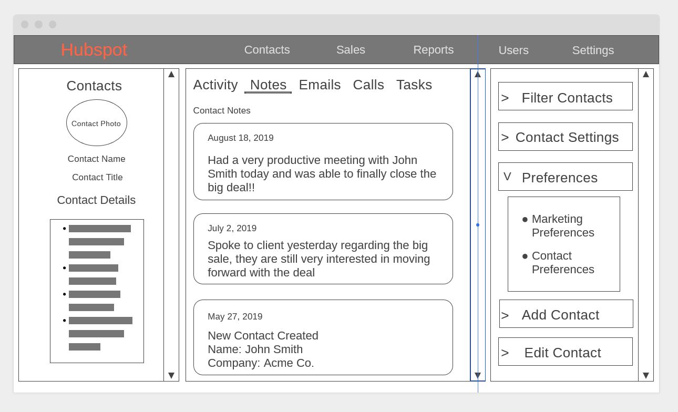
Link to view mock-up in browser: https://wireframe.cc/zW0jIE – Created by Russell Anderson, 8/20/2019
The inspiration for this design is found at: https://community.hubspot.com/t5/CRM/2019-UI-Update-Unintended-Byproduct-Side-Panel-Now-Resets-In-CRM/td-p/249818
Figure 1: Hubspot GUI Mock-up

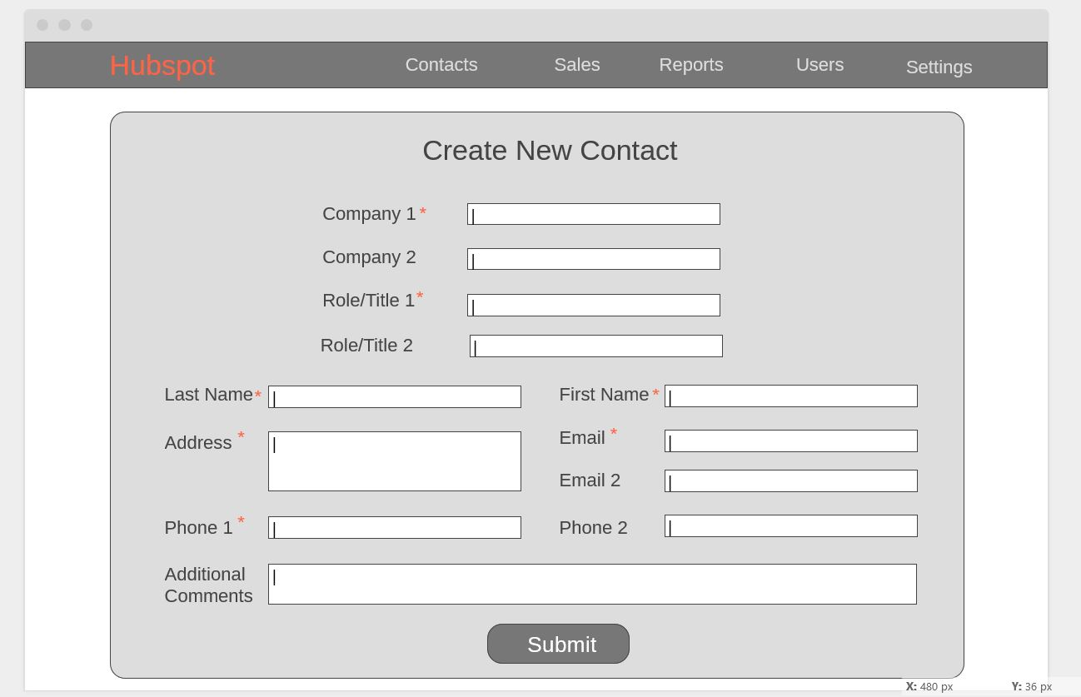
Shown below is Hubspot’s Create New Contact form. Required fields are denoted with an asterisk. Data input fields can easily be added, removed and modified from the Contact Dashboard.

Link to view New Contact Form in the browser: https://wireframe.cc/zW0jIE – Created by Russell Anderson, 8/20/2019

Testing
Three critical requirements will be tested thoroughly for the client. The first test being to verify contacts roles are properly assigned and filtered in the system based on a specific business need. The second test is to ensure the reporting feature has integrated properly with the existing system and able to build reports based on that data. Finally, ensuring proper functionality of the Order Management feature will be the last item tested.

Testing Type: black box
Our team has identified the black box method as the testing method of choice. Since we are using a COTS solution, the development and testing of the actual features has already been completed by their development team. Our testing goal in this scenario, is to ensure the system we configure and customize for the client correctly performs critical business operations based on their unique requirements.

Test 1: data types
Requirement to be tested:
Test whether or not contact roles are accurately being represented by the appropriate data type in the system. For instance, say a contact was created and given the role of Sales Personnel. Now, a user wishes to send out a task in the system to be viewed only by Sales Personnel under a certain company(business data type). If the system is preforming properly, then only sales personnel within the chosen company will be able to view the task.
Preconditions:
The contact(s) must be present in the system and must be assigned a valid role(data type).
Steps: The steps the tester must execute to test the feature.
1. Login into the system using your unique credentials
2. Navigate to the Contacts Management page
3. On the Contacts Management page, on the far right section, select Filter Contacts
4. On the drop down menu, select “Filter Contacts by Role”
5. Choose the name of the business the contacts are associated with
6. Select the role “Sales Personnel”
7. Now, click “Assign a Task” button
8. Type the task to be performed and click the “Send Task” button

Expected results: Expected results and any side effects such as updating a database, writing to a file, etc.
If the system performs as expected, only the sales personnel from the specifically chosen company will receive the task the has been assigned to them. A negative consequence could be a contact was mistakenly entered into the system with the incorrect role, thus receiving information not intended for them. Our team will rigorously validate and verify that all data is entered and migrated correctly into our client’s system.
Pass/Fail: Mark whether the test case passed or failed. The results can be compiled and used to determine if the application is ready for delivery/release.
PASS: In testing, after multiple attempts to break the system, all relevant roles are receiving the correct filtered information that is intended for them. This aspect of the system is approved to be put into production.

Test 2: reporting
Requirement to be tested
Reporting:
The client requires the new system should be able to provide user defined custom reports as well as standard pre-built reports. In addition, a user interface must be available for the act of exporting, filtering, querying and formatting data.
Preconditions: Conditions that must be present before test case can successfully run
The client’s database must be optimized for speed and efficient data retrieval in order to realize maximum performance of the new CRM system. The client also must have accurate query optimization techniques in place with their existing database for preferred system disk space allocation.
Steps: The steps the tester must execute to test the feature.
First Test: Standard Reports
1. Login to system using unique credentials
2. Navigate to and click on Reports tab button
3. Select “Standard Report: Monthly Gross Sales”
4. Select Date Parameters “July 1, 2019 through July 31, 2019”
5. Click “Run Report” button
6. View visual report
7. Verify data shown is correct by running the same SQL query directly to the database
8. Analyze that numbers match up correctly

Second Test: Custom Reports
1. Login to system using unique credentials
2. Navigate to and click on the Reports tab button
3. Select “Filter Custom Report”
4. Select “Annual Net Profits”
5. Select “Filter By” and choose “Mobile Sales Only”
6. Click “Run Report”
7. View visual report
8. Build and run the same query against the database
9. Determine whether the number match

Expected results: Expected results and any side effects such as updating a database, writing to a file, etc.
As long as the client provides our team with accurate and non-redundant data, the report features should be able to appropriately crunch the number entered into and return visual reports to the user that can easily be customized such as bar graph, PERT or pie chart.
Pass/Fail: Mark whether the test case passed or failed. The results can be compiled and used to determine if the application is ready for delivery/release.
These use cases both passed in testing, after attempting dozens of standard reports and custom reports, all data was accurately displayed by the system via visual graphs/charts etc. This feature is ready to be used immediately as soon as the system goes live.

Test Name 3
Requirement to be tested
Order Management:
Order Management is one of the most crucial components of this system, meaning testing must be strongly emphasized for this feature. The client’s existing system includes a portal where customers can make purchases from them. The new system must be able to integrate with the portal to allow for more accurate and robust order management.
Preconditions: Conditions that must be present before test case can successfully run
The client’s preexisting customer self-serve portal must be correctly integrated with the new system before testing of this feature can begin.
Steps: The steps the tester must execute to test the feature.
Test 1: Customer Sales Portal Integration
1. In the testing environment, login to the sales portal with unique credentials
2. Place an order for a new computer game
3. Confirm any necessary information during this process
4. Logout of the sales portal
5. Login to the CRM system
6. Navigate to and click on the Order Management tab/button
7. Look at sales completed in the past hour
8. Verify the order you placed in the sales portal is being reflected in the new CRM system

Expected results: Expected results and any side effects such as updating a database, writing to a file, etc.
The sale made from the customer self-serve portal should also be viewable in the CRM system.
Pass/Fail: Mark whether the test case passed or failed. The results can be compiled and used to determine if the application is ready for delivery/release.
PASS: After making countless dummy(test) orders, all orders made from the portal are being synced with the new system. This feature appears to be ready for a live environment.

Sources

Rouse, Margaret. Definition: CRM (Customer Relationship Management). (Last updated February 2019). Retrieved from: https://searchcustomerexperience.techtarget.com/definition/CRM-customer-relationship-management
Waterfall Methodology: Advantages, Disadvantages And When to Use It? (March 15, 2018). Retrieved from: https://lvivity.com/waterfall-model

