DS lab 8

General
Author: Ruslan Sabirov
Group: B17-DS-02
GitHub: https://github.com/russab0/DS/tree/master/lab8

Questions
Q1: What is a stratum in terms of NTP?
Stratum - one layer in a hierarchical network of layers that distribute accurate time across a network of devices.
Q2: Provide the output of ntpq -p command and describe the meaning of the following fields: remote, refid, st, t, when, poll, reach, delay, offset, and jitter.
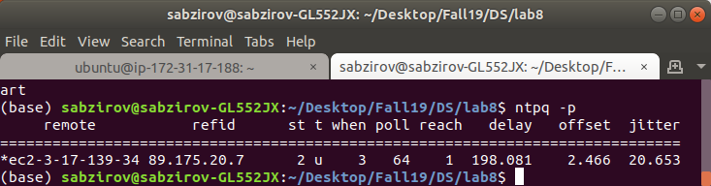

The ntpq utility program is used to query NTP servers which implement the standard NTP mode 6 control message formats.
- remote host name (or IP number) of peer. The value displayed will be truncated to 15 characters unless
- refid association ID or 'kiss code: decode.html#kiss
- st stratum
- t u: unicast or manycast client, b: broadcast or multicast client, l: local (reference clock), s: symmetric (peer), A: manycast server, B: broadcast server, M: multicast server
- when sec/min/hr since last received packet
- poll poll interval (log2 s)
- reach reach shift register (octal)
- delay roundtrip delay
- offset offset of server relative to this host (1-2 ns is OK)
- jitter jitter

Q3: What are the lacks of using the Lamport’s algorithm?
- It orders events only partially (as opposed to total order).
- It can’t tell you when two events are concurrent

Processes state
- Process a [7, 6, 1]
- Process b [2, 8, 1]
- Process c [2, 8, 4]

Code

from multiprocessing import Process, Pipe
from datetime import datetime
def local_time(counter):
return f' (LAMPORT_TIME={counter}, LOCAL_TIME={datetime.now()})'
def calc_recv_timestamp(recv_time_stamp, counter):
for id in range(len(counter)):
counter[id] = max(recv_time_stamp[id], counter[id])
return counter
def event(pid, counter):
counter[pid] += 1
print(f'Something happened in {pid}' + local_time(counter))
return counter
def send_message(pipe, pid, counter):
counter[pid] += 1
pipe.send(('Empty shell', counter))
print('Message sent from ' + str(pid) + local_time(counter))
return counter
def recv_message(pipe, pid, counter):
message, timestamp = pipe.recv()
counter = calc_recv_timestamp(timestamp, counter)
counter[pid] += 1
print('Message received at ' + str(pid) + local_time(counter))
return counter
def process_one(pipe12):
pid = 0
counter = [0, 0, 0]
counter = send_message(pipe12, pid, counter)
counter = send_message(pipe12, pid, counter)
counter = event(pid, counter)
counter = recv_message(pipe12, pid, counter)
counter = event(pid, counter)
counter = event(pid, counter)
counter = recv_message(pipe12, pid, counter)
print("Process a", counter)
def process_two(pipe21, pipe23):
pid = 1
counter = [0, 0, 0]
counter = recv_message(pipe21, pid, counter)
counter = recv_message(pipe21, pid, counter)
counter = send_message(pipe21, pid, counter)
counter = recv_message(pipe23, pid, counter)
counter = event(pid, counter)
counter = send_message(pipe21, pid, counter)
counter = send_message(pipe23, pid, counter)
counter = send_message(pipe23, pid, counter)
print("Process b", counter)
def process_three(pipe32):
pid = 2
counter = [0, 0, 0]
counter = send_message(pipe32, pid, counter)
counter = recv_message(pipe32, pid, counter)
counter = event(pid, counter)
counter = recv_message(pipe32, pid, counter)
print("Process c", counter)
if __name__ == '__main__':
oneandtwo, twoandone = Pipe()
twoandthree, threeandtwo = Pipe()
process1 = Process(target=process_one,
args=(oneandtwo,))
process2 = Process(target=process_two,
args=(twoandone, twoandthree))
process3 = Process(target=process_three,
args=(threeandtwo,))
process1.start()
process2.start()
process3.start()
process1.join()
process2.join()
process3.join()

References

https://www.galsys.co.uk/news/ntp-stratum-levels-explained/

https://towardsdatascience.com/understanding-lamport-timestamps-with-pythons-multiprocessing-library-12a6427881c6

ntpq manual (man ntpq)

