WATER - SEWER - STORM DRAIN
State Contractors Lic. No. 304795-Class "A" Est. 1966
(909) 981-1091 - Tel
(909) 981-6704 - Fax
PO Box 1206 Ontario CA 91762
105 Loma Pl Upland CA 91786

Lewis Properties
1156 N Mountain Ave
Upland, CA 91786
909-985-0971

Attn: Tom De Avila

Per the discussion between C.P. Construction and Lewis Properties we have come to an agreement to dispose of our trench spoils on your property located south corner of Cactus Ave. and Frederick Street. See attached for site location. All spoils shall be clean fill without any construction debris. Site access and maintenance of the site during the use of the property is the sole responsibility of C.P. Construction.

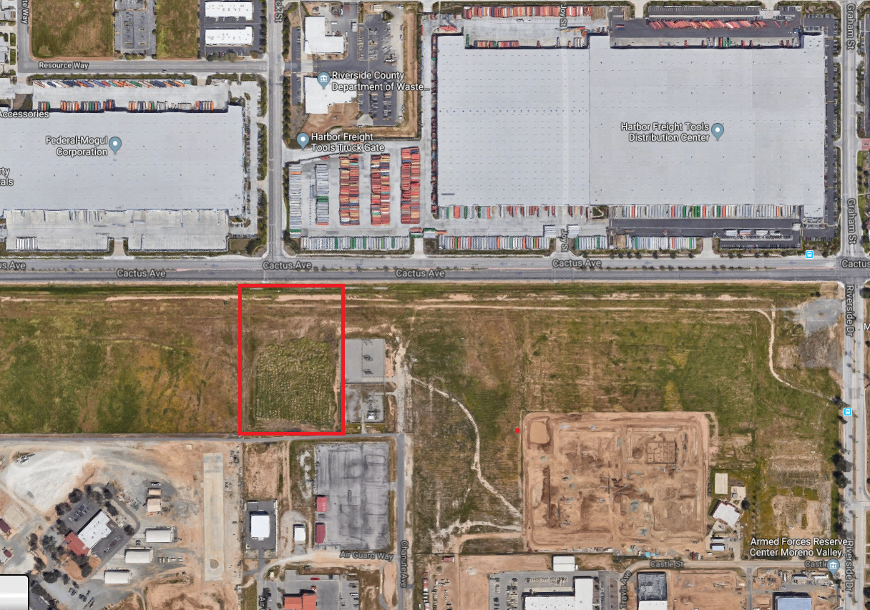

Tom De Avila Date ________________________

