Exploring Classic R Datasets
Russ Blessing
2026-04-27
Abstract
A short reproducible analysis of the iris and mtcars datasets, demonstrating how figures generated in a separate analysis notebook can be embedded directly into a Quarto manuscript. All figures are produced with ggplot2 and sourced from notebooks/analysis.qmd.

Introduction
This manuscript demonstrates a reproducible workflow using Quarto. All figures are generated in a dedicated analysis notebook (notebooks/analysis.qmd) and embedded here using the {{< embed >}} shortcode. Updating the notebook automatically updates this manuscript — no copy-paste required.

Iris Dataset
The iris dataset contains measurements of sepal and petal dimensions for 150 flowers across three species: setosa, versicolor, and virginica (Anderson 1935).

Sepal Dimensions
Figure 1 shows a clear separation between species in sepal space, with setosa occupying a distinct region of high width relative to length.
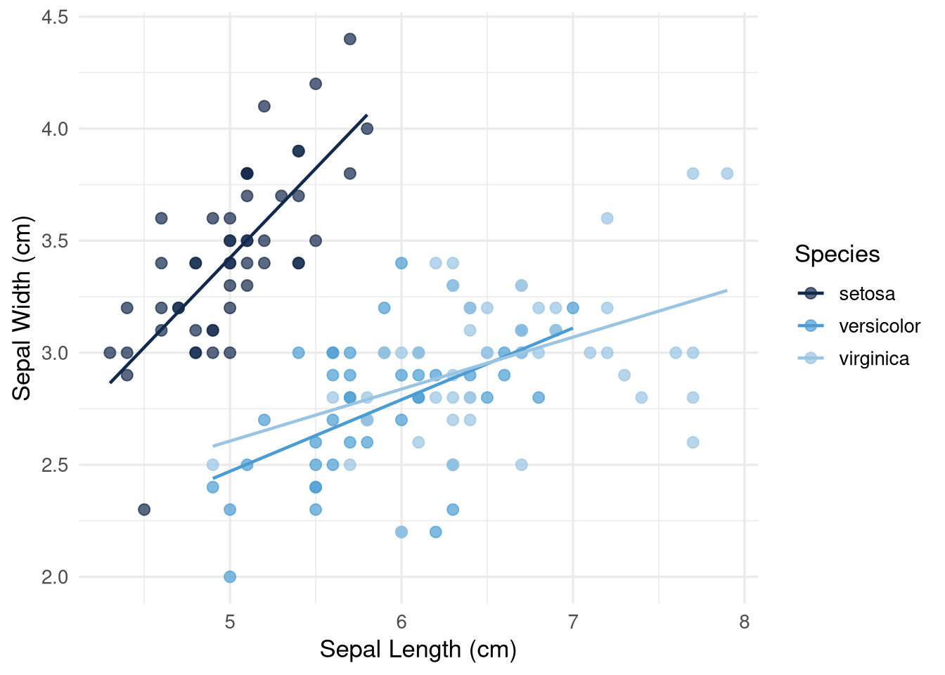
Figure 1: Sepal length vs. width across three iris species
_{Source: Analysis Notebook}

Petal Length
Species separation is even more pronounced in petal length (Figure 2), making it a reliable discriminating variable.
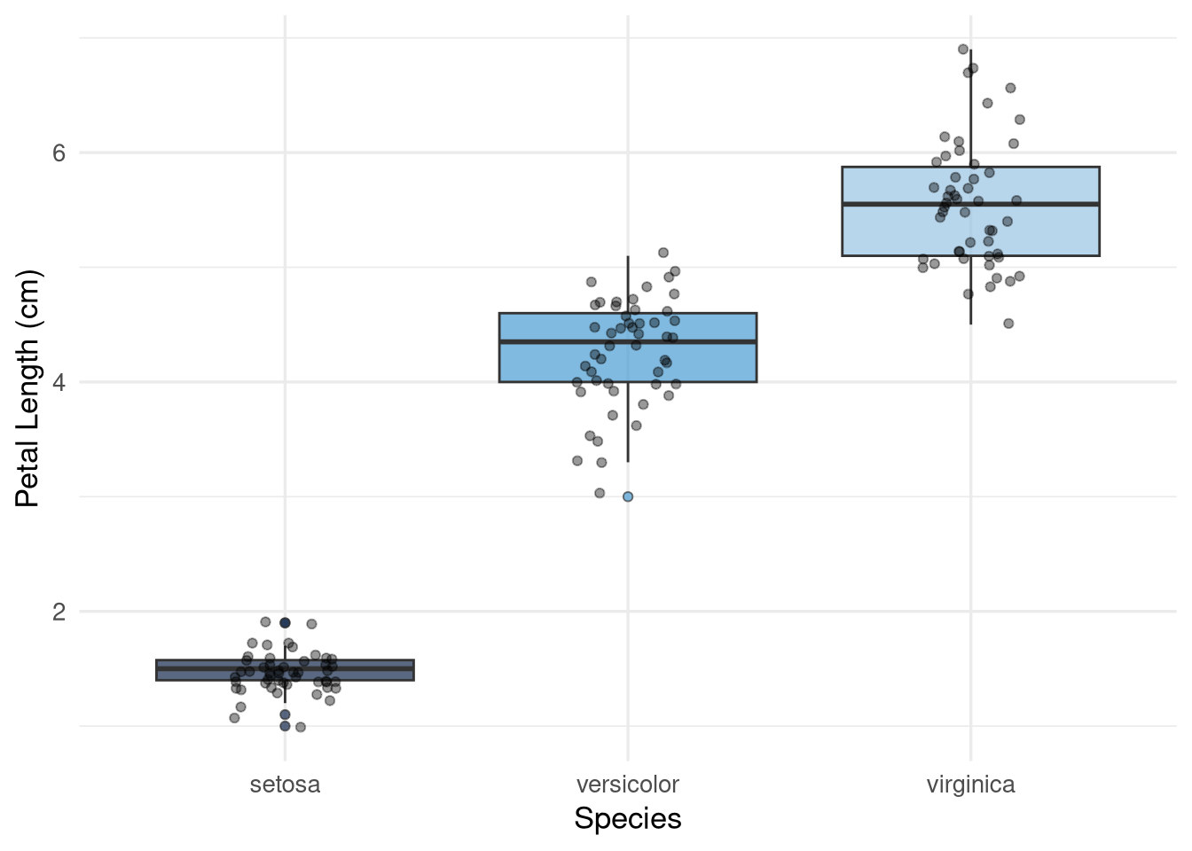
Figure 2: Distribution of petal length by species
_{Source: Analysis Notebook}

Motor Trend Cars
The mtcars dataset records fuel efficiency and physical characteristics for 32 automobiles from the 1974 Motor Trend magazine (Henderson and Velleman 1981). Figure 3 illustrates the well-known negative relationship between vehicle weight and fuel efficiency, stratified by cylinder count.
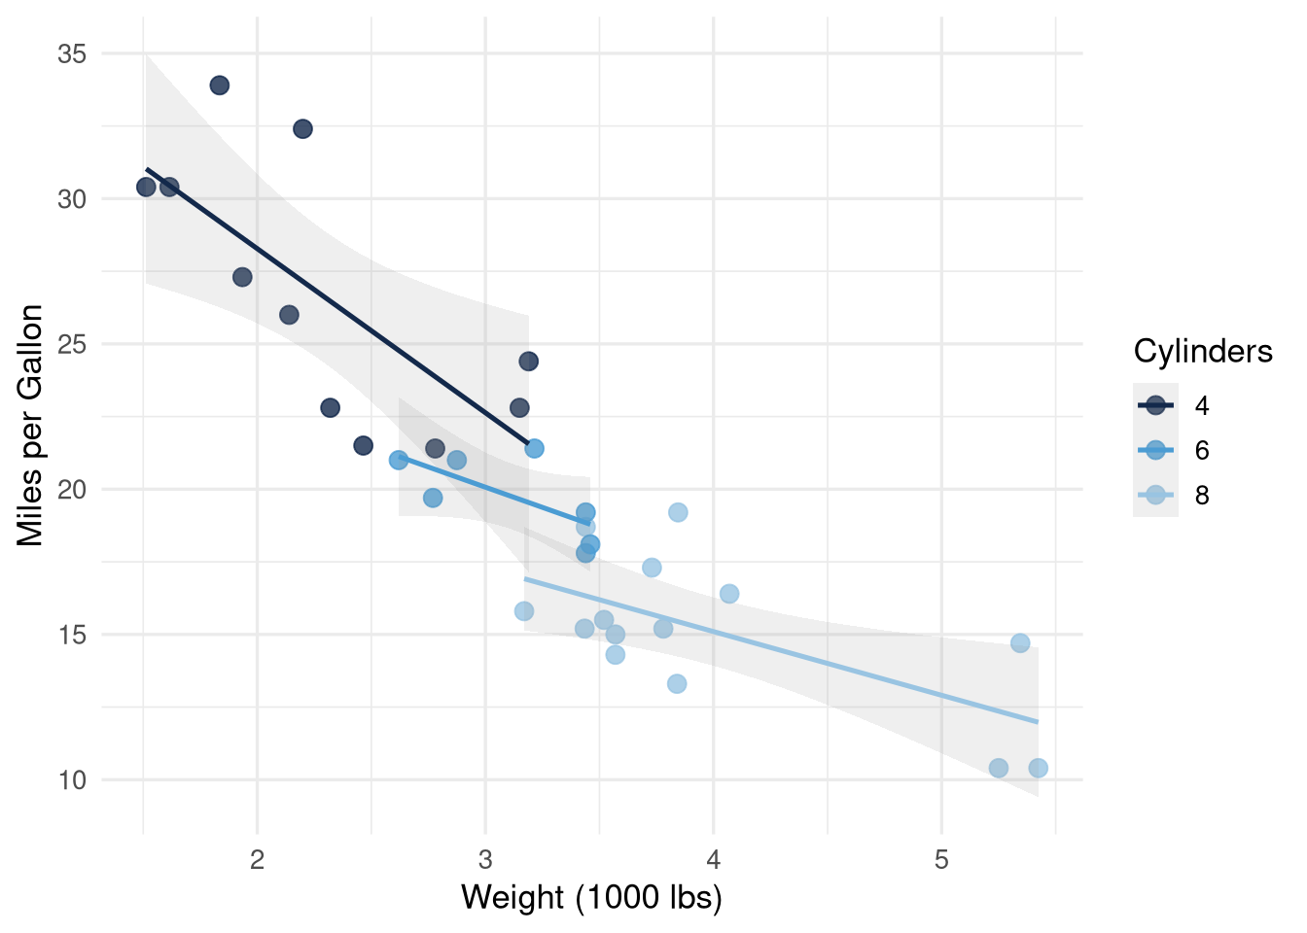
Figure 3: Vehicle weight vs. fuel efficiency, by number of cylinders
_{Source: Analysis Notebook}

Conclusion
This document was rendered entirely from plain-text source files. The figures above were produced in notebooks/analysis.qmd and embedded without manual copying. Any change to the analysis notebook is reflected here on the next render.

References
Anderson, Edgar. 1935. “The Irises of the Gaspe Peninsula.” Bulletin of the American Iris Society 59: 2–5.
Henderson, Harold V, and Paul F Velleman. 1981. “Building Multiple Regression Models Interactively.” Biometrics 37 (2): 391–411.

