**Microprocessor Lab**

Laboratory Activity No. 2

**Arduino and Tinkercad Interface**

|  |
| --- |
|  |

Score

*Submitted by:*

**Chua, Ruzzle Darwin D.**

**10:00-1:00PM (Saturday) / CPE 0412.1-1**

*Date Submitted*

**30-09-2023**

*Submitted to:*

**Engr. Maria Rizette H. Sayo**

1. Objectives

This laboratory activity aims to implement the principles and techniques of hardware programming using Arduino through:

- creating an Arduino programming and circuit diagram

1. Method/s

- Perform a task problem given in the presentation.

- Write a code and perform an Arduino circuit diagram of a ring counter that display eight (8) LEDs starting from left.

1. Results *- TinkerCad*

**Exercise 1:** Write a code that does a ring counter display for eight (8) LEDs starting from left.

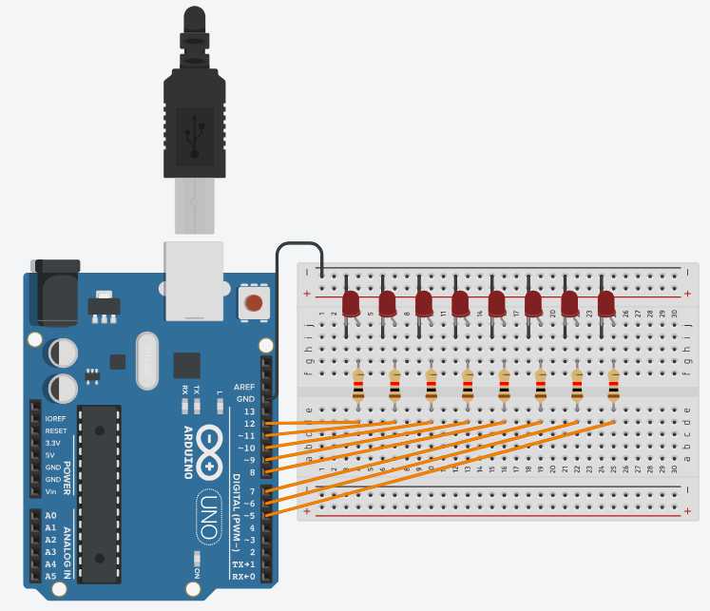

*Figure No.1* - *Ring Counter Display Circuit Diagram*

**Components Used**

1. 8 LEDs
2. Resistor
3. Breadboard

Source Code:

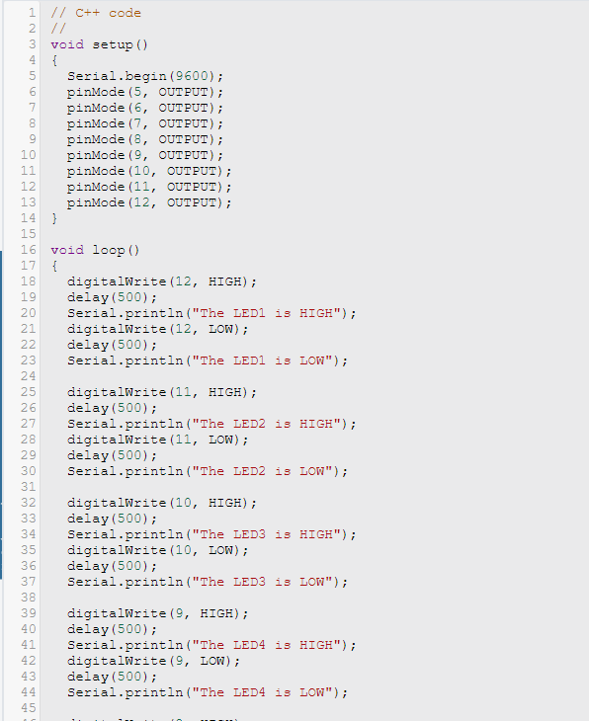

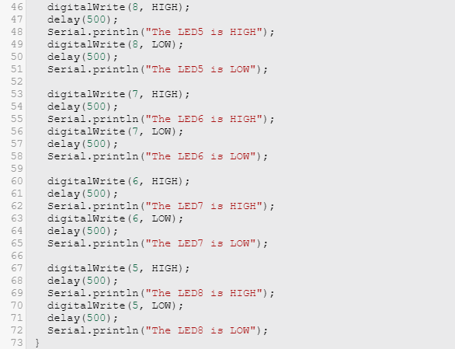

IV. Conclusion

Building a ring counter with Arduino and LEDs is a valuable project for college students studying electronics and programming. It combines practical hardware skills with coding knowledge, providing hands-on experience in creating digital circuits and developing control algorithms.

This project introduces students to the following key concepts:

* Digital Circuits: Understanding how digital signals control LEDs and the concept of a ring counter.
* Arduino Programming: Writing code to control the sequence and timing of LEDs.
* Problem-Solving: Debugging and modifying code to achieve the desired results.

In addition to the benefits listed above, this project can also help students develop their teamwork and communication skills. If students work on the project together, they will need to collaborate and share ideas. They will also need to communicate their ideas effectively to their teammates.

**References**

[1] D.J.D. Sayo. “University of the City of Manila Computer Engineering Department Honor Code,” PLM-CpE Departmental Policies, 2020.