

AMERICAN INTERNATIONAL UNIVERSITY–BANGLADESH (AIUB)

Faculty of Science and Technology

Dept. of Computer Science

COURSE: SOFTWARE ENGINEERING

Fall 2025-2026

Section: N

Group No: 01

Software Requirement Specification [SRS] Document On

Project Name: Travel and Ticket Management System

Supervised By: ZINNIYA TAFFANNUM PRITEE

Submitted By

Name |  | ID
1. | Md. Rasel Hossain | 23-55576-3
2. | Mohammad Hasib Khandaker | 23-55572-3
3. | Md. Taslimul Mahbub Jitu | 23-55552-3
4.
5.

Table of Contents

1. INTRODUCTION 3-4
2. SCOPES & FEATURES 4-5
2.1 Scope 1 4
2.2 Scope 2 4
2.3 Scope 3 5
2.4 Scope 4 5
2.5 Scope 5 5
2.6 Scope 6 5
3. USE CASE DIAGRAM 6-7
4. USER STORY TABLE 8-9
5. REQUIREMENT TRACEABILITY MATRIX 10
5.1 Functional Requirements 10
5.2 Non-Functional Requirements //

INTRODUCTION

1.1 Background to the Problem
The rapid growth of the global travel and aviation industry has significantly increased the need for fast, accurate, and reliable ticket management solutions. Despite this advancement, many local and small-scale travel agencies still depend on traditional, paper-based, or semi-manual processes for booking, managing, and storing flight ticket information. These traditional methods often lead to critical issues such as inaccurate data handling, duplicate records, operational delays, loss of important information, and overall inefficient customer service. As a result, customers face long waiting times, limited access to real-time flight information, and poor transparency in ticketing procedures.
Furthermore, the manual system provides limited support for managing large volumes of customers or group bookings. Agents struggle to handle data consistently, while administrators lack a centralized way to monitor user activity, maintain records, or evaluate performance. The absence of a secure and integrated platform makes the system vulnerable to errors, unauthorized access, and data inconsistency. In modern digital environments, such limitations hinder customer satisfaction and reduce operational reliability.
To address these challenges, there is a need for a centralized, automated, and user-friendly travel and ticket management system that improves operational workflow and provides real-time, secure access to data. The proposed Travel and Ticket Management System aim to fill this gap by offering a complete digital platform built using C# Windows Forms and SQL Server. This system not only automates the entire ticket management process but also ensures transparency, accuracy, and efficient handling of flight information. Through a multi-layered, object-oriented architecture, the system provides different access levels Customer, Agent, and Admin each designed to support specific roles and responsibilities while maintaining overall system integrity.
The system empowers customers with capabilities such as registration, login, search for flights, ticket booking, history tracking, and submitting reviews or reports. Agents are given enhanced tools to manage up to ten tickets at a time, update client information, process bookings, and respond to customer feedback. Administrators, functioning as the highest-level authority, can manage all users, oversee booking activities, monitor reviews, and maintain database records. This structured control ensures that every operation from booking and updating tickets to user management and system monitoring is handled efficiently and securely.
By providing an automated alternative to the traditional workflow, the system reduces human error, accelerates ticket processing time, ensures secure data storage, and enhances the user experience. Moreover, it supports scalability and future improvements, making it suitable for travel agencies of various sizes.

1.2 Target Group of Users
The proposed system is designed for three main user groups:

1. Customers (Travelers)
Individuals who want to book flight tickets, check availability, view ticket history, update passenger details, submit reviews, and manage personal profiles. This group benefits from fast, transparent, and secure booking processes.

2. Agents (Ticketing/Travel Agency Staff)
Staff members responsible for handling customer bookings, managing group reservations, maintaining passenger information, and generating reports. Agents require efficiency, accuracy, and tools to manage multiple bookings simultaneously.

3. Administrators (System/Agency Managers)
Admin users who oversee system operations, manage all user accounts, handle booking oversight, process feedback, and ensure overall system security and performance. They require complete control and access to all system resources.

SCOPES & FEATURES

Scope 1: User Management & Authentication
Features:
- Customers can register using name, email, username, password.
- Admin can manually add Customer or Agent accounts.
- All users can log in securely using credentials.
- Forgot password option (via username/email).
- Users can update personal profile information.
- Admin can activate/deactivate/edit user accounts.
- Role-based access control ensures security.

Scope 2: Flight Search & Ticket Booking
Features:
- Customers and Agents can search flights by From–To location.
- Display ticket details (time, price, date, seat availability).
- Both can book tickets; Agents can book up to 10 seats at once.
- Passenger details can be added/edited before confirmation.
- Booking confirmation summary is generated automatically.
- Users can view their booking history anytime.

Scope 3: Passenger & Booking Management
Features:
- Customers and Agents can edit passenger details before booking.
- Admin can view, update, or cancel any booking.
- Agents can manage group bookings and customer information.
- Users can check travel costs between cities.
- All bookings stored in centralized SQL database.

Scope 4: Review & Reporting System
Features:
- Customers can write travel reviews.
- Customers can submit complaints/issues.
- Agents and Admin can view all reviews or reports.
- Agents can respond to customer feedback.
- Admin can evaluate service quality through user reviews.

Scope 5: Administrative Control Panel
Features:
- Admin can handle all users (CRUD).
- Database records shown using DataGridView.
- Admin can cancel any ticket.
- Admin can track agent performance.
- Admin can view booking statistics and system logs.

Scope 6: Security & System Control
Features:
- Secure login and logout.
- Password encryption and data protection.
- Controlled access based on user roles (ACL).
- Session management.
- Safe exit and shutdown options.

USE CASE DIAGRAM
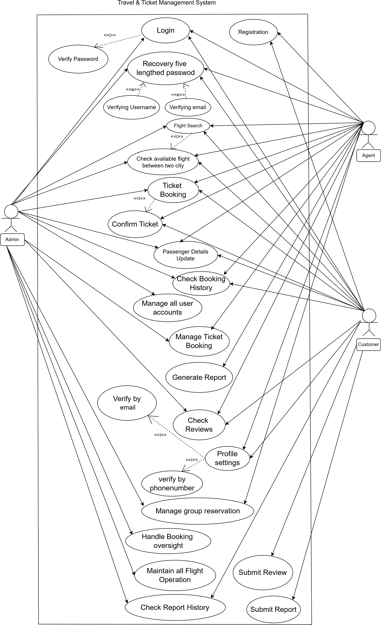
The Use Case Diagram of the Travel and Ticket Management System illustrate the complete interaction between the system and its three primary actors: Customer, Agent, and Admin. Each actor communicates with the system based on their assigned role and access privileges. The Customer represents a general traveller who uses the system to perform essential ticketing activities. The customer can register for a new account, log in securely, and recover their password if forgotten. After authentication, the customer can search for available flights by selecting origin and destination locations, view ticket details such as price, time, and date, and select a preferred flight. Before confirming a booking, the customer can enter and update passenger information, ensuring accuracy of the booking data. Once the booking is finalized, the customer receives a confirmation summary and can later view all previous booking records. Additionally, customers can share their travel experience through reviews and submit complaints or reports to the admin for service improvement. They also have access to profile settings where they can update their personal information and log out for secure session termination.
The Agent acts as a travel agency staff member and interacts with the system using more advanced privileges than a regular customer. An agent can search for flights, view detailed ticket information, and perform group bookings of up to ten tickets in a single session. They can manage passenger records for each booking, update or correct information before confirmation, and review all booking histories they have processed. Agents are also responsible for cancelling or modifying tickets when necessary and can view customer reviews to understand service quality. In some cases, agents may respond directly to customer feedback, enhancing communication and customer satisfaction. Like customers, agents can update their own profile information and log out of the system securely.
The Admin is the highest-authority user and interacts with the system to maintain overall control and ensure smooth operation. The admin can view all registered users, including customers and agents, and has full capability to add, update, or delete user accounts. The admin oversees all booking operations and can update or cancel any booking if errors or conflicts arise. They have complete access to customer reviews, submitted reports, and agent performance statistics. Through the administrative dashboard, the admin can monitor system activity, view booking trends, analyse ticket sales, and ensure database accuracy using DataGrid View control. The admin also maintains system security by managing login credentials, user permissions, and ensuring secure access and logout procedures.
Overall, the Use Case Diagram demonstrates how the Travel and Ticket Management System support three interconnected roles, each performing different functions while maintaining a consistent workflow. By defining clear actor boundaries and responsibilities, the diagram helps visualize system behaviour, improves understanding of requirements, and ensures that every core feature such as registration, booking, managing users, and reviewing feedback is properly supported and logically connected within the system.

User Story Table

Customer User Stories
As a / User | I want to (Goal) | So that (Purpose) | Acceptance Criteria
As a customer | register with basic personal details | I can create a new account and access the system | - Registration form accepts valid details- Email/username must be unique- Successful registration confirmation
As a customer | log in to the system | I can access my dashboard securely | - Valid credentials allow login- Invalid credentials show error- Redirected to dashboard
As a customer | recover my forgotten password | I can regain access to my account | - Password recovery option available- Reset link sent to email- Password updated successfully
As a customer | search flights between locations | I can find suitable flight options | - Source, destination, date selection- Available flights displayed- No-result message shown
As a customer | book flight tickets | I can confirm my travel plans | - Seat availability checked- Booking saved successfully- Confirmation shown
As a customer | update passenger details | my booking information is accurate | - Editable passenger form- Mandatory fields validated- Changes saved
As a customer | review booking summary | I can verify details before confirmation | - Summary page shown- Edit option available- Confirm button enabled
As a customer | view booking history | I can keep records of past bookings | - Previous bookings listed- Booking details visible
As a customer | write a travel review | I can share my experience | - Review form available- Review submitted successfully
As a customer | submit a complaint/report | the admin is informed of my issue | - Complaint form available- Admin notified
As a customer | update my profile information | my personal data stays current | - Profile editable- Updates saved
As a customer | log out of the system | my account remains secure | - Session terminated- Redirected to login page

Agent User Stories
As a / User | I want to (Goal) | So that (Purpose) | Acceptance Criteria
As an agent | log in to the system | I can manage customer bookings | - Valid login credentials- Access to agent dashboard
As an agent | search flights | I can assist customers in booking | - Flight search works accurately- Results displayed
As an agent | book tickets for customers | customer travel is confirmed | - Booking completed successfully- Confirmation generated
As an agent | update passenger details | booking records are correct | - Editable passenger data- Changes saved
As an agent | review booking summary | errors are avoided before confirmation | - Summary shown- Edit option available
As an agent | view booking history | I can track customer bookings | - Booking history accessible
As an agent | log out of the system | my session is secured | - Proper logout completed

Admin User Stories
As a / User | I want to (Goal) | So that (Purpose) | Acceptance Criteria
As an admin | log in to the system | I can manage the entire platform | - Secure admin login
As an admin | manage user accounts | the system stays organized and secure | - Add/edit/delete users- Changes saved instantly
As an admin | manage bookings | booking data remains accurate | - Update/cancel bookings- Status updated
As an admin | view reports and complaints | user issues are addressed promptly | - Reports visible- Action can be taken
As an admin | control system settings | the system runs smoothly | - Settings updated successfully
As an admin | log out of the system | unauthorized access is prevented | - Admin session terminated

REQUIREMENT TRACEABILITY MATRIX

5.1 Functional Requirements
5.1.1 Customer Requirements
- Registration
- Login
- Forgot password
- View dashboard
- Search flights
- Select flight
- Enter passenger details
- Edit passenger details
- Confirm booking
- View booking history
- Write review
- Submit report
- Update profile
- Logout

5.1.2 Agent Requirements
- Login using admin-provided credentials
- Search flights
- Book up to 10 tickets
- Enter/update passenger information
- View booking history
- Delete or cancel booked tickets
- Respond to customer reviews
- Generate reports
- Update personal profile
- Logout

5.1.3 Admin Requirements
- Login
- View all users
- Add new customer/agent
- Edit users
- Delete users
- View all bookings
- Update or cancel bookings
- View reviews and reports
- Monitor agent performance
- View system statistics
- Manage database records
- Logout

Non-Functional Requirements
//

