1-Run **putty.exe** (C:\Program Files\PuTTY\putty.exe)

Settings

Host Name: cbsusheehan.tc.cornell.edu

Port 22

Connection type: SSH

2-Helpful things to know:

/ = forward slash

\ = backslash

**ls** (lists items in current directory)

**ls –l** (list items in current directory with more information)

**ls –s** (print list of items with size)

**pwd** (present working directory)

**cd** (change directory)

**cd ..** (go UP directory)

**htop** (look at system processes)

**mkdir** (create new folder/directory)

**stat** file_name

Use the stat command to know the details of the file.

3-Starting working directory

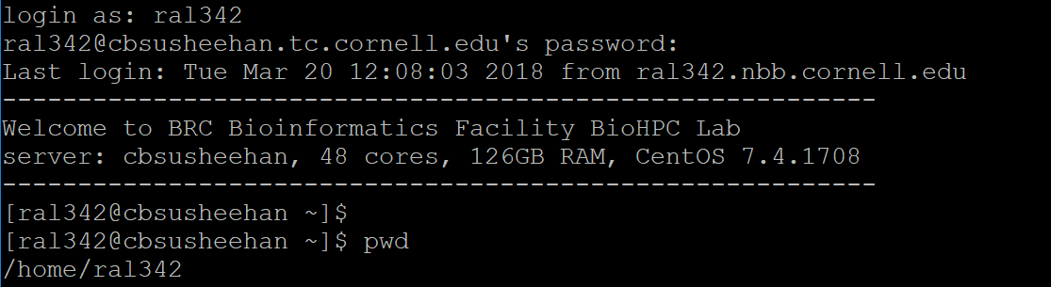

**cd ..** (changes directory UP to /home)

**cd /workdir** (changes directory to workdir for cbsusheehan)

4-Copy whole folder to cloud

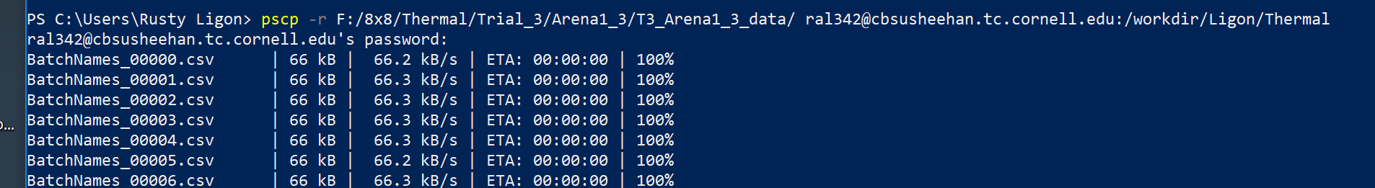

5-Run Rscript (i.e. saved R file) from command line

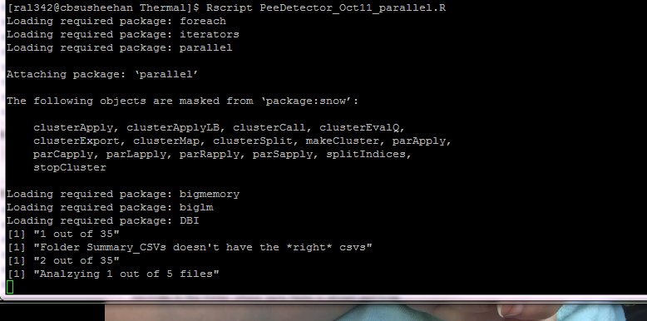

Run Rscript (i.e. saved R file) from command line with arguments:





Rscript PeeDetector_Oct30_trim_parallel.R "/local/workdir/CHM/TerritoryTrials_chm/2_Summary_Thermal_CSVs/NotDone/" "/local/workdir/Ligon/Thermal/PeeSummaries/CaitlinPeeData/" 4 n n ummary

$ Rscript PeeDetector_Dec4_trim_parallel.R "/local/workdir/Ligon/T010_data/" "/local/workdir/Ligon/" 1 y n Arena

Rscript PeeDetector_Dec5abcdef_trim_parallel.R "/local/workdir/Ligon/T012_data/one" "/local/workdir/Ligon/SummaryData/T012_processed/" 1 y n Arena 9

Rscript PeeDetector_Dec5abcdef_trim_parallel.R "/local/workdir/Ligon/T010_data/Day3" "/local/workdir/Ligon/" 1 y n Arena 9

**CAITLIN PEE PROCESSING March 4, 2019**

Rscript PeeDetector_Dec5abcdef_trim_parallel.R "/local/workdir/Ligon/NotDone/Batch1" "/local/workdir/Ligon/Summary_CHMdata" 4 n n ummary 9

dirmain<-"/local/workdir/Ligon/T010_data"

savedir<-"/local/workdir/Ligon/"

framerate<-as.numeric(as.character(1))

nightonly<-as.character('y')

downsample<-as.character('n')

folderclassifier<-as.character('Arena')

howmancoresshouldiuse<-9 #number of cores to use for this process

DOWNLOAD DATA OF CERTAIN EXTENTION TO COMPUTER

**pscp ral342@cbsusheehan.tc.cornell.edu:"/workdir/Ligon/Thermal/PeeSummaries/CaitlinPeeData/*.Rdata" "C:/Users/Rusty/Amazon Drive/MICE/Thermal/Next/Caitlin"**

**pscp ral342@cbsusheehan.tc.cornell.edu:"/workdir/Ligon/Thermal/PeeSummaries/CaitlinPeeData/*.Rdata" "C:/Users/Rusty/Amazon Drive/MICE/Thermal/Next/Caitlin"**

UPLOAD DATA TO TEMP COMPUTER (CBSUMM21) from Namaqua (Laptop)

pscp -r H:\8x8\Thermal\T013_data ral342@cbsumm21.tc.cornell.edu:/workdir/Ligon/

UPLOAD DATA TO TEMP COMPUTER (CBSUMM21) FROM OTHER LOCATION ON CLOUD

scp -r ral342@cbsusheehan.tc.cornell.edu:/workdir/CHM/TerritoryTrials_chm/2_Summary_Thermal_CSVs/NotDone ral342@cbsumm21.tc.cornell.edu:/workdir/Ligon

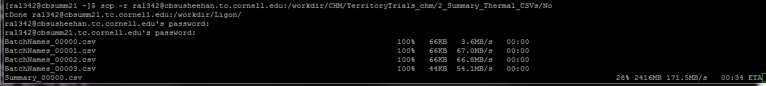

COPY ALL FILES OF A CERTAIN TYPE, COLLAPSING FOLDER/DIRECTORY STRUCUTRE



$ find /workdir/CHM/TerritoryTrials_chm/4_Tracked_Thermal/ -name \*.csv -exec cp {} /workdir/Ligon/Thermal/Coordinates/CHM \;

SCREENS:

$ screen -S sessionname

$ run script in this screen

ctrl-a d

[closes screen]

log out

next day:

$ screen -r sessionname

[and the last screen comes back to you! - screen -r will resume a session you started previously and either closed or was in a different location]

$ screen -list

[show all Attached and Detached screens on]

$ screen -X -S sessionname quit

[removes/deletes screen]

EXAMPLE:

$ screen -S CAR_VNO_Trinity

$ export PATH=/programs/trinityrnaseq-2.3.2:$PATH

$ Trinity --seqType fq --left CAR_VNO_RNA_ATTACTCG_AGGCGAAG_R1_TRIM_paired.fastq --right CAR_VNO_RNA_ATTACTCG_AGGCGAAG_R2_TRIM_paired.fastq --CPU 35 --max_memory 120G

$ screen -r CAR_VNO_Trinity

$ screen -X -S CAR_VNO_Trinity

FASTA

If you just want to extract the headers, on a Linux/Unix system, a simple grep "^>" myfile.fasta should work.

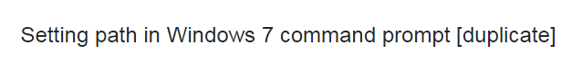



<https://superuser.com/questions/317631/setting-path-in-windows-7-command-prompt>

**Remote access to the workstations (Cornell users):**

**(non‐Cornell users should also consult http://cbsu.tc.cornell.edu/lab/doc/BioHPCLabexternal.pdf)**

**For Microsoft Windows Users:**

**1. Install the following software:**

**1.** putty: http://www.chiark.greenend.org.uk/~sgtatham/putty/download.html

Download and put the executable anywhere on your computer.

2. FileZilla (http://filezilla‐project.org/) or Winscp (http://winscp.net/eng/index.php)

Download the client installation package and install.

3. MobaXterm (optional for graphic user interface):

http://mobaxterm.mobatek.net/download.html

Download the client installation package and install.

4. VPN: Install VPN only if you are accessing the workstations from a computer outside Cornell

Campus. Follow the instruction at http://www.cit.cornell.edu/services/vpn/howto/install.cfm

5. Real VNC (optionally Java): required only if you want to use VNC connection.

**2. Connection by ssh**

1. Reserve a workstation through the web site http://cbsu.tc.cornell.edu.

2. Set up putty for the first time. If this is the first time you use putty, you will need to enter the

address of the workstation. A) under “host name”, enter “cbsuwrkstX.tc.cornell.edu” or

“cbsum1c1bXXX.tc.cornell.edu” (replace the “X” with the workstation that you just reserved); B)

under “Saved Session”, enter cbsuwrkstX or cbsum1c1bXXX; C) click SSH‐>X11 in the left panel,

check the box “Enable X11 forwarding”; D) If you prefer the black text on white background, you

can change the color setting. Click “Colours”, set “Default Foreground” to “0 0 0”, “Default Bold

Foreground” to “0 0 0”, “Default Background” to “255 255 255”, “Default Bold Background” to

“255 255 255”. E) Click “session”, click “save”

3. You can double click the saved “host” to start a session.

4. If you want to access the workstations from outside Cornell campus, you need to start VPN

before you run putty.

5. If the software takes long time to finish, disruption in network connection to the remote session

could terminate the job. To prevent this from happening, make sure to use "nohup" or "screen"

command . E.g. nohup mycommand >& log & (For detailed information, read this web site

https://en.wikipedia.org/wiki/Nohup or https://en.wikipedia.org/wiki/GNU_Screen ).

**3. Connection by VNC**

You can access your Linux workstations using VNC protocol and operate remotely in a graphical desktop

environment. You need to go to "My Reservations" page (http://cbsu.tc.cornell.edu/lab/labresman.aspx)

and click on "Connect VNC" for a workstation you want to connect to. It will initialize your VNC session.

If your password is not yet stored in VNC you will be asked first to enter it before the next page loads. In

order to connect to your VNC session you can use VNC Viewer from Real VNC. When your session is

initialized the page will display further instructions, including port number to which you need to connect.

Launch your Real VNC Viewer, type machine name and port number into appropriate fields and connect.

You can control the resolution of your VNC window using a pull‐down just below the reservations table

on “My Reservations” page.

It is also possible to use Java applet as VNC Viewer. However, very likely you will need to lower your Java

security settings to do so. The applet opens a Java application window, please click "OK" on "Connection

Details" form and then type in your password in "VNC authentication form" (user name is blank, and it

should be!). If your password is correct a Linux desktop will open in the Java applet window.

VNC connections are persistent, i.e. when you close the VNC window your desktop continues to run as

long as your reservation is active. You can reconnect at any time from any computer that supports Java.

NOTE: If your VNC window is plain black after reconnecting just click anywhere inside, desktop locks out

after some inactivity time (like screensaver). If by any reason you want to restart your VNC session (for

example you killed your desktop and now cannot do anything) just click on "Reset VNC" for your

reservation on "My Reservations" page.

**4. Transferring files between the workstation and your desktop computer**

Use the FileZilla or Winscp software to transfer files between the workstation and your local computer.

There are two dedicated machines for remote login and file transfer only (ssh/sftp only, no VNC logins

are accepted), **cbsulogin.tc.cornell.edu** and **cbsulogin2.tc.cornell.edu**, these machines can be used for

file transfer to and from your home directory and they do not require reservation. These machines are

also available from outside of Cornell.

**Important Note: After you reserve a BioHPC computer and start to work on a project, make sure to**

**copy the large data files from your home directory to the /workdir on your reserved computer. You**

**could also transfer files to and from the reserved workstation directly after your reservation. You**

**need to create your own directory under /workdir. Contact a CBSU staff if you do not know what is a**

**local disk. PLEASE DO NOT RUN ANY COMPUTATIONS ON OR UNDER HOME DIRECTORY.**

You can also use **Globus Online** to transfer data to and from your BioHPC Lab home directory. Pleasae

refer to this document (http://cbsu.tc.cornell.edu/lab/doc/Globus_at_BioHPC_Lab.pdf) for details.

**5. Launch X‐windows software.**

If you want to use a software with graphic interface, eg. 454 assembler, Galaxy. You need to start Xwindows

software. Start “MobaXterm” on your program menu. From your putty window, you can

directly type in the command. Eg. “gsAssembler”

**For MAC users:**

**1. Install the following software:**

FileZilla: https://filezilla‐project.org/download.php?show_all=1

Chicken of the VNC (optional, for VNC) http://sourceforge.net/projects/cotvnc/

**2. Connection by ssh**

Launch the terminal window. Type “ssh labid@cbsuwrkstX.tc.cornell.edu” or “ssh

labid@cbsum1c1bXXX.tc.cornell.edu” (replace the “X” with the workstation that you just reserved).

Enter user name and password when prompted.

**3. Connection by VNC.**

You can access your Linux workstations using VNC protocol and operate remotely in a graphical desktop

environment. You need to go to "My Reservations" page (http://cbsu.tc.cornell.edu/lab/labresman.aspx)

and click on "Connect VNC" for a workstation you want to connect to. It will initialize your VNC session.

If your password is not yet stored in VNC you will be asked first to enter it before the next page loads. In

order to connect to your VNC session you can use Chicken of the VNC or VNC Viewer from Real VNC.

When your session is initialized the page will display further instructions, including port number to

which you need to connect. Launch your VNC Viewer, type machine name and port number into

appropriate fields and connect.

You can control the resolution of your VNC window using a pull‐down just below the reservations table

on “My Reservation” page.

It is also possible to use Java applet as VNC Viewer. However, very likely you will need to lower your Java

security settings to do so. The applet opens a Java application window, please click "OK" on "Connection

Details" form and then type in your password in "VNC authentication form" (user name is blank, and it

should be!). If your password is correct a Linux desktop will open in the Java applet window.

VNC connections are persistent, i.e. when you close the VNC window your desktop continues to run as

long as your reservation is active. You can reconnect at any time from any computer that supports Java.

NOTE: If your VNC window is plain black after reconnecting just click anywhere inside, desktop locks out

after some inactivity time (like screensaver). If by any reason you want to restart your VNC session (for

example you killed your desktop and now cannot do anything) just click on "Reset VNC" for your

reservation on "My Reservations" page.

**4. Transferring files between the workstation and your desktop computer**

Use the FileZilla software to transfer files between the workstation and your local computer.

There are two dedicated machines for remote login and file transfer only (ssh/sftp only, no VNC logins

are accepted), **cbsulogin.tc.cornell.edu** and **cbsulogin2.tc.cornell.edu**, these machines can be used for

file transfer to and from your home directory and they do not require reservation. These machines are

also available from outside of Cornell.

**Important Note: After you reserve a BioHPC computer and start to work on a project, make sure to**

**copy the large data files from your home directory to the /workdir on your reserved computer. You**

**could also transfer files to and from the reserved workstation directly after your reservation. You**

**need to create your own directory under /workdir. Contact a CBSU staff if you do not know what is a**

**local disk. PLEASE DO NOT RUN ANY COMPUTATIONS ON OR UNDER HOME DIRECTORY.**

You can also use **Globus Online** to transfer data to and from your BioHPC Lab home directory. Please

refer to this document (http://cbsu.tc.cornell.edu/lab/doc/Globus_at_BioHPC_Lab.pdf) for details.

**5. Launch X‐windows software.**

If you want to use a software with graphic interface, eg. 454 assembler , Galaxy, you need to setup xwindows

tunneling. From the terminal window, type “ssh ‐X labid@cbsuwrkstX.tc.cornell.edu” or “ssh ‐

X labid@cbsum1c1bXXX.tc.cornell.edu”. After that, you can directly type in the command. Eg.

“gsAssembler” .