- void* element = (char*)arr+i*size
This is a generic method that used to convert from void* type to specific type.

2.
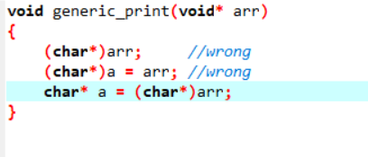
The third third method is the correct answer to convert type

