4_25



1. So in these two lines, SET_BIT(REG,bit) is not a function, actually it is a macro, which is handle by c preprocessor, not the compiler.
2. So before compiling, whenever you see SET_BIT(REG,bit) replace REG |= (1<<bit).
3. 1u: u is unsigned, however 1 is signed.

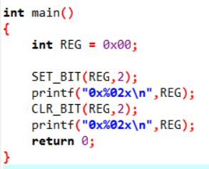

1. When u execute SET_BIT , actually you are executing REG |= (1<<bit).
2. 0x%02x means: 0x:the prefix of hex number,%x:output hex number. 0:pad with zero if needed, 2: total width should be at least 2 characters

Application in STM32:

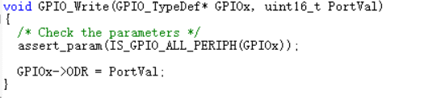

ODR: ODR is an output data register, it is a member of a structure and it’s used to control the pin voltage level of output.

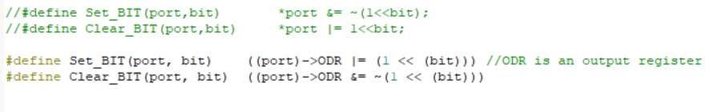

The first two lines are fault cause port in here actually a pointer to structure, so we could not apply bitwise operations to it directly.

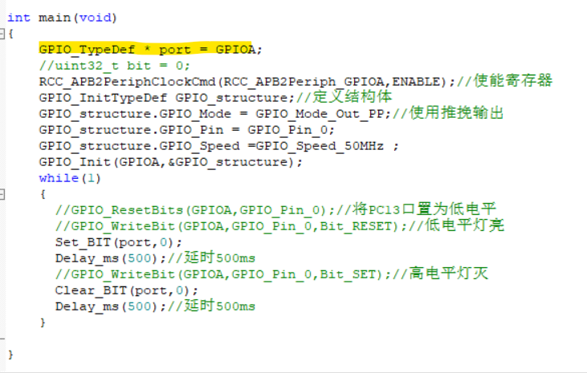

Port->

ODR = (*port).ODR

4_26

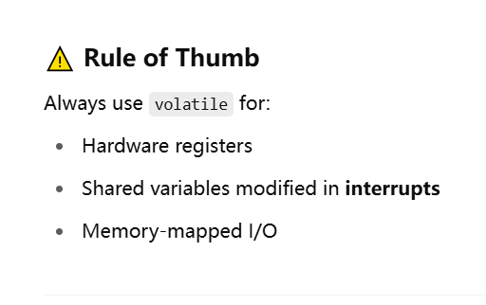

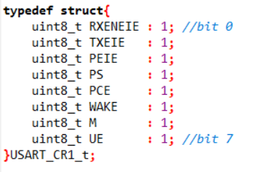

Define a struct with bit-field.defines a 1-bit field in the struct.



Volatile: Do not optimize read/write to this variable.It may change outside control

Why we need volatile?

1. hardware event
2. Interrupt routine
3. DMA or peripherals

If we don’t use volatile, the variable might change overtime and we don’t expect it to change.

4_27 FSM Design

Schematic:

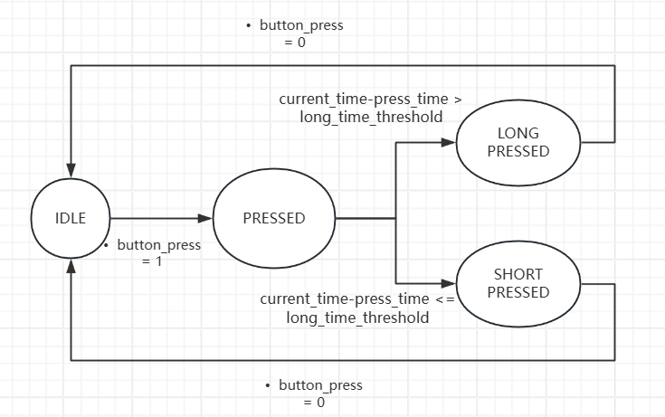

The key of FSM: always think about the next state

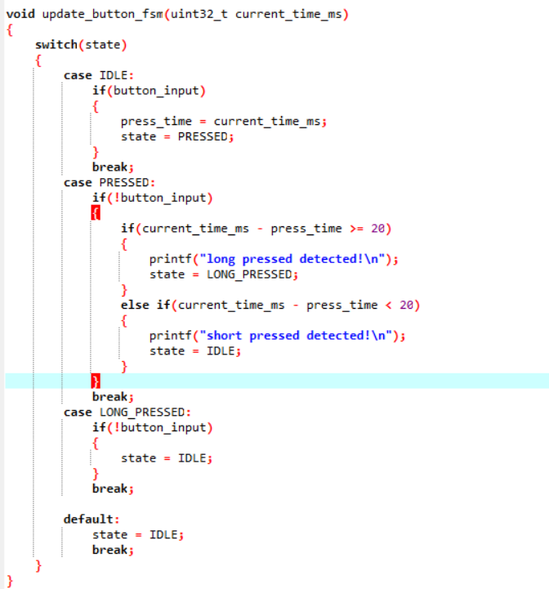

4_28 Timer Simulation

New function:

From #include<time.h>

Clock(): 这个函数用于获取当前cpu的时间，单位是（时钟周期数）

This function is used to get the current CPU time, and the unit is clock ticks

CLOCKS_PER_SEC：这个常量是将时钟周期数转换为秒，Clock()/CLOCKS_PER_SEC = 秒

This constant is used to convert clock ticks to second

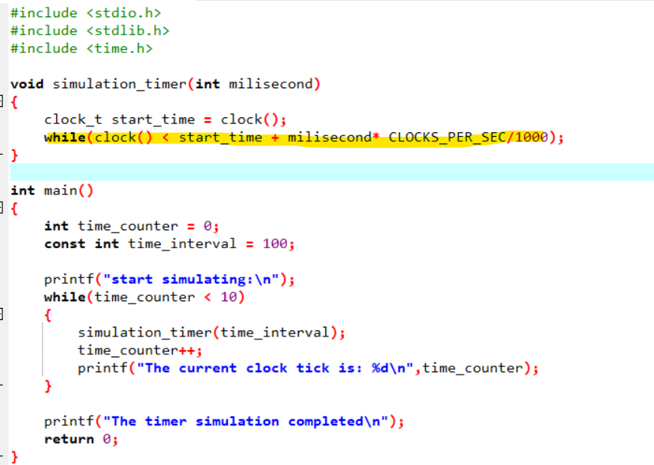

Continue to run the clock() function until it arrives to the specific time