**Distributed Mobile Sensor Network for the Detection of Radiation Anomalies**

**Michael Cheng Russell Michal**

**Abstract**

Distributed sensor networks have been used in many fields of science and engineering for over half a century. With the introduction of the smartphone in 2006, every individual that owns one has become a sensor. In addition to geospatial and timestamp data, smartphones are also capable of collecting radiation data when utilizing the photodetectors in the phone’s camera. Combining this with the concept of participatory sensing, a sensor network was established on the UIUC campus with the assistance of 53 volunteers to monitor background radiation levels and potentially alert people to anomalous sources of radiation if detected. An Android app designed specifically to allow the phones to collect radiation, geospatial, and timestamp data was written specifically for this project. Data collected by phones is streamed to an Amazon Web Services (AWS) repository in the cloud, were the data can be accessed in near real-time [1] for processing and analysis. A maximum likelihood estimation algorithm was used to identify potential radiation anomalies. Many of these anomalies however, turned out to be naturally elevated radiation levels caused by either building material or weather, leading to many false alarms. The potential radiation anomaly data sets were then used to train several machine learning algorithms to distinguish between naturally elevated radiation levels and actual anomalies. The results of applying machine learning algorithms to the anomaly data sets yielded an above 90% accuracy rate of identifying false positives.

**Introduction**

The concept of creating a distributed mobile sensor network comprised of many detectors for the purposes of monitoring radiation levels and detecting for radiation anomalies using participatory sensing dates to March of 2011 in the aftermath of the Fukushima Daiichi nuclear disaster. A group of citizen scientists came together and created a sensor network system based around small pocket-sized Geiger-Muller radiation detectors paired via Bluetooth with smartphones called Safecast [2].

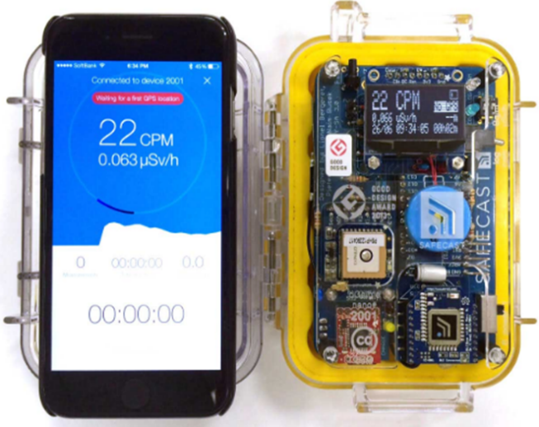

*Fig. 1: Safecast* *bGeigeNano and app [4]*

The Safecast app running on the phone queries radiation data from the bGeigeNano detector once every second and combines it geospatial data and a timestamp supplied by the phone. The data is stored on the phone and must be manually uploaded to Safecast’s GitHub repository. Due to the concern many Japanese citizens have for high radiation levels around their communities, the Safecast sensor network quickly grew to over 900 sensors by the end of 2011 [2]. The participants managed to cover the entirety of the Japanese Islands during that time and managed to collect over 20 million measurements. The figure below is a radiation heatmap of Japan generated from all the Safecast data collected from April of 2011 to December of 2011. Red indicates an area of high radiation and blue indicates an area of low radiation. As can be seen, the area of high radiation was concentrated within a 50-mile radius of the Fukushima Daiichi nuclear power plants. Everywhere else, the spread of radioactive material was minimal.

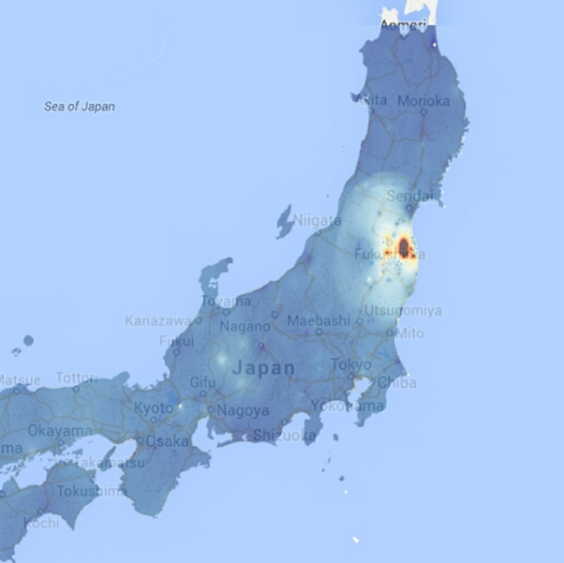

*Fig. 2: Safecast map of Japan (12/16/2011)*

However, in the years after Fukushima, the rate at which Safecast could add new sensors to its sensor network declined sharply, and by December of 2016, the number of sensors has only doubled to about 1800. The amount of data the participants collected has also decreased as by the same date, only about 50 million measurements have been collected [2]. This sharp decrease can directly be attributed to the general loss of interest by the public in wanting to participate in a radiation level monitoring sensor network and the high user input required of volunteers to manually upload collected data.

These short comings of Safecast were recognized by the radiation detection community. In late 2014, DARPA started the SIGMA program to create a radiation sensor network that can cover the entire United States and detect for radiation anomalies. The requirements for this sensor network was to make use of participatory sensing to maximize the number of sensors, automate the process of uploading collected data, identify radiation anomalies with minimal false positives and false negatives, and alert participants of potential danger in near real-time [3]. To accomplish its goal, DARPA funded various research groups in universities across the United States to create a sensor network that could satisfy these requirements outlined in the SIGMA program. The research group with the best radiation sensor network would be selected for nationwide use by DARPA at the end of 2018.

Setting up a Radiation Detection Sensor Network on the UIUC Campus

Among the research groups funded by DARPA’s SIGMA program is the Radiation Detection and Isotope Identification (RDII) group in the nuclear engineering department at the UIUC. The RDII group decided to go about the go about the challenges of designing a radiation sensor network by first simplifying the hardware involved in the network. The detectors used in the Safecast sensor network each cost $600 [4], a hefty price which no doubt contributed to the lack of participants willing to purchase the device. The members of the RDII group felt that by eliminating this cost barrier, participation in the sensor network would become far more accessible. DARPA representatives approved of this idea, and the project was allowed to proceed in early 2016.

In place of the radiation detector, the RDII group decided to make use of the photodetectors located in the cameras of all smartphones to detect for radiation. Radiation is simply energy released in the form of charged particles, neutral particles, or high energy photons when a highly energetic body gives off energy to transition into a more stable state. Radiation is present everywhere is very low levels in the form of background radiation. Background radiation mainly comes from naturally radioactive material in the environment and cosmic rays from celestial bodies such as stars [5]. Background radiation is comprised of predominantly high energy gamma-ray photons, meaning that the photodetectors in the cameras of smartphones can detect them. To do so, a camera cover was placed over the cameras of smartphones to block out all photons with lower frequency than gamma-rays.

An Android app was written by several members of the RDII group to convert input from a phone’s camera to radiation levels in the form of gamma-ray counts. One gamma-ray count is equal to one gamma-ray photon registering with the phone’s camera. The app aggregates the number of photons that interacts with the phone over a one second period and computes a gross gamma-ray count rate. The app combines this data with geospatial and timestamp data, packages everything into a CSV file, and sends the data file to an AWS S3 bucket located in the Amazon cloud. From there, S3’s built-in copy function copies the data over into an AWS Redshift SQL database. The entire data flow process can be seen in Fig. 3 below along with the GUI of the app in Fig. 4.

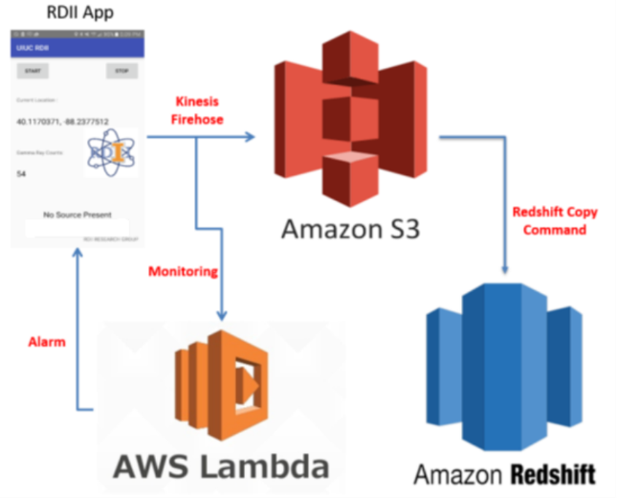

*Fig. 3: Data flow process from Phone to SQL database*

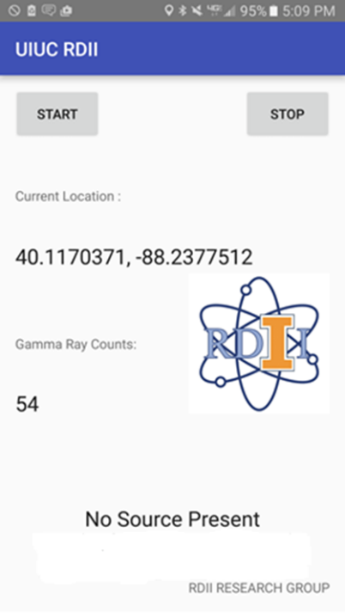

*Fig. 4: RDII app GUI*

As can be seen in *Fig. 3*, the app has the ability to alert users to presence of a radiation anomaly within their vicinity via an AWS Lambda function. The Lambda function monitors incoming data, and if a measurement exhibited abnormally high gamma-ray counts, the *No Source Present* text shown at the bottom of the app GUI in Fig. 4 would change to *Source Present*. As of May 2017, this ability of the app remains disabled as the current radiation anomaly detection algorithm produces too many false negatives. A detailed explanation of why this is the case is presented in the next section of this paper.

**Radiation Anomaly Detection**

Radiation is random in nature, meaning the probability an excited body will emit a radiation quanta follows a Poisson distribution. This property of radiation means that simply setting a gross gamma-ray count threshold and assuming count rate above the threshold to be a radiation anomaly will yield far too many false positives and false negatives. This is because in a 24-hour period, a single sensor collects 86,400 measurements assuming the app is running continuously. With 53 sensors deployed, the total number of measurements collected by a sensor network in one day is 4,579,200 assuming all sensors are running continuously.

In the field of radiation detection, a very commonly used algorithm for radiation anomaly detection is the *k-sigma* algorithm. The *k-sigma* algorithm states that if a measurement exhibited a gross gamma-ray count of more than *k-sigma*, standard deviation, above the mean radiation count rate, the measurement is indicative of a radiation anomaly [6]. The Nuclear Regulatory Commission (NRC) and International Atomic Energy Agency (IAEA) uses *3-sigma* above the mean radiation count rate. Since radiation count rates follow a Poisson distribution, the area underneath the curve that is above *3-sigma* is about *0.27%*, meaning that *0.27%* of measurements will yield a false positive. With 53 sensors, this will yield 12,264 false positives per day, far too many to be considered useful. Furthermore, 3-sigma is an arbitrary number selected by the NRC and IAEA, meaning that the threshold may be too high in certain scenarios and leading to false negatives. An example of this occurring was in the area beyond the *20-km* radius exclusion zone at Fukushima, which had higher levels of radiation but not enough to trigger the 3-sigma criteria [7].

As a result, the RDII group used a Maximum Likelihood Estimation (*MLE*) algorithm to detect for potential anomalies rather than relying on the *k-sigma* algorithm. The *MLE* algorithm is used to estimate the spatial and time variations of the radiation data collected by the sensor network and determine if any measurements are signs of radiation anomalies. To do this, the algorithm first takes into account how the radiation level changes as a function of time at each latitude and longitude coordinate point, which represents a 5m x 5m area. By doing this, the algorithm computes a Poisson parameter, , for each coordinate point every second. It then computes the probability, , the radiation measurement is within normal background ranges. By subtracting this probability from 1, one gets the probability of the radiation measurement coming from a potential anomaly. The *MLE* algorithm is applied to all unique coordinate points in the collected data, and probabilities are generated for each coordinate point [8]. The algorithm is comprised of the two equations below.

(1)

(2)

Where,

* is the Poisson parameter (mean radiation level) at coordinate
* is the Poisson parameter at time
* is the measurement taken at coordinate during time
* is the probability measurement came from a background radiation distribution with Poisson parameter

A major advantage of using MLE rather than k-sigma is that the MLE algorithm is insensitive to radiation fluctuations caused by its Poissonian nature. The MLE algorithm takes this fluctuation into account when computing the Poisson parameter. This feature greatly reduces the number of false positives and false negatives as the algorithm is not limited by a fixed threshold. However, the MLE algorithm does not consider the material composition and functions of buildings and landmarks that contribute to elevated radiation levels. Certain building materials such as granite and marble contain above normal concentrations of natural uranium and thorium, two naturally radioactive elements. Thus, buildings and landmarks that contain significant amounts of granite and marble naturally exhibit higher background radiation levels [9].

In field tests, the MLE algorithm consistently triggers an alarm indicating a radiation anomaly whenever a sensor passes by a building or landmark that contain a significant amount of these two materials. Technically, this is not a false positive as these buildings and landmarks do cause elevated radiation levels, but the increase is benign and consider by both the NRC and IAEA to be well within the safety limit. This is a major issue when the app is being used by individuals without a background in nuclear engineering or radiation safety, which will be a vast majority of the eventual users. Every time a user walks pass or goes into a landmark or building containing a significant amount of granite or marble, the app will trigger an alarm. In a city that contains a lot of buildings or landmarks made of granite or marble such as Washington D.C. or Rome, the alarm will constantly be going off, potentially leading to a public panic.

A building’s function can also cause elevated radiation levels. A medical facility that uses high energy x-rays and gamma-rays to image and treat patients has the potential to trigger the alarm. Such facilities are fairly common in large hospitals, meaning that running the app in a hospital that has such a medical facility can trigger the alarm and cause a public panic as well. This is certainly something one wants to avoid, especially in a hospitable full of patients.

In addition to material composition and functions, the weather can also cause elevated radiation levels. Precipitation and high humidity is capable of picking up radon gas in the atmosphere and deposit them onto environmental surfaces [10]. Radon is another naturally occurring radioactive element. It is produced from natural uranium and thorium decaying, releasing radon gas in the process. Being a dense gas, it is typically suspended in the air fairly close to the ground. During periods of high precipitation, condensing water droplets in the form of rain or snow picks of this radon, concentrates it, and deposits it on to environmental surfaces. The concentrated radon eventually dissipates back into atmosphere when the precipitation evaporates, but prior to this occurring, outdoor radiation levels are noticeably higher than normal levels. High humidity has a similar effect. Again, the increase in radiation levels is harmless to humans, but has the potential to trigger an alarm if a sensor is outdoors during periods of precipitation and high humidity.

These issues were quickly brought forth to DARPA during the app’s initial testing phase in the fall of 2016. Though these alarms are not technically considered false positives, DARPA wanted the app to be able to distinguish between harmless radiation level increases and real anomalies such as a leak from a nuclear power plant or a dirty bomb containing radioactive material. MLE on its own is incapable of accomplishing this task. Thus, several machine learning algorithms were tested to see if the measurements being considered as anomalies by the MLE algorithm are real anomalies or harmless increases. In the meantime, the app’s alarm function was disabled to prevent it from constantly panicking users.

**Application of Machine Learning for Anomaly Explanation**

The MLE algorithm was consistently identifying several buildings and landmarks on the UIUC campus as anomalous radiation sources. As mentioned earlier, these technically are radiation sources as their material compositions and functions cause them to emit above normal levels of radiation. However, they are harmless to humans, and therefore, should not be counted as anomalous radiation sources. They are also located in highly trafficked areas on the UIUC campus, meaning that if they will constantly be triggering an alarm had the alarm not been disabled. These landmarks and buildings are circled in red in *Fig. 5* below.

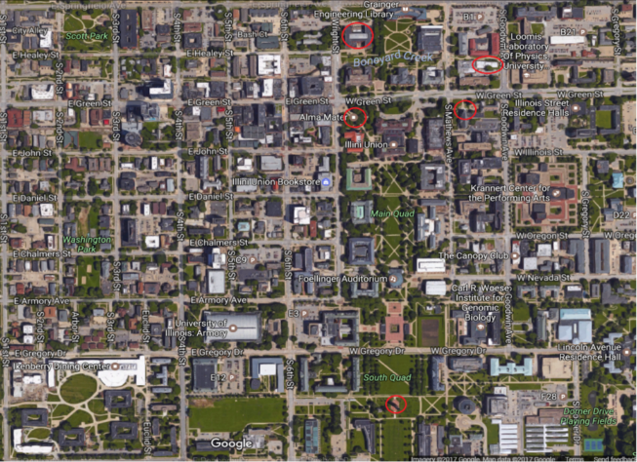

*Fig. 5: UIUC campus with areas of elevated radiation circled in red*

**Results**

The app began field tests on the UIUC campus by all 53 volunteers during the beginning of the 2017 spring semester in mid-January. From the mid-January to the beginning of April, the sensors collected a total of 50 GB of data comprising of 100 million readings. In comparison, Safecast only collected 50 million readings between April of 2011 and December of 2016, requiring over 900 sensors to do so. The reason why the RDII sensor network was able to collect so much more data than the Safecast sensor network is because of the sensors in the RDII sensor network automatically uploaded the data whereas with safecast, the users must do it manually. This reduction in user input made using the RDII sensors far easier than the Safecast sensors as reported by the 53 volunteers, and thus, significantly more data was collected in a much shorter period.

The delay between collecting data and having access to the data in the SQL database on AWS was found to be quite short, with *95%* of the data arriving in the SQL within *14-seconds*. Depending upon how quickly the MLE and machine learning algorithms run, a feed back in the form of an alarm can be returned to the user within *30-seconds*, assuming similar delays for sending the alarm to the user from AWS. This easily meets DARPA’s requirements as previous handheld radiation monitoring devices that give near real-time feedback were quite large and bulky, and cannot be easily be carried by a single person.

The average gross gamma-ray count was calculated from each day’s measurements, and the results are shown in *Fig. 6* below.

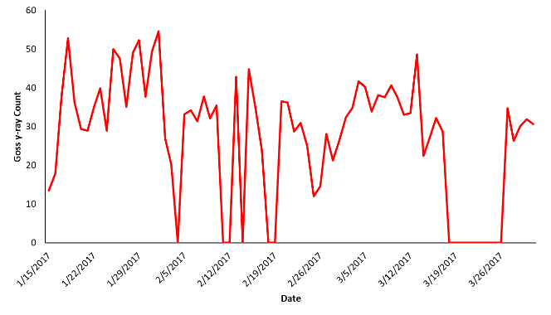

*Fig. 6: Daily average gamma-ray radiation levels on the UIUC campus*

As shown in *Fig. 6*, radiation levels fluctuate from day to day on a regular basis. The dips that reach 0 gamma-ray counts shown in the figure are caused by all the sensors going offline. These occurrences happened mostly during weekends and long school holidays such as spring breaks, which explains for the long continuous string of inactivity during the end of March. Despite having extended periods where none of the sensors were active, the data collected during the 3-month period was still quite expansive. As a result, a background radiation level heatmap of the entire UIUC campus was generated this data and can be seen in *Fig. 7* below. Note that this heatmap was generated by averaging the gamma-ray count at each coordinate point.

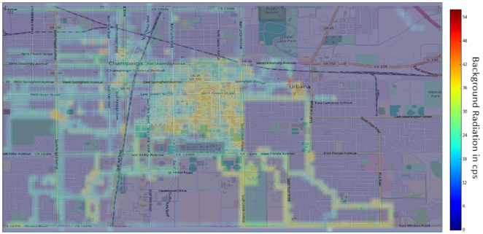

*Fig. 7: Background radiation level heatmap of the UIUC campus*

As shown in *Fig. 7*, radiation levels vary quite a bit on campus, ranging from a low of around 20 to a high of around 50 gamma-ray counts. This variation is directly attributed to the material composition of the environment as mentioned earlier. The MLE algorithm does not take the material composition into consideration, and thus, areas shown on the heatmap with high background radiation levels, above 45, will trigger the alarm. Machine learning algorithms were therefore used in conjunction with the MLE algorithm in an attempt to eliminate these false positives.

**Conclusion**

**References**

1. "Near real time", *Federal Standard 1037C*, Available: https://www.its.bldrdoc.gov/fs-1037/fs-1037c.htm, [Accessed: Feb - 2017].
2. Brown, P. Franken, S. Bonner, N. Dolezal, and J. Moross, "Safecast: successful citizen-science for radiation measurement and communication after Fukushima", *Journal of Radiological Protection*, vol. 36, no. 2, pp. S82-S101, 2016.
3. M. Cheng, “*Analysis of a Custom Android App Designed to Utilize Cloud Infrastructure in Support of Mobile Sensor Networks*”, Master Thesis, University of Illinois at Urbana-Champaign, 2017.
4. SAFECAST BGEIGIE NANO - MOBILE RADIATION MONITORING DEVICE. *KitHub*, 2017. [Online]. Available: <https://shop.kithub.cc/products/safecast-bgeigie-nano>
5. G. F. Knoll, "*Radiation detection and measurement*", John Wiley \& Sons, 2010.
6. A. H. Liu, J. J. Bunn, and K. M. Chandy, “Sensor networks for the

detection and tracking of radiation and other threats in cities", in *Infor-*

*mation Processing in Sensor Networks (IPSN*), 2011 10th International Conference on. IEEE, 2011, pp. 1-12.

1. M. Cheng, G. Gusloff, B. Yung, and C. Zircher, “*Passive Radiation Monitoring System (PARMOS)*”, Senior Design Project, The University of Illinois at Urbana-Champaign, 2015.
2. Z. Liu, “*Mobile Radiation Sensor Networks for Source Detection in a Fluctuating Background Using Geo-Tagged Count Rate Data”*, Master Thesis, The University of Illinois at Urbana-Champaign, 2016.
3. J. Zhao, “*Preliminary Study of Spectrum-based Anomaly Detection for Mobile Radiation Sensor Networks*”, Master Thesis, The University of Illinois at Urbana-Champaign, 2016.
4. R. J. Liversay, C. S. Blessinger, T. F. Guzzardo, and P. A. Hausladen, “Rain-induced increase in background radiation detected by Radiation Portal Monitors”, *Journal of Environmental Radioactivity*, vol. 137, pp. 137-141, 2014.