# Customer Application

These are the instructions to simply run the assignment code and to create an Eclipse project.

## Prerequisites

* Eclipse IDE for Enterprise Java Developers.
* Apache Maven 3.6.3

## Github

The code can be accessed from Github :-

To clone the project call :-

git clone https://github.com/rjennins/customersProject.git

Alternatively download the project using the green button. This will create a file called candidatesProject-main.zip. Extract all the data to a location where you want to have the Eclipse project.

## Building and Running the Code in Standalone Mode

Open a Windows Power Shell and go to the directory customersProject as below :-

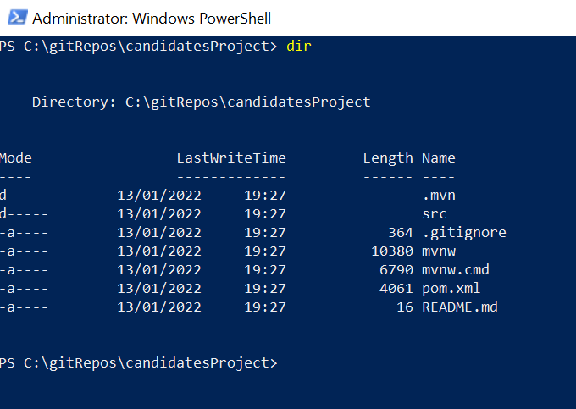

To build the project and run the unit tests call the following command (for this to work Maven needs to be deployed with the Maven bin directory in the system path variable) :-

mvn clean package spring-boot:repackage

When the about command has been executed you should see something similar to below :-

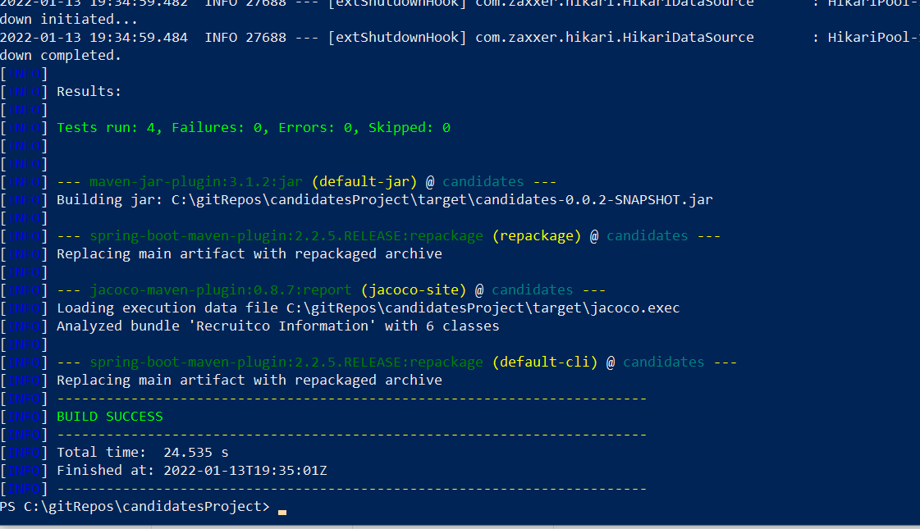

There are two ways to run the project in standalone mode :-

mvn spring-boot:run

OR

java -jar target/candidates-0.0.2-SNAPSHOT.jar

Upon completion of either of the commands above you should see something similar to below on the screen :-

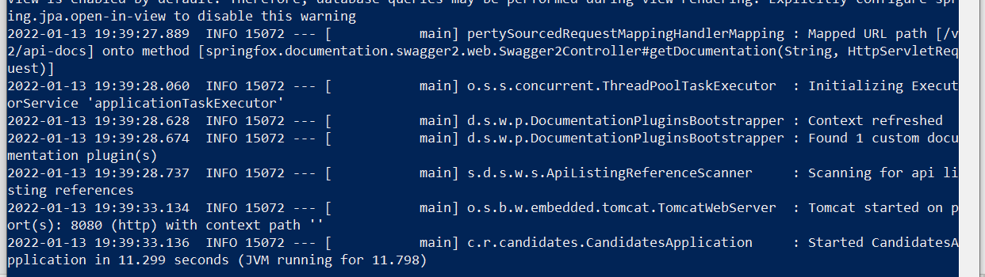

To test that the project has started correctly go to the Swagger URL :-

[http://localhost:8080/swagger-ui.html#](http://localhost:8080/swagger-ui.html)

The following screen should be displayed :-

Click on “candidates-controller” and you will see all the methods as shown below :-

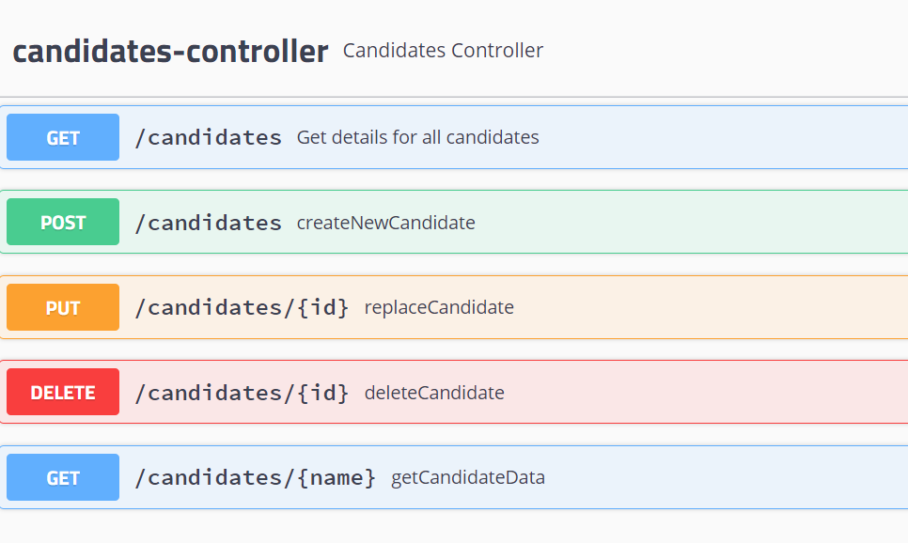

To call “candidates”, which gets all the candidates data, select the top blue button :-

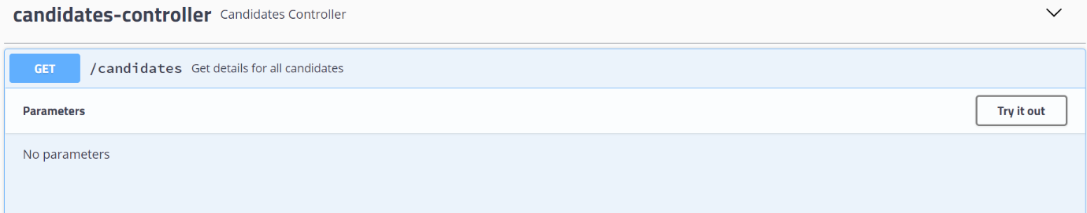

There are no parameters for this method call so select the “try it out button” and then the excute button

Upon execution you should see something similar to the following : -

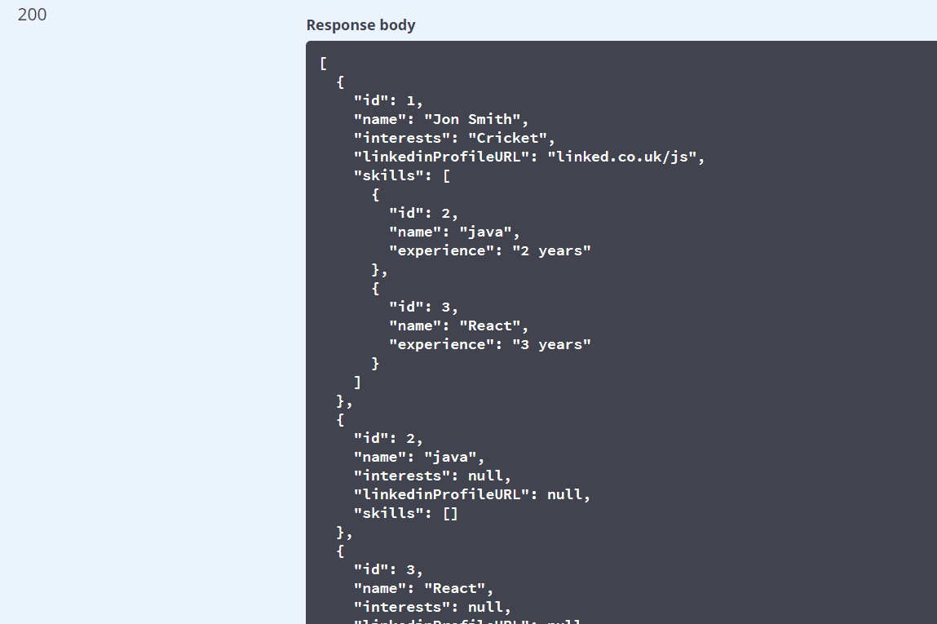

To call the URL directly in the browser the URL can be found in the “Curl” section shown below. For this example the URL is http://localhost:8080/candidates

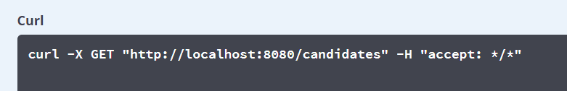

All the other methods follow the same pattern and should be self explanatory.

## Creating the Eclipse Project

In Eclipse import the project taken from Github and pickup the pom.xml file of the downloaded project.

The project should be created in Eclipse. To run the application right mouse on the project and select “Run As” or “Debug As” and in turn “Spring Boot App”. In the console window you should see the following. To confirm the application has started up okay call the Swagger code :-

[http://localhost:8080/swagger-ui.html#](http://localhost:8080/swagger-ui.html)

## H2 Database

An H2 Database has been utilised and the admin tool below has been enabled :-

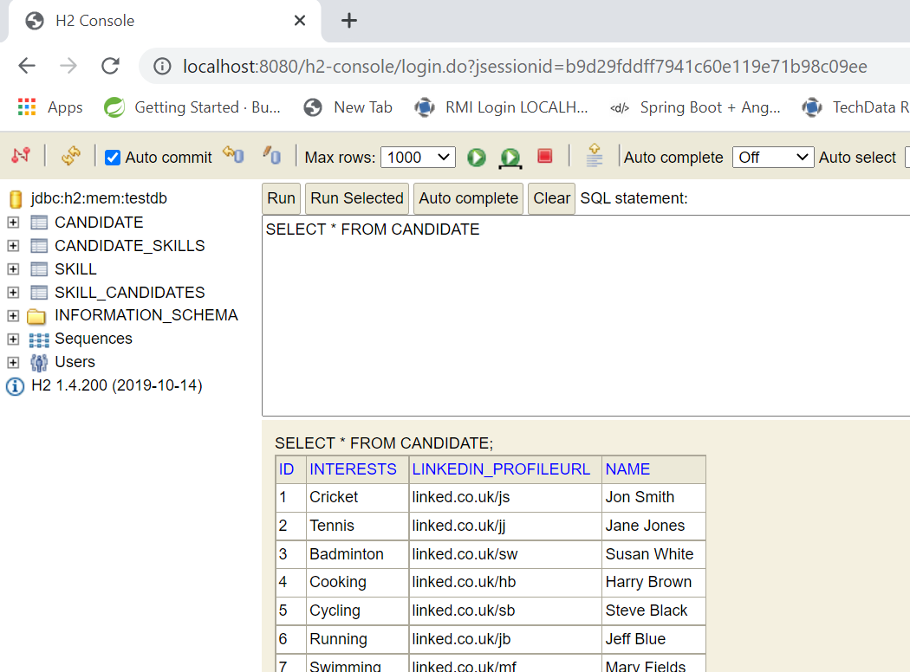

## Pagination and Sort

This can be demonstrated in the Swagger UI :-

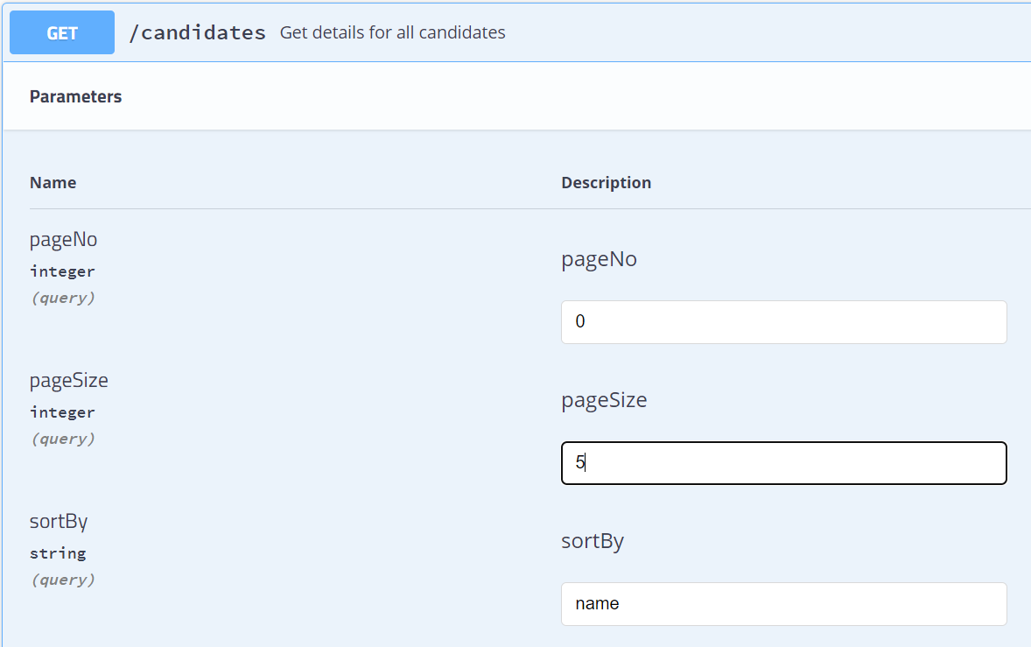

Then select the execute button and for above criteria 5 records are returned and ordered alphabetically by name :-

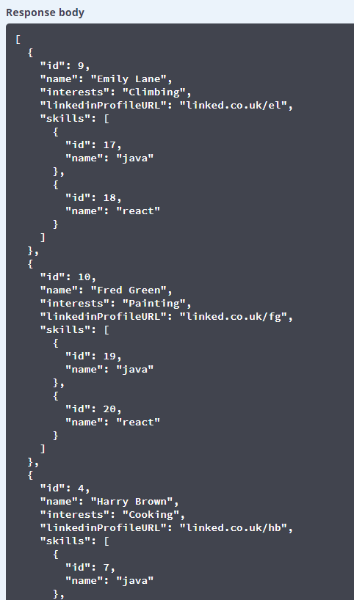

# H2 Angular12 Client

An Angular client is available to access the Candidate microservice. It can be downloaded from Gibhub :-

git clone <https://github.com/rjennins/CandidatesClient.git>

From a “Bash” window for exampl start the Angular test environment call :-

ng serve –-open

The following should appear :-

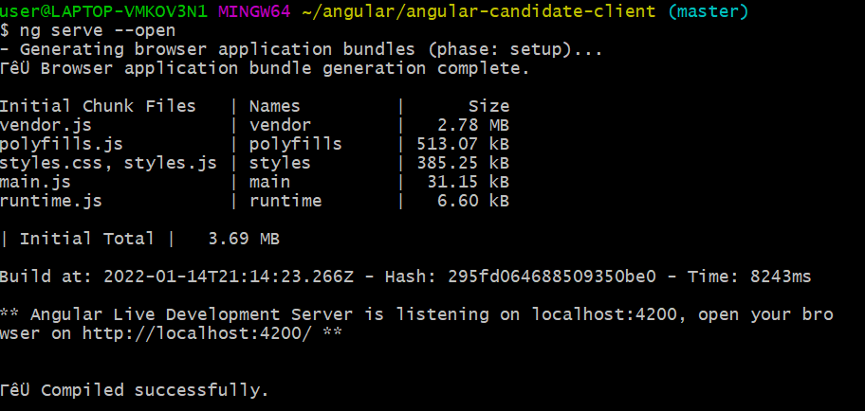

A browser will be started up :-

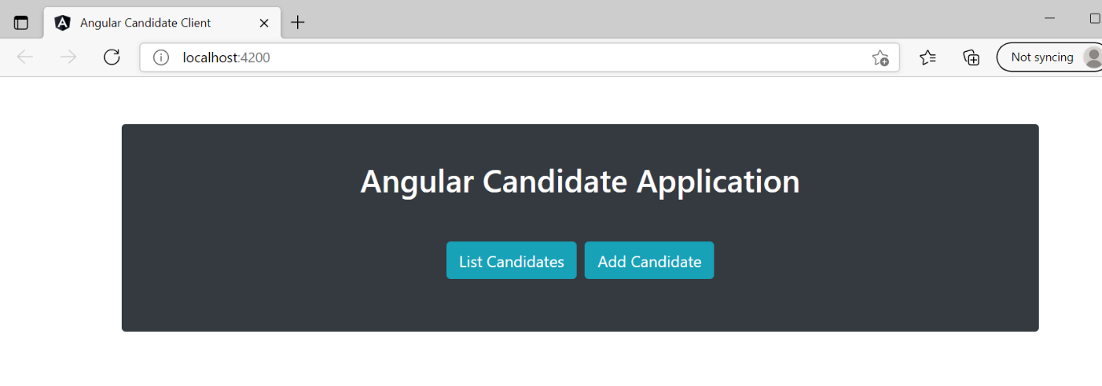

Selecting the “List Candidates” button :-

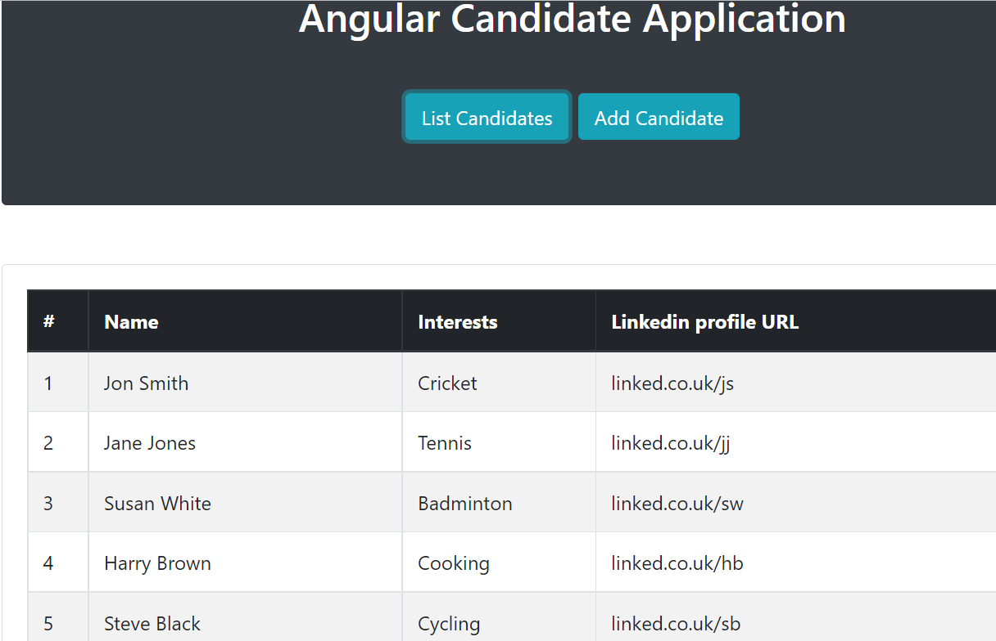

Selecting the “Add Candidates” button :-

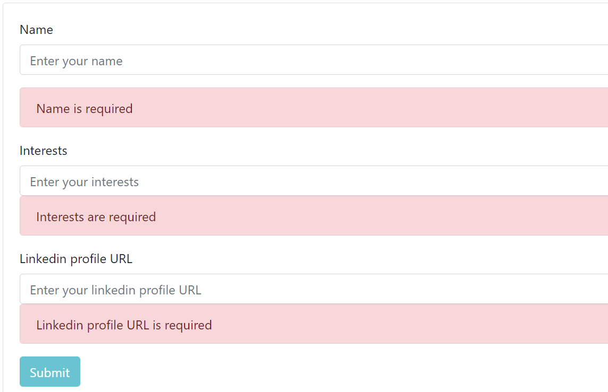

Values can be added and submitted and saved to the microservice H2 database. Subsequent selections of the “Add Candidates” button will display the newly added data.