**CS-4497/6497-2019-P3, individual, due Nov 5**

**Arrows > Loop of Steadily-Animated Similarities > Animated COTS pattern of strokes**

*The goal of this project is to expose students to the invention, implementation, and validation of animated motions and warps of patterns and of measures of their aesthetics.*

# Input

You are given base sketch that lets the user edit (move, add, delete) a set of arrows in the plane.

Change it so that your face and name appear on the canvas.

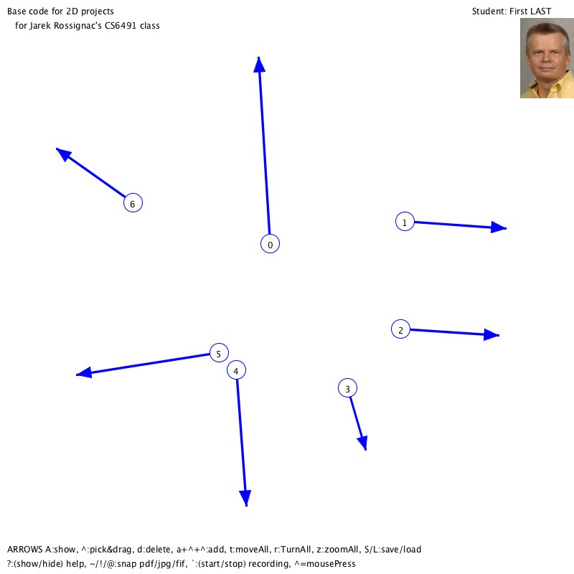

# Cyclic piecewise-SAS motion of an arrow in 2D

Read Section 2 of the COTS paper and implement a Steadily-Animated Similarity (SAS) motion between all consecutive pairs of arrows (including last-to-first). Use it to show a pattern of *s* intermediate frames between each pair. Let the user adjust the number *s* of these samples. Also provide the option to animate a continuous and cyclic motion of an arrow that interpolate all given arrows. Below, I am showing an example for the first 4 arrows (in black, marked A, B, C, D) with *s*=15 red frames. Note that, although continuous, the above cyclic concatenation of SAS motions is not smooth when it passes through B and C.

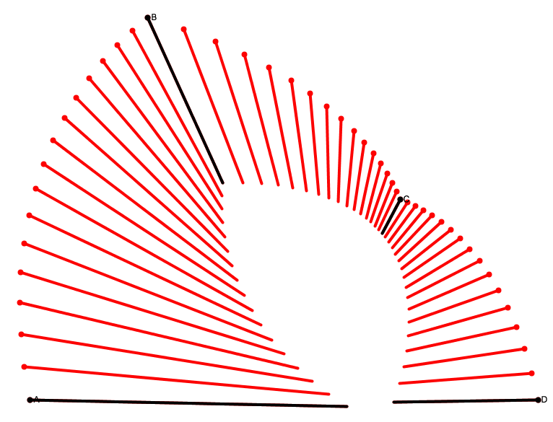

# Subdivision and smooth motion of an arrow control by a ring of key-arrows

Read the ScrewBender paper (which was limited to rigid motions in 3D) and also the SAM paper (which generalized it to affine motions in 2D and in 3D) and design, implement, and test a smoothing algorithm of the 2D motion of an arrow. We want the velocity of each end-point of the arrow to appear continuous throughout the motion. We show below (left) an example of the smoothened version of the sequence of 3 SAS motions shown above. Note that it appears smooth. Here, we used a Neville construction. Because you need to support a cyclic motion and arbitrary count of arrows, you need to implement subdivision (as discussed in these papers), but should use the above SAS as a basic interpolation primitive. On the right, we show a non-cyclic Catmull interpolation. You should implement a **quintic B-Spline** subdivision (see paper on J-splines from L10 on Curves) and an interpolating (it is your choice which, but I suggest **Four-Point**) subdivision of a **ring of key-arrows** (not of two independent rings of their endpoints). Let the user start/stop an animation of an arrow (by pressing ‘a’), which, at each frame, displays the next arrow in the subdivided ring.

**Grad students**: Note that editing smoothly one of the ends of one of the arrows may, in some configurations, produce a surprsing flip (jump between the previous and current subdivided ring of arrows). Such a discontinuity is aesthetically disturbing and should be remedied. I conjecture that it may be fixed by rectifying the choice of trigonometric branching during the computation of the angle between two arrows (you may need to add or subtract 2π to some angles). Read the relevant section in the COTS paper and devise a scheme for your algorithm to detect these branching problems and to compensate as appropriate.

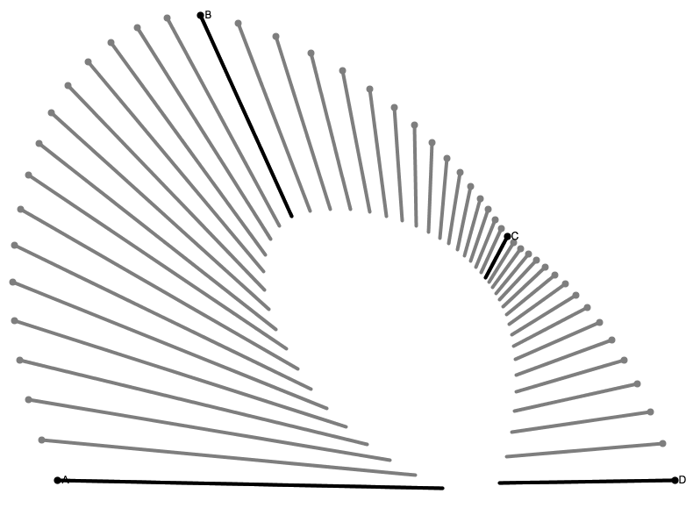 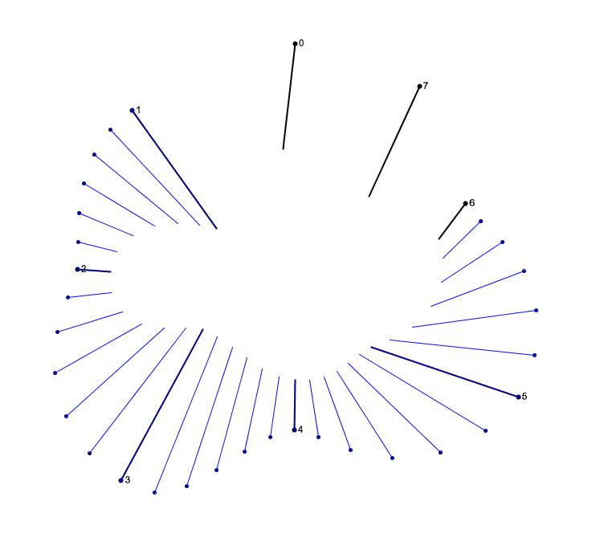

# Smooth-appearing motion of a COTS map

Use the first two **key-arrows** to define a control-quad (A,B,C,D). At each frame, slide each one of the two arrows, each by one along your subdivided ring of arrows in a cyclic manner, so that your motion is an infinite loop. At each frame of this animation, use the current control-quad to define a COTS map and use that COTS map to display a distorted version of **your** face. (Read the COTS paper for details and use the provided COTS-demo sketch.) You are welcome to use any part of the COTS sketch provided. Below, I show an example of the original image and its COTS distortion controlled by the four corners A, B, C, D.

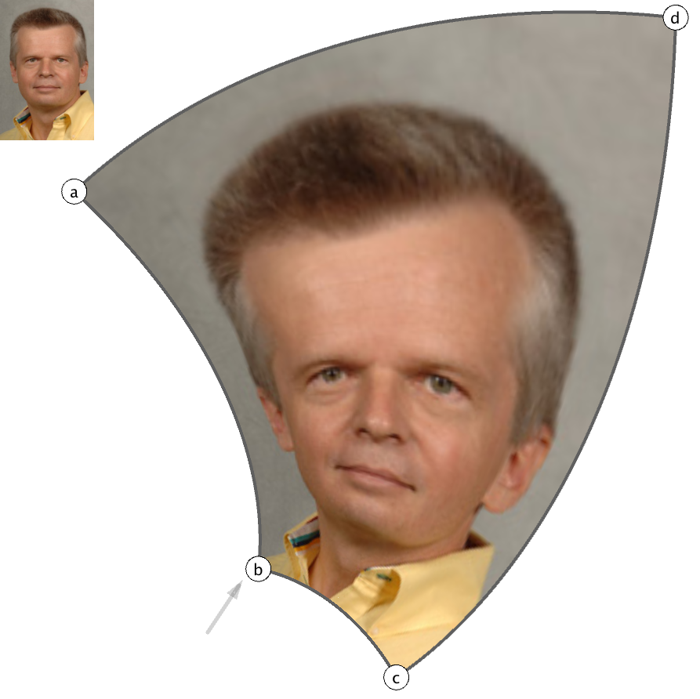

# Programmed pattern

Required phase for **graduate students** and extra-credit for undergraduates. Instead of using a texture map inside the sliding and deforming COTS, use an aesthetically pleasing shape that you programmed. It may be your signature, smoothened and beautified with non-uniform thickness strokes, or a static or animated pattern (see examples below). But it should have at least one parameter that controls its shape, one of its properties, and color. Provide a synchronization of that parameter with the beat of a music that plays during the animation.

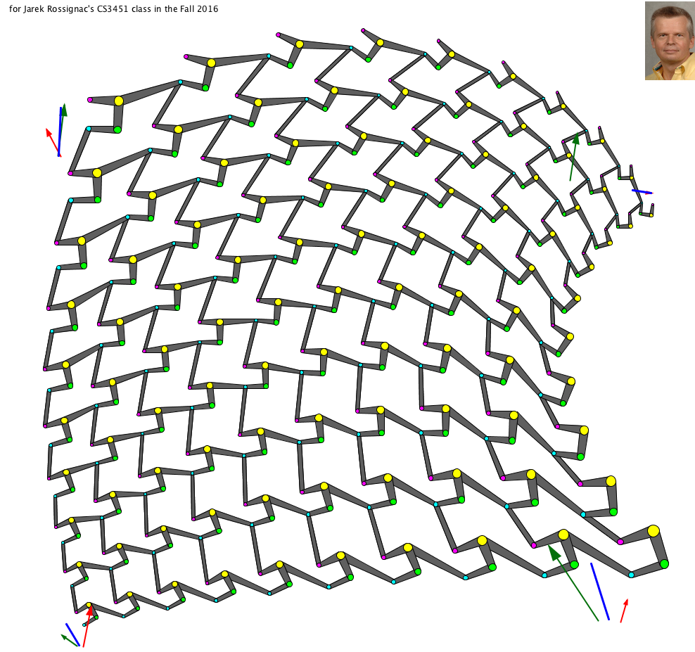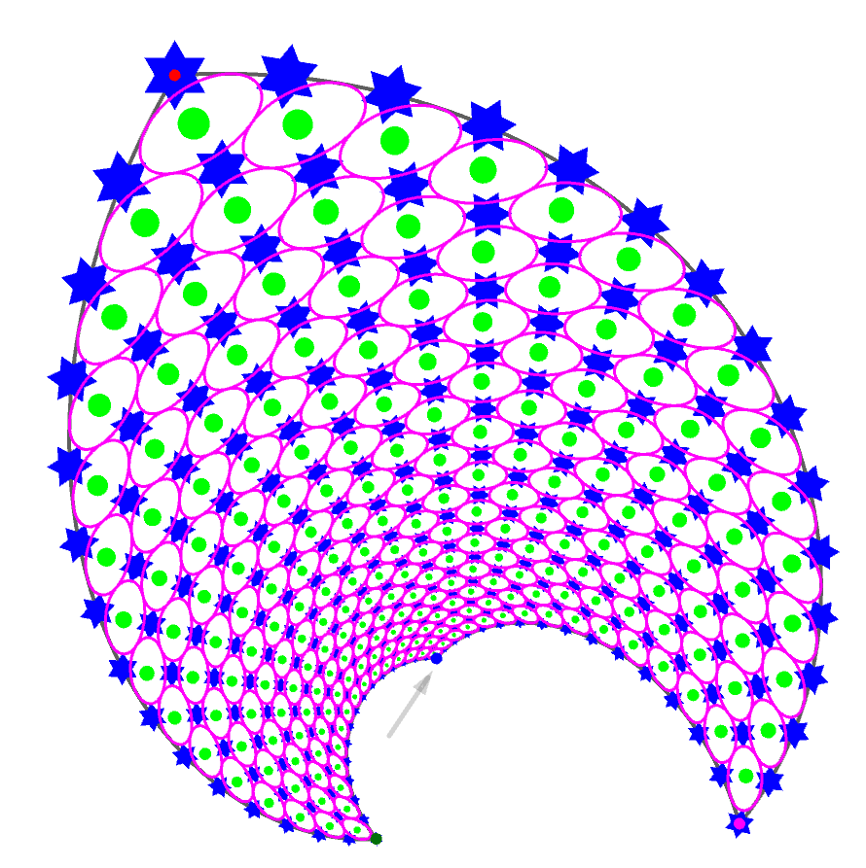

Some links to possible inspirations on patterns (but remember that your pattern must be procedural, ie. programmed, not texture mapped, and parameterized):

<https://www.pinterest.com/pin/779122804263311717/>

<https://www.pinterest.com/pin/90635011226342304/>

<https://www.pinterest.com/pin/374502525233097209/>

<https://www.pinterest.com/pin/444167581973828415/>

<https://www.pinterest.com/pin/571605377702620894/>

<https://www.pinterest.com/pin/373306256597333173/>

<https://www.pinterest.com/pin/716987203157259127/>

<https://www.pinterest.com/pin/152137293650240903/>

<https://www.pinterest.com/pin/152137293649907499/>

<https://www.pinterest.com/pin/152137293649790310/>

<https://www.pinterest.com/pin/152137293649566989/>

<https://www.pinterest.com/pin/152137293649446150/>

<https://www.pinterest.com/pin/152137293648084697/>

<https://www.pinterest.com/pin/152137293650130192/>

<https://www.pinterest.com/pin/851813717002972895/>

Some links with possible inspirations for animated patterns:

<https://8tracks.com/squal/live-for-the-beat>

<https://www.buzzfeed.com/kellyoakes/hypnotic-gifs-you-wont-be-able-to-stop-staring-at?sub=3291184_3039039>

<https://www.pinterest.com/pin/504755070721511692/>

<https://www.pinterest.com/pin/152137293650240316/>

<https://www.pinterest.com/pin/152137293650108839/>

<https://ello.co/hexeosis/post/nbpovnrgbgmbongywz2j-g>

<https://imgur.com/gallery/4Fld8>

<https://adamreeve.tumblr.com/post/140812519784>

<http://images4.fanpop.com/image/photos/19500000/Bright-and-twirly-bright-colors-19551229-240-320.gif>

<https://www.pinterest.com/pin/438960294908530048/>

<https://www.pinterest.com/pin/16677461095081250/>

# Symbols (if you need them in MS word)

# Symbols

  ! ¬ => ⇨⬄  ⭢⭡⭣⭤ 🠖🠚🠂🠆🠦

 ∂  ∪ ∩ ⊗ Ω **∅** ø ∈ ∉

√ ∫ ∑ ∏ π ∞   µ ∂  ± ≠ ƒ ≈ ~ ≤ ≥   

**U V Ø** ° ˆ • 🞨 🢜 🢭  ∆  🞊   🟂🟉     • º 🞩 △▽ ⭮ ⭯

  🕮 🖎 👍 ✓ 🗙 ❓⏺🞎 🌕

🄋➀➁➂➃➄➅➆➇➈➉

              □                 ☺ ☹          µ ß Ø

$ € §  ⌘ à ç

√ ≠ A0 **T0**=**A0B0C0** and **T1**=**A1B1C**1

**∅**.∈ ∉!**A A**⊗**B**=(**A**∪**B**)-(**A**∩**B**).

=>≠{}@|~•¶ß´¨≠Ø∞±≤≥µ∂∑∏π∫ºΩø¬√ƒ≈∆–—“◊⁄‹›·ˆ˜¯˙˚¸¸˝🗙⏹⏺⏵🔈🎔✔🗙❓⦸🛆🗖🖉👓🕮🖰🖎👍☺☹😐🞏🞟⬩⌘🄋➀➁➂➃➄➅➆➇➈➉🄌∙🕔•⬝⭘🞆🞊🞋▪🞎🟁🟅★🟋⌖🡪⇨⬄🢬🢭✓🖸☉🌕🞄⦁🞌🞍◾🞗🞘⬥🞨🞩🞯🟂🟉⭢⭡⭣⭤⭬⭫⭭⭍⭮⭯🡒▲▼△▽⯅🠖🠚🠂🠆🠦🢜

pt P =

cosθ , r(θ)=aebθ

## Shortcuts

<https://forlang.wsu.edu/help-pages/help-pages-keyboards-os-x/>

### accents

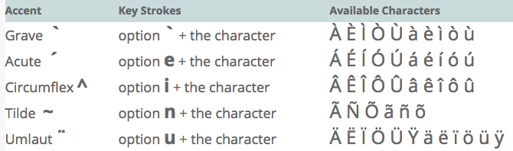

### Separators and non-math symbols

— : option + shift -

§ : option + 6

©: option + g

* is option

 ss dd xx  cc

aa aa aαaαβ

### Dictation

### French & German characters

€ : shift + option +

ç : option + c

ã : option + n + a : ñ, õ,

æ: option + ’

ß : option + s

### Greek letter

α : shift + command + SPACE + a + shift + command + SPACE

β : shift + command + SPACE + a + shift + command + SPACE

; ς ε ρ τ υ θ ι ο π

α σ δ φ γ η ξ κ λ

ζ χ ψ ω β ν μ

µ : option + m

∂ : option + d

### Equation

Ctrl + = : type equation

Ctrl + = \alpha

### Math symbols

Ø : option + o

√ : option + v

UˆV : option + i

U•V : option + 8 , S·R : option + shift + 9

U°V : option + shift + 8 , UºV : option + 0, U˚: option + k, U˙ : option + h

≠ : option + +, ≈ : option + x, ≤ : option + ,, ≥ : option + .

± : option + +, – : option + -

÷ : option + /

∆ : option + j

Ω : option + z

∫ : option + b

∞: option + 5

⁄ : option + !

‹ : option + #

› : option + $

ƒ: option + f

¬: option + l

: option + K

◊: option + V

U¯ : option + <

U˘ : option + >

¿ : option + ?

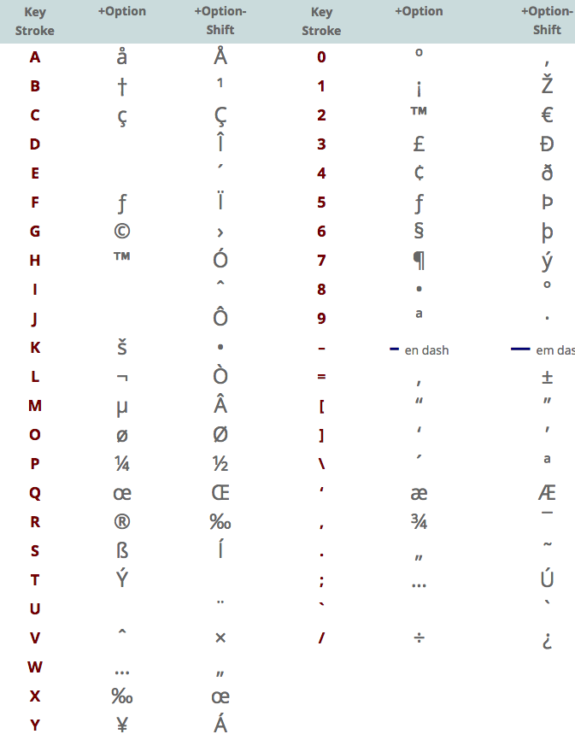

 Highlight words that you do not know in the paragraph above and look up their definition.

## Motivation and applications

Graphics is.

 Why are points important in graphics?

## Relation to other lectures

Most of the following.

 How is a frame defined?

than and AB rather than .